
SIMATS ENGINEERING
Saveetha Institute of Medical and Technical Sciences
ASSIGNMENT - 5

Student Name | M. Mokshith Reddy
Registration No. | 192372373
College Name | Saveetha Institute of Medical and Technical Sciences
Course Code | CSA10
Subject Name | Software Engineering
Assignment | Assignment - 5

Submitted in partial fulfilment of the requirements for
CSA10 — Software Engineering

Question 1
Explain technical debt. What are the major causes of technical debt, and how can organizations minimize it during software evolution?
[Marks: 10 | CO: CO explains software evolution and maintenance concepts]

1.1 What is Technical Debt?
Technical debt is a metaphor introduced by Ward Cunningham to describe the implied long-term cost of choosing an easy or quick solution in software development instead of a better, more time-consuming approach. Just as financial debt accrues interest over time, technical debt accrues "interest" in the form of extra effort required for future changes, bug fixes, and maintenance. If left unpaid, this interest compounds until the software becomes difficult, expensive, or even impossible to evolve further.
Technical debt is not always bad. Teams sometimes take on debt deliberately to meet a critical deadline or validate a market idea quickly, with the intention of refactoring later. The danger arises when debt is taken on unknowingly, or when it is never repaid and keeps accumulating alongside new debt.
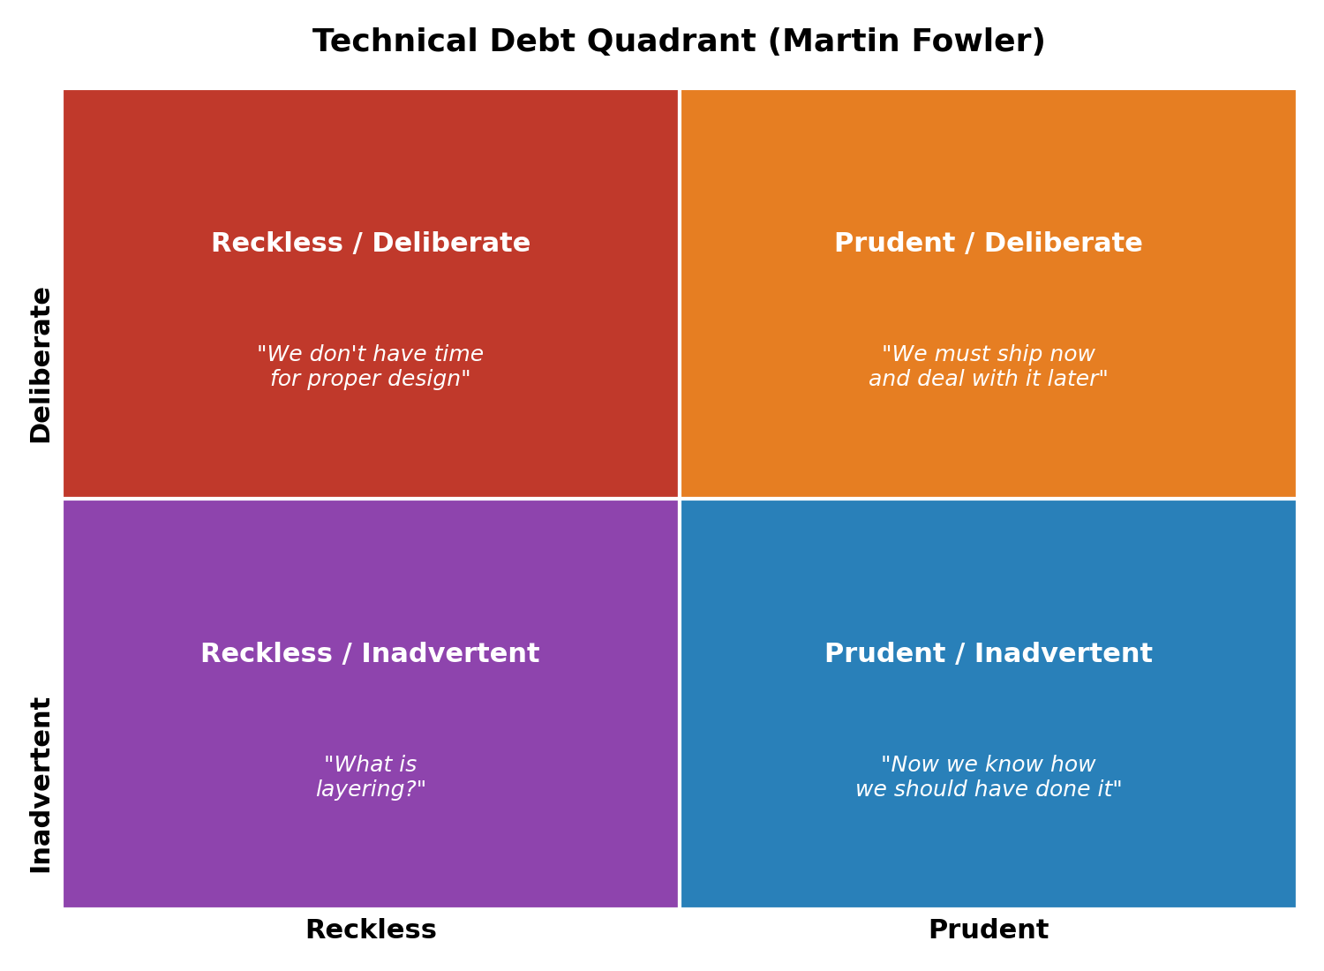
Figure 1.1 — Technical Debt Quadrant (Reckless/Prudent x Deliberate/Inadvertent), adapted from Martin Fowler.

1.2 Major Causes of Technical Debt
- Time and deadline pressure: Teams under tight schedules skip proper design, testing, or refactoring to ship features faster, planning to "fix it later" — a plan that is frequently postponed indefinitely.
- Poor or missing documentation: When design decisions and rationale are not recorded, future developers must reverse-engineer intent, leading to inconsistent or incorrect changes.
- Lack of automated testing: Without a strong test suite, developers are afraid to refactor safely, so risky code is patched around instead of fixed properly.
- Insufficient code reviews: Skipping peer review lets poor design choices, duplicated logic, and anti-patterns enter the codebase unchecked.
- Changing or unclear requirements: Frequent scope changes force architecture built for one purpose to be repeatedly bent to fit new, unanticipated needs.
- Lack of skills or experience: Developers unfamiliar with best practices or the existing architecture may unintentionally introduce debt ("inadvertent" debt).
- Legacy technology and outdated dependencies: Old frameworks, unsupported libraries, and obsolete platforms make every new feature harder to build cleanly.
- Business pressure to prioritize new features: Management may consistently prioritize visible features over invisible internal quality, deferring refactoring indefinitely.

1.3 Minimizing Technical Debt During Software Evolution
- Maintain a visible debt register: Track known debt items (e.g., as tagged backlog issues) with an estimated cost/impact so they are not forgotten and can be prioritized alongside features.
- Allocate dedicated refactoring time: Reserve a fixed percentage of every sprint (a common practice is 10–20%) for paying down debt rather than treating it as optional.
- Enforce code reviews and coding standards: Mandatory peer review and static analysis tools (e.g., SonarQube) catch quality issues before they are merged.
- Invest in automated testing and CI/CD: A strong regression suite gives teams the confidence to refactor safely and frequently, preventing debt from calcifying.
- Apply the Boy Scout Rule: Encourage developers to leave the code slightly cleaner than they found it with every change, so small debts are paid continuously.
- Improve documentation and architectural decision records (ADRs): Recording the "why" behind decisions reduces the chance that future changes unintentionally reintroduce debt.
- Educate stakeholders on the cost of debt: Translating technical debt into business terms (delivery speed, defect rate, cost) helps secure management support for refactoring time.
- Refactor incrementally, not in "big bang" rewrites: Small, continuous improvements are lower risk and easier to validate than large rewrites, which often introduce new debt of their own.
In summary, technical debt is an unavoidable part of software evolution, but its impact can be controlled through deliberate tracking, disciplined engineering practices, and organizational support for continuous refactoring, rather than allowing it to accumulate silently until it cripples the system.

Question 2
Explain how AI/ML and Edge Computing are transforming modern software engineering. Provide one practical example for each.
[Marks: 10 | CO: CO relates emerging technology trends to software engineering practice]

2.1 AI/ML Transforming Software Engineering
Artificial Intelligence and Machine Learning are reshaping nearly every phase of the software development lifecycle — from requirements analysis to deployment and maintenance.
- Intelligent code generation and completion: AI models trained on large code corpora can suggest entire functions, complete boilerplate, and even generate tests, significantly speeding up development.
- Automated testing and defect prediction: ML models can analyze code churn and historical defect data to predict which modules are most likely to contain bugs, allowing testing effort to be focused efficiently.
- Smarter DevOps and CI/CD pipelines: AI-driven pipelines can predict build failures, optimize test selection, and flag risky deployments before they reach production.
- Requirements and code-review assistance: Natural Language Processing can extract requirements from stakeholder discussions and flag ambiguous or conflicting statements early.
Practical example: GitHub Copilot, an AI pair-programming tool built on large language models, suggests real-time code completions and entire functions inside the developer's editor. It reduces the time developers spend writing repetitive or boilerplate code and helps less experienced developers follow established patterns.

2.2 Edge Computing Transforming Software Engineering
Edge computing moves computation and data storage closer to the source of data generation (devices, sensors, local gateways) rather than relying solely on a centralized cloud. This shift changes how software is architected, tested, and deployed.
- Low-latency, real-time processing: Applications that need instant responses (e.g., autonomous systems) cannot tolerate the round-trip delay of sending data to a distant cloud server.
- Distributed microservice architectures: Software must be designed to run reliably in small, resource-constrained, distributed units rather than a single large backend.
- Reduced bandwidth and cloud cost: Only relevant, pre-processed data is sent to the cloud, reducing network load and operating expenses.
- Offline-first and resilient design: Edge applications must function correctly with intermittent connectivity, requiring new patterns for local caching and eventual synchronization.
Practical example: Smart security cameras with on-device AI (such as modern IP cameras with built-in object detection chips) analyze video locally to detect people or vehicles in real time, sending only relevant alerts or clips to the cloud instead of a continuous video stream — cutting both latency and bandwidth usage dramatically.
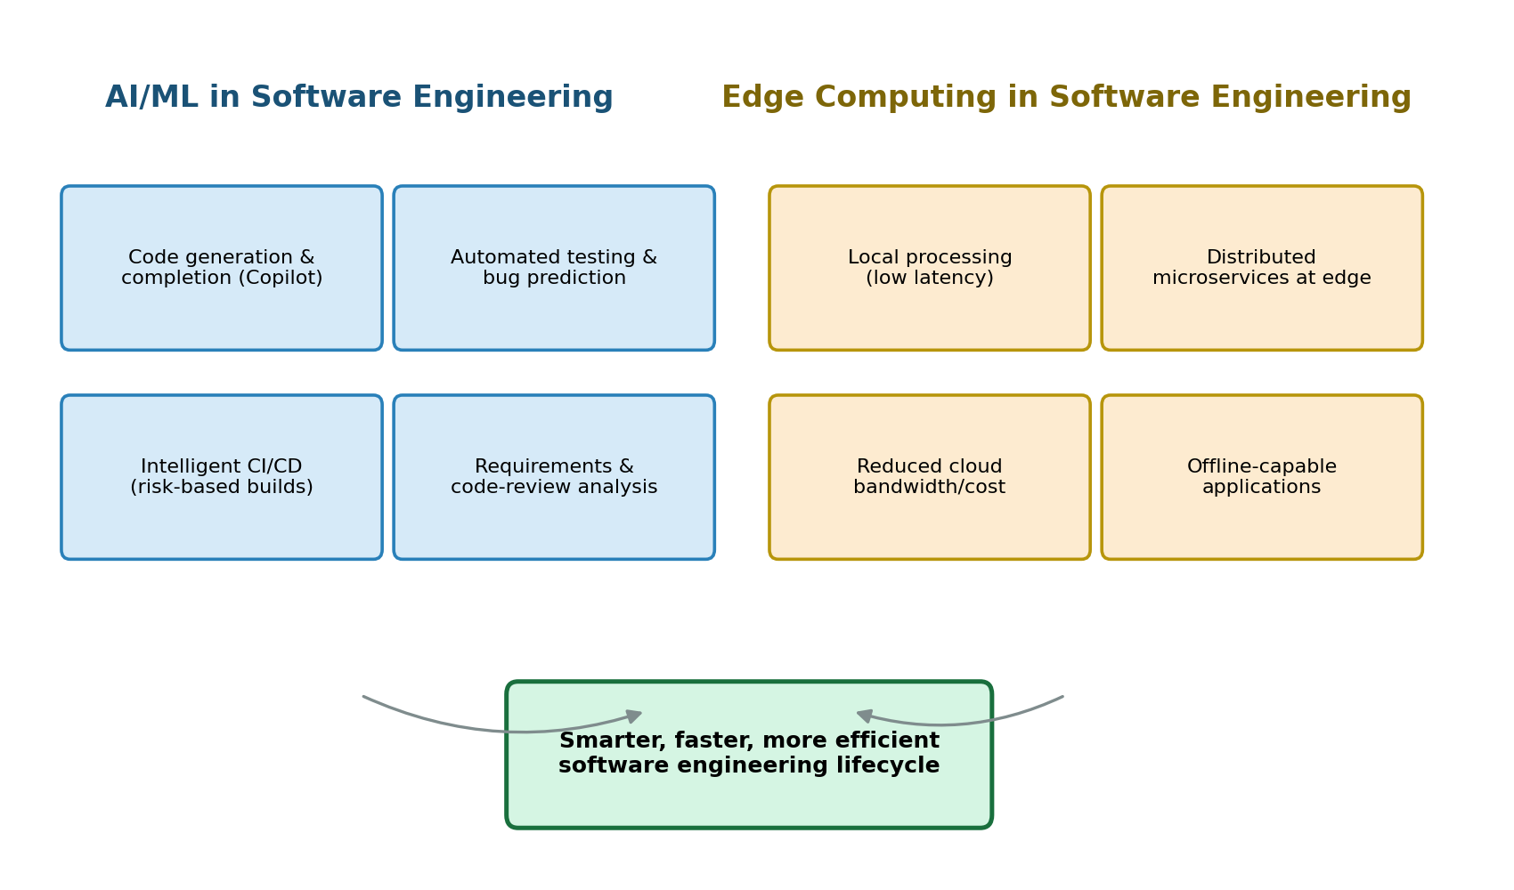
Figure 2.1 — AI/ML and Edge Computing converging to transform the software engineering lifecycle.

2.3 Combined Impact
AI/ML and Edge Computing increasingly work together: models are trained in the cloud on large datasets, then compressed and deployed to edge devices for fast, private, low-bandwidth inference (a pattern often called "TinyML" or edge AI). This convergence is pushing software engineering toward architectures that are more distributed, more data-driven, and more autonomous than traditional client-server systems.

Question 3 — Case Study
A company deploys dozens of microservices in the cloud and notices that resource usage and energy consumption are increasing. Explain three sustainable DevOps practices that can reduce energy consumption and cloud cost.
[Marks: 10 | CO: CO applies DevOps and sustainability principles to real-world scenarios]

3.1 Context of the Problem
As the number of microservices grows, each with its own compute, storage, and networking footprint, inefficiencies compound: idle containers keep running, over-provisioned resources sit unused, and inefficient pipelines rebuild and redeploy more than necessary. This directly increases both energy consumption (and the associated carbon footprint) and cloud billing. "Green DevOps" or "Sustainable DevOps" practices aim to embed environmental and cost efficiency directly into the development and operations workflow.

3.2 Three Sustainable DevOps Practices
1. Right-Sizing and Auto-Scaling of Resources
Many microservices are provisioned with fixed CPU and memory allocations based on worst-case estimates, leaving resources idle most of the time. Implementing auto-scaling (horizontal pod autoscaling in Kubernetes, for example) allows the number of running instances to grow and shrink automatically based on real-time demand. Combined with periodic right-sizing reviews — analyzing actual usage metrics and adjusting resource requests/limits accordingly — this prevents over-provisioning, reduces the number of active compute nodes during low-traffic periods, and directly cuts both energy draw and cloud spend.
2. Carbon-Aware and Efficient Scheduling
Not all compute regions and times draw power from the same energy mix. Carbon-aware scheduling shifts non-urgent or batch workloads (e.g., nightly data processing, batch analytics, report generation) to times or regions where the electricity grid has a higher share of renewable energy, or to the most energy-efficient data centers available. Serverless and event-driven design also fits here: functions execute only when triggered and scale to zero when idle, avoiding the energy cost of always-on services for workloads that are used intermittently.
3. Continuous Monitoring, FinOps, and Efficient CI/CD Pipelines
Sustainability requires visibility. Integrating continuous monitoring tools that track per-service energy/resource consumption (alongside standard performance metrics) lets teams identify wasteful services — for example, containers that are over-provisioned, duplicated environments left running, or logging that is far more verbose than necessary. Pairing this with FinOps practices (treating cloud cost as a shared engineering responsibility with regular cost reviews) and optimizing CI/CD pipelines — using build caching, incremental builds, and avoiding unnecessary full rebuilds/redeployments — reduces both wasted compute cycles and the cloud bill, while making sustainability an ongoing, measurable practice rather than a one-time effort.
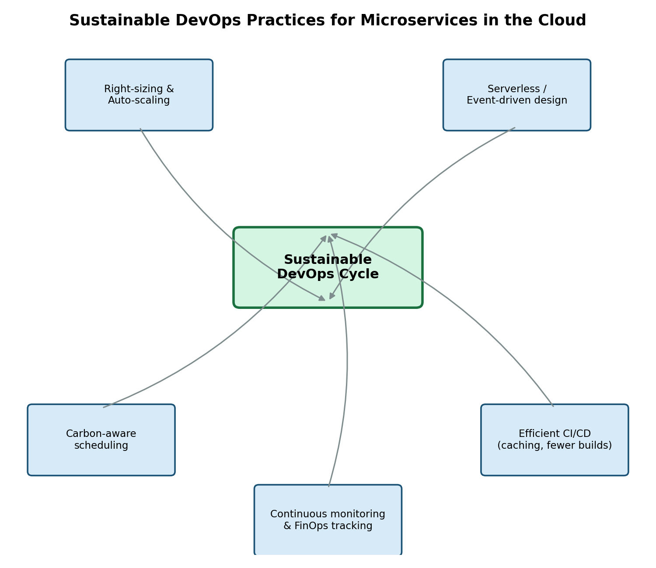
Figure 3.1 — Sustainable DevOps cycle for cloud-deployed microservices.

3.3 Expected Outcome
Applying these three practices together allows the company to keep only the resources it actually needs running at any given time, run remaining workloads on cleaner energy where possible, and continuously surface waste before it accumulates — reducing both the environmental footprint and the operating cost of the microservices deployment without sacrificing reliability.

