Full-Stack Development, Containerization, Version Control, and Advanced Algorithms
UNIT – III Assignment Report

Problem 1: Full-Stack Web App Development for an E-Commerce Dashboard

1. System Architecture Diagram (React → API → Database)
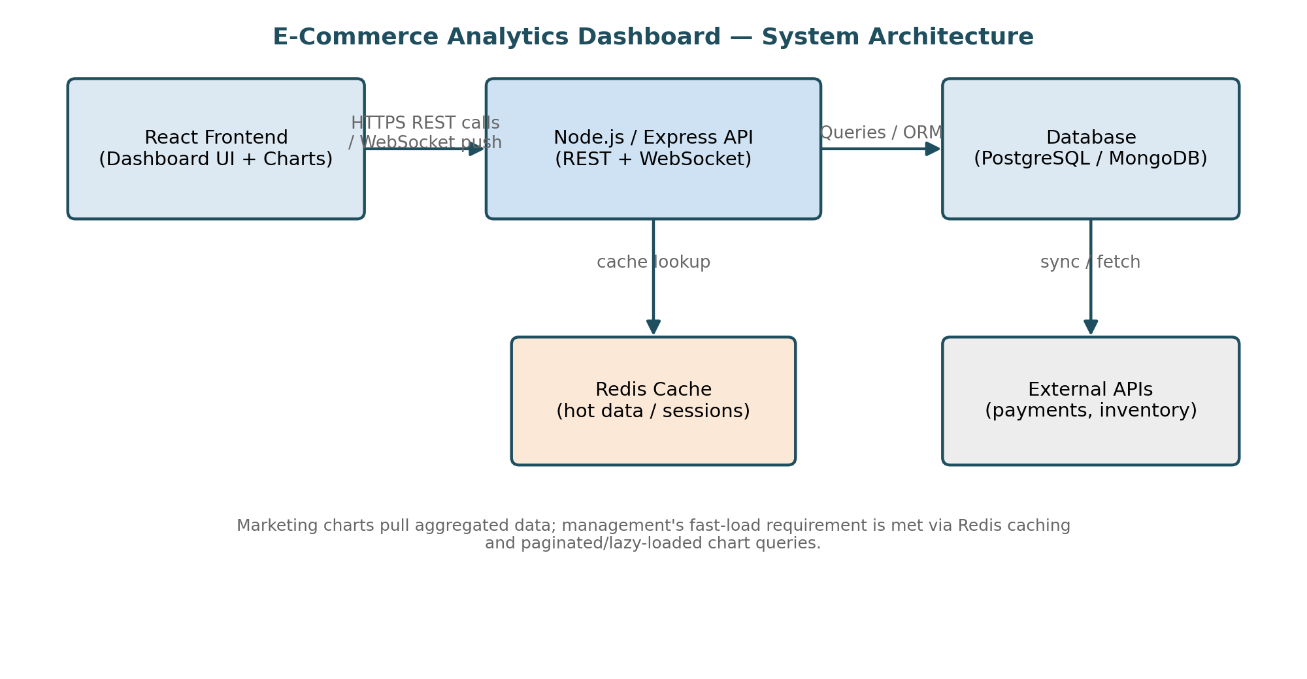

2. Git Branching Strategy
A lightweight Feature Branching model is recommended over full Git Flow, since the team needs frequent, small, iterative releases (new charts, UI tweaks) rather than scheduled release trains:
- main — always production-ready and protected; deployable at any commit.
- develop — integration branch where completed, reviewed features accumulate before a release.
- feature/* — one short-lived branch per ticket (e.g., feature/sales-chart, feature/auth), branched from develop and merged back via pull request.
- hotfix/* — branched directly from main for urgent production fixes, merged to main and back-merged into develop.
This model is simpler to operate than full Git Flow's release branches, while still giving management a stable main branch and marketing team a fast-moving develop branch for new dashboard features.

3. Proposed CI Flow
- On push to any feature/* branch: run linting (ESLint/Prettier) and unit tests automatically.
- On pull request into develop: run the full test suite, a production build check, and deploy a temporary preview environment for the marketing/design team to review the new charts.
- On merge to main: run the production build, execute smoke tests against a staging copy, then trigger the CD pipeline (e.g., GitHub Actions → Docker build → deploy to production).
- Branch protection rules enforce that these checks must pass, and that at least one code review is completed, before any merge into develop or main is allowed.

4. API Data Flow Explanation
The React frontend requests data from Express endpoints (e.g., GET /api/sales-summary) using REST calls managed through a data-fetching library (e.g., React Query). The Express controller first checks the Redis cache; on a cache miss it queries the database, formats the result as JSON, and populates the cache before responding. The frontend caches the response client-side and renders it into interactive charts. For live updates (e.g., new orders arriving), a WebSocket channel pushes incremental data to connected dashboards so charts update without a full page reload — satisfying both the marketing team's need for interactivity and management's fast-loading-time requirement.

5. Example Pull Request Review Checklist
[ ] Code builds successfully and passes lint with no new warnings
[ ] Unit tests added/updated for the change, and the full suite passes
[ ] No hardcoded secrets, API keys, or credentials in the diff
[ ] API request/response shapes validated against the agreed schema
[ ] UI changes checked against the design spec and basic accessibility (labels, contrast)
[ ] No leftover debug code (console.log, commented-out blocks)
[ ] PR description links the related issue and explains the testing performed
[ ] Reviewed and approved by at least one other developer before merge

Problem 2: Dockerizing a News Aggregator Application

1. Dockerfile
# Base image — small, production-ready Node.js runtime
FROM node:18-alpine

# Set working directory inside the container
WORKDIR /usr/src/app

# Install dependencies first (better layer caching)
COPY package.json package-lock.json ./
RUN npm ci --omit=dev

# Copy the rest of the application source
COPY . .

# The aggregator service listens on port 3000
EXPOSE 3000

# Run as a non-root user for security
USER node

CMD ["node", "server.js"]

2. Commands to Build and Run the Container
# Build the image and tag it
docker build -t news-aggregator:1.0 .

# Run the container, mapping port 3000 and passing environment variables
docker run -d --name news-aggregator -p 3000:3000 --env-file .env news-aggregator:1.0

# View logs / confirm it is healthy
docker logs -f news-aggregator

3. Steps to Push the Image to a Container Registry
# Log in to the registry (Docker Hub shown; GHCR is similar)
docker login

# Tag the local image with the registry's namespace and version
docker tag news-aggregator:1.0 <dockerhub-username>/news-aggregator:1.0

# Push the tagged image
docker push <dockerhub-username>/news-aggregator:1.0

# --- For GitHub Packages (GHCR) instead ---
docker tag news-aggregator:1.0 ghcr.io/<org>/news-aggregator:1.0
docker push ghcr.io/<org>/news-aggregator:1.0

4. Why Containerization Improves Consistency
A Docker image bundles the application code, its exact dependency versions, and the runtime environment into a single immutable artifact. That same artifact is built once and then run unchanged on a developer's laptop, the CI server, and production, which removes the classic 'works on my machine' problem caused by differing Node versions, OS libraries, or missing environment variables. It also makes deployments reproducible and reversible — rolling back is simply redeploying the previous image tag — and lets the CI server test the exact bytes that will run in production.

Problem 3: Kubernetes Deployment for a Video-Streaming Microservice

1. Kubernetes Deployment YAML
apiVersion: apps/v1
kind: Deployment
metadata:
name: video-api
labels:
app: video-api
spec:
replicas: 3
selector:
matchLabels:
app: video-api
template:
metadata:
labels:
app: video-api
spec:
containers:
- name: video-api
image: registry.example.com/video-api:1.4.0
ports:
- containerPort: 8080
resources:
requests:
cpu: "250m"
memory: "256Mi"
limits:
cpu: "500m"
memory: "512Mi"
readinessProbe:
httpGet:
path: /healthz
port: 8080
initialDelaySeconds: 5

2. Horizontal Pod Autoscaler (HPA) Configuration
apiVersion: autoscaling/v2
kind: HorizontalPodAutoscaler
metadata:
name: video-api-hpa
spec:
scaleTargetRef:
apiVersion: apps/v1
kind: Deployment
name: video-api
minReplicas: 3
maxReplicas: 25
metrics:
- type: Resource
resource:
name: cpu
target:
type: Utilization
averageUtilization: 65

3. Service YAML for Exposing the API
apiVersion: v1
kind: Service
metadata:
name: video-api-service
spec:
type: LoadBalancer
selector:
app: video-api
ports:
- protocol: TCP
port: 80
targetPort: 8080
The Deployment's multiple replicas, combined with the readiness probe, ensure Kubernetes keeps the required number of healthy pods running and reroutes traffic away from any pod that crashes or fails its health check, satisfying the 'remain available even if some pods fail' requirement.

4. High-Level Helm Chart Folder Structure
video-api-chart/
├── Chart.yaml # chart name, version, description
├── values.yaml # default configurable values (replicas, image tag, limits)
├── templates/
│ ├── deployment.yaml # templated version of the Deployment above
│ ├── service.yaml # templated version of the Service above
│ ├── hpa.yaml # templated version of the HPA above
│ └── _helpers.tpl # shared naming/label template helpers
├── charts/ # any subchart dependencies
└── README.md # usage and configuration notes

Problem 4: Git Collaboration for a Social Media App

1. Git / GitHub Workflow Diagram
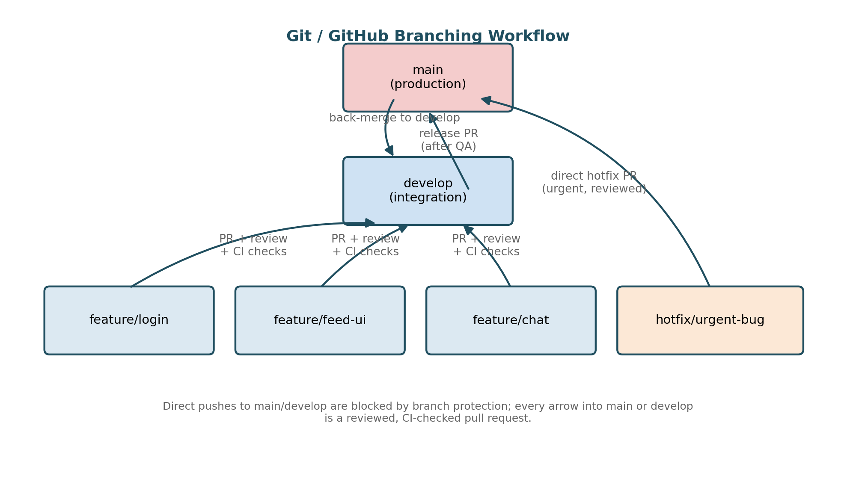

2. Rules for Pull Requests and Approvals
- Branch protection is enabled on main and develop: direct pushes are blocked for everyone, including admins.
- Every change reaches those branches only through a pull request with a filled-in description (what changed, why, how it was tested).
- A minimum of one approval is required for routine features; two approvals for changes touching shared/core modules (auth, data models).
- The PR author cannot approve their own PR, and stale approvals are dismissed automatically if new commits are pushed.
- All required CI status checks must pass before the 'Merge' button is enabled (enforced by branch protection, not by convention).

3. CI Checks Required Before Merge
- Linting — ESLint/Prettier (or the language equivalent) run against the diff; the build fails on any error-level rule violation.
- Unit tests — the full unit test suite must pass, with a minimum coverage threshold enforced on changed files.
- Build check — the application must compile/bundle successfully (catches type errors and broken imports before merge).
- (Optional but recommended) a dependency/security scan to catch known-vulnerable packages introduced by the change.

4. Guidelines for Resolving Merge Conflicts
- Rebase (or merge) the feature branch onto the latest develop frequently, rather than letting it drift for days — small, frequent syncs produce small, easy conflicts instead of large, risky ones.
- Before resolving, understand the intent of both changes (read the related commits/PR descriptions) rather than blindly accepting 'ours' or 'theirs'.
- After resolving conflicts locally, re-run the full test suite before pushing — a clean merge can still be logically wrong.
- For conflicts in core shared logic, pair with the other author instead of resolving unilaterally, since only they may know why their lines were written that way.

Problem 5: High-Performance Algorithm Optimization for a Ride-Sharing Platform

1. Identification of Algorithm Bottlenecks
- Brute-force matching: comparing every waiting rider against every available driver is O(n × m), which becomes untenable once n and m are each in the thousands during peak hours.
- Synchronous, single-threaded processing: each match request blocks on I/O (database/location lookups) before the next request can be handled, capping throughput far below 100,000 requests/minute.
- Repeated expensive location queries: fetching driver locations from a disk-backed database on every match request adds latency that a purely relational query pattern was never designed for at this scale.
- A single central matcher: all requests funnel through one component, so it becomes both a throughput bottleneck and a single point of failure.
- Lock contention: multiple concurrent match attempts competing for the same shared, mutable driver-availability data structure serialize work that should be parallel.

2. Proposed Optimized Algorithm
Replace brute-force comparison with spatial indexing: partition the city into geohash cells (or a quadtree), so each driver is bucketed by location. A ride request only needs to compare against drivers in its own cell and immediate neighbors — reducing the candidate set from all drivers to a small local subset. Within that reduced candidate set, use a greedy nearest-driver selection backed by a min-heap keyed on distance/ETA, so the best available match is found in O(log k) for k local candidates rather than scanning the whole city. Driver locations are held in an in-memory geospatial store (e.g., Redis GEOADD/GEOSEARCH) instead of a relational database, turning proximity lookups into near-constant-time operations and removing the disk-query bottleneck.

3. Concurrency Model
- Asynchronous, non-blocking request handling (event loop / async-await, or an actor-model worker) so a request waiting on a cache lookup does not block other requests from being processed on the same node.
- Geographic sharding: the city is split into zones, each owned by an independent worker/thread pool, so match requests in different zones run truly in parallel with no shared-lock contention.
- A message queue (e.g., Kafka) sits in front of the workers to buffer incoming ride requests during load spikes and distribute them across the worker pool, smoothing bursts above the sustained 100,000-requests/minute rate instead of dropping or timing out requests.

4. Diagram of the Distributed Matching Workflow
