CRYPTOGRAPHY AND NETWORK SECURITY
Course Code: CSA51
Annexure A — Concept Mapping Assessment
CO1: Apply classical encryption techniques using symmetric and asymmetric ciphers
to encrypt and decrypt data for ensuring data security. (BL3, BL4)
Assessment Tool Weightage: 20% | Questions Answered: 1 and 3 | Total Marks: 50

Code of Conduct
I M. Mokshith Reddy – 192372373 (Name / Reg. No.) certify that this submission is my original work and that I have adhered to the guidelines specified for this assessment.
I understand that any violation of academic integrity rules will result in disciplinary action.
Signature of the student: __Mokshith_________________________

Question 1 — Concept Map: Security Attacks, Threats, Risks and Security Goals
A concept map is used below to trace the causal chain from a Security Attack, through the Threat it realises and the Risk it creates for an organisation, to the Security Goal (Confidentiality, Integrity, Availability) that mitigates it. Each node is colour-coded by category and arrows represent the relation "leads to / is mitigated by".

Concept Map
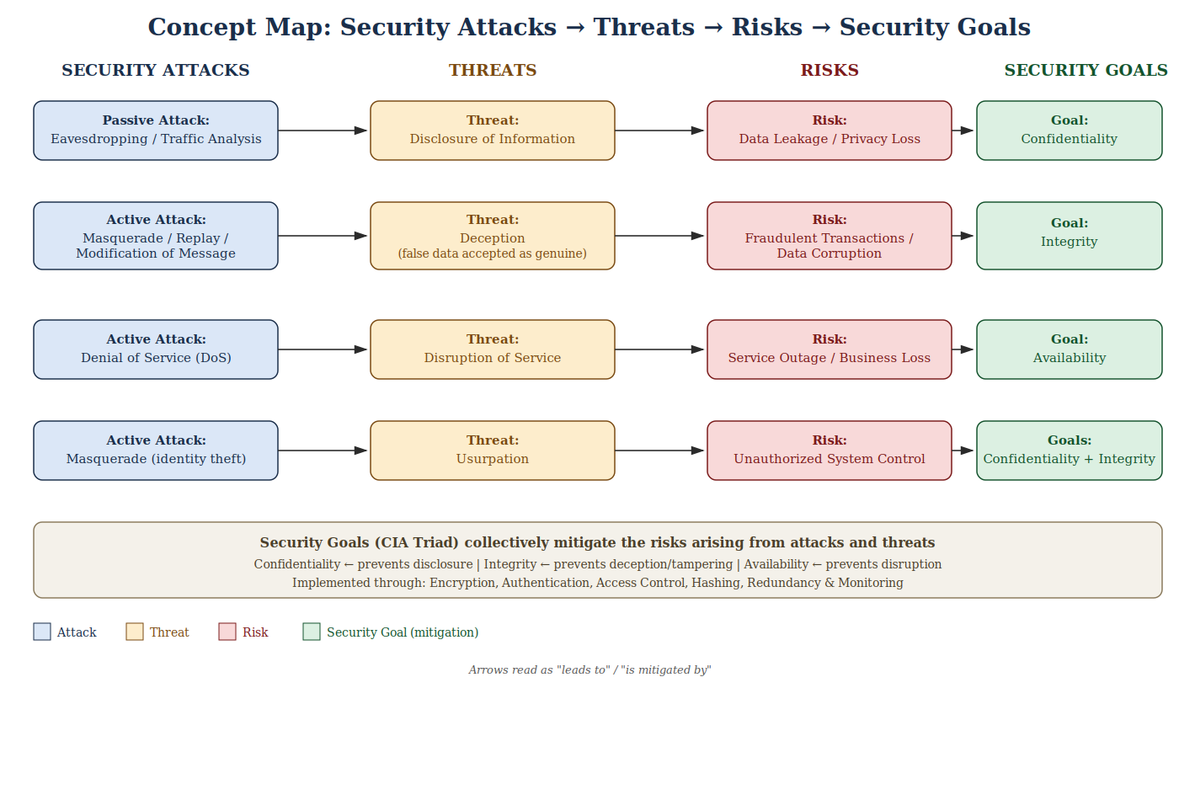
Fig. 1 — Concept map linking Security Attacks &#8594; Threats &#8594; Risks &#8594; Security Goals

(a) How Each Attack Leads to Specific Threats and Risks
The table below documents each causal link shown in the concept map, together with one real-world example, as required by the task.
Attack | Threat | Risk | Real-World Example
Eavesdropping / Traffic Analysis (Passive) | Disclosure | Data leakage, privacy loss | An attacker sniffing packets on an unsecured public Wi-Fi network to capture login credentials sent in plaintext.
Masquerade / Replay / Modification (Active) | Deception | Fraudulent transactions, data corruption | An attacker capturing and re-sending ("replaying") a legitimate encrypted funds-transfer request to withdraw money twice.
Denial of Service (Active) | Disruption | Service outage, business/revenue loss | The 2016 Dyn DNS DDoS attack that flooded servers with traffic and knocked Twitter, Netflix and other sites offline for hours.
Masquerade / Identity Theft (Active) | Usurpation | Unauthorized system control | An attacker using stolen administrator credentials to log in and take control of a company's server infrastructure.

(b) How Security Goals Help Mitigate Each Link
- Confidentiality mitigates disclosure — encrypting data in transit prevents eavesdroppers from reading it even if traffic is intercepted. Example: HTTPS/TLS protects online-banking sessions from packet sniffers.
- Integrity mitigates deception — hashing and digital signatures detect any tampering or replay of a message. Example: software vendors sign update packages so a modified/replayed installer is rejected.
- Availability mitigates disruption — redundancy, load balancing and rate-limiting keep a service running under attack. Example: Content Delivery Networks and firewalls absorbed the traffic during later Dyn-style DDoS attacks on other providers.
- Confidentiality + Integrity together mitigate usurpation — strong authentication (passwords, MFA) and access-control lists stop an attacker who has stolen an identity from being treated as a legitimate user.

Analysis
The concept map shows that no single security goal stands alone: each attack category maps cleanly onto exactly one primary CIA element, but usurpation shows that some attacks straddle more than one goal, so a single control (e.g. encryption alone) is rarely sufficient. Effective security design therefore layers controls — encryption for confidentiality, hashing/signatures for integrity and redundancy/monitoring for availability — a principle usually called "defense in depth". The map also illustrates that Risk is a business consequence (financial loss, reputation damage, outage) of a Threat, while the Threat itself is the abstract way an Attack can violate a Security Goal; keeping these three layers distinct is what allows a security team to trace an incident back to the specific control that failed.

Tools and Method Used
The concept map was built as a layered node-and-arrow diagram (vector graphic), with each of the four categories — Attacks, Threats, Risks, Security Goals — assigned a distinct colour so the causal chain can be read left-to-right at a glance. This keeps the diagram both technically accurate and easy to present to a reviewer, satisfying the documentation and tool-use expectations of the rubric.

Question 3 — Concept Map: Classical Encryption Schemes (Substitution vs Transposition)
Classical encryption is built from two foundational families of technique. A substitution technique changes the identity of each symbol while keeping its position fixed; a transposition technique keeps every symbol's identity unchanged but rearranges its position. The concept map below expands both branches under a common root and lines them up so that each property can be compared directly.

Concept Map
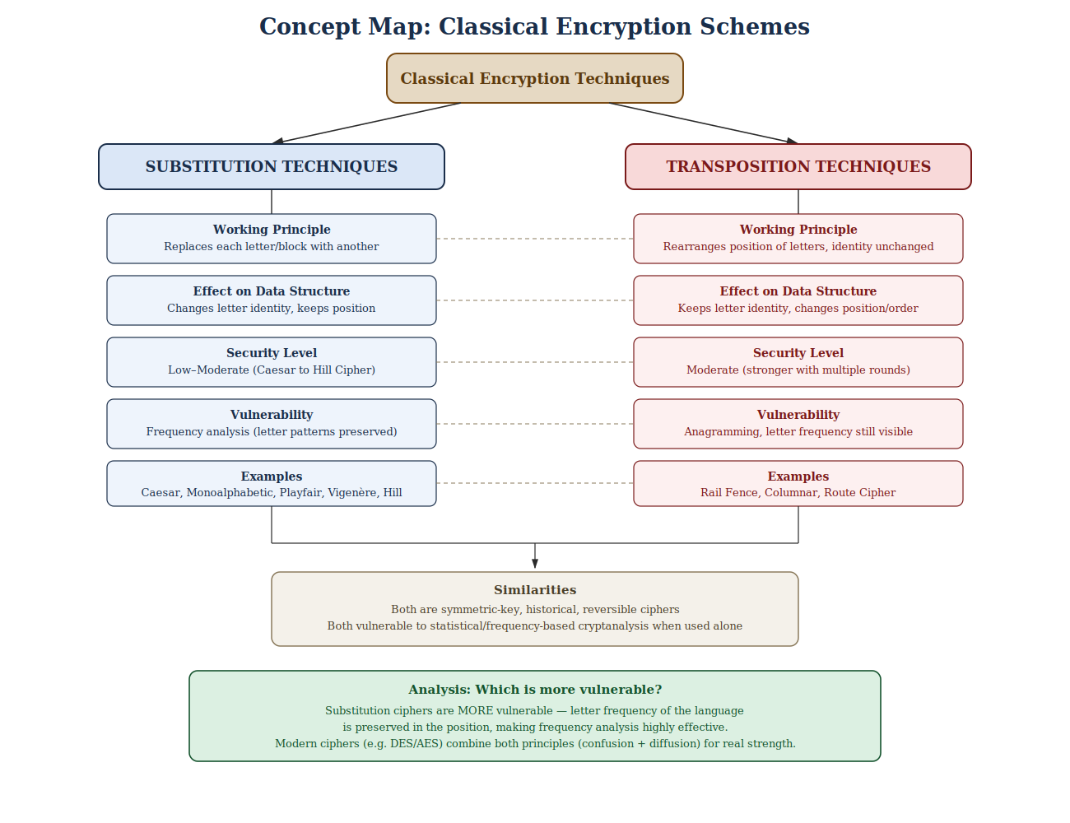
Fig. 2 — Concept map comparing Substitution and Transposition techniques

(a) Differences and Similarities
Property | Substitution Techniques | Transposition Techniques
Principle | Replace each letter/block with another letter/symbol | Rearrange the order/position of letters
Effect on data structure | Letter identity changes; position unchanged | Letter identity unchanged; position changes
Key usage | A shift value, substitution table, or keyword (Caesar, Vigenère) or matrix (Hill) | A rail depth or a column/key order that fixes the permutation
Security level | Low (Caesar) to moderate (Hill) — grows with alphabet/matrix size | Moderate — increases when several transposition rounds are chained
Examples | Caesar, Monoalphabetic, Playfair, Vigenère, Hill Cipher | Rail Fence, Columnar Transposition, Route Cipher
Both families are symmetric-key, reversible, historical ciphers, and both are cryptographically weak in isolation because the letter-frequency profile of the underlying language survives the transformation — merely relocated (transposition) or relabelled (substitution). This is precisely why modern block ciphers such as DES and AES combine both principles: substitution provides confusion and transposition/permutation provides diffusion.

Worked Example (illustrating the data-structure difference)
Plaintext: HELLO
- Substitution (Caesar, key = 3): each letter is shifted three places down the alphabet — H→K, E→H, L→O, L→O, O→R, giving ciphertext KHOOR. The letters have changed identity but H is still in position 1, E in position 2, and so on.
- Transposition (Rail Fence, depth = 2): the letters are written in a zig-zag across 2 rows — Row 1: H, L, L; Row 2: E, O — then read row-by-row to give ciphertext HLLEO. Every original letter (H, E, L, L, O) is still present, only its position has moved.
This confirms the map's central distinction: substitution disturbs letter identity while transposition disturbs letter position.

(i) Data Structure and Security Level
As mapped above, substitution techniques operate on the symbol space (an attacker who recovers the substitution key can decrypt instantly, and simple monoalphabetic substitution is broken by frequency analysis in seconds). Transposition techniques operate on the sequence space (the character set of the ciphertext is identical to the plaintext, so a frequency count alone reveals the language but not the plaintext order). Security level in both families is a function of key space size: Hill Cipher's matrix key and multi-round columnar transposition are considerably stronger than a single Caesar shift or a single rail-fence pass.

(ii) Which Is More Vulnerable, and Why
Substitution ciphers, especially simple monoalphabetic ones, are more vulnerable overall. Because each plaintext letter always maps to the same ciphertext letter, the statistical frequency distribution of the language (e.g., 'E' being the most common letter in English) is preserved and directly exposed in the ciphertext — classic frequency analysis breaks these ciphers with only a modest amount of ciphertext. Transposition ciphers preserve the same letter frequencies too, but an attacker must additionally reconstruct the correct permutation (anagramming), which is a combinatorially harder search, especially as message length and key complexity grow. Vigenère (polyalphabetic substitution) improves on monoalphabetic substitution by using multiple shift values, which flattens the frequency profile, but is still breakable via the Kasiski/Friedman methods once the key length is found. Hill Cipher, being a substitution technique operating on blocks via linear algebra, resists simple frequency analysis but is vulnerable to known-plaintext attack because it is linear.

Analysis of Results
Mapping both technique families side by side against the same four properties (principle, data-structure effect, key usage, security level) makes the comparison auditable rather than descriptive: it shows precisely where each technique's strength comes from (larger key space, multiple rounds) and precisely where it fails (frequency analysis, anagramming, known-plaintext attack). The concept map also correctly generalises to the historical trajectory of cryptography — the recognition that neither family alone is secure directly motivated the product ciphers (substitution + transposition rounds) that underlie DES and AES today.

Tools and Method Used
The concept map was constructed as a two-branch hierarchical diagram rooted at "Classical Encryption Techniques", with dashed connector lines aligning corresponding properties across the Substitution and Transposition branches so that the comparison in the table above can be read directly off the diagram. Colour-coding (blue = substitution, red = transposition, green = concluding analysis) was used consistently with the Question 1 map for a uniform documentation style across the assessment.

