Nmap Commands – Purpose, Content and Result

1. Scan common ports
Command: nmap 192.168.1.1
Purpose: Scan common ports
Content: Runs Nmap's default scan on the target. It checks that the host is up, then probes the 1000 most commonly used TCP ports and reports each port's state (open, closed or filtered).
Expected result: Lists the open ports and their services (e.g., 22/ssh, 80/http, 443/https) and shows how many hosts are up.
Result (screenshot):
(Paste screenshot of the result here)

2. Discover live hosts
Command: nmap -sn 192.168.1.0/24
Purpose: Discover live hosts
Content: -sn is a ping scan (no port scan). 192.168.1.0/24 covers all 256 addresses in the subnet. Nmap uses ARP/ICMP/TCP probes to find which devices respond, mapping the live network.
Expected result: Lists each live host's IP address with "Host is up", and ends with the count of hosts found out of 256 addresses.
Result (screenshot):
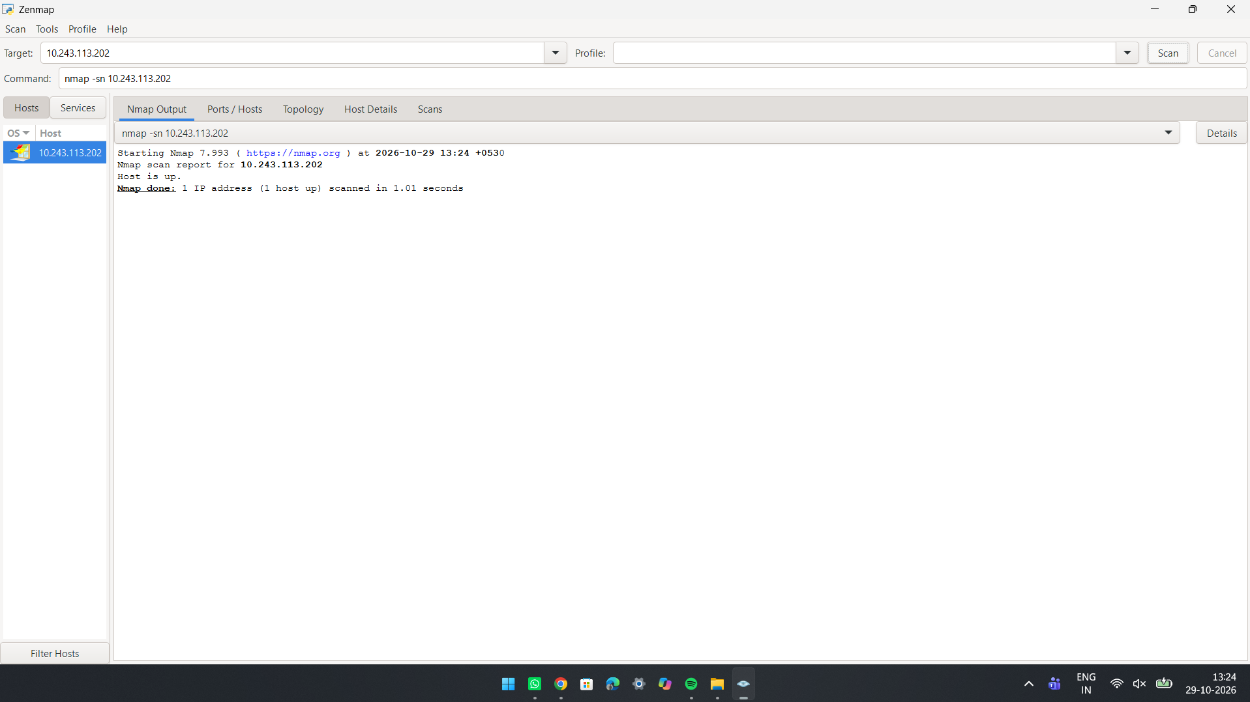

3. Detect service versions
Command: nmap -sV 192.168.1.1
Purpose: Detect service versions
Content: -sV probes every open port and compares the replies with Nmap's service fingerprint database to identify the software name and version (e.g., OpenSSH, Apache). Useful for spotting outdated, vulnerable software.
Expected result: Adds a VERSION column beside each open port, such as OpenSSH 8.9 or Apache httpd 2.4.52.
Result (screenshot):
(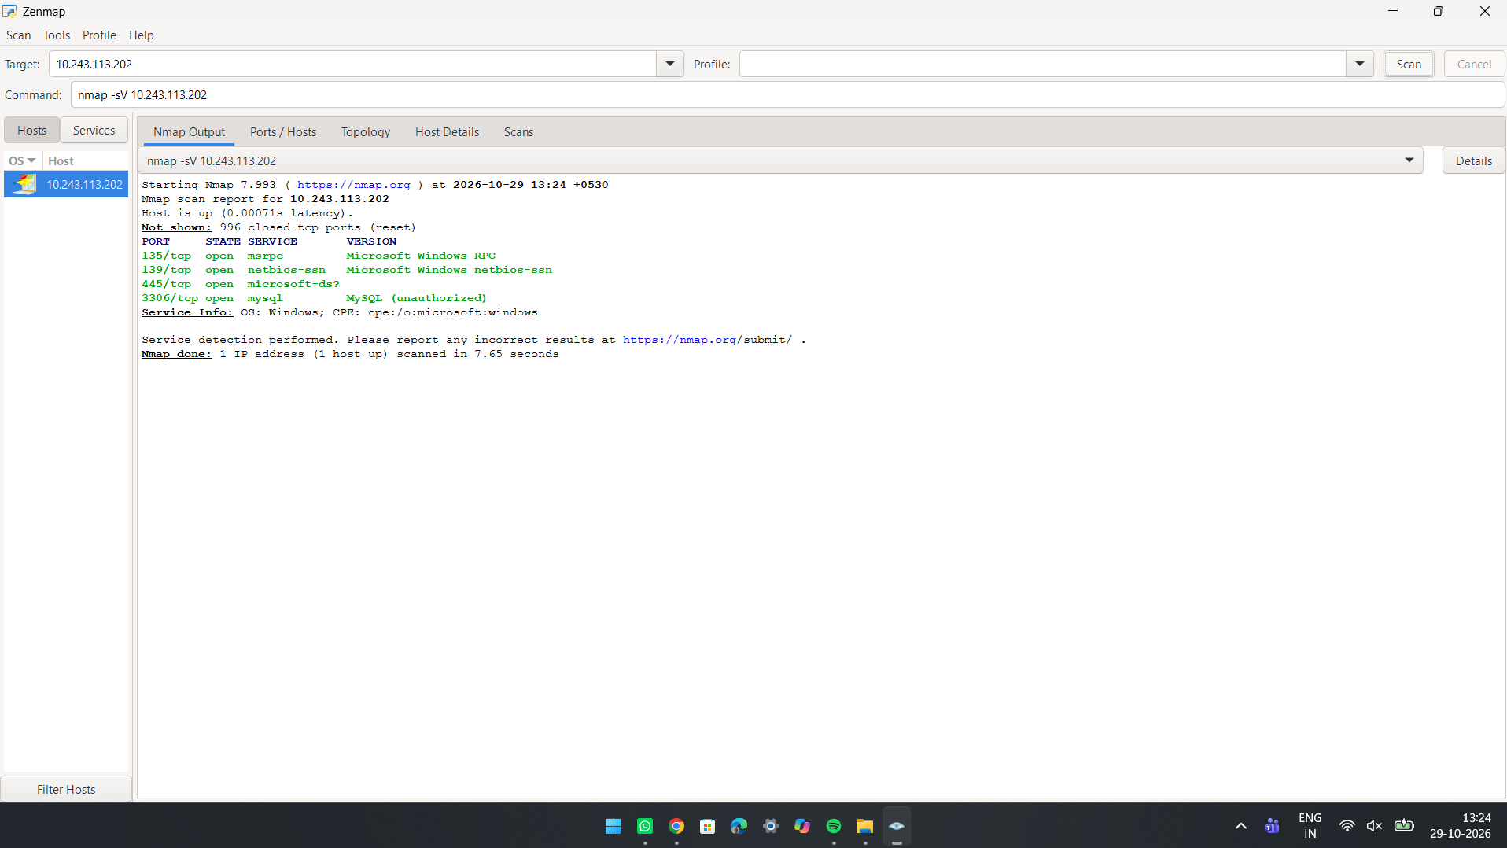Paste screenshot of the result here)

4. Identify the operating system
Command: nmap -O 192.168.1.1
Purpose: Identify the operating system
Content: -O performs OS detection (OS fingerprinting). Nmap sends crafted TCP/IP packets and analyses the responses (TTL, window size, options) to guess the operating system and version. Needs root/administrator privileges.
Expected result: Shows the device type, the OS guess (e.g., Linux 5.x), OS details and the network distance.
Result (screenshot):
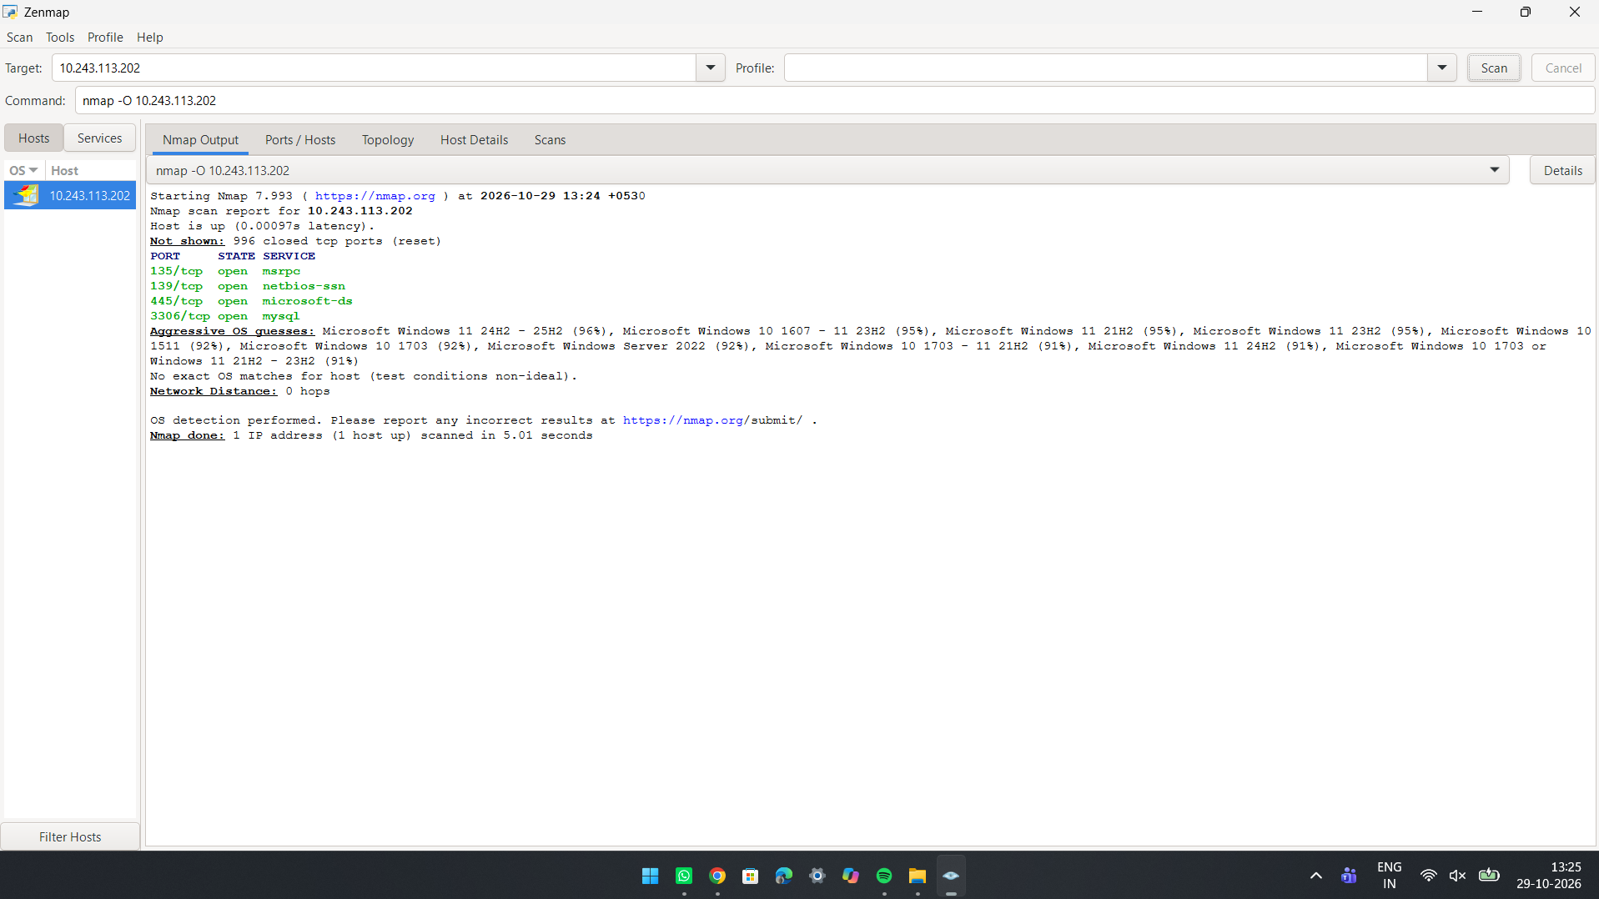

5. Scan specific ports
Command: nmap -p 80,443 192.168.1.1
Purpose: Scan specific ports
Content: -p limits the scan to the listed ports only (here HTTP 80 and HTTPS 443). Ranges such as -p 1-1024 or -p- (all 65535 ports) can also be used. Faster and quieter than a full scan.
Expected result: Shows the state of only ports 80 and 443 (open, closed or filtered).
Result (screenshot):
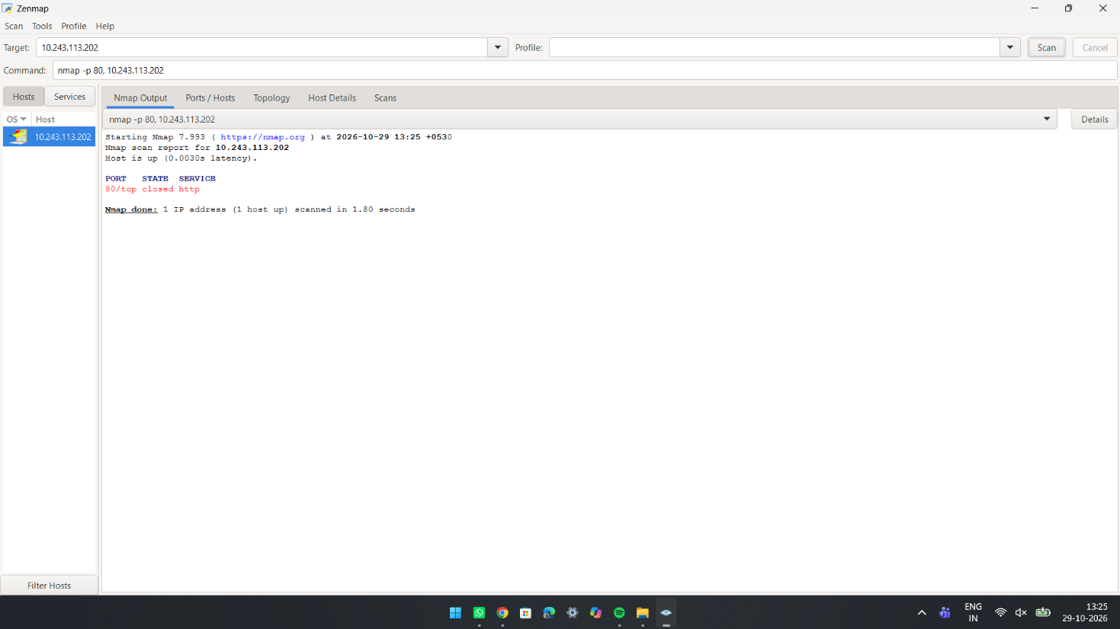

6. Run default NSE scripts
Command: nmap -sC 192.168.1.1
Purpose: Run default NSE scripts
Content: -sC runs Nmap's default set of safe Nmap Scripting Engine (NSE) scripts on open ports. They gather extra details such as SSH host keys, HTTP page titles, server headers and SSL certificate information.
Expected result: Under each open port, extra script output appears (lines starting with | or |_), e.g., ssh-hostkey, http-title, ssl-cert.
Result (screenshot):
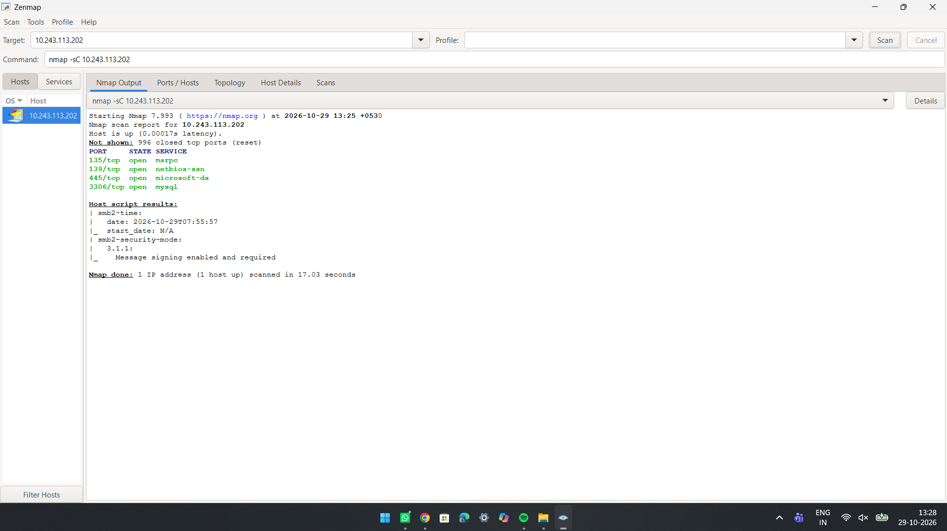

7. Skip host discovery
Command: nmap -Pn 192.168.1.1
Purpose: Skip host discovery
Content: -Pn treats the target as online and skips the ping step. Useful when a firewall blocks ICMP/ping so the host wrongly appears down. Nmap goes straight to port scanning, which can be slower on dead addresses.
Expected result: The port scan runs even if the host does not answer ping, and the open ports are listed as usual.
Result (screenshot):
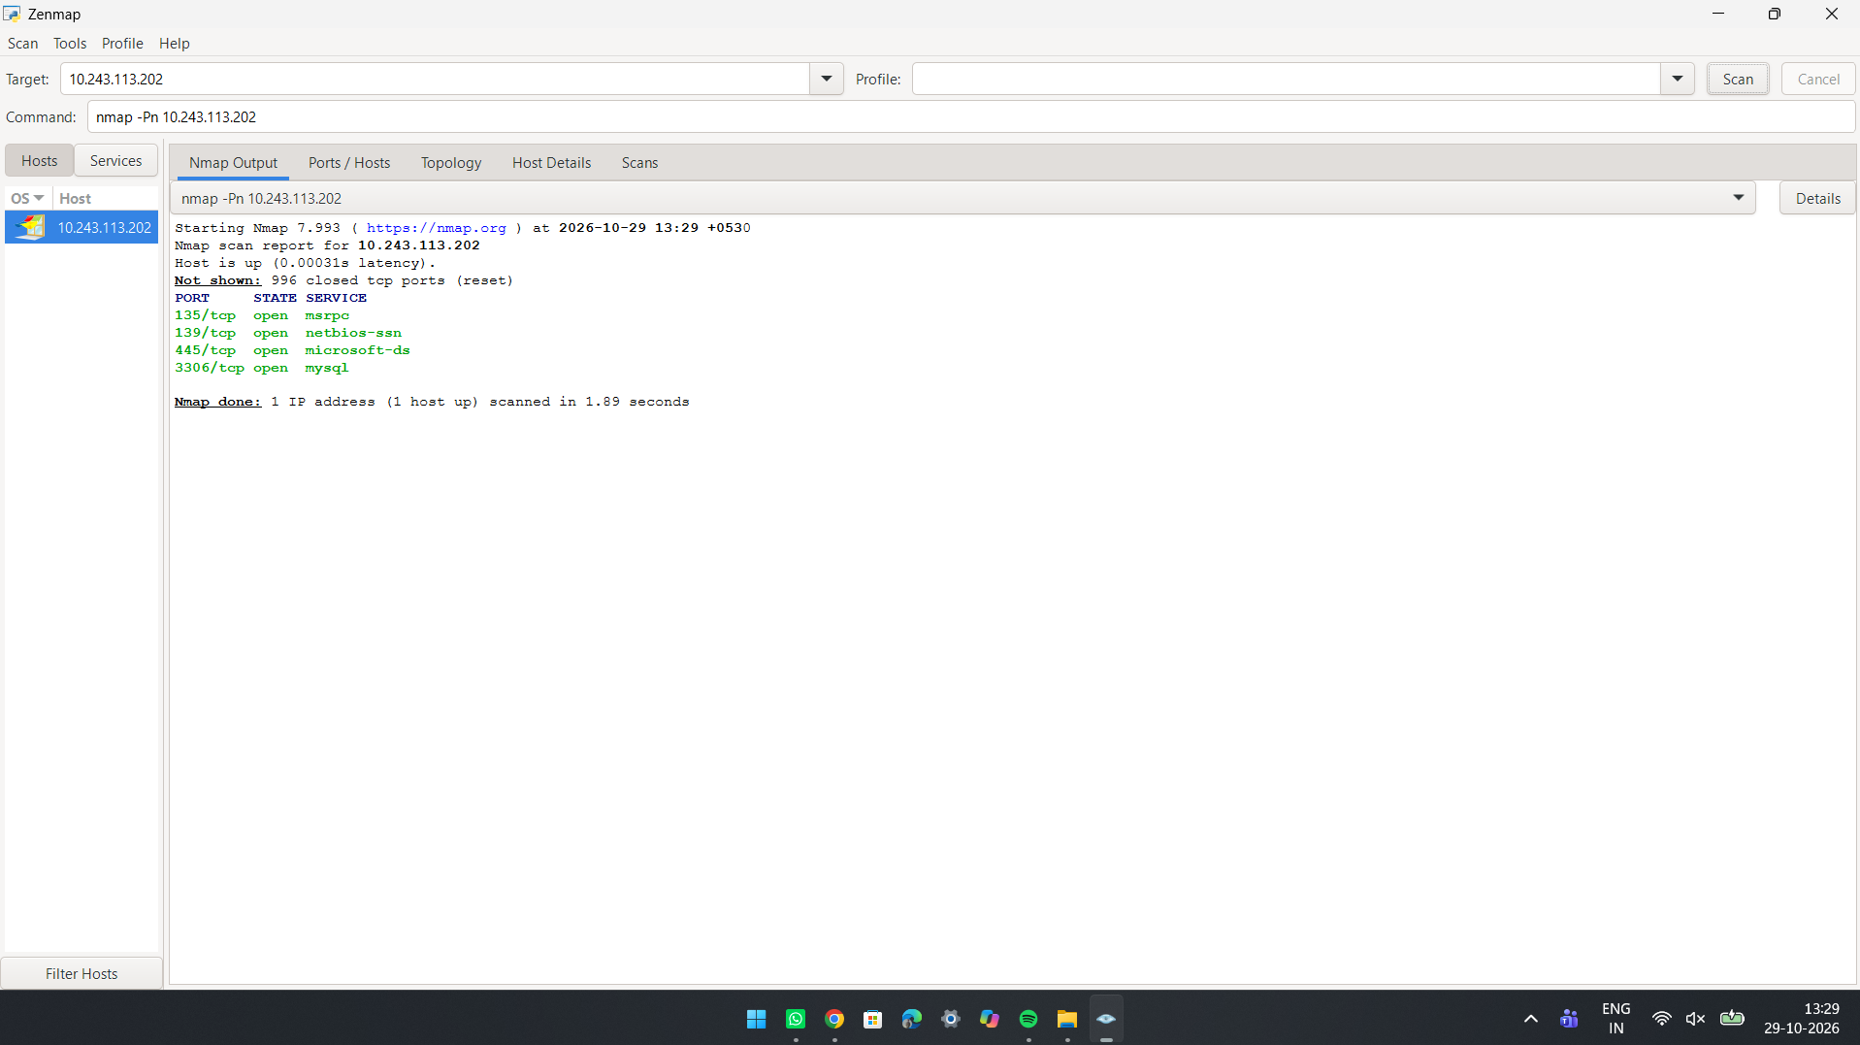

8. Save scan results to a file
Command: nmap -oN scan.txt 192.168.1.1
Purpose: Save scan results to a file
Content: -oN writes the output in normal (human-readable) format to the file scan.txt, in addition to showing it on screen. Other formats: -oX (XML), -oG (grepable), -oA (all formats).
Expected result: The scan appears on screen as usual and the file scan.txt is created in the current folder (view it with cat scan.txt or open it in a text editor).
Result (screenshot):
(Paste screenshot of the result here)

