Database Foundations for Business Analytics

***BUAN 6320***

**PROJECT 1**

# Group Members

1. Moksh Mehta- mxm220009

2. Urvi Shah- uxs220005

3. Vishwa Shukla- vks210004

4. Anjali Patel- axp220017

5. Lakshmi Priya Darshini S P- lxs220009

# Dataset

The on-time performance of domestic flights run by significant airlines is monitored by the U.S. Department of Transportation's (DOT) Bureau of Transportation Statistics. This dataset of 2018 obtained from Kaggle contains the number of on-time, delayed, canceled, and diverted flights.

# Business Understanding

Airlines face high costs due to delays and cancellations, including expenses on compensation to stuck travelers and maintenance. Domestic flight delays put a $32.9 billion dent in the U.S. economy, and about half that cost is borne by airline passengers, according to a study led by UC Berkeley researchers. They also found that airlines with high delay rates also have higher operating costs overall, and the inefficiency adversely affects the U.S. economy.

Airport delays are a significant problem for airlines and passengers alike. To reduce delays, airlines and airports need to better understand the causes of delays and use data analytics to improve their operations.

The first step is to collect data on delays. This data can come from a variety of sources, including flight tracking websites, airport management systems, and even social media. Once this data is collected, it can be analyzed to identify patterns and trends.

There are several ways in which data can be used to reduce delays. For example, data can be used to improve flight planning and scheduling, identify potential problems with airport infrastructure, and even help predict future delays. By using data, airlines and airports can make more informed decisions that can help reduce delays. Additionally, the data can be used to identify which airlines are consistently performing well and which ones are not, which can be helpful for consumers when choosing an airline.

The questions that we are trying to answer by studying this dataset for the year 2018 are:

* What airline gets the most delayed?
* What airline has the best on time performance?
* Which airport has the highest on time arrivals?
* Which state has the highest incoming flights?
* Which months have the highest cancellations?
* Which airline has the maximum number of delays?

# Data Understanding

The overall size of the dataset is 800 mb. The data has approximately 7,000,000 rows, which can be identified uniquely by flight_id. The original dataset had 18 columns. We removed the country column from the original dataset because it was not related to our business understanding. Based on this relationship structure we could see that there are functional dependencies between these columns, therefore we broke the larger dataset into 5 tables to minimize the functional dependency and to bring it into 4th normal form (i.e., BCNF). We have used iata (which is starting 3 letter acronym airport code) as primary key in airport table. Using iata we can access all other columns like city, state, airport name, longitude, latitude from airport table. We have used flight_id as foreign key in arrival and departure table which we have separated after normalization.

|  |  |  |  |  |
| --- | --- | --- | --- | --- |
| Original Column Name | Modified Column Name | SQL Data Type | Description | Missing Values(Y/N) |
| FL_DATE | FL_DATE | date (yy/mm/dd) | Date of departure of flight | N |
| OP_CARRIER | AIR_ID | varchar (45) | Two letter unique code to identify the airline | N |
| OP_CARRIER_FL_NUM | FL_NUM | int | Flight number | N |
| ORIGIN | ORIGIN | varchar (45) | Starting 3 Letter Acronym Airport Code | N |
| DEST | DEST | varchar (45) | Destination 3 Letter Acronym Airport Code | N |
| CRS_DEP_TIME | PL_DEP_TIME | time (hh:mm: ss) | Planned Departure Flight | N |
| DEP_TIME | DEP_TIME | time (hh:mm: ss) | Actual Departure Time | Y |
| DEP_DELAY | DEP_DELAY | time (mm: ss) | Total Delay on Departure in minutes | Y |
| CRS_ARR_TIME | PL_ARR_TIME | time (hh:mm: ss) | Planned Arrival Time | N |
| ARR_TIME | ARR_TIME | time (hh:mm: ss) | Actual Arrival Time | Y |
| ARR_DELAY | ARR_DELAY | time (mm: ss) | Total Delay on Arrival in minutes | Y |

|  |  |  |  |  |
| --- | --- | --- | --- | --- |
| Original Column Name | Modified Column Name | SQL Data Type | Description | Missing Values(Y/N) |
| CANCELLED | CANCELLED | int | Flight Cancelled | N |
| AIR_TIME | AIR_TIME | time (mm: ss) | The time duration in air between arrival and departure | Y |
| DISTANCE | DISTANCE | int | Distance between two airports | N |
| AIRPORT | AIRPORT | varchar (255) | Airport full names derived from its identifier | N |
| CITY | CITY | varchar (50) | Airport situated in which US city | N |
| STATE | STATE | varchar (5) | Airport situated in which US state | N |

|  |  |  |  |  |  |  |
| --- | --- | --- | --- | --- | --- | --- |
| Column Name | Mean | Min | Max | Range | Std Dev | |
| FL_DATE | | - | - | - | - |  |
| AIR_ID | | - | - | - |  |  |
| FL_NUM | | 2610 | 1 | 7909 | - | 1860 |
| ORIGIN | | - | - | - | - |  |
| DEST | | - | - | - | - |  |
| PL_DEP_TIME | | 1200 | 0001 | 2400 | - | 491 |
| DEP_TIME | | 1200 | 0001 | 2400 | - | 505 |
| DEP_DELAY | | 9.97 | -122 | 2710 | - | 44.8 |
| PL_ARR_TIME | | 1200 | 0001 | 2400 | - | 518 |
| ARR_TIME | | 1200 | 0001 | 2400 | - | 538 |
| ARR_DELAY | | 5.05 | -120 | 2690 | - | 49.6 |
| CANCELLED | | - | 0 | 1 | - |  |
| AIR_TIME | | 112 | 7 | 696 | - | 71.1 |
| DISTANCE | | 800 | 31 | 4980 |  | 598 |
| AIRPORT | | - | - | - | - |  |
| CITY | | - | - | - | - |  |
| STATE | | - | - | - | - |  |

# Design a Database

We have constructed total 3 tables before BCNF

1. Flight
2. Airports
3. Airlines

Here below we are attaching a E-R diagram of five tables,

Next, we have performed checks for identifying whether our schema is in BCNF (Boyce-Codd Normal Form)

|  |  |  |
| --- | --- | --- |
| COLUMN DETAILS | CHECK FOR BCNF | FUNCTIONAL DEPENDENCY |
| {FLIGHT_ID}->{ORIGIN} | FLIGHT_ID AND ORIGIN ARE IN TABLE 1, FLIGHT_ID IS KEY | BASED ON INITIAL DECOMPOSITION |
| {FLIGHT_ID}->{ARR_DELAY} | FLIGHT_ID AND ARR_DELAY ARE IN TABLE 3, FLIGHT_ID IS KEY | BASED ON INITIAL DECOMPOSITION |
| {FLIGHT_ID}->{DEP_DELAY} | FLIGHT_ID AND DEP_DELAY ARE IN TABLE 4, FLIGHT_ID IS KEY | BASED ON INITIAL DECOMPOSITION |
| {FLIGHT_ID}->{OP_CARRIER} | FLIGHT_ID AND OP_CARRIER ARE IN TABLE 5, FLIGHT_ID IS KEY | BASED ON INITIAL DECOMPOSITION |
| {ORIGIN}->{CITY} | ORIGIN AND CITY ARE IN TABLE 2, ORIGIN IS KEY | INFERRED |
| {ORIGIN}->{STATE} | ORIGIN AND STATE ARE IN TABLE 2, ORIGIN IS KEY | INFERRED |
| {ORIGIN}->{AIRPORT} | ORIGIN AND AIRPORT ARE IN TABLE 2, ORIGIN IS KEY | INFERRED |
| {ORIGIN}->{LATTITUDE} | ORIGIN AND LATTITUDE ARE IN TABLE 2, ORIGIN IS KEY | INFERRED |
| {ORIGIN}->{LONGITUDE} | ORIGIN AND LONGITUDE ARE IN TABLE 2, ORIGIN IS KEY | INFERRED |
| {FLIGHT_ID}->{CRS_ARR_TIME} | FLIGHT_ID AND CRS_ARR_TIME ARE IN TABLE 3, FLIGHT_ID IS KEY | INFERRED |
| {FLIGHT_ID}->{CRS_DEP_TIME} | FLIGHT_ID AND CRS_DEP_TIME ARE IN TABLE 3, FLIGHT_ID IS KEY | INFERRED |
| {FLIGHT_ID}->{ARR_TIME} | FLIGHT_ID AND ARR_TIME ARE IN TABLE 4, FLIGHT_ID IS KEY | INFERRED |
| {FLIGHT_ID}->{DEP_TIME} | FLIGHT_ID AND DEP_TIME ARE IN TABLE 4, FLIGHT_ID IS KEY | INFERRED |
| {FLIGHT_ID}->{OP_CARRIER_FL_NUM} | FLIGHT_ID AND OP_CARRIER_FL_NUM ARE IN TABLE 1, FLIGHT_ID IS KEY | INFERRED |
| {FLIGHT_ID}->{OP_CARRIER} | FLIGHT_ID AND OP_CARRIER ARE IN TABLE 5, FLIGHT_ID IS KEY | INFERRED |

We had constructed 3 tables before BCNF

After performing all the required normalizations, we have the following tables:

1. Flight
2. Airports
3. Airlines
4. Departure
5. Arrival

This is the E-R diagram after normalization,

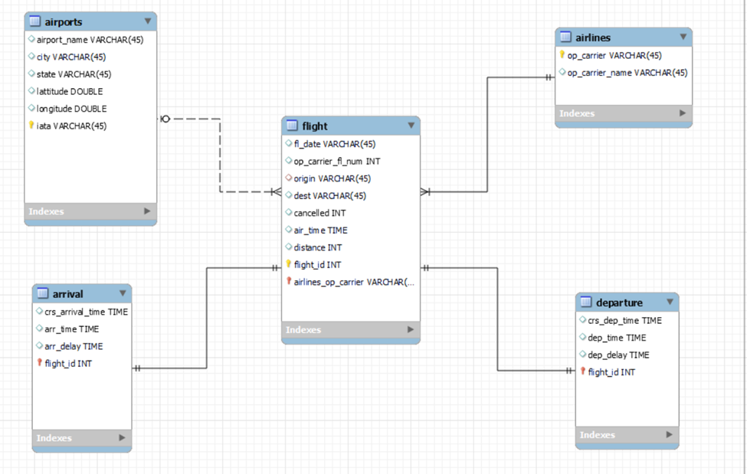

Data loading

We have loaded the data into the MySQL server using the MySQL program.

# Database cleaning

The dataset cleaning is performed by removing inconsistencies like the names of columns sometimes being entered in uppercase or lowercase or the data variables being in unacceptable format by MySQL. Also, we have removed numerical data with comma, as MySQL truncates data at comma leading to incorrect data. We have loaded our dataset with the help of queries shown in the below picture.

Here are some pictures of our dataset before and after data cleaning using queries.

Below, attached picture displayed crs_arr_time and arr_time in INT datatype from arrival table before the cleaning process.

Using the following query, we have performed the cleaning of data variables from arrival table to convert INT datatype for crs_arr_time and arr_time into TIME datatype.

We have performed the following query to check whether datatype is correct for time variables (i.e, crs_arr_time, arr_time).

We have also removed double quotes from dataset as a part of data cleaning using the attached queries. We are attaching pictures to show output before and after execution of MySQL query.

# Database testing

After checking for all the constraints, we performed the following queries to answer the business understanding questions:

1. List the top 5 airports which have faced maximum cancelled flights?

As per our result, we can say that airport Yakutat in state Arkansas has faced maximum cancelled flights followed by Northwest Arkansas regional.

1. Which airline has faced the maximum number of cancellations?

We ran this query to find out which airline has faced the maximum number of cancellations, and we get Air U.S as our answer.

1. What is the number of flights per month?

According to our query, we can see that January has 570118 number of flights. We can know the number of flights for January, February, March, April, May, June, July, August, September, and October as per our dataset.

1. Which airport has the maximum number of flights?

Airport having airport_id ATL has maximum number of flights i.e., 780125 and hence busiest airport in United states of America.

1. Which airport has the minimum traffic in the USA?

As per result of the query we ran, Aberdeen regional airport has a minimum number of flights.