NEXT LEVEL GAMING
& ESPORTS ARENA
Final Website & Mobile App
Scenario 3 | Client: Jason Naidoo | Johannesburg

Website Design Mockups
Desktop layouts use a consistent dark navy and neon colour palette, clear navigation, prominent calls to action, and package cards.

Website: Home
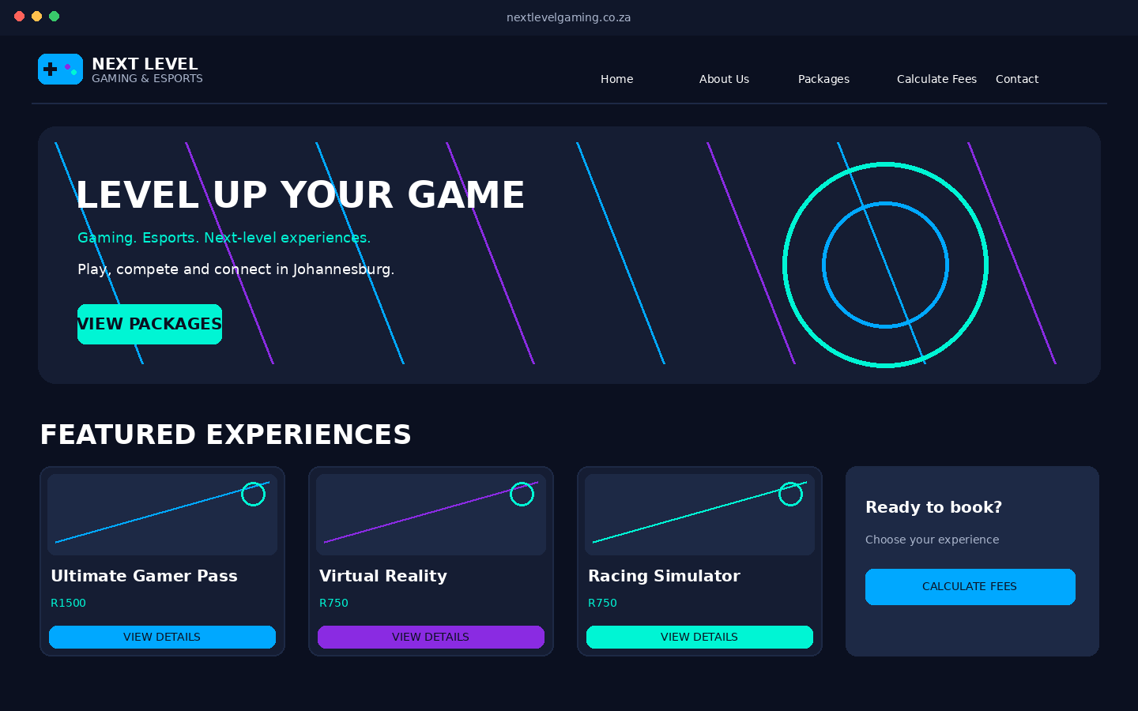
Key elements: consistent branding, clear hierarchy, and navigation to related pages.

Website: About Us
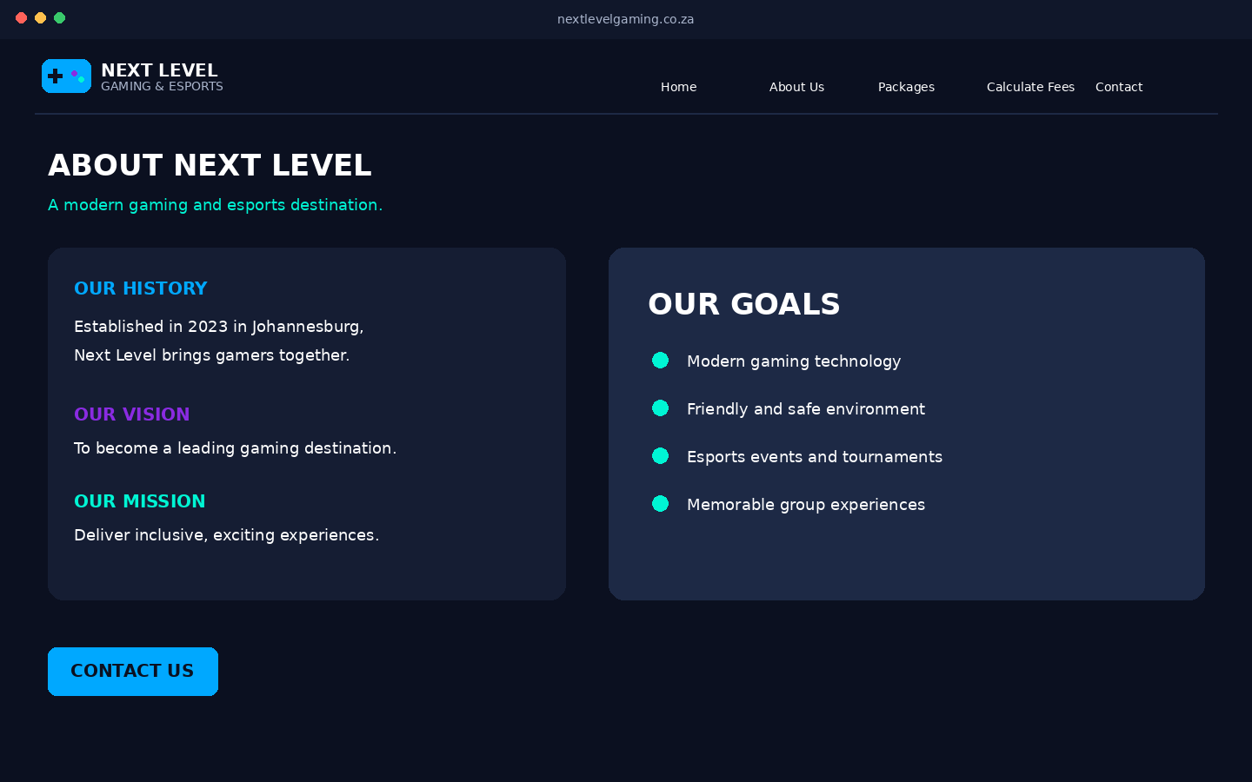
Key elements: consistent branding, clear hierarchy, and navigation to related pages.

Website: Packages & Experiences
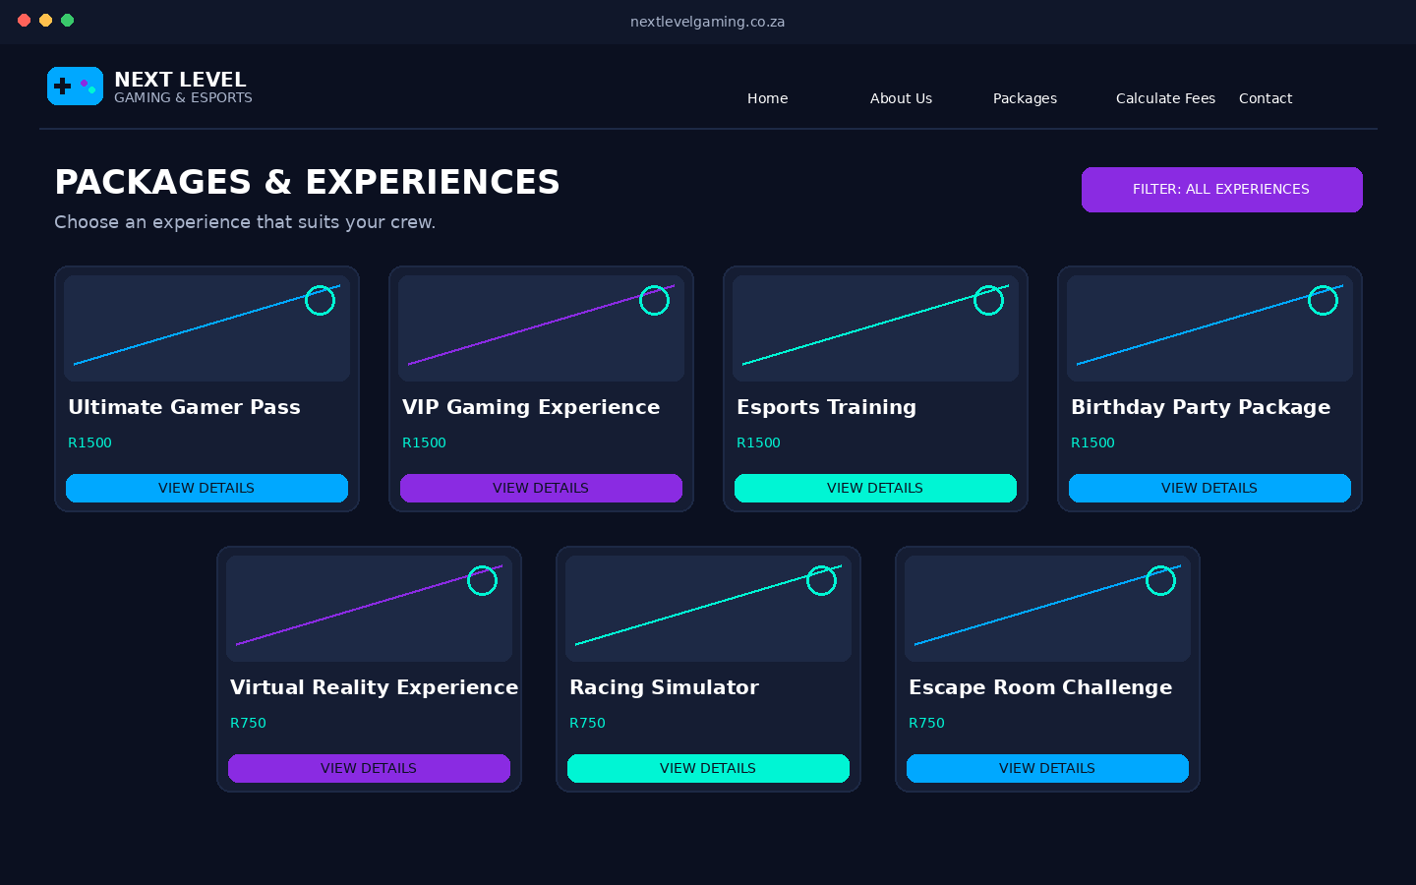
Key elements: consistent branding, clear hierarchy, and navigation to related pages.

Website: Package Details
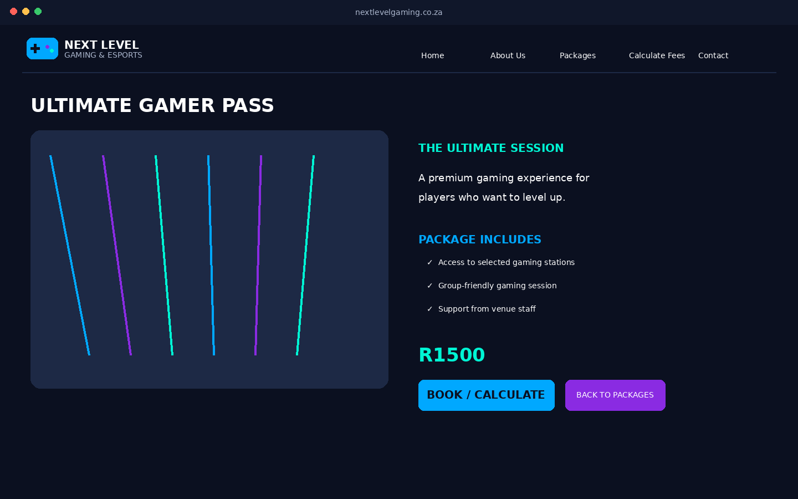
Key elements: consistent branding, clear hierarchy, and navigation to related pages.

Website: Calculate Fees
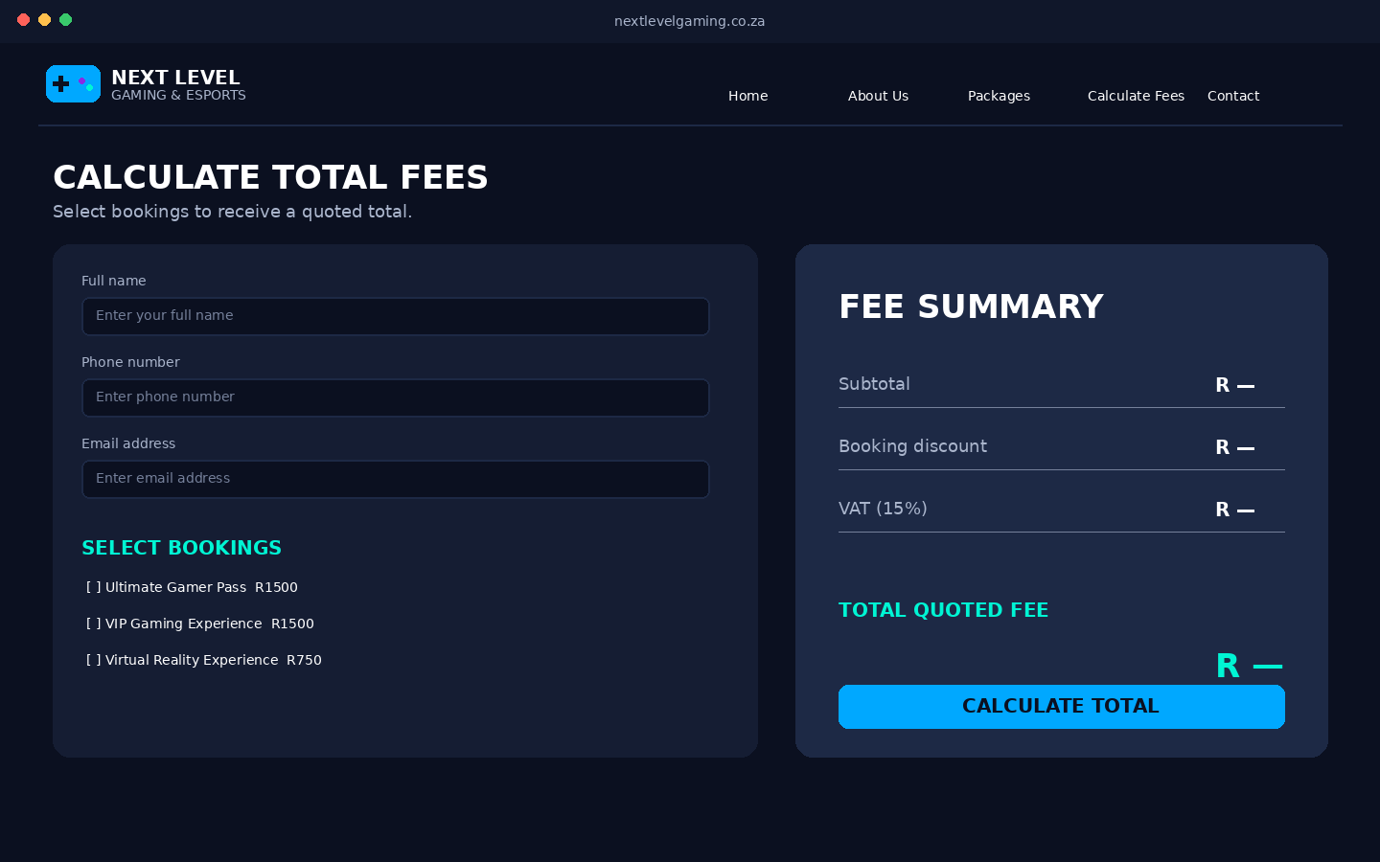
Key elements: consistent branding, clear hierarchy, and navigation to related pages.

Website: Contact Us
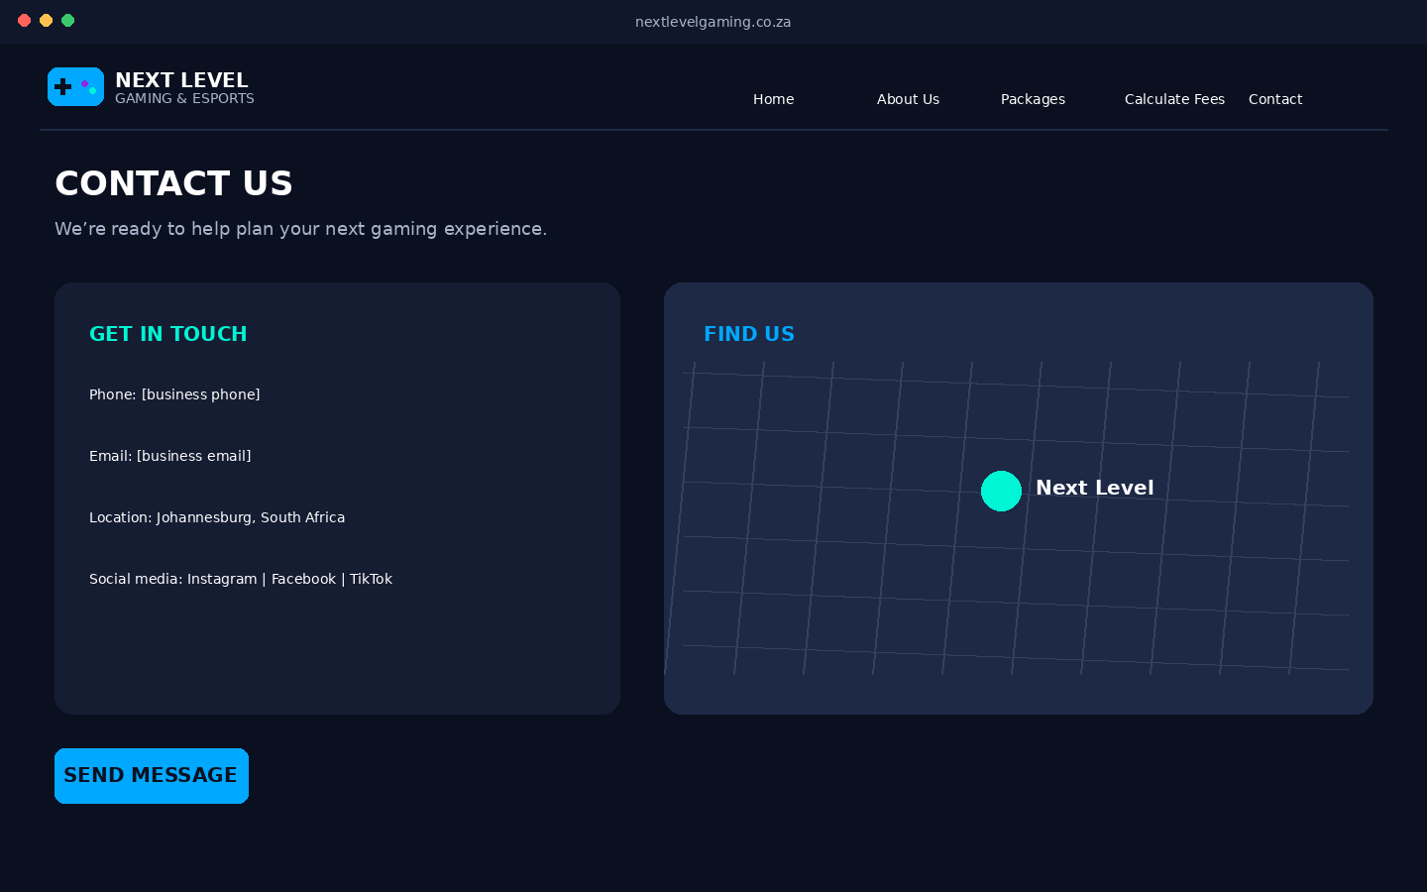
Key elements: consistent branding, clear hierarchy, and navigation to related pages.

Mobile App Design Mockups
Mobile screens use vertically stacked content and touch-friendly controls to suit smaller screens.

Mobile App: Home
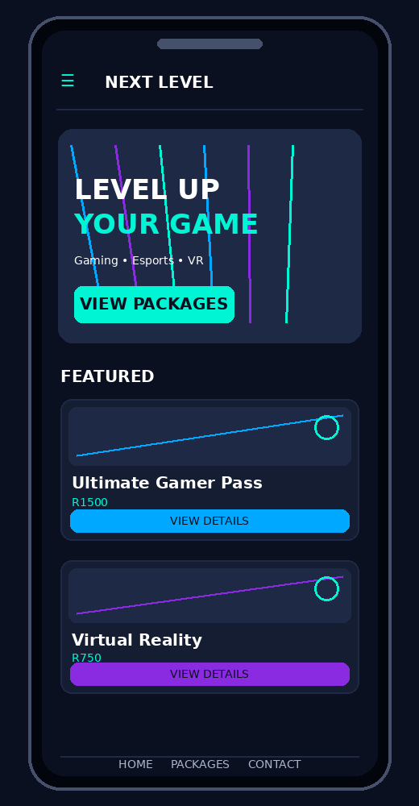
Key elements: compact screen layout, readable text, and clear touch targets.

Mobile App: About Us
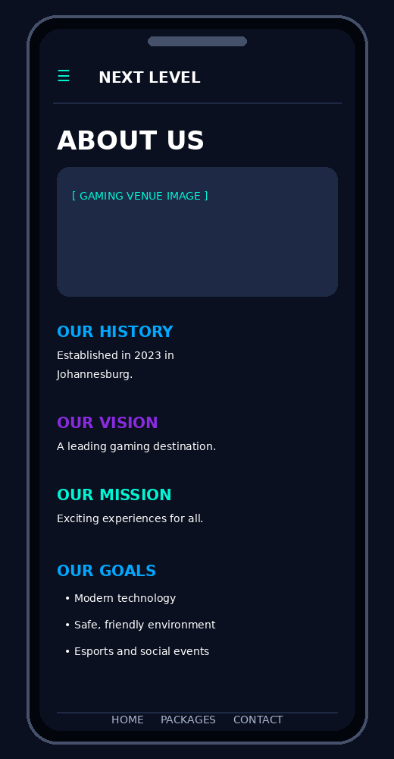
Key elements: compact screen layout, readable text, and clear touch targets.

Mobile App: Packages & Experiences
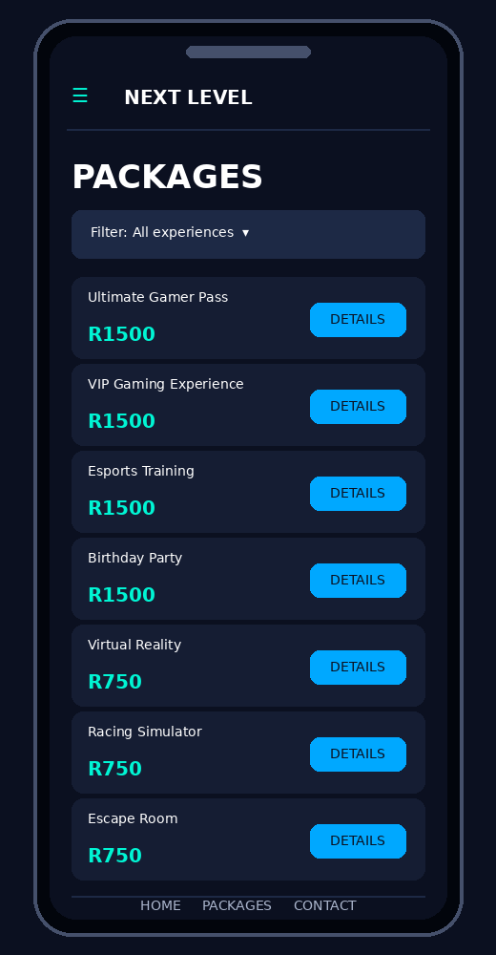
Key elements: compact screen layout, readable text, and clear touch targets.

Mobile App: Package Details
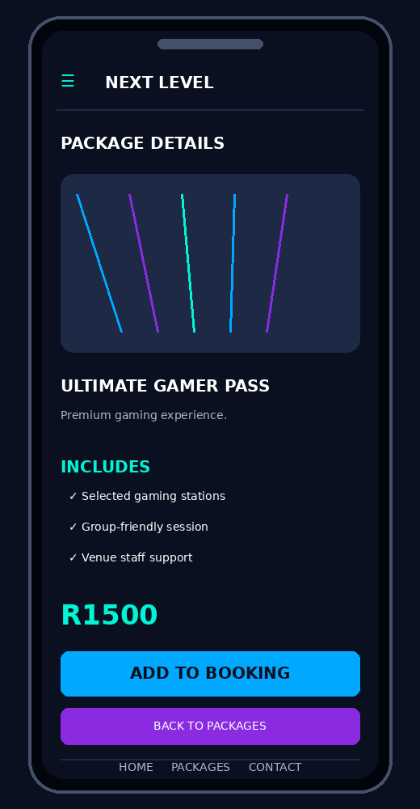
Key elements: compact screen layout, readable text, and clear touch targets.

Mobile App: Calculate Fees
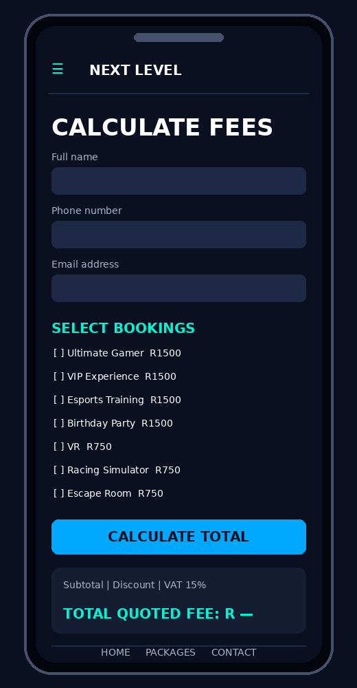
Key elements: compact screen layout, readable text, and clear touch targets.

Mobile App: Contact Us
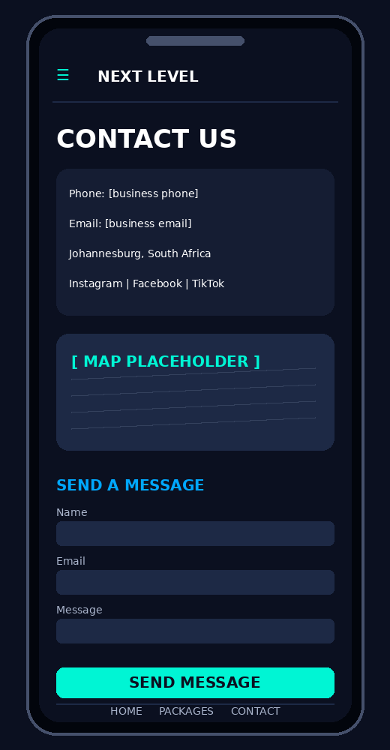
Key elements: compact screen layout, readable text, and clear touch targets.

Functional Requirements Shown in the Designs
- Booking prices: four packages at R1500 each and three individual experiences at R750 each.
- Discounts: 1 booking = 0%; 2 bookings = 5%; 3 bookings = 10%; more than 3 bookings = 15%.
- The fee calculator includes customer details, booking selections, subtotal, discount, 15% VAT and total quoted fee.
- Validation should check required fields, email and phone formats, and at least one selected booking.
- The final website and app should include a drop-down menu and a table, adapted to each layout.
- Replace bracketed contact placeholders with the client's confirmed phone number, email and social links before final submission.

