|  |
| --- |
| HTML5 Elements Cookbook |
| H5E Experiment: Fixed Header & Footer |
| DRAFT  Published 15 July, 2011 |
|  |

|  |
| --- |
|  |
| H5E Scout Team  Windows Web Partners  Microsoft Corporation  Microsoft Confidential |

# Summary

One pattern that is common in many web UI designs is the presence of a header and/or footer on the page. The header or footer areas typically contain status information, navigational buttons, advertisements, and/or a toolbar. In many cases, these areas should remain visible on the screen even when the main content of the page is being scrolled.

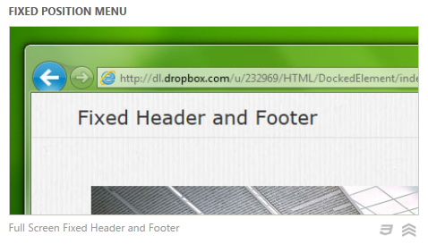

## Scope

This document describes an experiment conducted by the H5E scout team using Clarity Consulting that creates fixed-position header and footer areas. Our objective is to test the limits of HTML5 solving real-world partner questions. This document assumes an existing knowledge of JavaScript and jQuery. This document does not supersede any requirements or instructions provided by the IE team.

## Keywords

Fixed position, header, footer, tool bar, status bar, advertisements, navigation

## Contact us

To contact us for questions or support, please email Chewy Chong ([ChewyC](mailto:ChewyC?subject=HTML5%20Cookbooks)). Feedback is welcome.

Contents

Summary 2

Scope 2

Keywords 2

Contact us 2

Fixed Header and Footer Overview 4

Video 4

Experience Walkthrough 4

How do I build this using HTML5? 6

Implementation details 7

Conclusions and Recommendations 9

Resources 9

Relevant Web sites and specifications 9

Microsoft Resources 9

Appendix A: About H5E 10

What is an HTML5 Elements Cookbook? 10

Contact us 10

Copyright and trademark information 10

Document Revision History 11

# Fixed Header and Footer Overview

As web-based applications continue to draw design inspiration from native apps, they often want to recreate the toolbars, status bars, and other areas that are common in native apps. These areas are generally fixed at the top and/or bottom of the app. They do not scroll with the main content of the application’s page, but instead maintain their position and remain visible to provide feedback or allow actions to be taken.

***NOTE****: Many of the HTML5 Experiments are still under development. Our initial target is to build prototypes that work on current HTML5-supported browsers and tablet devices, including the iPad. The experiments do not aim for full cross-browser support at this stage, but we will likely build in graceful degradation in future updates.*

## Video

To see the Fixed Header and Footer demo in action, see the following: <http://www.youtube.com/watch?v=EXngIrVXn70>

## Experience Walkthrough

The Fixed Header and Footer sample creates static header and footer areas on a web page. The demo page includes the following behavior:

1. The user navigates to the HTML application or web page which displays header and footer information.  
   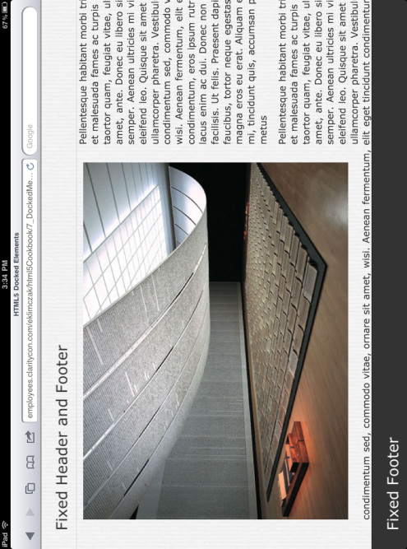
2. 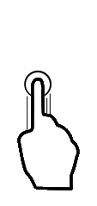User scrolls the main content of the page (headers and footers may disappear briefly).  
   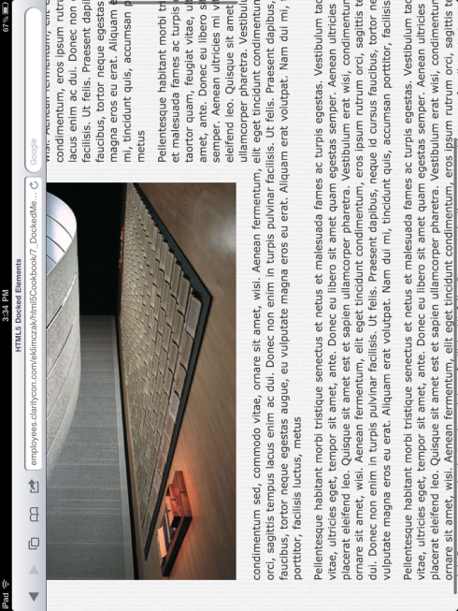
3. Header/footer is present after the user completes the scrolling operation.  
   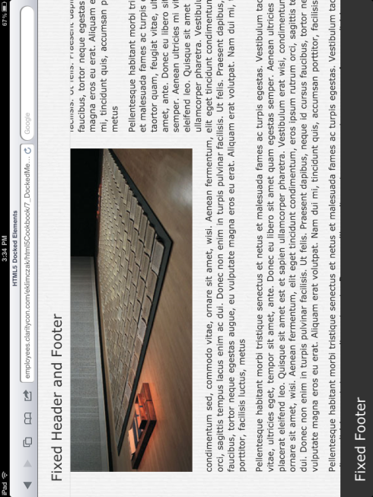

# How do I build this using HTML5?

A complete demo of fixed headers and footers is available here (this link may not be publically available at this time):

<https://github.com/molant/BrowserExperiments/tree/master/cookbook/7_DockedMenu>/

***NOTE****: Many of the HTML5 Experiments are still under development. Our initial target is to build prototypes that work on current HTML5-supported browsers and tablet devices, including the iPad. The experiments do not aim for full cross-browser support at this stage, but we will likely build in graceful degradation in future updates.*

To ensure that users have a similar cross-browser experience, the following table describes the compatibility of the solutions in this document:

|  |  |  |  |  |  |  |  |  |  |  |  |  |  |  |
| --- | --- | --- | --- | --- | --- | --- | --- | --- | --- | --- | --- | --- | --- | --- |
| HTML5 Logo**HTML5 Feature** | IE6.0 | IE7.0 | IE8.0 | IE9.0 | IEPP | Chrome11 | | Chrome12 | Safari4.x | Safari5.x | Firefox3.6 | Firefox4.x | Firefox5.x | Opera11 |
| jQuery |  |  |  |  |  |  | |  |  |  |  |  |  |  |
|  | | | | | | | Full Support | | | | | | |  |
|  | | | | | | | Supported with Shim | | | | | | |  |
|  | | | | | | | No current support | | | | | | |  |

***NOTE****: In general, shims are not incorporated into the HTML5 Experiments at this stage. If a shim or polyfill is required for cross-browser support, see* [*http://browserexperiments.com*](http://browserexperiments.com) *for details on shim implementation.*

## Primary files in this solution

### Source Location

<https://github.com/molant/BrowserExperiments/tree/master/cookbook/7_DockedMenu>

### Sample Location

<http://employees.claritycon.com/eklimczak/html5Cookbook/7_DockedMenu/>

## Implementation details

Markup for the header and footer is placed into the HTML document:

|  |
| --- |
|  |
|  |  | <div class="ui-header ui-fixed-inline "> |
|  |  | <h2>Fixed Header and Footer</h2> |
|  |  | </div> |
|  |
|  | <div class="ui-footer ui-fixed-inline " >  <h2>Fixed Footer</h2> | | |
|  | </div> | | |

The CSS can reflect whatever styling is appropriate for the document:

.ui-header{

position: absolute;

width: 100%;

color: #333;

height: 50px;

border-bottom: solid 1px #dcdcdc;

}

.ui-footer {

position: absolute;

width: 100%;

background: #333;

height: 50px;

color: #fff;

border-top: solid 1px #000;

}

This cryptic CSS rule has two functions. It ensures the fixed toolbars are positioned over the remainder of the page, and most importantly it encourages Webkit browsers to use hardware acceleration for CSS animations used to show and hide the toolbars. By default, 2D animations are not hardware accelerated, so specifying the Z axis convinces Webkit browsers that hardware 3D acceleration should be used.

.ui-header-fixed, .ui-footer-fixed {

z-index: 1000;

-webkit-transform: translateZ(0);

}

A relatively small Javascript object named Docker handles the bulk of the remaining work; it depends on jQuery to support its use of browser events.

On platforms with touch events, such as the iPad, Android, and iPhone, Docker attaches to the touchstart/touchstop events and uses a CSS animation to remove the fixed header/footer while the user is scrolling the page. When the user completes scrolling by lifting their finger, it “re-docks” the fixed header/footer to the page using another animation.

if (supportTouch) {

$(document).bind(touchStartEvent, function (event) {

self.hide();

}).bind(touchStopEvent, function (event) {

self.show();

});

}

This is consistent with the way native apps work on those platforms, and can be seen in the screen shots from an iPad above.

For desktop browsers, Docker continues to show the header/footer even when scrolling. Whenever a scroll event is triggered, the script redraws the toolbars and sets them to position: fixed to ensure they were not clipped or removed by the scrolling part of the page.

var fromTop = $(window).scrollTop(),

screenHeight = window.innerHeight,

thisHeight = el.outerHeight(),

relval;

if (el.is('.ui-header-fixed')) { //Set header

if (supportTouch) {

return el.css('top', fromTop);

} else { //For smoother positioning

return el.css({

position: 'fixed',

top: 0

});

}

} else { //set footer

if (supportTouch) {

return el.css('top', fromTop + screenHeight - thisHeight); //needed for iOS

} else {

return el.css({

position: 'fixed',

top: screenHeight - thisHeight

});

}

}

# Conclusions and Recommendations

This simple and small combination of HTML, CSS, and JavaScript can easily add fixed headers and footers to most designs. It works well for both desktop and mobile browsers, and takes advantage of hardware acceleration on platforms where CSS animations are supported. For mobile designs with limited screen space, the “disappear while scrolling” behavior lets the user see maximum content but still allows them to interact with the header/footer toolbars at all other times. Where a fixed-toolbar component is appropriate for HTML-based designs, this implementation allows it to be done across multiple platforms with a minimum of effort.

# Resources

## Relevant Web sites and specifications

|  |  |
| --- | --- |
| jQuery reference | <http://docs.jquery.com/Main_Page> |

## Microsoft Resources

|  |  |
| --- | --- |
| H5E Primary Contact | Chewy Chong ([ChewyC](mailto:%20chewyc?subject=HTML5%20Experiments%20Cookbooks)) |
| H5E Development Contact | Anton Molleda Quintana ([v-anmoll](mailto:v-anmoll?subject=HTML5%20Experiments%20Cookbooks)) |

# Appendix A: About H5E

## What is an HTML5 Elements Cookbook?

Each HTML5 Elements Cookbook reflects a case study of an aspirational experience that is provided by a native or component-based application. The HTML5 Experiments that are conducted by the H5E team use HTML5 and related technologies to replicate these experiences. Our primary objective is to learn from these experiments to determine if an HTML5 alternative to component-based or native implementations is both possible, and practical. Each Cookbook provides a description of the element and technical details of the HTML5 replication of that feature. We also include recommendations on whether it makes sense to pursue this approach.

## Contact us

If you need assistance with technical solutions or have a best practice to share, please contact us by sending email to Chewy Chong ([ChewyC](mailto:chewyc?subject=H5E%20Cookbooks%20and%20Documentation)).

## Copyright and trademark information

This document is Microsoft Confidential.

Complying with all applicable copyright laws is the responsibility of the user. Without limiting the rights under copyright, no part of this document may be reproduced, stored in or introduced into a retrieval system, or transmitted in any form or by any means (electronic, mechanical, photocopying, recording, or otherwise), or for any purpose, without the express written permission of Microsoft Corporation.

 2011 Microsoft Corporation. All rights reserved.

# Document Revision History

|  |  |  |
| --- | --- | --- |
| **Reviser** | **Date** | **Revisions** |
| **v-davime** | 13 July 2011 | Initial draft |
| **v-jgeige** | 17 July 2011 | Minor edit |
|  |  |  |
|  |  |  |
|  |  |  |
|  |  |  |
|  |  |  |
|  |  |  |