## **MOTOR VEHICLE COLLISION- SQL QUERIES for VISUALIZATION**

1. How many accidents occurred in NYC, Austin, and Chicago?

SQL Query:-

SELECT COUNT (*) AS Number_of_Accidents, d.Source

FROM Fct_Accidents f

Join Dim_Source d ON d.Source_SK = f.Source_SK

GROUP BY d.Source;

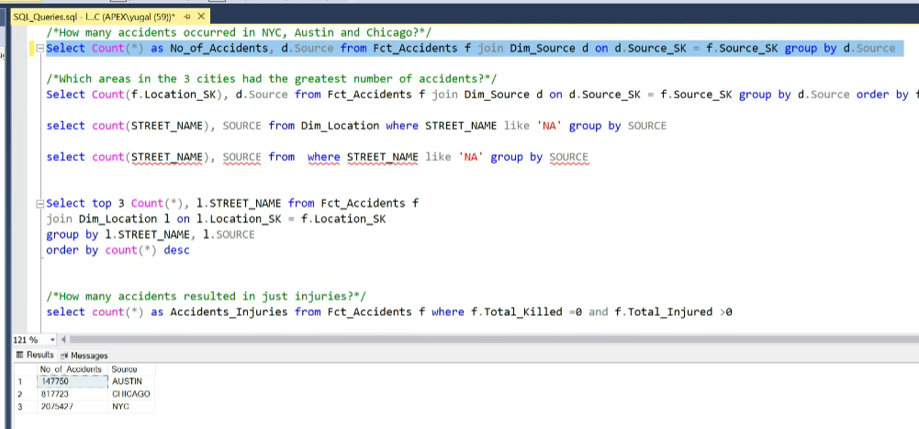

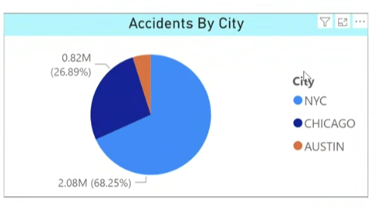

1. Which areas in the 3 cities had the greatest number of accidents? (Top 3 areas in each city).

SQL Query:-

WITH RankedAccidents AS (

SELECT Dim_Location.STREET_NAME, Dim_Location.SOURCE,

COUNT (Fct_Accidents.Accidents_FCT_SK) AS Total Accidents,

ROW_NUMBER () OVER (PARTITION BY Dim_Location. SOURCE ORDER BY

COUNT (Fct_Accidents.Accidents_FCT_SK) DESC) AS Rank

FROM Fct_Accidents

JOIN Dim_Location ON Fct_Accidents.Location_SK = Dim_Location.Location_SK

GROUP BY Dim_Location. STREET_NAME, Dim_Location. SOURCE

) SELECT STREET_NAME, SOURCE, Total Accidents FROM RankedAccidents

WHERE Rank <= 3;

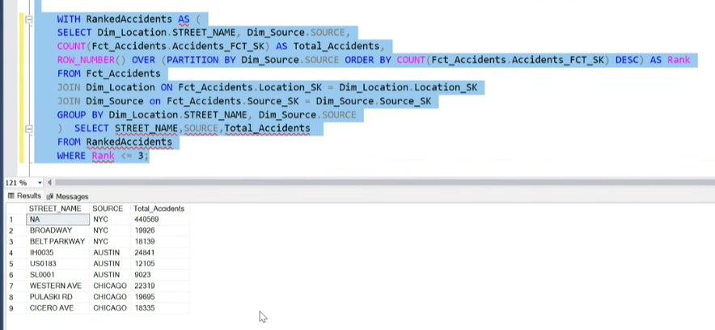

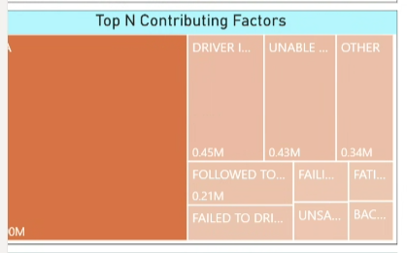

1. How many accidents resulted in just injuries?

* Overall

SQL Query:-

SELECT COUNT (*) AS Accidents_Injuries

FROM Fct_Accidents f

WHERE f.Total_Killed =0 and f.Total_Injured >0

* By City

SQL Query:-

SELECT d.Source, COUNT (*) AS Accidents

FROM Fct_Accidents f

JOIN Dim_Source d ON d.Source_SK = f.Source_SK

WHERE f.Total_Killed =0 and f.Total_Injured >0

GROUP BY d.Source

**OR**

SELECT Source, City_Accidents_Injuries, Overall_Accidents_Injuries

FROM (

SELECT d.Source,

COUNT (*) AS City_Accidents_Injuries,

SUM (COUNT (*)) OVER () AS Overall_Accidents_Injuries

FROM Fct_Accidents f

JOIN Dim_Source d ON f.Source_SK = d.Source_SK

WHERE f.Total_Killed = 0 AND f.Total_Injured > 0

GROUP BY d.Source) AS Sub;

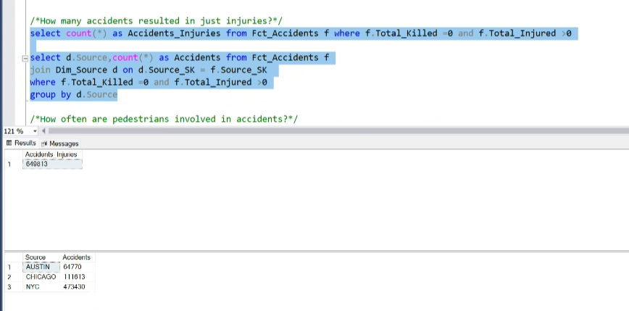

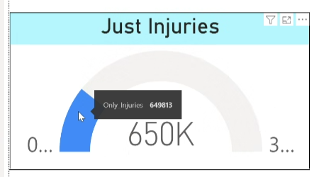

1. How often are pedestrians involved in accidents?

* Overall

SQL Query:-

SELECT COUNT (*) AS Accidents_Pedestrians FROM Fct_Accidents f WHERE f.IS_PEDESTRIAN = 'Y';

* By City

SQL Query:-

SELECT d.Source, COUNT (*) AS Accidents_Pedestrians

FROM Fct_Accidents f

JOIN Dim_Source d ON d.Source_SK = f.Source_SK

WHERE f.IS_PEDESTRIAN = 'Y'

GROUP BY d.Source

**OR**

SELECT d.Source,

COUNT (*) AS Accidents_Pedestrians,

SUM (COUNT (*)) OVER () AS Total_Accidents_Pedestrians

FROM Fct_Accidents f

JOIN Dim_Source d ON f.Source_SK = d.Source_SK

WHERE f.IS_PEDESTRIAN = 'Y'

GROUP BY d.Source;

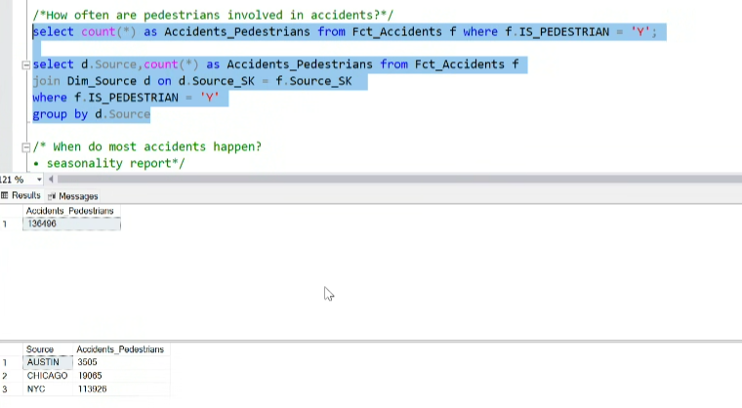

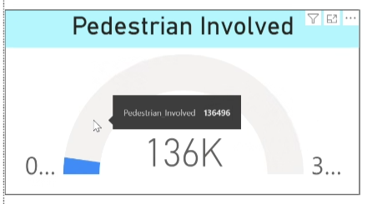

1. When do most accidents happen? (Seasonality Report)

SQL Query:-

SELECT d.Season, COUNT (*) AS No_of_Accidents FROM Fct_Accidents f

JOIN Dim_Date d ON f.Date_SK = d.Date_SK

GROUP BY d.Season

ORDER BY COUNT (*) DESC;

SELECT Season, No_of_Accidents,

SUM (No_of_Accidents) OVER (ORDER BY No_of_Accidents DESC) AS Cumulative_Total,

ROUND (100.0 * No_of_Accidents / SUM (No_of_Accidents) OVER (), 2) AS Percentage_of_Total

FROM (

SELECT d.Season, COUNT (*) AS No_of_Accidents

FROM Fct_Accidents f

JOIN Dim_Date d ON f.Date_SK = d.Date_SK

GROUP BY d.Season

) AS SeasonData

ORDER BY No_of_Accidents DESC;

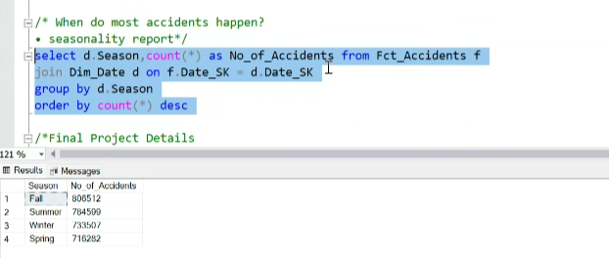

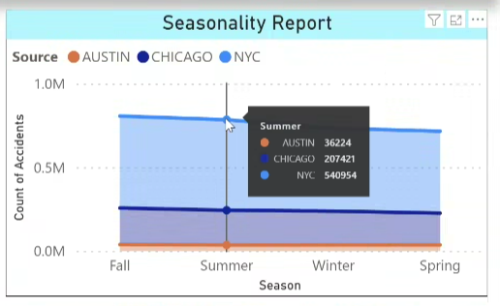

1. How many motorists are injured or killed in accidents?

SQL Query:-

SELECT

SUM (Motorist_Injured) AS Total_Motorist_Injuries,

SUM (Motorist_Killed) AS Total_Motorist_Fatalities

FROM Fct_Accidents;

SELECT s.Source,

SUM (Motorist_Injured) AS Total_Motorist_Injuries,

SUM (Motorist_Killed) AS Total_Motorist_Fatalities

FROM Fct_Accidents f

JOIN Dim_Source s ON f.Source_SK = s.Source_SK

GROUP BY S.Source; /* Chicago doesn't have bifurcation for motorists*/

SELECT s.Source,

SUM (f.Motorist_Injured) AS Total_Motorist_Injuries,

SUM (f.Motorist_Killed) AS Total_Motorist_Fatalities,

SUM (SUM (f.Motorist_Injured)) OVER () AS Overall_Motorist_Injuries,

SUM (SUM (f.Motorist_Killed)) OVER () AS Overall_Motorist_Fatalities

FROM Fct_Accidents f

JOIN Dim_Source s ON f.Source_SK = s.Source_SK

GROUP BY s.Source

ORDER BY s.Source;

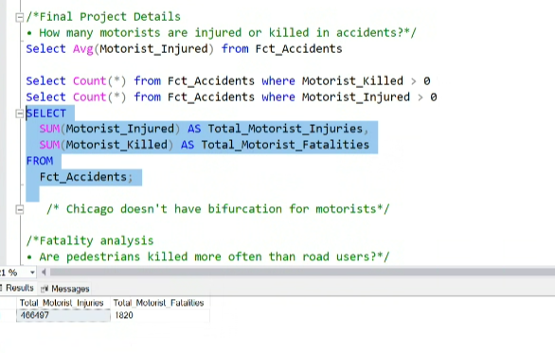

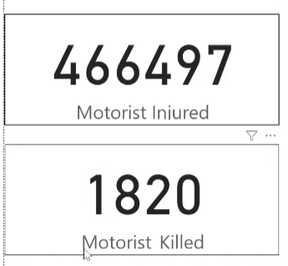

1. Which top 5 areas in 3 cities have the most fatal accidents?

SQL Query:-

SELECT top 5 COUNT (*), l.STREET_NAME, l.SOURCE FROM Fct_Accidents f

JOIN Dim_LocatiON l ON l.LocatiON_SK = f.LocatiON_SK

GROUP BY l.STREET_NAME, l.SOURCE

HAVING l.STREET_NAME NOT LIKE 'NA'

ORDER BY COUNT (*) DESC /*Given NYC's NA COUNT of street name is ignored*/

SQL Query:-

WITH RankedAccidents AS (

SELECT Dim_LocatiON.STREET_NAME, Dim_Source.SOURCE,

COUNT (Fct_Accidents.Accidents_FCT_SK) AS Total_Accidents,

ROW_NUMBER () OVER (PARTITION BY Dim_Source.SOURCE

ORDER BY COUNT (Fct_Accidents.Accidents_FCT_SK) DESC) AS Rank

FROM Fct_Accidents

JOIN Dim_LocatiON ON Fct_Accidents.LocatiON_SK = Dim_LocatiON.LocatiON_SK

JOIN Dim_Source ON Fct_Accidents.Source_SK = Dim_Source.Source_SK

GROUP BY Dim_LocatiON.STREET_NAME, Dim_Source.SOURCE

) SELECT STREET_NAME, SOURCE, Total_Accidents

FROM RankedAccidents WHERE Rank <= 5;

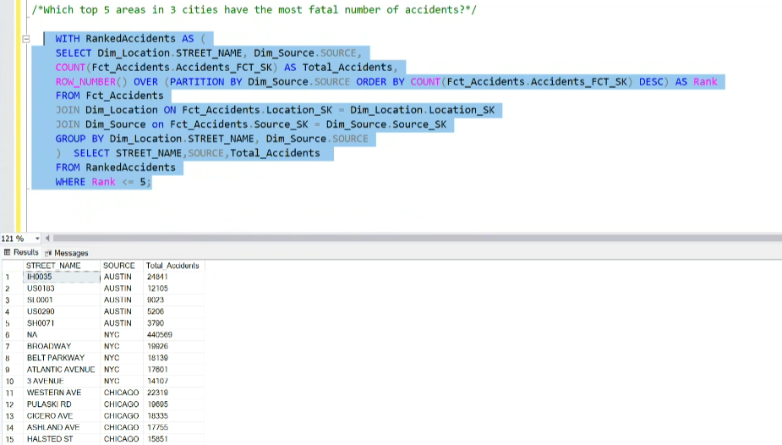



1. Time-based analysis of accidents (Time of the day, day of the week, weekdays or weekends).

* Day of the Week

SELECT d.Day, COUNT (*) AS No_of_Accidents

FROM Fct_Accidents f

JOIN Dim_Date d ON f.Date_SK = d.Date_SK

GROUP BY d.Day

ORDER BY No_of_Accidents;

* Weekend vs. Weekday Accidents

-- Weekend Accidents

SELECT COUNT (*) AS Weekend_Accidents

FROM Fct_Accidents f

JOIN Dim_Date d ON f.Date_SK = d.Date_SK

WHERE d.Day > 5;

-- Weekday Accidents

SELECT COUNT (*) AS Weekday_Accidents

FROM Fct_Accidents f

JOIN Dim_Date d ON f.Date_SK = d.Date_SK

WHERE d.Day <= 5;

* Hour of the Day

SELECT d.Hour, COUNT (*) AS No_of_Accidents

FROM Fct_Accidents f

JOIN Dim_Time d ON f.Time_SK = d.Time_SK

GROUP BY d.Hour

ORDER BY d.Hour;

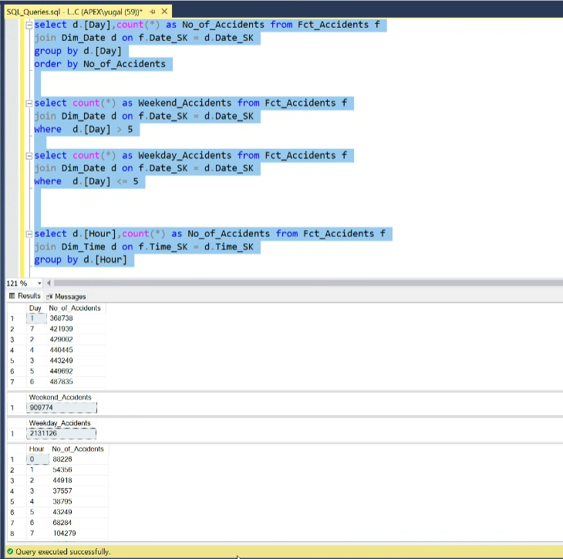

USE FILTERS ON VISUALIZATION

1. Are pedestrians killed more often than road users? (Fatality analysis)

SELECT

SUM (Pedestrian_Killed) AS Total_Pedestrian_Fatalities,

(SUM (Total_Killed) – SUM (Pedestrian_Killed)) AS Total_Other_Road_User_Fatalities

FROM Fct_Accidents;

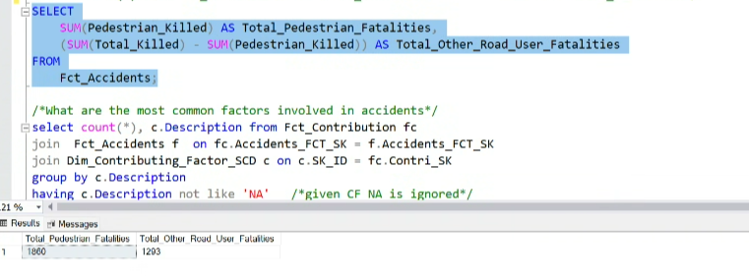

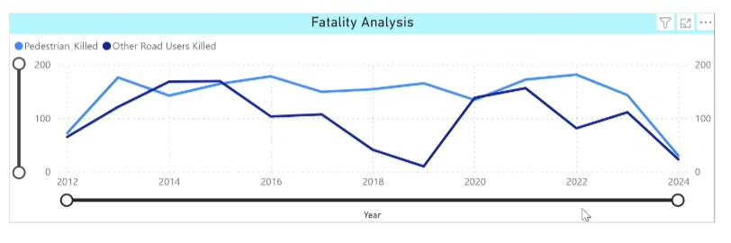

1. What are the most common factors involved in accidents?

SELECT

COUNT (*) Number, c.DescriptiON AS Most_Common_Factors FROM Fct_Contribution fc

JOIN Fct_Accidents f ON fc.Accidents_FCT_SK = f.Accidents_FCT_SK

JOIN Dim_Contributing_Factor_SCD c ON c.SK_ID = fc.Contri_SK

GROUP BY c.Description

ORDER BY COUNT (*) DESC;

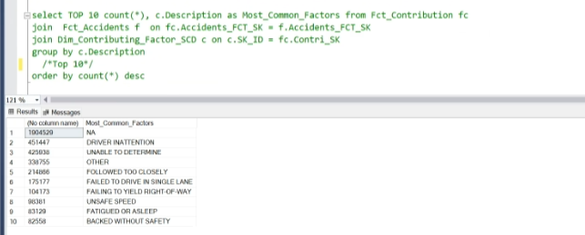

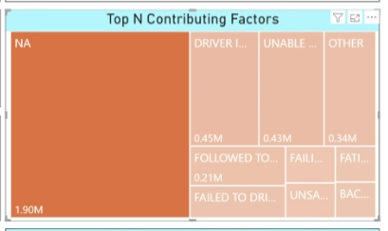

/* ADDITIONAL REQURIREMENT*/

(Using Austin and NYC datasets, Create a visualization to show the number of Accident that involved more than 2 vehicles. Show this data as a comparison between these 2 cities).

SELECT

Count (Vehicle_Fct_Sk) AS Number_of_Vehicle, s.Source

FROM Fct_Accidents a

JOIN Fct_Vehicle f ON f.Accidents_FCT_SK = a.Accidents_FCT_SK

JOIN Dim_Source s ON a.Source_SK = s.Source_SK

WHERE f.Vehicle_Count >2

GROUP BY s.Source

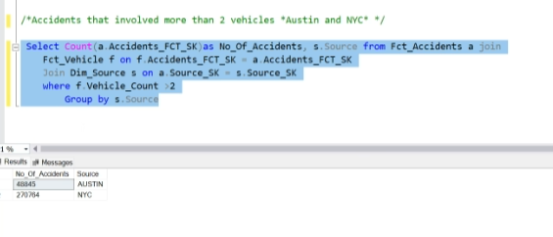

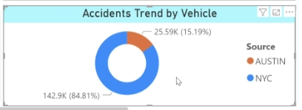

/* LOCATION TREND*/

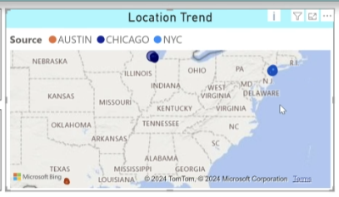 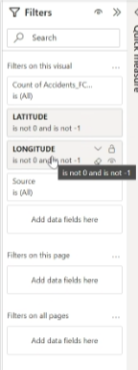

* Ignoring 0 and 1 values for latitude longitude as they are outlier.
* Latitude longitude combination (0,0) is present in New York.
* Latitude longitude combination (-1,-1) is to replace missing values.

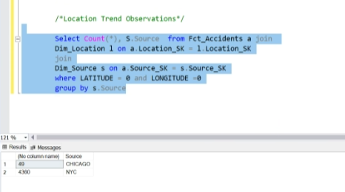

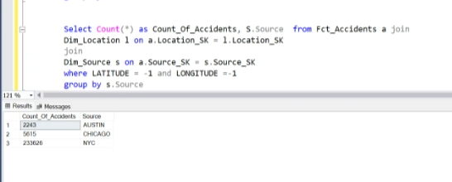

## **PowerBI VISUALIZATION**

## **Tableau VISUALIZATION**

