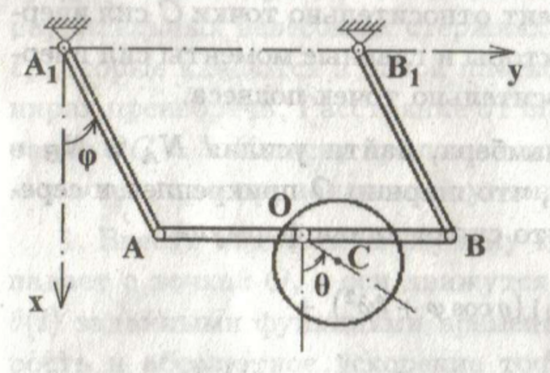
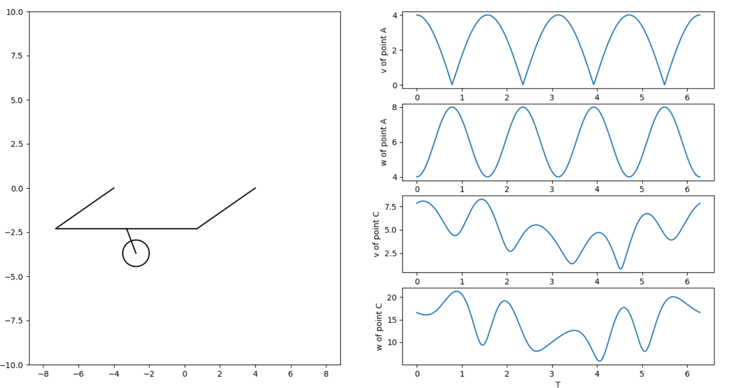
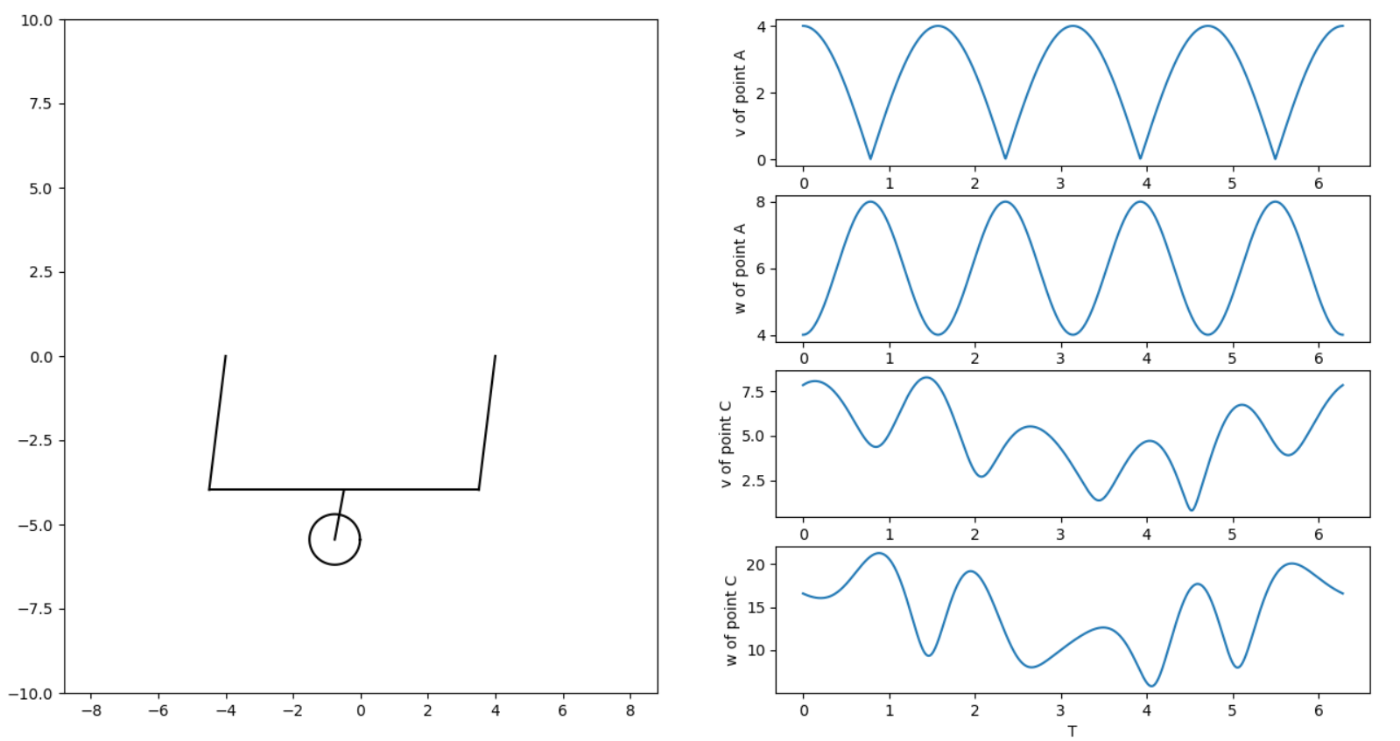
Московский авиационный институт
(национальный исследовательский университет)
Институт № 8 «Информационные технологии и прикладная математика»

Лабораторная работа №2
по курсу «Теоретическая механика»
Анимация системы

Выполнил студент группы М8О-207Б-20
Молчанов Владислав Дмитриевич
Преподаватель: Волков Евгений Валерьевич

Оценка:
Дата: 01.11.21

Москва, 2021

Вариант №«14 »
Задание:
Реализовать анимацию движения по данным законам движения, используя язык программирования Python.
Законы:
r = 2 + sp.sin(12 * t)
phi = 1.8 * t + 0.2 * sp.cos(12 * t)

Текст программы:
import matplotlib.pyplot as plt
import numpy as np
import math
from matplotlib.animation import FuncAnimation
import sympy as sp

def Rot2D(X, Y, Alpha):
RX = X * np.cos(Alpha) - Y * np.sin(Alpha)
RY = X * np.sin(Alpha) + Y * np.cos(Alpha)
return RX, RY

def anima(j):
a = math.sqrt(VX[j] ** 2 + VY[j] ** 2)
b = math.sqrt(WX[j] ** 2 + WY[j] ** 2)

P.set_data(X[j], Y[j])
Vline.set_data([X[j], X[j] + VX[j] / a], [Y[j], Y[j] + VY[j] / a])
Vline2.set_data([X[j], X[j] + WX[j] / b], [Y[j], Y[j] + WY[j] / b])
Vline3.set_data([X_[j], X[j]], [Y_[j], Y[j]])
Vline4.set_data([X[j], X[j] + (Y[j] + VY[j]) * Ro[j]/((Y[j] + VY[j])**2 +
(X[j] + VX[j])**2)**0.5], [Y[j], Y[j] - (X[j] + VX[j]) *
Ro[j]/((Y[j] + VY[j])**2 + (X[j] + VX[j])**2)**0.5])
RArrowX, RArrowY = Rot2D(ArrowX, ArrowY, math.atan2(VY[j], VX[j]))
VArrow.set_data(RArrowX + X[j] + VX[j] / a, RArrowY + Y[j] + VY[j] / a)
RArrowWX, RArrowWY = Rot2D(ArrowWX, ArrowWY, math.atan2(WY[j], WX[j]))
WArrow.set_data(RArrowWX + X[j] + WX[j] / b, RArrowWY + Y[j] + WY[j] / b)
RArrowRX, RArrowRY = Rot2D(ArrowRX, ArrowRY, math.atan2(Y[j], X[j]))
RArrow.set_data(RArrowRX + X[j], RArrowRY + Y[j])
return P, Vline, VArrow, Vline2, WArrow, Vline3, RArrow, Vline4,

T = np.linspace(1, 15, 1000)
t = sp.Symbol('t')
R_lim = 4

r = 2 + sp.sin(12 * t)
phi = 1.8 * t + 0.2 * sp.cos(12 * t)

x = r * sp.cos(phi)
y = r * sp.sin(phi)
Vx = sp.diff(x, t)
Wx = sp.diff(Vx, t)
Vy = sp.diff(y, t)
Wy = sp.diff(Vy, t)
W_ = sp.sqrt(Wx * Wx + Wy * Wy)
W_t = sp.diff(sp.sqrt(Vx**2 + Vy**2),t)
ro = (Vx**2 + Vy**2)/sp.sqrt((Wx * Wx + Wy * Wy) - sp.diff(sp.sqrt(Vx**2 + Vy**2), t)**2)

R = np.zeros_like(T)
PHI = np.zeros_like(T)
X = np.zeros_like(T)
Y = np.zeros_like(T)
VX = np.zeros_like(T)
VY = np.zeros_like(T)
WX = np.zeros_like(T)
WY = np.zeros_like(T)
W = np.zeros_like(T)
W_T = np.zeros_like(T)
Ro = np.zeros_like(T)
X_ = [0 for i in range(1000)]
Y_ = [0 for i in range(1000)]

for i in np.arange(len(T)):
R[i] = sp.Subs(r, t, T[i])
PHI[i] = sp.Subs(phi, t, T[i])
X[i] = sp.Subs(x, t, T[i])
Y[i] = sp.Subs(y, t, T[i])
VX[i] = sp.Subs(Vx, t, T[i])
VY[i] = sp.Subs(Vy, t, T[i])
WX[i] = sp.Subs(Wx, t, T[i])
WY[i] = sp.Subs(Wy, t, T[i])
W[i] = sp.Subs(W_, t, T[i])
W_T[i] = sp.Subs(W_t, t, T[i])
Ro[i] = sp.Subs(ro, t, T[i])

fig = plt.figure()
ax1 = fig.add_subplot(1, 1, 1)
ax1.axis('equal')
ax1.set(xlim=[-1.5 * R_lim, 1.5 * R_lim], ylim=[-R_lim, R_lim])
ax1.plot(X, Y)
P, = ax1.plot(X[0], Y[0], 'r', marker='o')
Vline, = ax1.plot([X[0], X[0] + VX[0]], [Y[0], Y[0] + VY[0]], 'r') # vector of speed
Vline2, = ax1.plot([X[0], X[0] + WX[0]], [Y[0], Y[0] + WY[0]], 'g') # vector of acceleration
Vline3, = ax1.plot([X_[0], X[0]], [Y_[0], Y[0]], 'b') # vector of radius vector
Vline4, = ax1.plot([X[0], X[0] + (Y[0] + VY[0]) * Ro[0]/((Y[0] + VY[0])**2 +
(X[0] + VX[0])**2)**0.5], [Y[0], Y[0] - (X[0] + VX[0]) * Ro[0]/
((Y[0] + VY[0])**2 + (X[0] + VX[0])**2)**0.5], 'm') # vector of radius of curvature

ArrowX = np.array([-0.1 * R_lim, 0, -0.1 * R_lim]) # arrow of speed
ArrowY = np.array([0.05 * R_lim, 0, -0.05 * R_lim])
ArrowWX = np.array([-0.05 * R_lim, 0, 0.05 * -R_lim]) # arrow of acceleration
ArrowWY = np.array([0.05 * R_lim, 0, 0.05 * -R_lim])
ArrowRX = np.array([-0.05 * R_lim, 0, -0.05 * R_lim]) # arrow of radius vector
ArrowRY = np.array([0.05 * R_lim, 0, -0.05 * R_lim])

RArrowX, RArrowY = Rot2D(ArrowX, ArrowY, math.atan2(VY[0], VX[0]))
RArrowWX, RArrowWY = Rot2D(ArrowWX, ArrowWY, math.atan2(WY[0], WX[0]))
RArrowRX, RArrowRY = Rot2D(ArrowRX, ArrowRY, math.atan2(Y[0], X[0]))
VArrow, = ax1.plot(RArrowX + X[0] + VX[0], RArrowY + Y[0] + VY[0], 'r')
WArrow, = ax1.plot(RArrowWX + X[0] + WX[0], RArrowY + Y[0] + WY[0], 'g')
RArrow, = ax1.plot(ArrowRX + X[0], ArrowRY + Y[0], 'b')

anim = FuncAnimation(fig, anima, frames=1000, interval=80, blit=True)

plt.show()
Результат работы:
