PowerShell SQL Deployment Notes

1. Details on the conflicts
   1. First, I had none of these problems on my work computer which is Windows 10 which I also run at home.
   2. Install-Module -Name SqlServer -RequiredVersion 21.1.18068 -AllowClobber
      1. If prompted to install the module from an untrusted repository, choose "Yes to All"
      2. If you get permission errors, try running Visual Studio Code as an Administrator
      3. I was prompted to install the latest NuGet PackageProvider, which I answered yes to.
         1. I received an error that some of the SQL commands already existed
         2. Not understanding the error I ran the recommended force install of the NuGet package provider
      4. Install-PackageProvider -Name NuGet -MinimumVersion 2.8.5.201 -Force
         1. I still had conflicts with SQL commands, so I ran the -AllowClobber
      5. Install-Module -Name SqlServer -RequiredVersion 21.1.18068 -AllowClobber

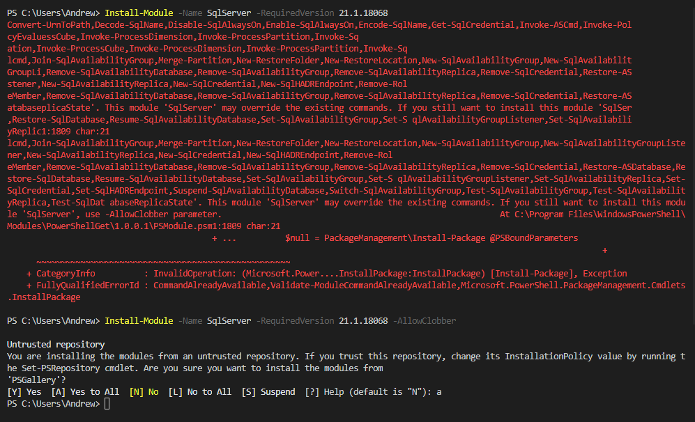

* 1. I had nothing but problems installing the SQL Server module
  2. I had the Azure* and AzureRM* module installed as a side effect of some Azure development work I was doing. I figured you cannot install the SQL Server module with them. I had the Azure* and AzureRM* modules installed from other tests that I was doing. I did not want any conflicts with this article, so I chose to uninstall all modules first.
  3. I tried to [Uninstall the Azure PowerShell module](https://docs.microsoft.com/en-us/powershell/azure/uninstall-az-ps?view=azps-2.5.0), unfortunately none of the techniques worked, so I had to Uninstall-Module each module manually.
  4. [Uninstall-Module](https://docs.microsoft.com/en-us/powershell/module/powershellget/uninstall-module?view=powershell-6)
     1. Ex. Uninstall-Module –Name AzureRM.Sql
  5. I also had to delete the Azure* modules from the program files folder.
     1. C:\Program Files (x86)\WindowsPowerShell\Modules\Azure*
  6. In the end I could not find a "clean" way to get PowerShell in order, so I used the "-AllowClobber" which felt like a hack

1. I learned after I did all of this about the following command:
   1. Get-Command -CommandType Cmdlet | Out-GridView
      1. This opens a pop-up window that lists all Cmdlet's and their source

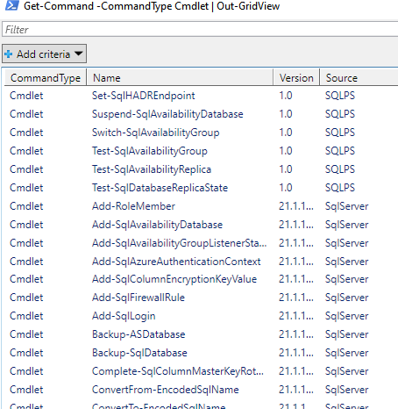

* + 1. This would have helped me understand which source was conflicting
       1. I'm pretty sure it was the SQLPS, but I couldn't find a way to uninstall it
       2. "[Out with the SQLPS, In with the SqlServer](http://www.mikefal.net/2016/07/12/out-with-the-sqlps-in-with-the-sqlserver/)" is an old article that mentioned you could remove the module, but I couldn't



