1. 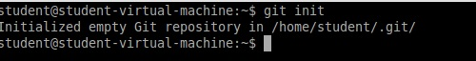
2. 3. 4.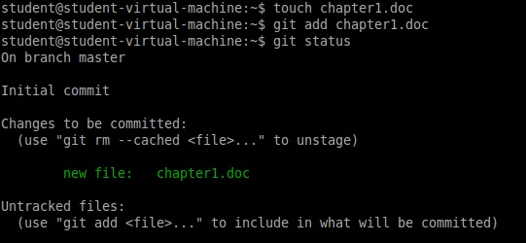

Chapter1.doc is created, at creattion stage the file is not tracked. File to be tracked, “git add” command line allows file to be tracked and added to the tracking list...

Later file is commited to keep progress of change within the file.

5. 6. 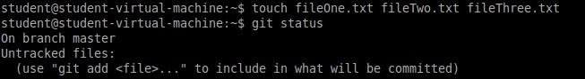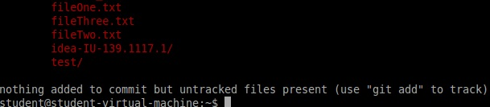

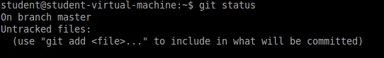

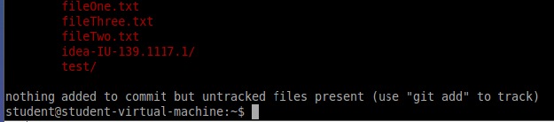

Three files are created at early stage, the files are not tracked and appear in read. After been modified files stil stays in red because they are not tracked.

7. 8

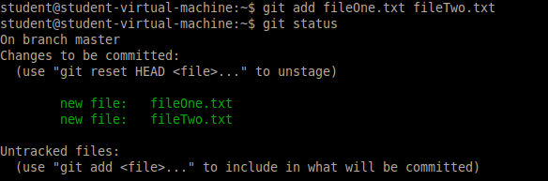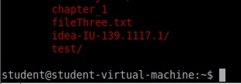

At this stage files are tracked, “git add” command line was used. Three files were created but only keeping track of two

9

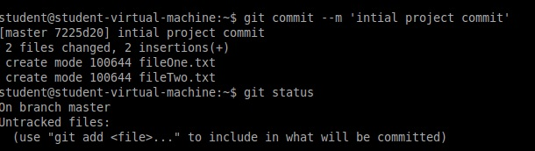

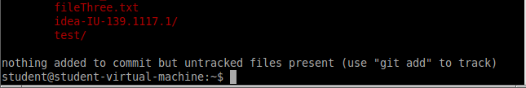

10

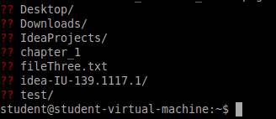

11. 12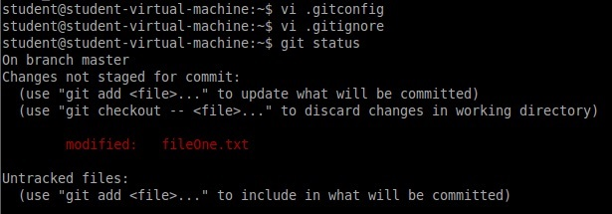

13