稠环

**Chrysene 䓛 1，2-苯并菲（1,2-benzophenanthrene）。**

**C18H12**

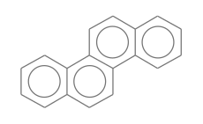

smiles:

1）C1=CC=C2C(=C1)C=CC3=C2C=CC4=CC=CC=C43

2）C12=CC=CC=C1C3=C(C(C=CC=C4)=C4C=C3)C=C2

Benz[a]anthracene

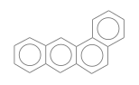

[Naphthacene](http://webbook.nist.gov/cgi/cbook.cgi?ID=C92240&Units=SI)

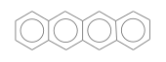

[**Phenanthrene**](http://webbook.nist.gov/cgi/cbook.cgi?ID=C85018&Units=SI) 菲 C14H10

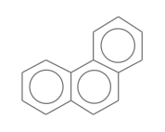

**Anthracene 蒽**

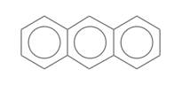

**Naphthalene 萘 C10H8**

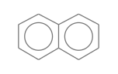

c1cccc2c1cccc2

C1=CC=C2C=CC=CC2=C1

**benzo[c]picene**

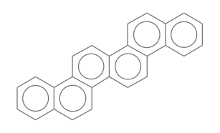

c1ccc2c(c1)ccc5c2ccc6c4ccc3ccccc3c4ccc56

**PICENE**

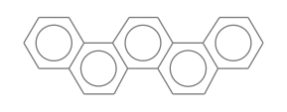

C1=CC=C2C(=C1)C=CC3=C2C=CC4=C3C=CC5=CC=CC=C54