**What is WormQTL?**

Worm species belonging to the genus *Caenorhabditis* are widely used for fundamental and applied research in the field of genetics, genomics and developmental biology. WormQTL is a comprehensive public portal for the management of data on natural variation in *Caenorhabditis spp*. and integrated analysis tools. QTL are Quantitative Trait Loci, i.e. genomic regions associated with phenotypic variation and can be used to study the genetic architecture of traits and to detect potential phenotypic regulators.

Recently, the number of QTL and especially expression (e)QTL studies in *C. elegans* has increased. These (e)QTL studies consists of large datasets which, until now, are difficult to access. No means of tapping in to this rich source of data by a broad group of biologists has been available. Therefore we provide easy access to most of the (e)QTL studies published, by search, browse and plot functions. We support relatively simple questions like “does my gene have an eQTL?” to more advanced like “how do these genes fit in to an eQTL network?”. Furthermore WormQTL is the first portal that allows comparison of (e)QTLs over multiple experiments and environments, giving insight in the plastic nature of genetic regulation.

To enable fast feedback and a close link to the community, users can upload and share new R scripts as 'plugin' for the colleagues in the community to use directly. New data can be uploaded and downloaded using XGAP, an extensible text format for genotype and phenotypes. All data and tools can be accessed via a public web user interface as well as programming interfaces.

WormQTL is freely accessible without registration and is hosted on a large computational cluster enabling high throughput analyses.

**To find QTLs, click “Find QTLs”.**

Before you do a reach, you can restrict the search by suing the drop down menu:

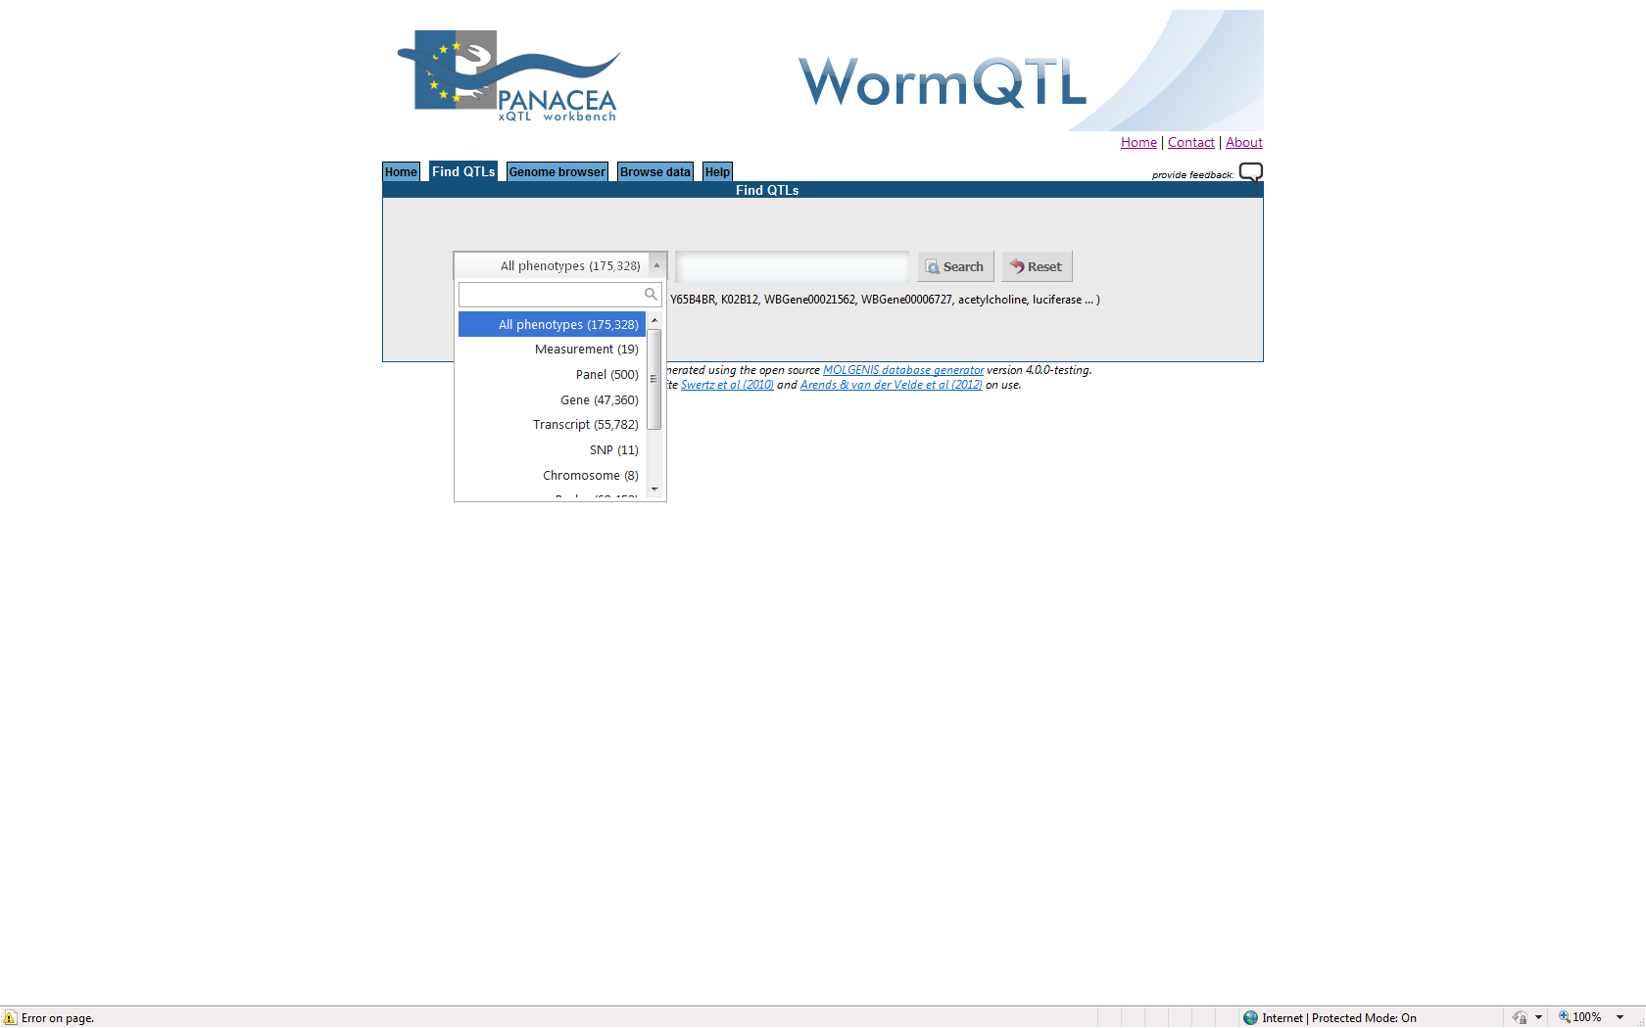

You can choose from 10 different “sub data bases” called “all”. For instance if you want to search for QTL associated with the trait “fertility”, than select “measurement” and type: “fertility”. If you choose “all”, than you search in the data also for anything, including genes, that is linked to fertility.

Then type the name or identifier of your interest and press “Search”. For instance the gene “daf-16”:

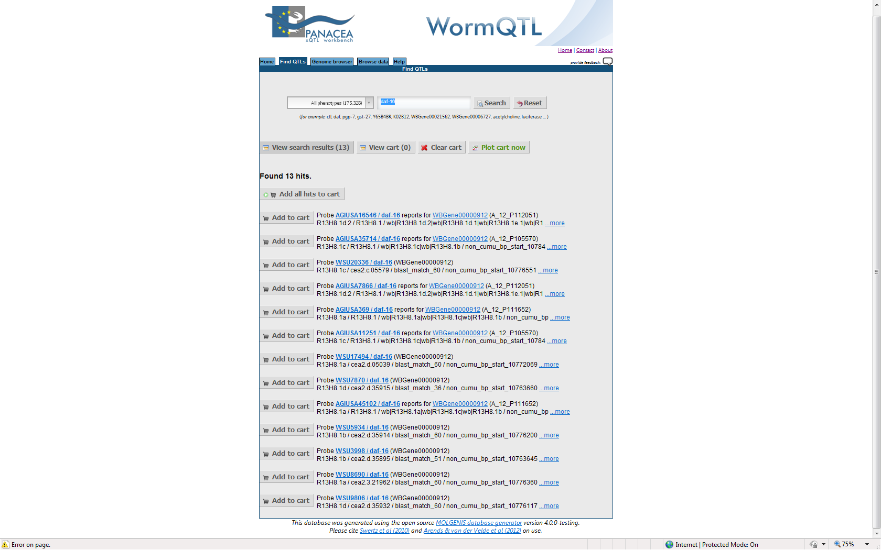

Select the data you want from specific data sets (or choose all data sets) and put them in your shopping cart by clicking “Add al hits to shopping cart”

Then click ”Plot cart now”:

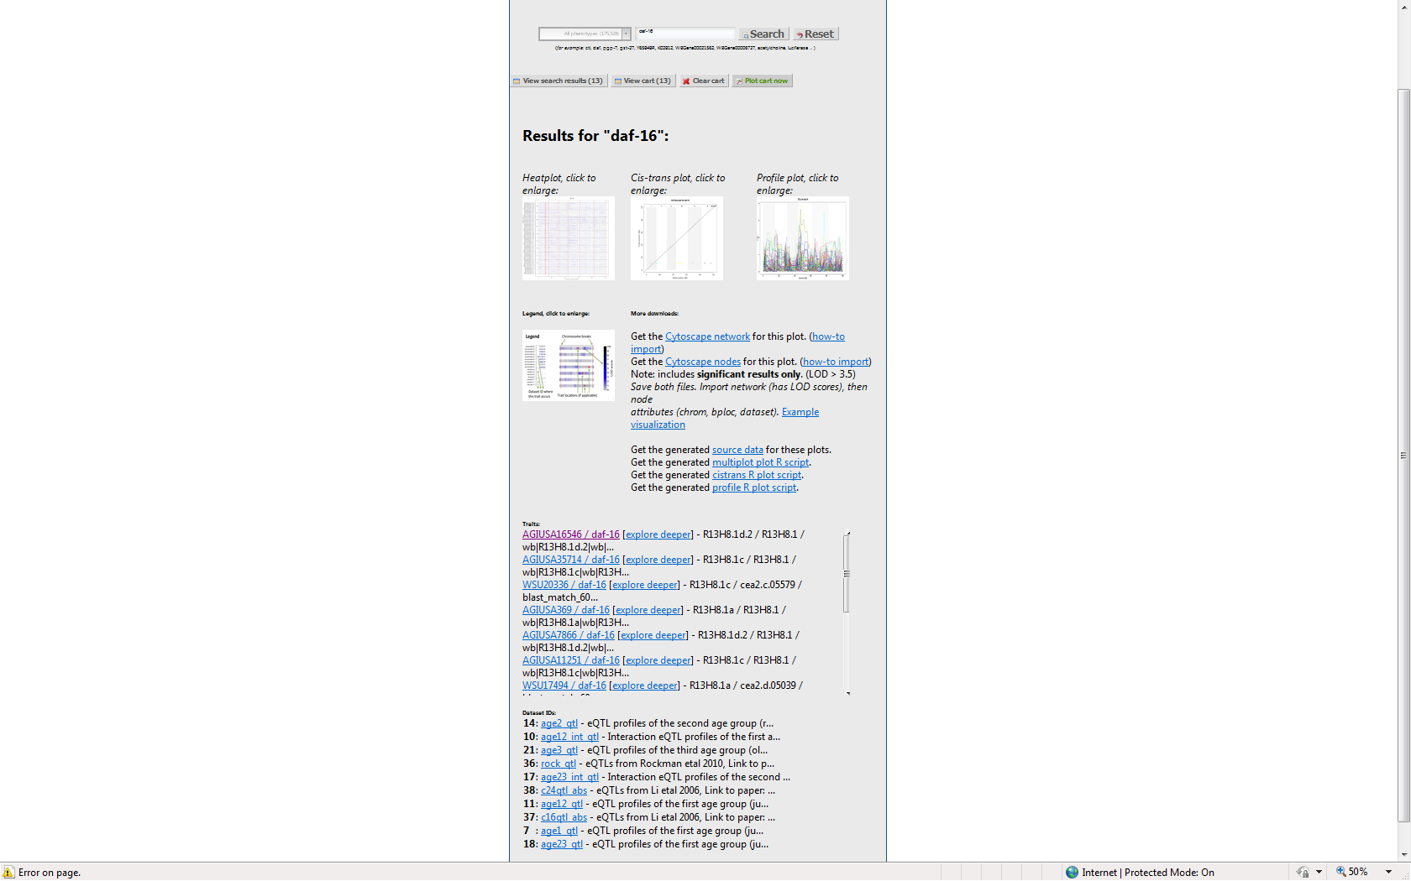

The heat plot of daf-16:

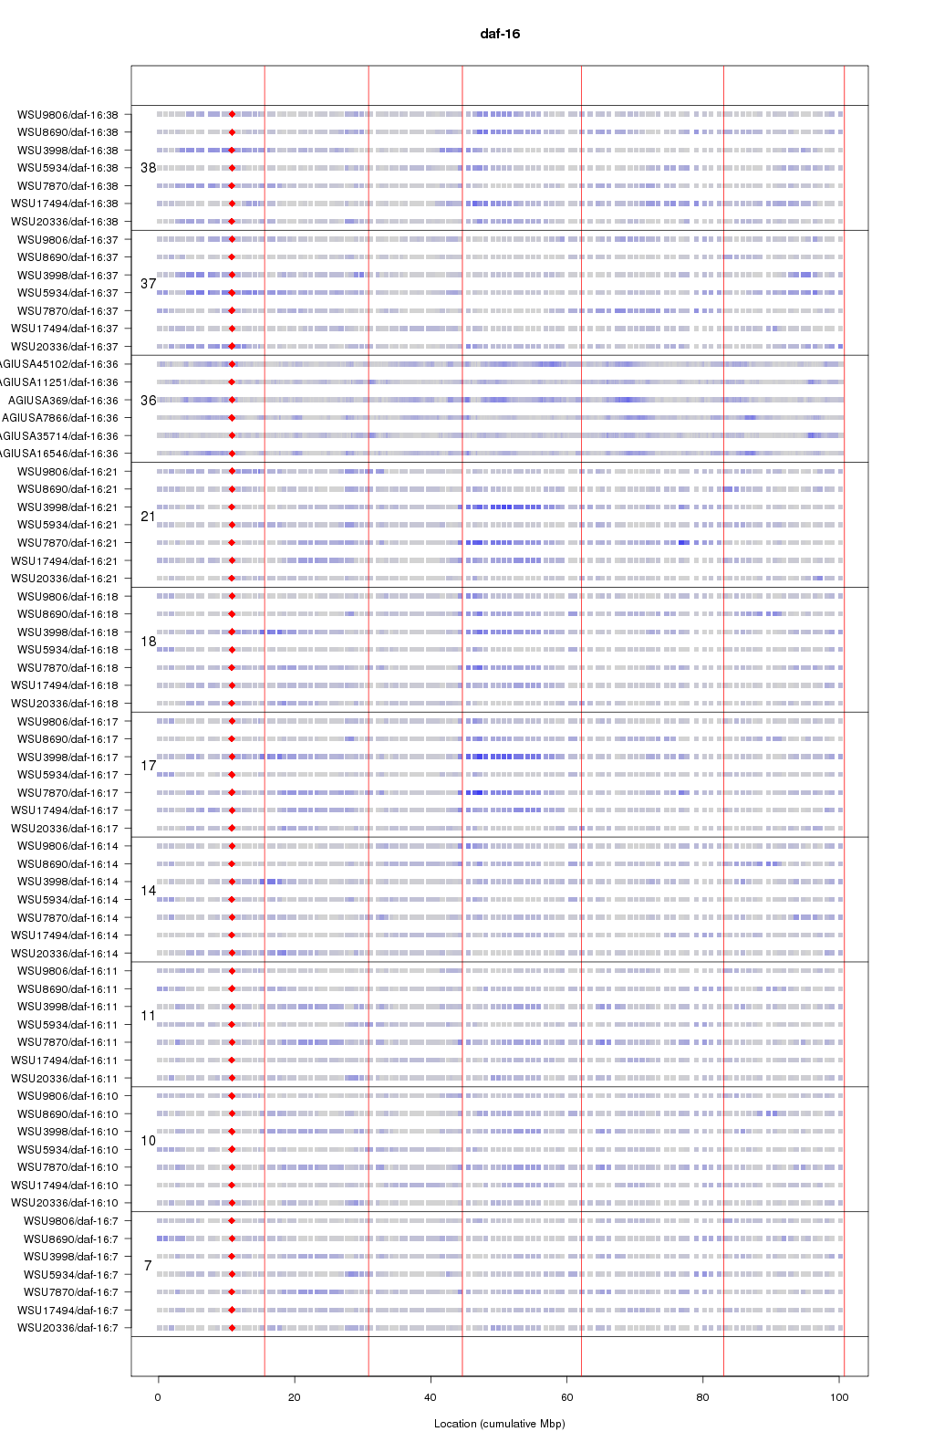

The legend shows:

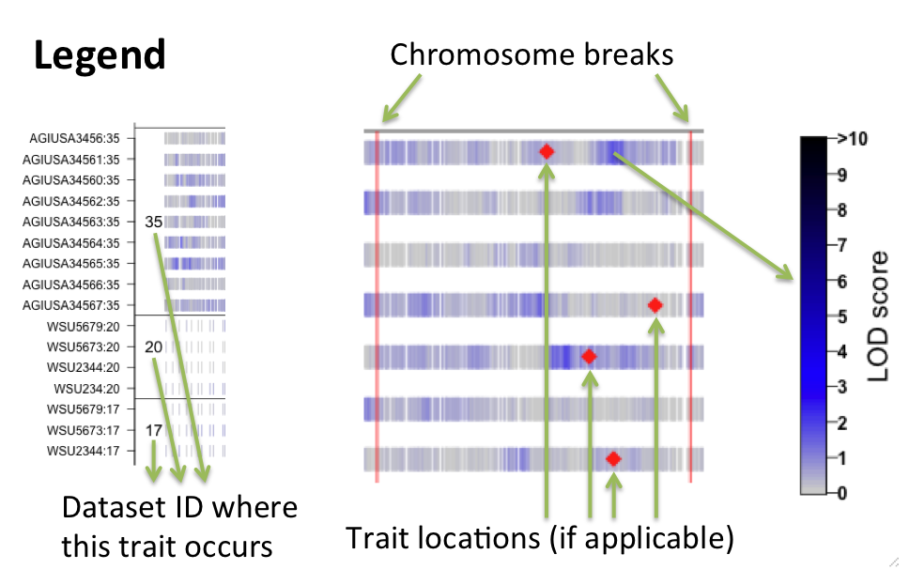

Where the LOD score is the significance level of the linked locus with the selected phenotype in question, in this case the expression level of the gene daf-16. The ID values refer to the data sets below on the same page.

The *cis- trans* plot: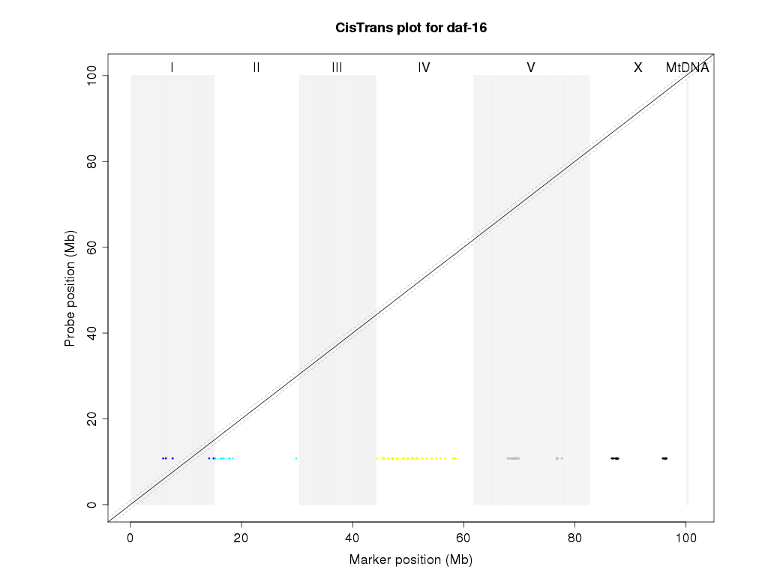

shows the QTL for daf-16. *Cis* are locally regulated QTL and *trans* are distantly regulated QTL.

The profile plot:

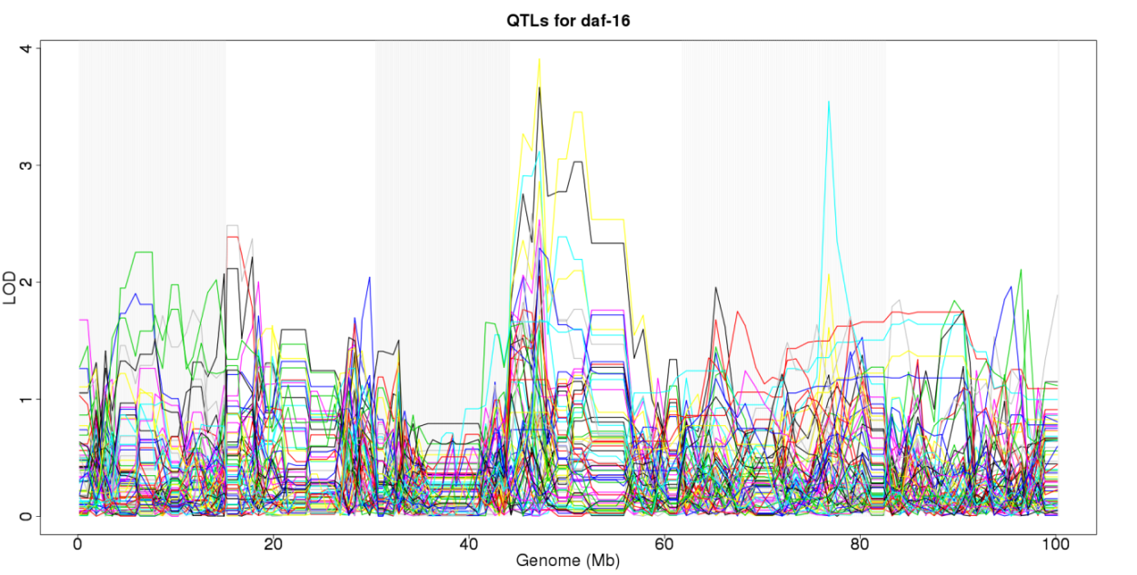

is an alternative way of presenting the QTL. It shows all the QTL for daf-16 as reported in the different studies designated by the different colors.

More optional downloads are available on the same webpage for more advanced studies into Cytoscape networks and R-scripts.

**The “Reset” button empties all loaded carts. You have to reset your search every time you perform a new search!**

**To find the genes that have an QTL on your favourite position, click “Genome browser”:**

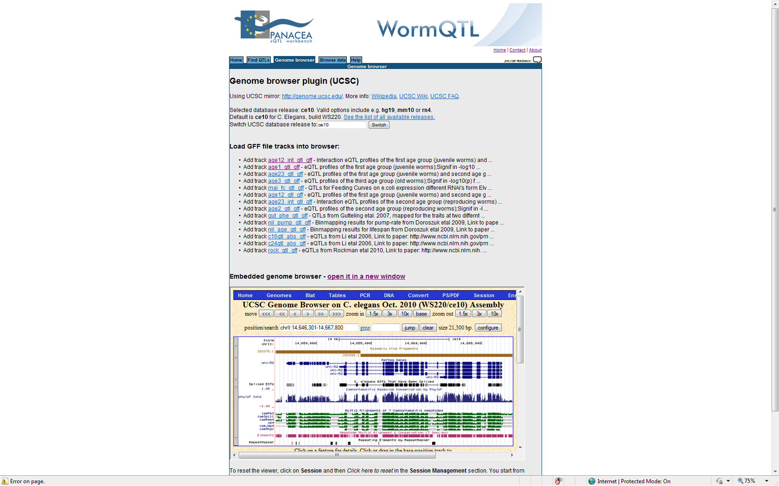

You can select here from all the different releases of the UCSC (University of California, Santa Cruz) genome releases.

You can add tracks from the designated experiments of interest. Then navigate to your favourite location (tip: use open in new window) and collect significant probe identifiers from that region. Use the identifiers to e.g. search with “Find QTLs”.

**To compare the QTLs of two and more traits or genes**

Go to “Find QTLs”. Type the name or identifier of your trait or gene and press “Search”. Put any relevant matching hits in the shopping cart. Repeat from step 2 to add more hits, up to 500. Press “Plot cart now” and explore the results.

**To find all data and analyses in WormQTL in order to know everything about your trait**

Go to “Find QTLs”. Type the name or identifier of your trait and press “Search”.

Click the bold hyperlink of your trait name (e.g. AGIUSA9288 / gst-30). After a short while you are presented with an aggregate of all WormQTL data for this trait

**There is also an option to browse all raw data.**

Click “Browse data” which brings you to:

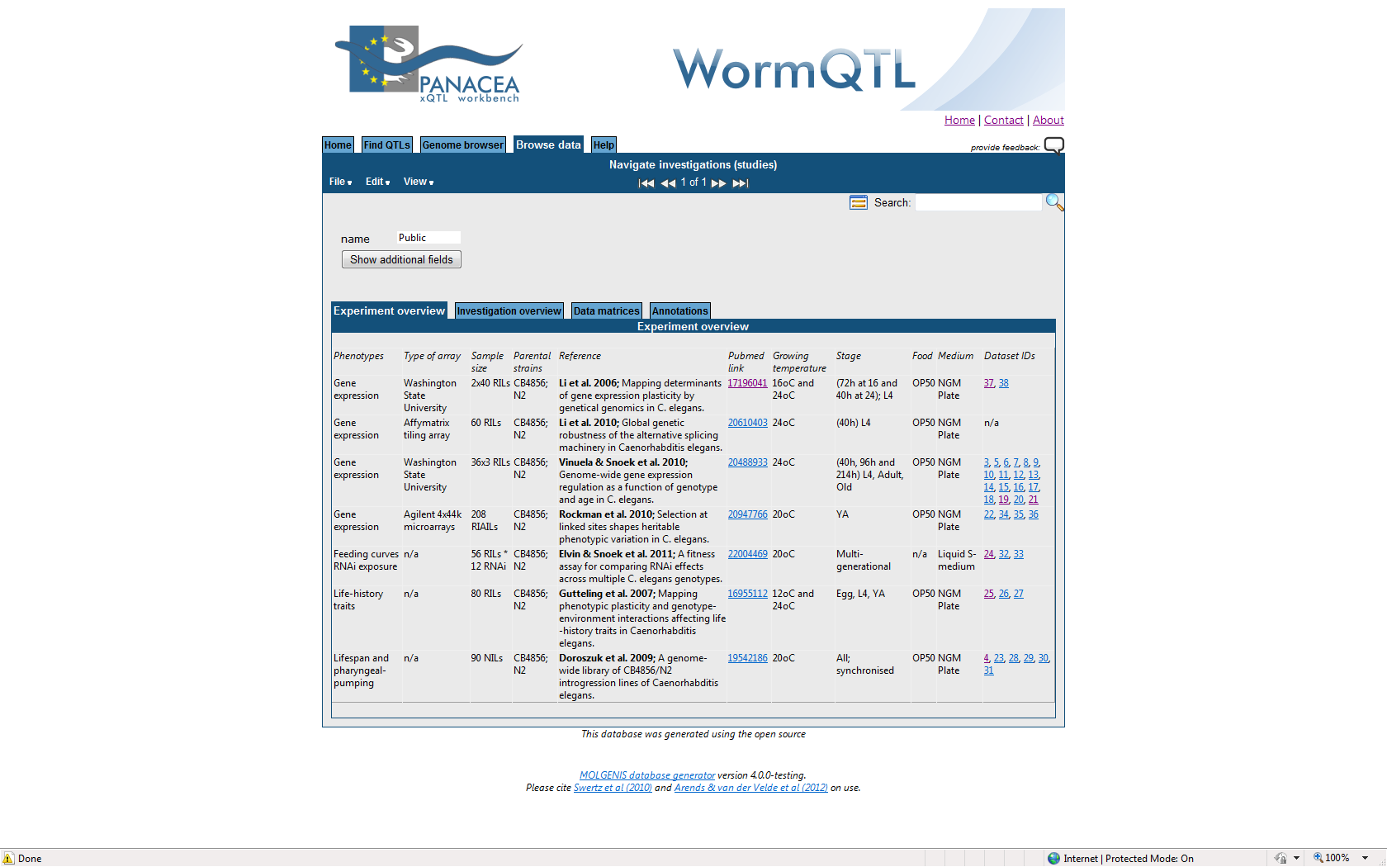

These are the public data stored into WormQTL at the moment. You can also click on “Investigation overview” to search more specific for different types of raw data, like was shown for the “Drop down menu” as described above. A search can further be conducted using data matrices or any type of annotations.