Bilinear interpolation
Bilinear interpolation requires that the measuring points are stored in a regular grid. In this case, a grid in x and y with the divisions dx and dy is used. Each measuring point i has the value g_{i} (here: values from the original satellite image). For an arbitrary point (x_{p},y_{p}), the value g(x_{p},y_{p}) can be interpolated by applying the following calculation procedure:
1) Determine in which square the point (x_{p},y_{p}) is located. Find the 4 measuring points which form corner points in this square (these points are called g₁, g₂, g₃ and g₄ in the figure below). These points are, of course, the four nearest points to the point (x_{p},y_{p}).

g₁
(xp,y p)
dy
g₂
g₄
g₃
dx
x
x_{p}
x_{o}
y_{o}
y_{p}
2) Determine where the point (x_{p},y_{p}) is in this square, i.e. determine u and w according to the equations (names as shown in the figure above):
u = (yp- yo)/dy
w = (xp - xo)/dx
3) Interpolate the value g(x_{p},y_{p}) according to the following equation:

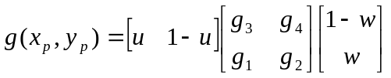= (1-u)(1-w) g₁ + (1-u)w g₂ + u(1-w) g₃ + uw g₄ =
= g₁ + (g₃- g₁)u + (g₂- g₁)w + (g₁- g₂- g₃+ g₄)uw

