Table of Contents

PMSM Machines, Control, and Fault Diagnosis — Engineering Background
Industrial Electrical Appliances Lab · Mechatronics Engineering. This chapter provides the electrical-machines and control-engineering foundation for the project. It explains the motor itself, its drive/control system, each fault and how it arises, how such faults are detected today (manually and by existing automated methods), how the proposed scalogram-CNN approach improves on them, and how the PMSM compares with its relatives. It is meant to be read as the theory part of the main report (report.md).

1. Why this matters in industry
Electric motors consume roughly 40–45 % of the world’s electricity and are the core actuator of almost every industrial appliance: pumps, fans, compressors, conveyors, CNC spindles, robots, and electric vehicles. An unplanned motor failure stops a production line; in many plants downtime costs thousands of dollars per hour. The maintenance philosophy has therefore shifted:
- Reactive (“run to failure”) → expensive, dangerous.
- Preventive (fixed schedule) → wasteful, still misses random faults.
- Predictive / condition-based (CBM) → monitor the machine’s signals and act before failure. This is a pillar of Industry 4.0 / smart manufacturing.
This project sits squarely in predictive maintenance: it listens to the motor’s own current and vibration and flags an incipient stator fault early enough to schedule a repair. Detecting an inter-turn short in its first seconds can prevent a burned-out winding and a full motor replacement.

2. The PMSM machine

2.1 Construction
A Permanent-Magnet Synchronous Motor has two main parts (Fig. 1):
- Stator (stationary): a laminated iron core with slots carrying a three-phase distributed winding (phases A, B, C). Laminations reduce eddy -current losses; the winding insulation is the component that fails in an inter-turn fault.
- Rotor (rotating): carries permanent magnets (typically NdFeB) that provide the excitation flux — no rotor winding, no slip rings, no brushes.
- Air gap: the small magnetic clearance between stator and rotor where energy is transferred.
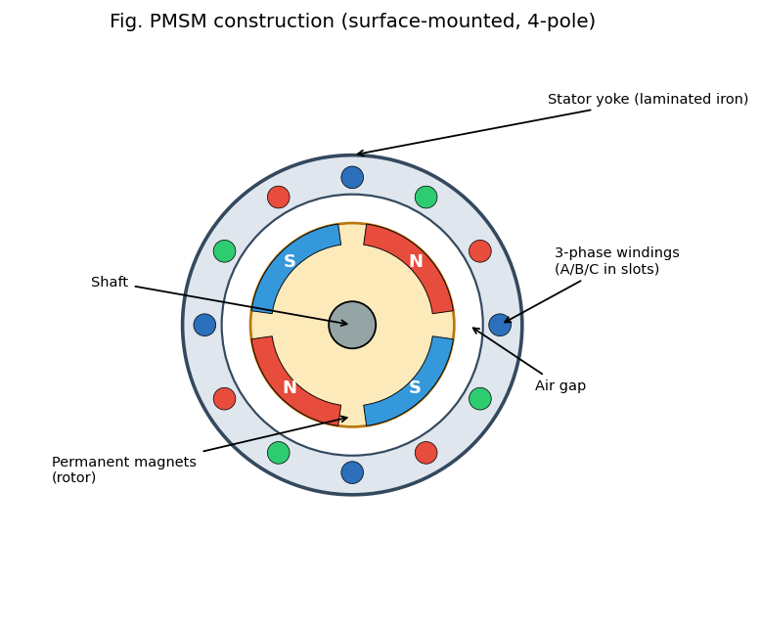
Fig. 1 — PMSM cross-section
Two rotor topologies matter:
- SPM (Surface-mounted PM): magnets glued on the rotor surface; L_d ≈ L_q (no saliency); simple, used at low/medium speed.
- IPM (Interior PM): magnets buried inside the rotor; L_d ≠ L_q gives extra reluctance torque and a wide field-weakening range (preferred in EV traction).

2.2 Operating principle — synchronous rotation
When the three stator phases are fed with balanced sinusoidal currents 120° apart, their magneto-motive forces add up to a rotating magnetic field whose speed is set by the supply frequency and pole pairs, n_s = 120·f / P (rpm). The rotor magnets lock onto this rotating field and turn in synchronism with it — hence synchronous motor (Fig. 2). Unlike an induction motor there is no slip and no rotor current, which is the root of the PMSM’s high efficiency.
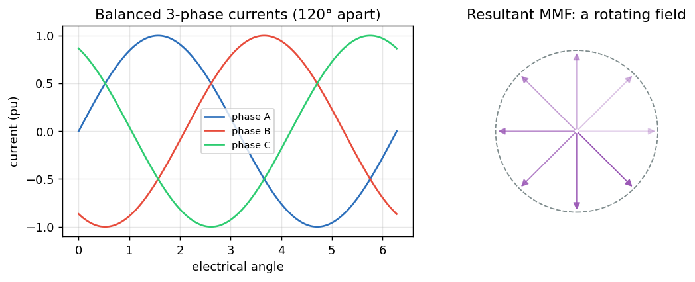
Fig. 2 — Rotating field from 3-phase currents

2.3 Electromagnetic torque and the d–q frame
Controlling an AC motor directly in the three-phase (abc) frame is hard because everything is sinusoidal and coupled. The Clarke transform collapses abc → two orthogonal stationary axes (αβ); the Park transform rotates αβ → a frame that spins with the rotor (d–q), where the sinusoids become DC quantities:
- d-axis (direct): aligned with the rotor flux. In a PMSM we usually force i_d ≈ 0 (the magnets already provide the flux).
- q-axis (quadrature): perpendicular to the flux; torque is proportional to it, T ≈ (3/2)·P·λ_m·i_q. So i_q is the “torque knob.”
This decoupling (flux and torque made orthogonal, exactly as in a DC motor) is what makes high-performance PMSM control possible.

2.4 Back-EMF: sinusoidal (and why it matters)
A spinning rotor induces a back-EMF in the stator. Its shape distinguishes the PMSM (sinusoidal) from the BLDC (trapezoidal) (Fig. 3). The sinusoidal back-EMF is why PMSM drives use sinusoidal currents and Field-Oriented Control, and why time–frequency (wavelet) analysis of the current is so natural — the healthy signal is a clean fundamental, and faults perturb it in characteristic ways.
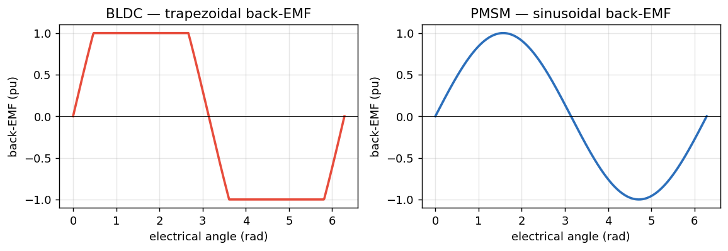
Fig. 3 — Back-EMF: BLDC vs PMSM

2.5 Torque–speed envelope
Below base speed the drive holds constant torque; above it, the back-EMF would exceed the supply, so the controller injects negative i_d to weaken the field and runs at constant power (Fig. 4). Operating point (load, speed) strongly affects the measured signals — a key reason fixed-threshold fault detectors struggle and learned features help.
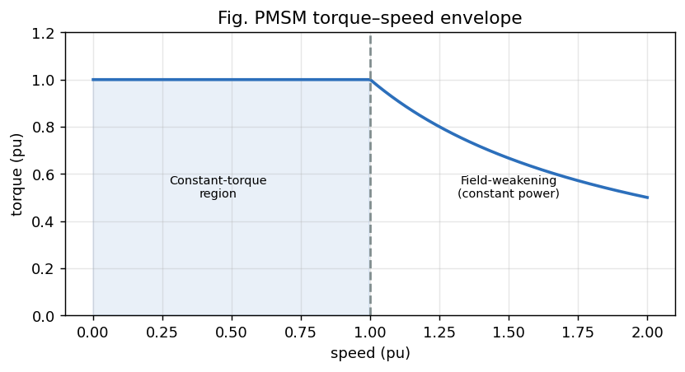
Fig. 4 — Torque–speed envelope

3. PMSM vs its relatives (PMDC, BLDC, induction)
Understanding why the PMSM was chosen requires comparing it with neighbouring machines (Fig. 5):
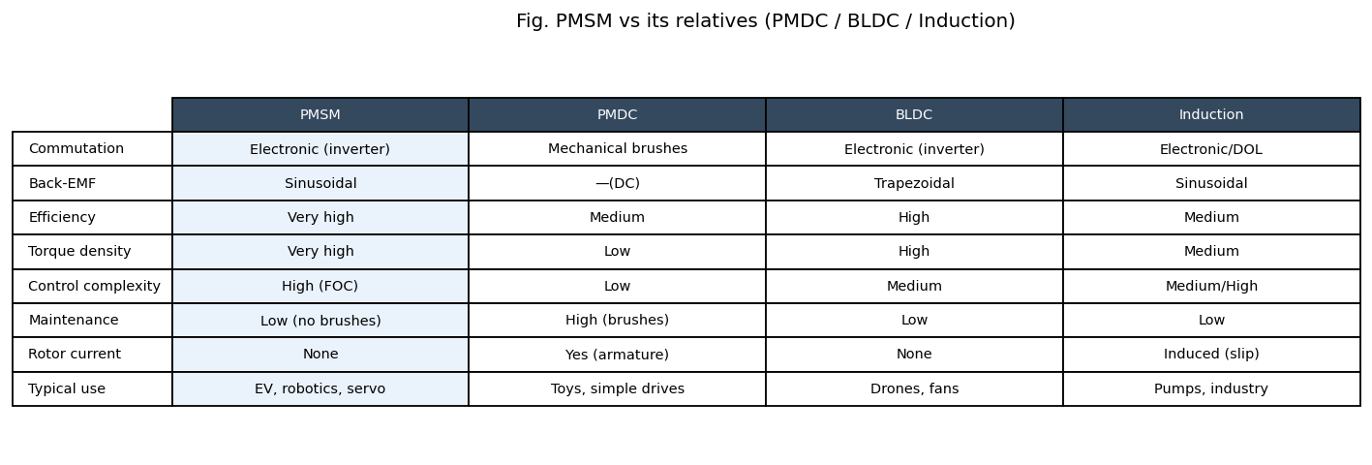
Fig. 5 — Motor family comparison
- PMDC (brushed DC): simplest control (voltage = speed), but mechanical brushes/commutator wear out, spark, and need maintenance; lower efficiency. The PMSM is essentially “a PMDC turned inside-out” with electronic commutation — same easy torque control, no brushes.
- BLDC: also PM rotor + electronic commutation, but trapezoidal back-EMF, driven with six-step square currents → higher torque ripple, simpler/cheaper control. PMSM (sinusoidal + FOC) gives smoother torque and higher efficiency — better for servo/traction.
- Induction motor: rugged and cheap, no magnets, but relies on rotor slip and induced rotor current → rotor copper losses and lower efficiency/torque density. Dominant in fixed-speed industrial pumps/fans.
Summary: the PMSM combines the DC motor’s easy, decoupled torque control with brushless reliability and the highest efficiency and torque density — which is why it dominates EVs, robotics, and high-performance servo drives, and why its health monitoring is economically important.

4. The control / drive system
A PMSM almost never runs “across the line”; it is driven by a power-electronic inverter under Field-Oriented Control (Fig. 6).
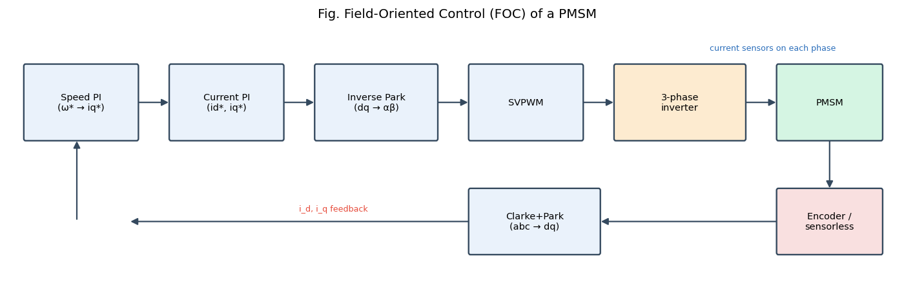
Fig. 6 — FOC block diagram
The loop, outer to inner:
- Speed controller (PI): compares commanded vs measured speed → produces the torque command i_q* (with i_d* ≈ 0).
- Current controllers (PI): regulate i_d, i_q to their references using the measured phase currents transformed into the d–q frame (Clarke + Park).
- Inverse Park + SVPWM: convert the d–q voltage demands back to three-phase and compute the switching pattern.
- Three-phase voltage-source inverter (Fig. 7): six power switches (IGBT/MOSFET) chop the DC bus to synthesise the desired sinusoidal voltages.
- Rotor position from an encoder/resolver (or a sensorless estimator) closes the Park transform and the speed loop.
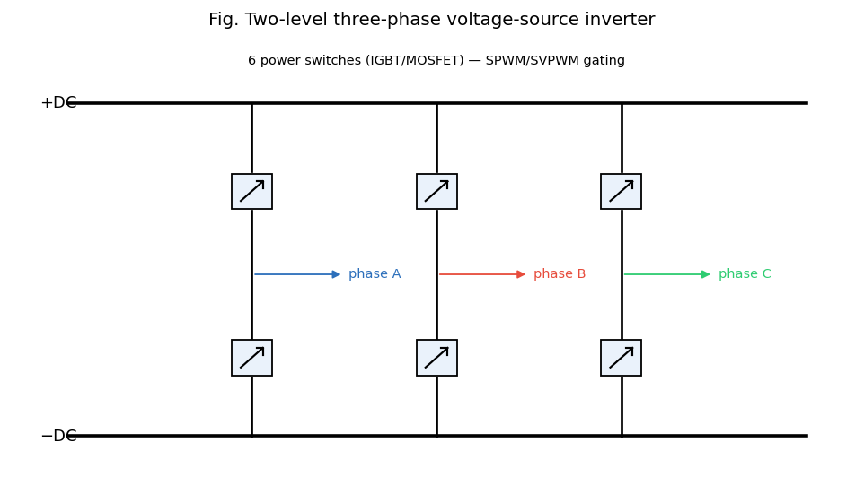
Fig. 7 — Three-phase inverter
Why the controller matters for diagnosis (important): the current control loop is designed to reject disturbances. When a fault perturbs the current, the PI controllers partially cancel that perturbation to keep i_d, i_q on target — so the fault signature in the stator current is attenuated. The vibration signal is outside this loop and responds directly to the fault. This is the physical reason our results show vibration ≫ current for inter-turn detection.

5. PMSM faults — one by one
Machine faults are grouped as electrical (≈ 35–40 %, mostly stator winding), mechanical (bearings ≈ 40 %, the largest single category), and magnetic (demagnetization). This project targets the stator electrical fault and treats the others as context.

5.1 Inter-turn stator short circuit (ITSC) — primary fault
- Cause: insulation between adjacent turns of the same phase degrades from thermal ageing, voltage spikes (inverter dv/dt), moisture, vibration, or manufacturing defects.
- Mechanism (Fig. 8): the failed insulation creates a shorted loop. The rotating flux induces a large circulating current in those few turns (can be many times rated current), causing intense local heating.
- Symptoms: stator-current asymmetry, extra harmonics and side-bands, increased negative-sequence current, a localized hot-spot, and a characteristic vibration signature at twice the supply frequency.
- Progression: heat damages neighbouring insulation → the short grows turn-to -turn → phase-to-phase → ground fault → complete winding burnout, often within minutes. Early detection is therefore critical — exactly this project’s goal.
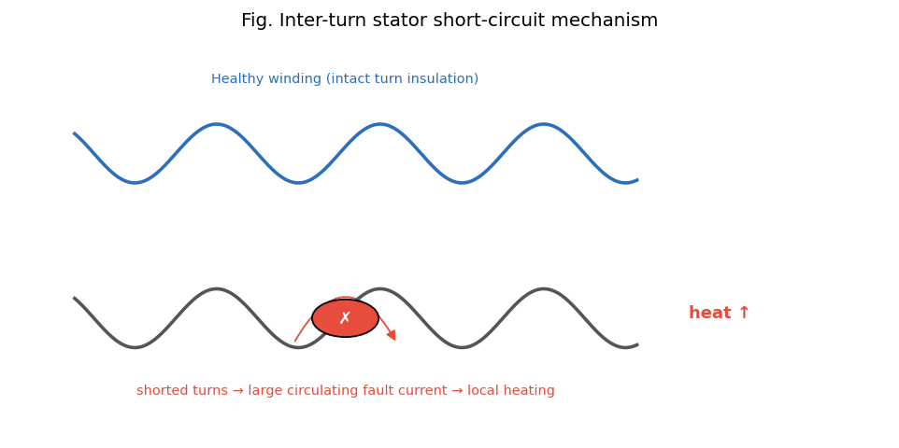
Fig. 8 — Inter-turn short mechanism

5.2 Demagnetization
- Cause: rotor magnets lose strength from over-temperature, ageing, or large demagnetising stator currents (e.g., a fault or aggressive field weakening).
- Mechanism: reduced PM flux λ_m lowers the back-EMF and torque constant.
- Symptoms: the drive draws more current for the same torque; sub-harmonics and side-bands at f₀ ± k·f_r (around the rotational frequency) appear; efficiency drops.
- Note: absent from the public real dataset, so represented synthetically here.

5.3 Overload / thermal stress
- Cause: sustained operation above rated load/torque, blocked cooling, high ambient temperature.
- Mechanism/symptoms: raised fundamental current, extra harmonics, and rising winding temperature that accelerates insulation ageing — i.e., overload is often the precursor to an inter-turn fault. A degraded operating state rather than a hard fault.

5.4 Mechanical faults (context)
- Bearings (the most common mechanical fault): wear/pitting produce vibration at characteristic defect frequencies and, via air-gap modulation, current side-bands.
- Eccentricity / misalignment: uneven air gap → side-bands around the fundamental. Addressed naturally by the same scalogram+CNN method on vibration, and listed as future work.

6. How these faults are detected today
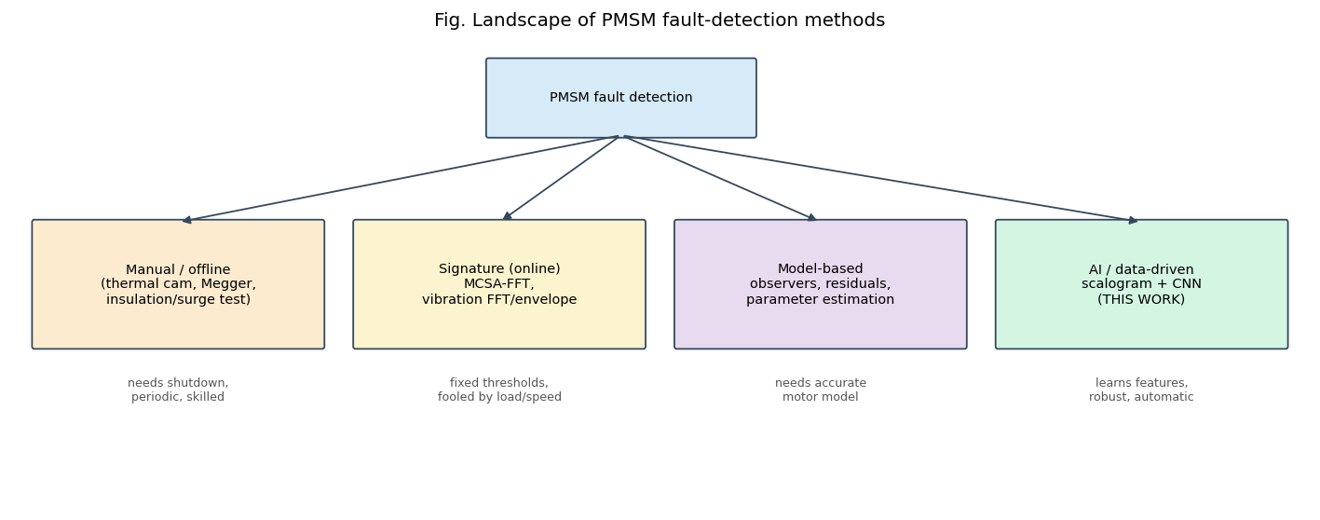
Fig. 9 — Fault-detection landscape

6.1 Manual / offline methods (machine stopped)
- Visual + thermal imaging: an infrared camera finds hot-spots — but only once heating is significant, and it needs access and a technician.
- Insulation-resistance test (Megger) / polarization index: DC megohmmeter checks winding-to-ground insulation. Catches gross degradation, not an incipient turn-to-turn short.
- Surge / hi-pot test: applies steep voltage to reveal turn insulation weakness — sensitive, but offline and potentially stressful to the winding.
- Limitations: require shutdown, are periodic (miss faults between inspections), and need skilled labour.

6.2 Online signature-based methods (machine running)
- Motor Current Signature Analysis (MCSA): take the FFT of the steady-state stator current and watch specific fault frequencies / side-bands (Fig. 10). The classic, sensor-free industrial method.
- Vibration analysis: accelerometer + FFT / envelope analysis for bearing and mechanical faults (ISO 10816 severity bands).
- Park’s Vector / instantaneous power / negative-sequence approaches.
- Limitations: assume (near-)stationary operation; use fixed thresholds that are easily fooled by changing load and speed; the analyst must know which frequency to inspect; transients get smeared by the FFT.
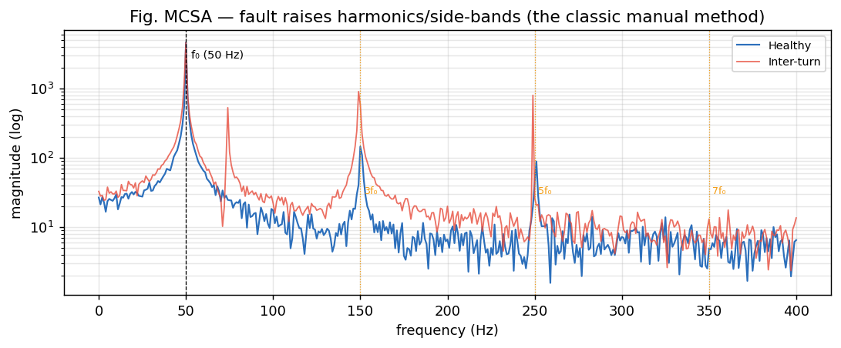
Fig. 10 — MCSA spectrum, healthy vs faulty

6.3 Model-based methods
- State observers, parameter estimation, residual generation: compare the real machine with a mathematical model; a growing residual flags a fault.
- Limitations: need an accurate motor model and parameters, which drift with temperature and ageing.

7. How the proposed method (CWT scalogram + CNN) improves things
The new approach replaces “pick a frequency and a threshold” with “let the network learn the fault’s time–frequency fingerprint”:
- Captures non-stationary / transient signatures. The Continuous Wavelet Transform keeps time and frequency, so a brief fault transient that the FFT would smear stays localized and visible (this is the core of §3–§4 of the main report).
- Automatic feature learning. The CNN discovers the discriminative patterns in the scalogram itself — no expert must specify side-band frequencies.
- Robust to operating point. Learned 2-D textures generalise across load/speed better than a single fixed amplitude threshold.
- Earlier, more sensitive detection. Because subtle patterns are learned, the fault is flagged at lower severity than a fixed-threshold FFT alarm (Fig. 11) — buying time before burnout.
- Online, automatic, and sensor-reuse. Current sensors already exist in every FOC drive; the method runs continuously with no shutdown.
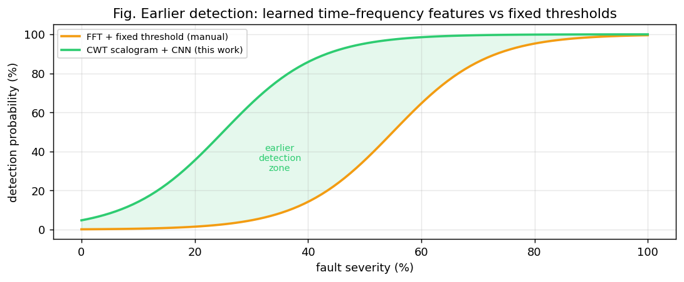
Fig. 11 — Earlier detection vs fixed-threshold FFT
Honest positioning. It does not replace offline safety tests (Megger/surge remain part of commissioning); it complements them as a continuous, intelligent online monitor. Its current limitation is data diversity (few healthy recordings), discussed in the results.

8. Standards, safety, and economics
- Condition-monitoring standards: ISO 20958 (electrical signal CM of machines), ISO 10816 / 20816 (vibration severity), IEEE 1415 (motor maintenance), IEC 60034 (rotating machines).
- Insulation classes (IEC 60085: B/F/H) set the thermal limits whose violation drives inter-turn failure — linking overload (§5.3) to ITSC (§5.1).
- Safety: an undetected stator short is a fire/arc-flash hazard; early detection is a safety function, not just an economic one.
- Economic case: a low-cost software monitor reusing existing current sensors, preventing one burnout, typically pays for itself many times over in avoided downtime and motor-replacement cost.

9. Link to the rest of the report
This background motivates the pipeline detailed in the main report: signal → CWT scalogram (§3–§4) → CNN (§5) → diagnosis (§7–§8), with the engineering insight that vibration carries the strongest inter-turn signature (because the current loop suppresses it, §4) — exactly what the experimental results confirm.
All figures in this chapter are generated reproducibly by python/figures_engineering.py into docs/figures/.

