二、涉及文件（7.3）

```text
app/src/main/java/com/passingguest/myapplication/
├── ui/dashboard/DashboardFragment.kt 首页
├── ui/dashboard/DashboardViewModel.kt 仪表盘 ViewModel
├── ui/adapter/RecentRecordAdapter.kt 最近账单适配器
├── data/dao/AccountRecordDao.kt 新增趋势统计查询
├── util/DateUtils.kt 新增周/月辅助方法
└── res/layout/fragment_dashboard.xml 记账本布局
```

三、核心功能

（1）仪表盘布局与数据聚合

仪表盘作为应用首页，整合四块核心信息：月度概览卡片、支出趋势折线图、预算进度条、最近账单预览：
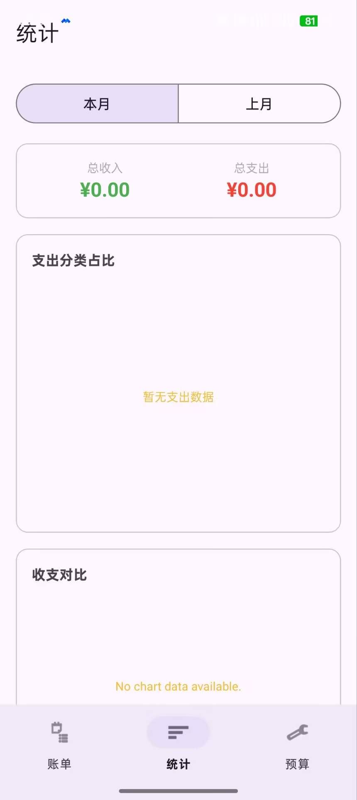
```kotlin
// DashboardFragment.kt — 仪表盘主页面
class DashboardFragment : Fragment() {

private lateinit var viewModel: DashboardViewModel
private lateinit var viewPager: ViewPager2
private lateinit var lineChart: LineChart
private lateinit var rvRecent: RecyclerView
private lateinit var tvMonthIncome: TextView
private lateinit var tvMonthExpense: TextView
private lateinit var tvBalance: TextView

override fun onViewCreated(view: View, savedInstanceState: Bundle?) {
super.onViewCreated(view, savedInstanceState)
viewModel = ViewModelProvider(this)[DashboardViewModel::class.java]
setupViews(view)
setupLineChart()
setupRecentList()
setupObservers()
setupQuickActions(view)
}

private fun setupObservers() {
// 月度汇总
viewModel.monthlySummary.observe(viewLifecycleOwner) { summary ->
tvMonthIncome.text = CurrencyUtils.format(summary.totalIncome)
tvMonthExpense.text = CurrencyUtils.format(summary.totalExpense)
tvBalance.text = CurrencyUtils.format(summary.totalIncome - summary.totalExpense)
}

// 支出趋势数据
viewModel.trendData.observe(viewLifecycleOwner) { entries ->
updateLineChart(entries)
}

// 最近账单
viewModel.recentRecords.observe(viewLifecycleOwner) { records ->
rvRecent.adapter = RecentRecordAdapter(records)
if (records.isEmpty()) {
tvEmptyRecent.visibility = View.VISIBLE
} else {
tvEmptyRecent.visibility = View.GONE
}
}

// 预算进度
viewModel.budgetProgress.observe(viewLifecycleOwner) { (budget, spent) ->
progressBudget.max = if (budget > 0) budget.toInt() else 1
progressBudget.progress = spent.toInt()
tvBudgetStatus.text = "${CurrencyUtils.format(spent)} / ${CurrencyUtils.format(budget)}"
}
}
}
```

DashboardViewModel 通过 MediatorLiveData 合并四条数据流，使用 `async { }` 协程并行请求：

```kotlin
// DashboardViewModel.kt
class DashboardViewModel(application: Application) : AndroidViewModel(application) {

private val accountRepo = (application as App).accountRepository
private val budgetRepo = (application as App).budgetRepository
private val scope = CoroutineScope(SupervisorJob() + Dispatchers.IO)

private val now = System.currentTimeMillis()
private val monthStart = DateUtils.getStartOfMonth(now)
private val monthEnd = DateUtils.getEndOfMonth(now)
private val currentYearMonth = DateUtils.getCurrentYearMonth()

// 月度收入/支出汇总
val monthlySummary: LiveData<MonthlySummary> =
accountRepo.getPeriodSummary(monthStart, monthEnd)

// 最近 10 条账单
val recentRecords: LiveData<List<AccountRecord>> =
accountRepo.getRecentRecords(10)

// 预算进度（结合总预算和当月已支出）
val budgetProgress = MediatorLiveData<Pair<Double, Double>>().apply {
var budgetAmount = 0.0
var spentAmount = 0.0
val refresh = { value = Pair(budgetAmount, spentAmount) }

addSource(budgetRepo.getOverallBudget(currentYearMonth)) { budgets ->
budgetAmount = budgets.firstOrNull()?.amount ?: 0.0
refresh()
}
addSource(accountRepo.getTotalByTypeAndPeriodLive("EXPENSE", monthStart, monthEnd)) { spent ->
spentAmount = spent
refresh()
}
}

// 近 7 天支出趋势（每天总支出）
val trendData: LiveData<List<DailyTrend>> = MutableLiveData<List<DailyTrend>>().apply {
scope.launch {
val data = calculateDailyTrend()
withContext(Dispatchers.Main) { value = data }
}
}

private suspend fun calculateDailyTrend(): List<DailyTrend> {
val data = mutableListOf<DailyTrend>()
val calendar = Calendar.getInstance()
// 从今天往前推 7 天
repeat(7) { i ->
calendar.timeInMillis = now
calendar.add(Calendar.DAY_OF_YEAR, -i)
val dayStart = DateUtils.getStartOfDay(calendar.timeInMillis)
val dayEnd = DateUtils.getEndOfDay(calendar.timeInMillis)
val dailyTotal = accountRepo.getTotalByTypeAndPeriod("EXPENSE", dayStart, dayEnd)
data.add(DailyTrend(date = calendar.timeInMillis, total = dailyTotal))
}
return data.reversed() // 按时间正序排列
}
}

data class DailyTrend(val date: Long, val total: Double)
```

（2）支出趋势折线图
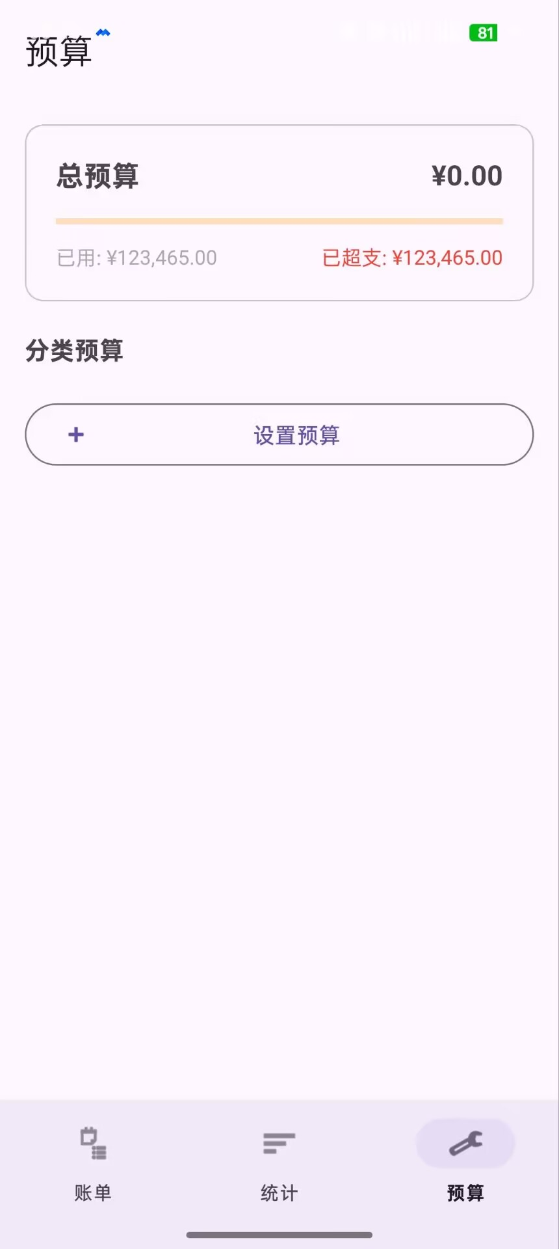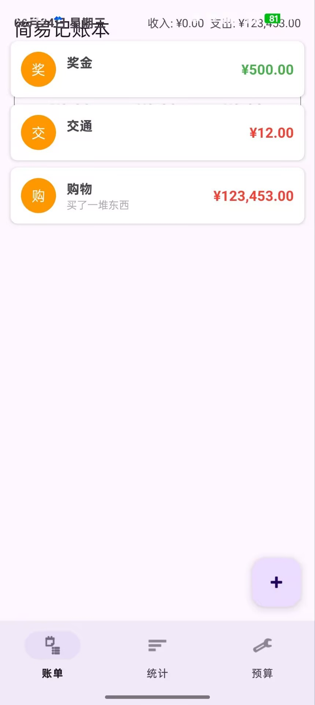
使用 MPAndroidChart 的 LineChart 绘制近 7 天支出变化趋势：

```kotlin
private fun setupLineChart() {
lineChart.apply {
description.isEnabled = false
setTouchEnabled(true)
isDragEnabled = true
setScaleEnabled(false)
legend.apply {
verticalAlignment = Legend.LegendVerticalAlignment.TOP
horizontalAlignment = Legend.LegendHorizontalAlignment.RIGHT
}
axisLeft.apply {
setDrawGridLines(true)
axisMinimum = 0f
gridColor = Color.LTGRAY
}
axisRight.isEnabled = false
xAxis.apply {
setDrawGridLines(false)
position = XAxis.XAxisPosition.BOTTOM
valueFormatter = object : IndexAxisValueFormatter() {
override fun getFormattedValue(value: Float): String {
val index = value.toInt()
val trend = viewModel.trendData.value
if (trend != null && index in trend.indices) {
return DateUtils.formatShortDate(trend[index].date)
}
return ""
}
}
granularity = 1f
}
}
}

private fun updateLineChart(trendData: List<DailyTrend>) {
if (trendData.isEmpty()) {
lineChart.setNoDataText("暂无趋势数据")
lineChart.invalidate()
return
}

val entries = trendData.mapIndexed { index, trend ->
Entry(index.toFloat(), trend.total.toFloat())
}

val dataSet = LineDataSet(entries, "每日支出").apply {
color = resources.getColor(R.color.expense_color, null)
setCircleColor(resources.getColor(R.color.expense_color, null))
circleRadius = 4f
lineWidth = 2f
setDrawValues(true)
valueTextSize = 10f
mode = LineDataSet.Mode.CUBIC_BEZIER // 平滑曲线
setDrawFilled(true)
fillDrawable = resources.getDrawable(R.drawable.gradient_expense, null)
}

lineChart.data = LineData(dataSet)
lineChart.invalidate()
}
```
趋势数据效果示意：

（3）最近账单预览与快捷操作
仪表盘底部展示最近 5 条账单，右侧提供快捷操作按钮：
```kotlin
// 最近账单适配器
class RecentRecordAdapter(
private val records: List<AccountRecord>
) : RecyclerView.Adapter<RecentRecordAdapter.ViewHolder>() {

override fun getItemCount() = minOf(records.size, 5)

override fun onBindViewHolder(holder: ViewHolder, position: Int) {
val record = records[position]
holder.tvCategory.text = getCategoryName(record.categoryId)
holder.tvAmount.text = CurrencyUtils.format(record.amount)
holder.tvAmount.setTextColor(
if (record.type == "INCOME") Color.parseColor("4CAF50")
else Color.parseColor("F44336")
)
holder.tvNote.text = record.note ?: ""
}
}

// 快捷操作按钮
private fun setupQuickActions(view: View) {
view.findViewById<FloatingActionButton>(R.id.fabQuickAdd).setOnClickListener {
startActivity(Intent(requireContext(), AddEditRecordActivity::class.java))
}
view.findViewById<MaterialButton>(R.id.btnGoRecords).setOnClickListener {
// 切换到账单 Tab
(requireActivity() as MainActivity).switchTab(R.id.nav_records)
}
view.findViewById<MaterialButton>(R.id.btnGoStats).setOnClickListener {
(requireActivity() as MainActivity).switchTab(R.id.nav_statistics)
}
}
```

（4）仪表盘导航集成

MainActivity 中将仪表盘设为默认首页 Tab：

```kotlin
// MainActivity.kt — 集成仪表盘
class MainActivity : AppCompatActivity() {

private val fragments = mutableMapOf<Int, Fragment>()

override fun onCreate(savedInstanceState: Bundle?) {
super.onCreate(savedInstanceState)
setContentView(R.layout.activity_main)
bottomNavigation = findViewById(R.id.bottomNavigation)

// 添加首页仪表盘
fragments[R.id.nav_dashboard] = DashboardFragment()
fragments[R.id.nav_records] = RecordListFragment()
fragments[R.id.nav_statistics] = StatisticsFragment()
fragments[R.id.nav_budget] = BudgetFragment()

bottomNavigation.setOnItemSelectedListener { item ->
when (item.itemId) {
R.id.nav_dashboard -> { switchFragment(R.id.nav_dashboard); true }
R.id.nav_records -> { switchFragment(R.id.nav_records); true }
R.id.nav_statistics -> { switchFragment(R.id.nav_statistics); true }
R.id.nav_budget -> { switchFragment(R.id.nav_budget); true }
else -> false
}
}
// 默认选中仪表盘
bottomNavigation.selectedItemId = R.id.nav_dashboard
}

fun switchTab(tabId: Int) {
bottomNavigation.selectedItemId = tabId
}
}
```

底部导航菜单新增仪表盘入口：

```xml
<!-- menu_bottom_nav.xml -->
<menu xmlns:android="http://schemas.android.com/apk/res/android">
<item android:id="@+id/nav_dashboard"
android:icon="@android:drawable/ic_menu_home"
android:title="首页" />
<item android:id="@+id/nav_records"
android:icon="@android:drawable/ic_menu_agenda"
android:title="账单" />
<item android:id="@+id/nav_statistics"
android:icon="@android:drawable/ic_menu_sort_by_size"
android:title="统计" />
<item android:id="@+id/nav_budget"
android:icon="@android:drawable/ic_menu_manage"
android:title="预算" />
</menu>
```

DAO 层新增最近记录查询方法：

```kotlin
// AccountRecordDao.kt — 新增
@Query("SELECT * FROM account_records ORDER BY date DESC LIMIT :limit")
fun getRecentRecords(limit: Int): LiveData<List<AccountRecord>>

@Query("SELECT COALESCE(SUM(amount), 0) FROM account_records WHERE date BETWEEN :startDate AND :endDate AND type = :type")
fun getTotalByTypeAndPeriodLive(type: String, startDate: Long, endDate: Long): LiveData<Double>

