Class17 Vax Mini Project

Monica Lin (PID: A15524235)

11/25/2021

# Background

The goal of this hands-on mini-project is to examine and compare the Covid-19 vaccination rates around San Diego.

We will start by downloading the most recently dated “Statewide COVID-19 Vaccines Administered by ZIP Code” CSV file from: <https://data.ca.gov/dataset/covid-19-vaccine-progress-dashboard-data-by-zip-code>

Move the downloaded CSV file to the Class17 project directory, then read/import into an R object named vax. Use this data to answer all the questions below.

# Import vaccination data  
vax <- read.csv("covid19vaccinesbyzipcode_test.csv")  
head(vax)

## as_of_date zip_code_tabulation_area local_health_jurisdiction county  
## 1 2021-01-05 92395 San Bernardino San Bernardino  
## 2 2021-01-05 93206 Kern Kern  
## 3 2021-01-05 91006 Los Angeles Los Angeles  
## 4 2021-01-05 91901 San Diego San Diego  
## 5 2021-01-05 92230 Riverside Riverside  
## 6 2021-01-05 92662 Orange Orange  
## vaccine_equity_metric_quartile vem_source  
## 1 1 Healthy Places Index Score  
## 2 1 Healthy Places Index Score  
## 3 3 Healthy Places Index Score  
## 4 3 Healthy Places Index Score  
## 5 1 Healthy Places Index Score  
## 6 4 Healthy Places Index Score  
## age12_plus_population age5_plus_population persons_fully_vaccinated  
## 1 35915.3 40888 NA  
## 2 1237.5 1521 NA  
## 3 28742.7 31347 19  
## 4 15549.8 16905 12  
## 5 2320.2 2526 NA  
## 6 2349.5 2397 NA  
## persons_partially_vaccinated percent_of_population_fully_vaccinated  
## 1 NA NA  
## 2 NA NA  
## 3 873 0.000606  
## 4 271 0.000710  
## 5 NA NA  
## 6 NA NA  
## percent_of_population_partially_vaccinated  
## 1 NA  
## 2 NA  
## 3 0.027850  
## 4 0.016031  
## 5 NA  
## 6 NA  
## percent_of_population_with_1_plus_dose  
## 1 NA  
## 2 NA  
## 3 0.028456  
## 4 0.016741  
## 5 NA  
## 6 NA  
## redacted  
## 1 Information redacted in accordance with CA state privacy requirements  
## 2 Information redacted in accordance with CA state privacy requirements  
## 3 No  
## 4 No  
## 5 Information redacted in accordance with CA state privacy requirements  
## 6 Information redacted in accordance with CA state privacy requirements

**Q1**. What column details the total number of people fully vaccinated?

The column “persons_fully_vaccinated” details the total number of people fully vaccinated.

**Q2**. What column details the Zip code tabulation area?

“zip_code_tabulation_area”.

**Q3**. What is the earliest date in this dataset?

head(vax$as_of_date)

## [1] "2021-01-05" "2021-01-05" "2021-01-05" "2021-01-05" "2021-01-05"  
## [6] "2021-01-05"

The earliest date in the dataset is 2021-01-05, by Year-month-date.

**Q4**. What is the latest date in this dataset?

tail(vax$as_of_date)

## [1] "2021-11-23" "2021-11-23" "2021-11-23" "2021-11-23" "2021-11-23"  
## [6] "2021-11-23"

The latest date in this dataset is 2021-11-23.

Let’s call the skim() function from the **skimr** package to get a quick overview of this dataset.

library(skimr)  
skimr::skim(vax)

Data summary

|  |  |
| --- | --- |
| Name | vax |
| Number of rows | 82908 |
| Number of columns | 14 |
| _______________________ |  |
| Column type frequency: |  |
| character | 5 |
| numeric | 9 |
| ________________________ |  |
| Group variables | None |

**Variable type: character**

| skim_variable | n_missing | complete_rate | min | max | empty | n_unique | whitespace |
| --- | --- | --- | --- | --- | --- | --- | --- |
| as_of_date | 0 | 1 | 10 | 10 | 0 | 47 | 0 |
| local_health_jurisdiction | 0 | 1 | 0 | 15 | 235 | 62 | 0 |
| county | 0 | 1 | 0 | 15 | 235 | 59 | 0 |
| vem_source | 0 | 1 | 15 | 26 | 0 | 3 | 0 |
| redacted | 0 | 1 | 2 | 69 | 0 | 2 | 0 |

**Variable type: numeric**

| skim_variable | n_missing | complete_rate | mean | sd | p0 | p25 | p50 | p75 | p100 | hist |
| --- | --- | --- | --- | --- | --- | --- | --- | --- | --- | --- |
| zip_code_tabulation_area | 0 | 1.00 | 93665.11 | 1817.39 | 90001 | 92257.75 | 93658.50 | 95380.50 | 97635.0 | ▃▅▅▇▁ |
| vaccine_equity_metric_quartile | 4089 | 0.95 | 2.44 | 1.11 | 1 | 1.00 | 2.00 | 3.00 | 4.0 | ▇▇▁▇▇ |
| age12_plus_population | 0 | 1.00 | 18895.04 | 18993.94 | 0 | 1346.95 | 13685.10 | 31756.12 | 88556.7 | ▇▃▂▁▁ |
| age5_plus_population | 0 | 1.00 | 20875.24 | 21106.04 | 0 | 1460.50 | 15364.00 | 34877.00 | 101902.0 | ▇▃▂▁▁ |
| persons_fully_vaccinated | 8355 | 0.90 | 9585.35 | 11609.12 | 11 | 516.00 | 4210.00 | 16095.00 | 71219.0 | ▇▂▁▁▁ |
| persons_partially_vaccinated | 8355 | 0.90 | 1894.87 | 2105.55 | 11 | 198.00 | 1269.00 | 2880.00 | 20159.0 | ▇▁▁▁▁ |
| percent_of_population_fully_vaccinated | 8355 | 0.90 | 0.43 | 0.27 | 0 | 0.20 | 0.44 | 0.63 | 1.0 | ▇▆▇▆▂ |
| percent_of_population_partially_vaccinated | 8355 | 0.90 | 0.10 | 0.10 | 0 | 0.06 | 0.07 | 0.11 | 1.0 | ▇▁▁▁▁ |
| percent_of_population_with_1_plus_dose | 8355 | 0.90 | 0.51 | 0.26 | 0 | 0.31 | 0.53 | 0.71 | 1.0 | ▅▅▇▇▃ |

**Q5**. How many numeric columns are in this dataset?

9

**Q6**. Note that there are “missing values” in the dataset. How many NA values are there in the persons_fully_vaccinated column?

sum( is.na(vax$persons_fully_vaccinated) )

## [1] 8355

There are 8355 NA values in that column.

**Q7**. What percent of persons_fully_vaccinated values are missing (to two significant figures)?

sum( is.na(vax$persons_fully_vaccinated) ) / nrow(vax)

## [1] 0.1007744

10.08% of persons_fully_vaccinated values are missing.

**Q8**. [Optional]: Why might this data be missing?

Optional.

# Working with dates

One of the “character” columns of the data is as_of_date, which contains dates in the Year-Month-Day format.

Dates and times can be annoying to work with at the best of times. However, in R we have the excellent **lubridate** package, which makes life a lot easier when dealing with dates and times. Here is a quick example to get you started:

# install.packages("lubridate")  
library(lubridate)

## Warning: package 'lubridate' was built under R version 4.1.2

##   
## Attaching package: 'lubridate'

## The following objects are masked from 'package:base':  
##   
## date, intersect, setdiff, union

What is today’s date?

today()

## [1] "2021-11-27"

The as_of_date column of our data is currently not that usable. For example, we can’t easily do math with it like answering the simple question of how many days have passed since data was first recorded:

However, if we convert our date data into a lubridate format, this like this will be much easier (as well as plotting time series data later on).

# Specify that we are using the Year-month-day format  
vax$as_of_date <- ymd(vax$as_of_date)

Now we can do math with dates. For example: How mnay days have passed since the first vaccination reported in this dataset?

today() - vax$as_of_date[1]

## Time difference of 326 days

Using the last and the first date value, we can now determine how many days the dataset span.

vax$as_of_date[nrow(vax)] - vax$as_of_date[1]

## Time difference of 322 days

**Q9**. How many days have passed since the last update of the dataset?

today() - vax$as_of_date[nrow(vax)]

## Time difference of 4 days

It has been 4 days since the last entry.

**Q10**. How many unique dates are in the dataset (i.e. how many different dates are detailed?)

length(unique(vax$as_of_date))

## [1] 47

There are 47 unique dates in the dataset.

# Working with ZIP codes

One of the numeric columns in the dataset (namely vax$zip_code_tabulation_area) are actually ZIP codes – a postal code used by the United States Postal Service (USPS). In R, we can use the **zipcodeR** package to make working with these codes easier. For example, let’s install and thn load up this package to find the centroid of the La Jolla 92037 (i.e. UC San Diego) ZIP code area.

# install.packages("zipcodeR")  
library(zipcodeR)

## Warning: package 'zipcodeR' was built under R version 4.1.2

# Find centroid of La Jolla 92037 ZIP code area  
geocode_zip('92037')

## # A tibble: 1 x 3  
## zipcode lat lng  
## <chr> <dbl> <dbl>  
## 1 92037 32.8 -117.

Calculate the distance between the centroids of any two ZIP codes in miles, e.g.

zip_distance('92037', '92109')

## zipcode_a zipcode_b distance  
## 1 92037 92109 2.33

More usefully, we can pull census data about ZIP code areas (including median household income, etc.) For example:

reverse_zipcode(c('92037', '92109'))

## # A tibble: 2 x 24  
## zipcode zipcode_type major_city post_office_city common_city_list county state  
## <chr> <chr> <chr> <chr> <blob> <chr> <chr>  
## 1 92037 Standard La Jolla La Jolla, CA <raw 20 B> San D~ CA   
## 2 92109 Standard San Diego San Diego, CA <raw 21 B> San D~ CA   
## # ... with 17 more variables: lat <dbl>, lng <dbl>, timezone <chr>,  
## # radius_in_miles <dbl>, area_code_list <blob>, population <int>,  
## # population_density <dbl>, land_area_in_sqmi <dbl>,  
## # water_area_in_sqmi <dbl>, housing_units <int>,  
## # occupied_housing_units <int>, median_home_value <int>,  
## # median_household_income <int>, bounds_west <dbl>, bounds_east <dbl>,  
## # bounds_north <dbl>, bounds_south <dbl>

We can use this reverse_zipcode() to pull census data later on for any or all ZIP code areas we might be interested in.

# Pull data for all ZIP codes in the dataset  
zipdata <- reverse_zipcode( vax$zip_code_tabulation_area)

# Focus on the San Diego area

Let’s now focus in on the San Diego County area by restricting ourselves first to vax$county == "San Diego" entries. We have two main choices on how to do this: the first using base R, the second using the **dplyr** package:

table(vax$county)

##   
## Alameda Alpine Amador Butte   
## 235 2303 47 564 846   
## Calaveras Colusa Contra Costa Del Norte El Dorado   
## 846 329 2021 188 1034   
## Fresno Glenn Humboldt Imperial Inyo   
## 2585 282 1645 705 470   
## Kern Kings Lake Lassen Los Angeles   
## 2303 329 658 611 13630   
## Madera Marin Mariposa Mendocino Merced   
## 564 1316 376 1222 893   
## Modoc Mono Monterey Napa Nevada   
## 517 329 1316 470 564   
## Orange Placer Plumas Riverside Sacramento   
## 4136 1363 752 3290 2538   
## San Benito San Bernardino San Diego San Francisco San Joaquin   
## 188 4183 5029 1269 1504   
## San Luis Obispo San Mateo Santa Barbara Santa Clara Santa Cruz   
## 1034 1363 1081 2726 799   
## Shasta Sierra Siskiyou Solano Sonoma   
## 1222 329 987 705 1692   
## Stanislaus Sutter Tehama Trinity Tulare   
## 1128 423 611 611 1551   
## Tuolumne Ventura Yolo Yuba   
## 611 1269 799 517

inds <- vax$county=="San Diego"  
head(vax[inds, ])

## as_of_date zip_code_tabulation_area local_health_jurisdiction county  
## 4 2021-01-05 91901 San Diego San Diego  
## 14 2021-01-05 91902 San Diego San Diego  
## 21 2021-01-05 92011 San Diego San Diego  
## 22 2021-01-05 92055 San Diego San Diego  
## 25 2021-01-05 92067 San Diego San Diego  
## 33 2021-01-05 92081 San Diego San Diego  
## vaccine_equity_metric_quartile vem_source  
## 4 3 Healthy Places Index Score  
## 14 4 Healthy Places Index Score  
## 21 4 Healthy Places Index Score  
## 22 3 CDPH-Derived ZCTA Score  
## 25 4 Healthy Places Index Score  
## 33 2 Healthy Places Index Score  
## age12_plus_population age5_plus_population persons_fully_vaccinated  
## 4 15549.8 16905 12  
## 14 16620.7 18026 22  
## 21 20503.6 23247 NA  
## 22 11548.0 11654 NA  
## 25 6973.9 7480 11  
## 33 25558.0 27632 14  
## persons_partially_vaccinated percent_of_population_fully_vaccinated  
## 4 271 0.000710  
## 14 374 0.001220  
## 21 NA NA  
## 22 NA NA  
## 25 241 0.001471  
## 33 346 0.000507  
## percent_of_population_partially_vaccinated  
## 4 0.016031  
## 14 0.020748  
## 21 NA  
## 22 NA  
## 25 0.032219  
## 33 0.012522  
## percent_of_population_with_1_plus_dose  
## 4 0.016741  
## 14 0.021968  
## 21 NA  
## 22 NA  
## 25 0.033690  
## 33 0.013029  
## redacted  
## 4 No  
## 14 No  
## 21 Information redacted in accordance with CA state privacy requirements  
## 22 Information redacted in accordance with CA state privacy requirements  
## 25 No  
## 33 No

Using the **dplyr** package and its **filter()** function, the code would look like this:

library(dplyr)

##   
## Attaching package: 'dplyr'

## The following objects are masked from 'package:stats':  
##   
## filter, lag

## The following objects are masked from 'package:base':  
##   
## intersect, setdiff, setequal, union

sd <- filter(vax, county == "San Diego")  
  
nrow(sd)

## [1] 5029

Using **dplyr** is often more convenient when we are subsetting across multiple criteria – for example, all San Diego county areas with a population of over 10,000.

sd.10 <- filter(vax, county == "San Diego" &  
 age5_plus_population > 10000)

**Q11**. How many distinct zip codes are listed for San Diego County?

length(unique(sd$zip_code_tabulation_area))

## [1] 107

There are 107 distinct ZIP codes listed for San Diego County.

**Q12**. What San Diego County zip code area has the largest 12+ Population in this dataset?

which.max(sd$age12_plus_population)

## [1] 60

sd$zip_code_tabulation_area[23]

## [1] 92057

The San Diego County ZIP code area of 92057 has the largest 12+ population in this dataset.

Using **dplyr**, select all San Diego *“county”* entries on *“as_of_date”* “2021-11-09” and use this for the following questions.

sd.11.09 <- filter(vax, county=="San Diego" & as_of_date=="2021-11-09")

**Q13**. What is the overall average “Percent of Population Fully Vaccinated” value for all San Diego “County” as of “2021-11-09”?

mean(sd.11.09$percent_of_population_fully_vaccinated, na.rm=TRUE)

## [1] 0.6734714

The overall average “Percent of Population Fully Vaccinated” value is 67.34714%.

We can look at the 6-number summary.

summary(sd.11.09$percent_of_population_fully_vaccinated)

## Min. 1st Qu. Median Mean 3rd Qu. Max. NA's   
## 0.01017 0.60805 0.67711 0.67347 0.76257 1.00000 4

**Q14**. Using either ggplot or base R graphics, make a summary figure that show the distribution of Percent of Population Fully Vaccinated values as of “2021-11-09”?

Using base R plots:

hist(sd.11.09$percent_of_population_fully_vaccinated,  
 main="Histogram of Vaccination Rates Across San Diego County",  
 xlab="Percent Fully Vaccinated on 2021-11-09",  
 ylab="Frequency")

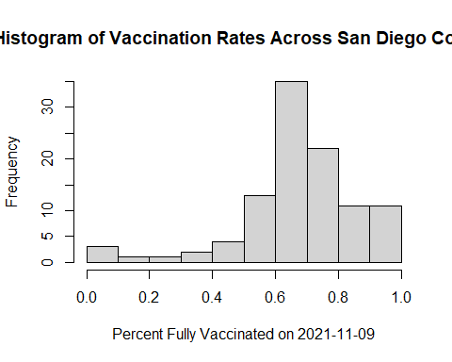

Using ggplot:

library(ggplot2)  
  
ggplot(sd.11.09) +  
 aes(percent_of_population_fully_vaccinated) +  
 geom_histogram(bins=10) +  
 labs(x="Percent Fully Vaccinated on 2021-11-09", y="Count (ZIP Code Areas",  
 title="Histogram of Vaccination Rates Across San Diego County")

## Warning: Removed 4 rows containing non-finite values (stat_bin).

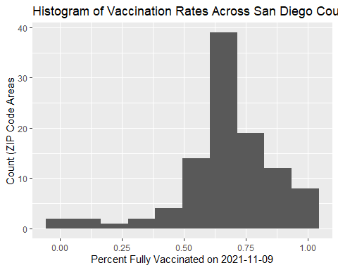

# Focus on UCSD/La Jolla

UC San Diego resides in the 92037 ZIP code area nd is listed with an age 5+ population size of 36,144.

ucsd <- filter(sd, zip_code_tabulation_area == "92037")  
  
ucsd[1,]$age5_plus_population

## [1] 36144

**Q15**. Using **ggplot**, make a graph of the vaccination rate time course for the 92037 ZIP code area:

ggplot(ucsd) + aes(as_of_date, percent_of_population_fully_vaccinated) +   
 geom_point() + geom_line(group=1) + ylim(c(0,1)) +  
 labs(x="Date", y="Percent Vaccinated",   
 title="Vaccination Rate for La Jolla CA 92037")

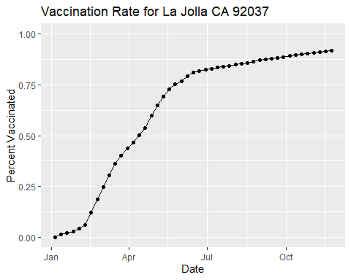

This plot shows an initial slow roll out in January into Febuary (likely due to limited vaccine availability). This is followed with rapid ramp up until a clear slowing trend from June time onward. Interpertation beyond this requies context from other zip code areas to answer questions such as: is this trend representative of other areas? Are more people fully vaccinated in this area compared to others? Etc.

# Comparing 92037 to other similar sized areas

Let’s return to the full dataset and look across every zip code area with a population at least as large as that of 92037 on *as_of_date* “2021-11-16”.

# Subset to all CA areas with a population as large as 92037  
vax.36 <- filter(vax, age5_plus_population > 36144 &  
 as_of_date == "2021-11-16")  
  
head(vax.36)

## as_of_date zip_code_tabulation_area local_health_jurisdiction county  
## 1 2021-11-16 92020 San Diego San Diego  
## 2 2021-11-16 92563 Riverside Riverside  
## 3 2021-11-16 92806 Orange Orange  
## 4 2021-11-16 93291 Tulare Tulare  
## 5 2021-11-16 92335 San Bernardino San Bernardino  
## 6 2021-11-16 92618 Orange Orange  
## vaccine_equity_metric_quartile vem_source  
## 1 2 Healthy Places Index Score  
## 2 3 Healthy Places Index Score  
## 3 2 Healthy Places Index Score  
## 4 1 Healthy Places Index Score  
## 5 1 Healthy Places Index Score  
## 6 4 Healthy Places Index Score  
## age12_plus_population age5_plus_population persons_fully_vaccinated  
## 1 49284.5 54991 35128  
## 2 55897.8 63794 36051  
## 3 33050.9 36739 24810  
## 4 46879.7 54254 27936  
## 5 79670.3 91867 49820  
## 6 40348.0 44304 39695  
## persons_partially_vaccinated percent_of_population_fully_vaccinated  
## 1 5161 0.638795  
## 2 4224 0.565116  
## 3 2355 0.675304  
## 4 4012 0.514911  
## 5 5970 0.542306  
## 6 3936 0.895969  
## percent_of_population_partially_vaccinated  
## 1 0.093852  
## 2 0.066213  
## 3 0.064101  
## 4 0.073948  
## 5 0.064985  
## 6 0.088841  
## percent_of_population_with_1_plus_dose redacted  
## 1 0.732647 No  
## 2 0.631329 No  
## 3 0.739405 No  
## 4 0.588859 No  
## 5 0.607291 No  
## 6 0.984810 No

**Q16**. Calculate the mean *“Percent of Population Fully Vaccinated”* for ZIP code areas with a population as large as 92037 (La Jolla) *as_of_date* “2021-11-16”. Add this as a straight horizontal line to your plot from above with the geom_hline() function.

vaccination.36 <- mean(vax.36$percent_of_population_fully_vaccinated)

ggplot(ucsd) + aes(as_of_date, percent_of_population_fully_vaccinated) +   
 geom_point() + geom_line(group=1) + ylim(c(0,1)) +   
 labs(x="Date", y="Percent Vaccinated",   
 title="Vaccination Rate for La Jolla CA 92037") +   
 geom_hline(yintercept=vaccination.36, color="red", linetype="dashed")

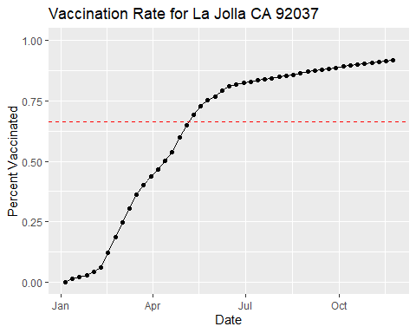

**Q17**. What is the 6 number summary (Min, 1st Qu., Median, Mean, 3rd Qu., and Max) of the *“Percent of Population Fully Vaccinated”* values for ZIP code areas with a population as large as 92037 (La Jolla) *as_of_date* “2021-11-16”?

summary(vax.36$percent_of_population_fully_vaccinated)

## Min. 1st Qu. Median Mean 3rd Qu. Max.   
## 0.3529 0.5905 0.6662 0.6640 0.7298 1.0000

**Q18**. Using ggplot, generate a histogram of this data.

ggplot(vax.36) + aes(percent_of_population_fully_vaccinated) +   
 geom_histogram(bins=40) + labs(x="Percent Vaccinated", y="Count")

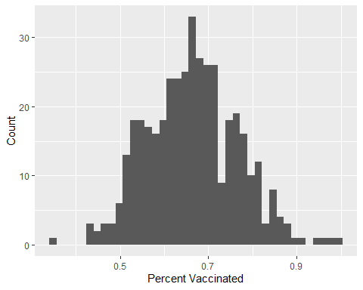

**Q19**. Is the 92109 and 92040 ZIP code areas above or below the average value you calculated for all these above?

vax %>% filter(as_of_date == "2021-11-16") %>%   
 filter(zip_code_tabulation_area=="92109") %>%  
 select(percent_of_population_fully_vaccinated)

## percent_of_population_fully_vaccinated  
## 1 0.68863

vax %>% filter(as_of_date == "2021-11-16") %>%   
 filter(zip_code_tabulation_area=="92040") %>%  
 select(percent_of_population_fully_vaccinated)

## percent_of_population_fully_vaccinated  
## 1 0.521047

The 92109 ZIP code area is above the average value of 0.6630. However, the 92040 ZIP code area is below the average value.

**Q20**. Finally, make a time course plot of vaccination progress for all areas in the full dataset with a age5_plus_population > 36144.

vax.36.all <- filter(vax, age5_plus_population > 36144)  
  
  
ggplot(vax.36.all) +  
 aes(as_of_date,percent_of_population_fully_vaccinated,   
 group=zip_code_tabulation_area) +  
 geom_line(alpha=0.2, color="blue") +  
 ylim(c(0,1)) +  
 labs(x="Date", y="Percent Vaccinated",  
 title="Vaccination Rate Across California",  
 subtitle="Only areas with a population above 36K are shown.") +  
 geom_hline(yintercept=0.66, linetype="dashed")

## Warning: Removed 176 row(s) containing missing values (geom_path).

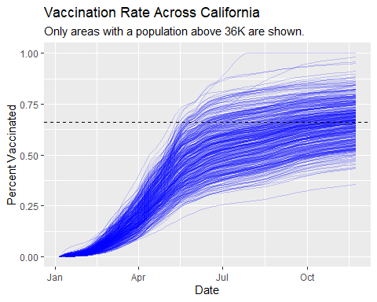

**Q21**. How do you feel about traveling for Thanksgiving and meeting for in-person class next Week?

With the detection of the omicron variant, which is more transmittable than the delta variant, and the combination of the lower-than-expected vaccination rates uncovered in this activity, I feel hesitant about meeting for in-person class next week. Traveling by car is safe enough, but traveling by plane for Thanksgiving is slightly concerning to me.