* baguio city-<https://baguioguide.com/how-many-barangays-in-baguio-city/#>
* Legazpi city-点击barangay-<https://en.wikipedia.org/wiki/Legazpi,_Albay#Barangays>

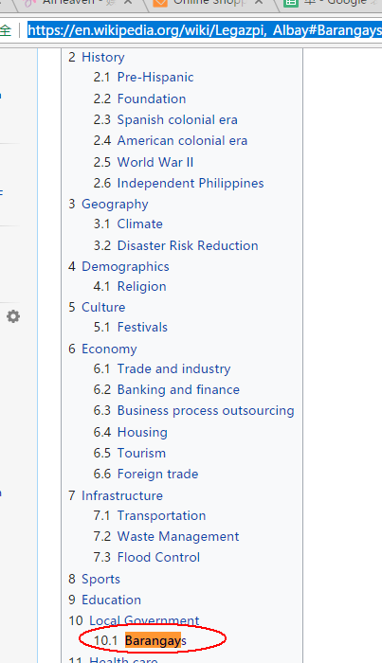

* Calumpit-<https://en.wikipedia.org/wiki/Calumpit,_Bulacan#Barangays>

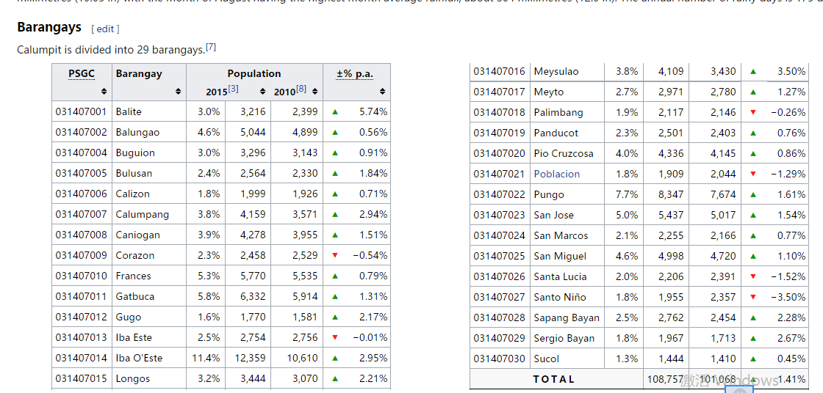

* Isulan- <https://en.wikipedia.org/wiki/Isulan,_Sultan_Kudarat#Barangays>

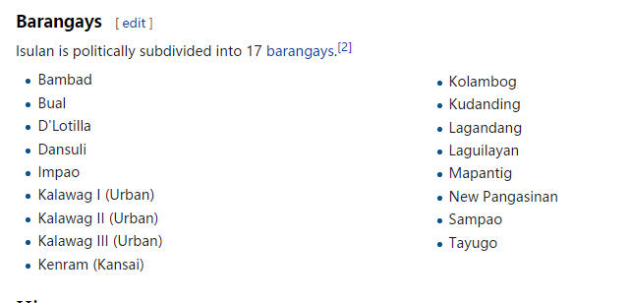

* Tacurong-https://en.wikipedia.org/wiki/Tacurong#Barangays

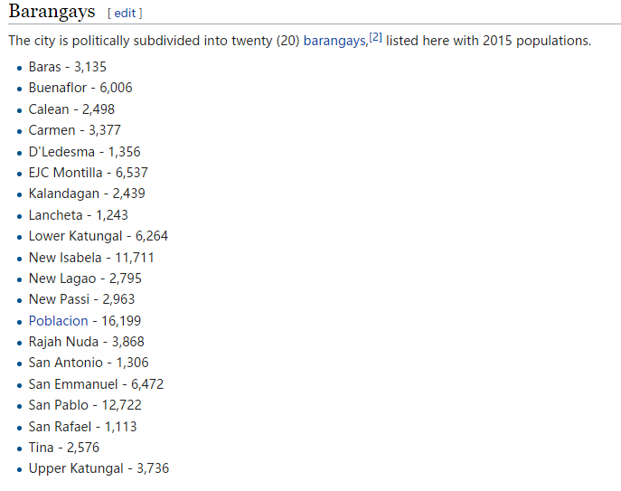

* Malungon -https://en.wikipedia.org/wiki/Malungon,_Sarangani

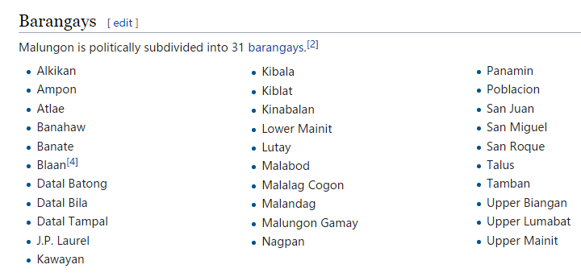

* Capas- <https://en.wikipedia.org/wiki/Capas,_Tarlac#Barangays>

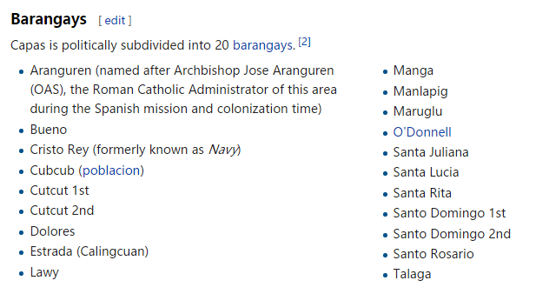

* Ipil - https://en.wikipedia.org/wiki/Ipil,_Zamboanga_Sibugay#Barangays

