Behave Predictive
User Guide

AI-Powered Sales Forecasting Platform

SIRYOS
Version 1.0

Understanding Behave Predictive: The 5 W's

Before diving into details, let's answer the fundamental questions:

WHO should use Behave Predictive?

Behave Predictive is designed for:

- Sales Managers - Who need accurate sales forecasts for planning
- Marketing Teams - Who want to predict campaign outcomes
- Business Analysts - Who require data-driven insights
- Finance Teams - Who need revenue projections
- Executives & Decision Makers - For strategic planning
- Operations Managers - For demand forecasts

No technical expertise required! Built for business professionals.

WHAT is Behave Predictive?

An AI-powered forecasting platform that analyzes historical sales data and generates accurate future predictions.

Key capabilities:

- Automated AI Analysis - Upload data, let machine learning do the work
- Multiple Models - LSTM, TCN, TSMixer optimized for different patterns
- Visual Insights - Interactive charts show trends and predictions
- Accuracy Metrics - Clear indicators (MAPE, RMSE) show reliability
- Real-time Monitoring - Track forecast generation progress
- Downloadable Results - Export for reports and presentations

Your personal AI forecasting assistant.

WHERE can you use Behave Predictive?

Accessibility:

- Web-Based Platform - Any computer with internet
- No Installation - Works in web browser
- Office or Remote - Access from anywhere
- Multi-Device - Desktop, laptop, tablet
- Secure Cloud - Enterprise-grade security

Industry use cases:

- Retail - Product sales, seasonal demand, inventory
- E-commerce - Online sales, traffic, conversions
- Manufacturing - Production demands, materials
- Finance - Revenue, expenses, cash flow
- Hospitality - Occupancy, bookings, seasonality
- Healthcare - Patient volumes, resources, supplies

WHEN should you use Behave Predictive?

Ideal scenarios:

- Strategic Planning - Quarterly/annual business plans
- Budget Preparation - Setting targets, allocating resources
- Inventory Management - Planning stock levels
- Marketing Campaigns - Predicting outcomes
- Seasonal Planning - Busy/slow periods
- Product Launches - Estimating demand
- Resource Allocation - Staffing, investment
- Performance Reviews - Comparing actuals vs predictions

Recommended frequency:

- Monthly - Fast-changing markets
- Quarterly - Stable markets
- As New Data Arrives - Significant updates
- Before Major Decisions - Fresh forecasts

Best practice: Regular updates improve accuracy.

WHY use Behave Predictive?

Business value:

1. Make Better Decisions
- Replace guesswork with data-driven predictions
- Reduce uncertainty in planning
- Support with quantifiable forecasts

2. Save Time & Resources
- Automate days of manual analysis
- No data scientists needed
- Focus on strategy, not calculations

3. Improve Accuracy
- AI detects patterns humans miss
- Handle complex seasonal patterns
- Continuously learn from data

4. Gain Competitive Advantage
- Respond faster to changes
- Optimize inventory, reduce waste
- Anticipate opportunities

5. Increase Confidence
- Back plans with solid predictions
- Show data-supported projections
- Track accuracy over time

ROI Benefits:

- Decrease stockouts and lost sales
- Optimize marketing spend
- Enhance cash flow management

1. Introduction

1.1 What is Behave Predictive?
Behave Predictive is an advanced AI-powered sales forecasting platform developed by SIRYOS. It uses state-of-the-art machine learning models to analyze your historical sales data and generate accurate predictions for future periods.

1.2 Key Benefits
- Accurate forecasts using advanced AI (LSTM, TCN, TSMixer)
- Easy-to-use interface - no technical knowledge required
- Visual charts and reports for better decisions
- Real-time monitoring of forecast generation
- Multi-user support with role-based access

1.3 Who Should Use This Guide?
This guide is for business users, marketing teams, and sales professionals who want to leverage AI forecasting without technical expertise. Whether you're a sales manager, marketing director, or business analyst, this guide helps you get the most out of Behave Predictive.

2. Getting Started

2.1 Accessing the Platform
To access Behave Predictive, open your web browser and navigate to the application URL provided by your administrator.

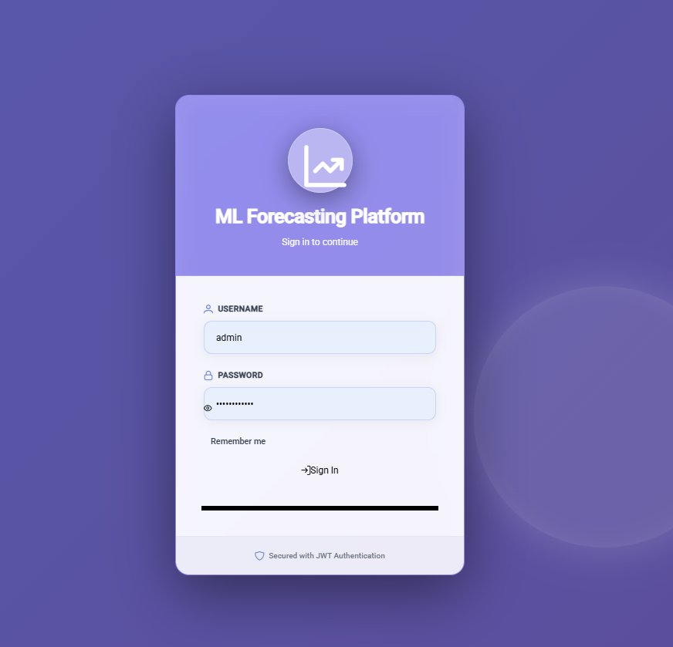

2.2 Logging In
Enter your credentials:

- Enter your username
- Enter your password
- Click 'Sign In'

Note: If you've forgotten your password, contact your administrator.

2.3 Understanding User Roles
Behave Predictive has two user types:

Regular User
- Upload data and create forecasts
- View and monitor own forecast jobs
- Access detailed results and reports

Administrator
- All regular user capabilities
- View all forecasts from all users
- Manage users and companies
- See who created each forecast

3. Dashboard Overview

The Dashboard is your central hub for managing forecasts and viewing system statistics.

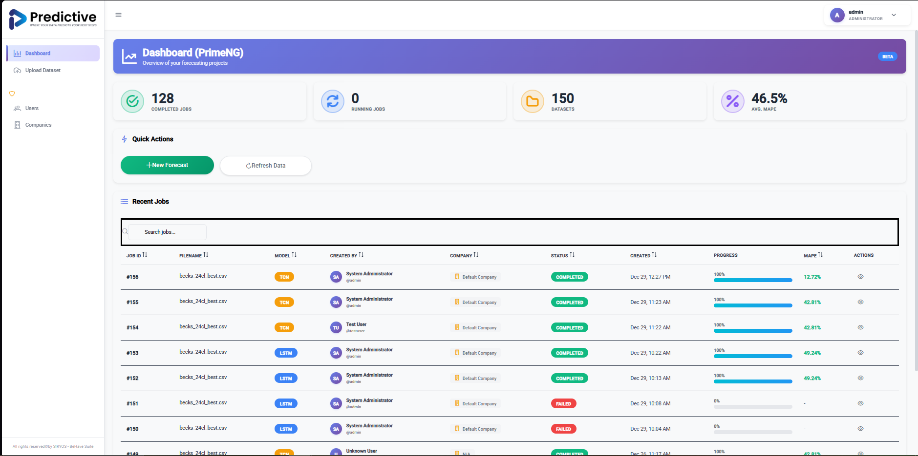

3.1 Dashboard Statistics
Four key statistics at the top:

- Completed Jobs - Successfully completed forecasts
- Running Jobs - Forecasts currently processing
- Datasets - Total uploaded data files
- Average MAPE - Overall forecast accuracy (lower is better)

3.2 Recent Jobs Table
The table displays:

- Job ID - Unique identifier
- Filename - Data file used
- Model - AI model (LSTM, TCN, TSMixer)
- Status - Current state (Pending, Running, Completed, Failed)
- Progress - Completion percentage (0-100%)
- MAPE - Accuracy metric (lower is better)

Note for Administrators: You'll also see 'Created By' and 'Company' columns.

3.3 Quick Actions
- New Forecast - Start creating a new forecast
- Refresh Data - Update dashboard with latest information
- Search - Filter jobs by filename, model, or status

4. Creating Your First Forecast

4.1 Preparing Your Data
Data requirements:

- File Format: CSV (Comma-Separated Values)
- Required Columns: Date and Value columns
- Date Format: YYYY-MM-DD (e.g., 2023-01-15) {
- "M/d/yyyy", // 1/1/2020 (single digits)
- "MM/dd/yyyy", // 01/01/2020 (double digits)
- "d/M/yyyy", // 1/1/2020 (day first)
- "dd/MM/yyyy", // 01/01/2020 (day first)
- "yyyy-MM-dd", // 2020-01-01
- "yyyy/MM/dd", // 2020/01/01
- "M-d-yyyy", // 1-1-2020
- "MM-dd-yyyy", // 01-01-2020
- "d-M-yyyy", // 1-1-2020 (day first)
- "dd-MM-yyyy" // 01-01-2020 (day first)}
- Data Frequency: Daily, weekly, or monthly
- Minimum Rows: At least 50 data points recommended

Example data structure:

date,sales
2023-01-01,15000
2023-01-02,16500
2023-01-03,14800

4.2 Uploading Your Data
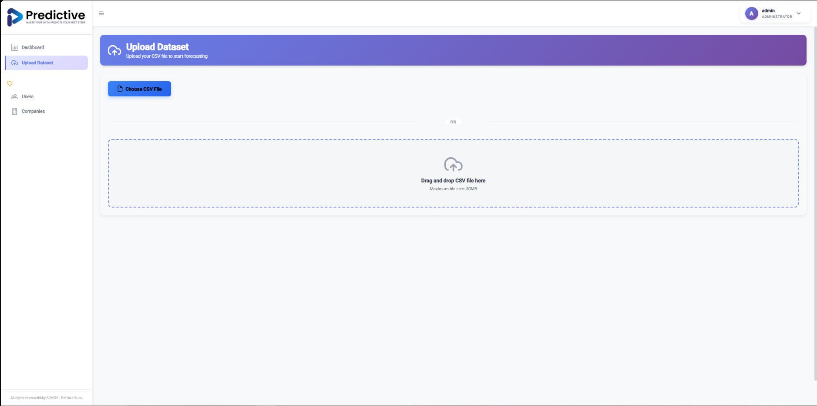
- Click 'New Forecast' from Dashboard
- Click 'Choose File' and select your CSV
- Select the Date Column from dropdown
- Select the Target Column (e.g., 'sales')
- Click 'Upload' to proceed

4.3 Configuring Your Forecast

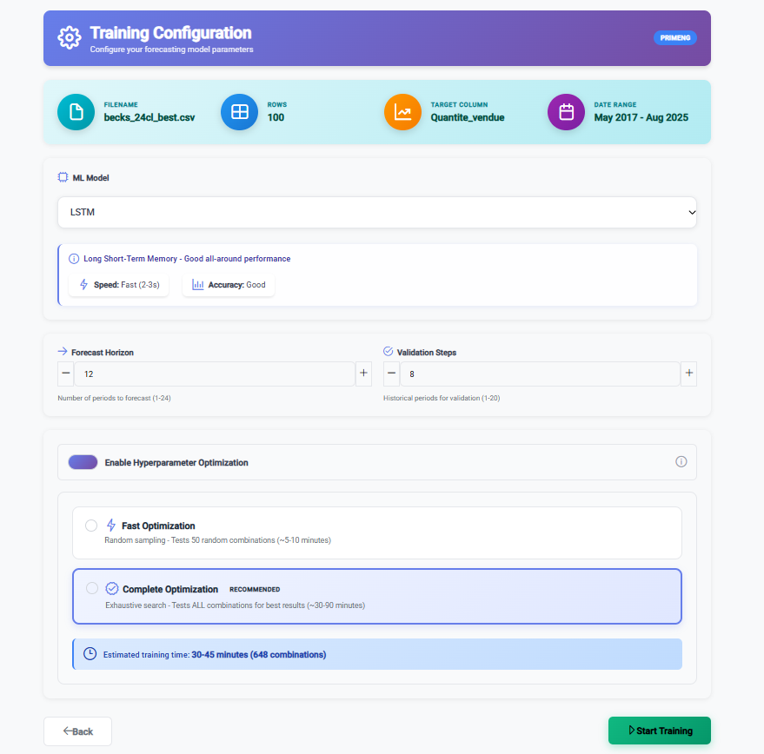

Configure forecast parameters:

Model Selection
- LSTM - Best for long-term patterns and trends
- TCN - Excellent for seasonal patterns
- TSMixer - Latest model, good all-around

Forecast Settings
- Forecast Horizon - Periods ahead to predict
- Validation Steps - Data portion for testing
- Optimize Hyperparameters - Auto-tune (recommended)

- Select your preferred model
- Set forecast horizon (future periods)
- Enable 'Optimize Hyperparameters'
- Click 'Start Training'

5. Monitoring Your Forecast

Track progress in real-time on the monitoring page.

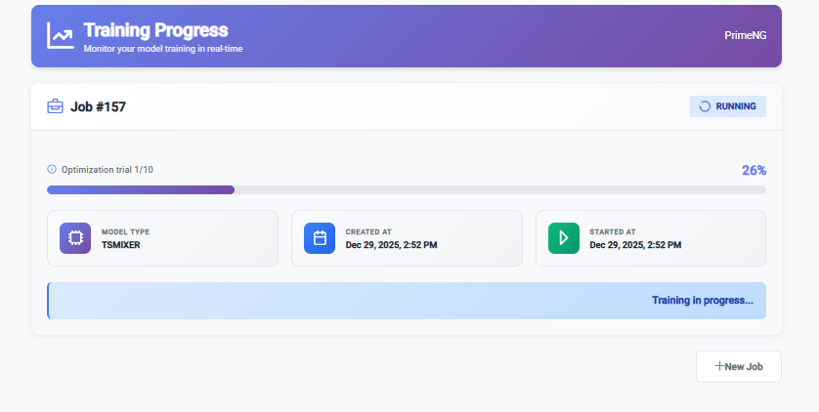

5.1 Status Indicators
- Pending - Job queued, waiting to start
- Queued - Job being prepared
- Running - AI model actively training
- Completed - Forecast ready to view
- Failed - Error occurred (contact support)

5.2 Progress Tracking
Monitor page shows:

- Real-time progress bar (0-100%)
- Current status messages
- Estimated time remaining
- Model details and parameters

5.3 Training Phases
AI model goes through:

- Data preprocessing and validation
- Model architecture setup
- Training on historical data
- Hyperparameter optimization (if enabled)
- Validation and accuracy testing
- Future predictions generation

6. Understanding Your Results

View comprehensive results including accuracy metrics and visual charts.
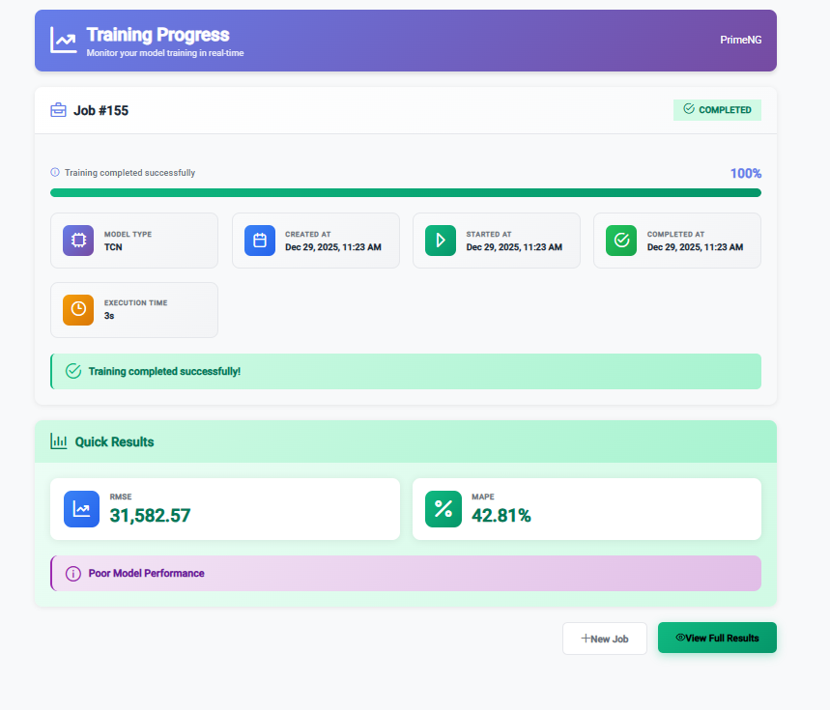

6.1 Performance Metrics

RMSE (Root Mean Square Error)
- Measures average prediction error in data units
- Lower values = better accuracy
- Useful for understanding error magnitude

MAPE (Mean Absolute Percentage Error)
- Error expressed as percentage
- Easier to interpret across scales
- Guidelines: <5% Excellent, 5-10% Good, 10-20% Acceptable, >20% Poor

6.2 Visual Charts

Historical Data & Future Predictions Chart

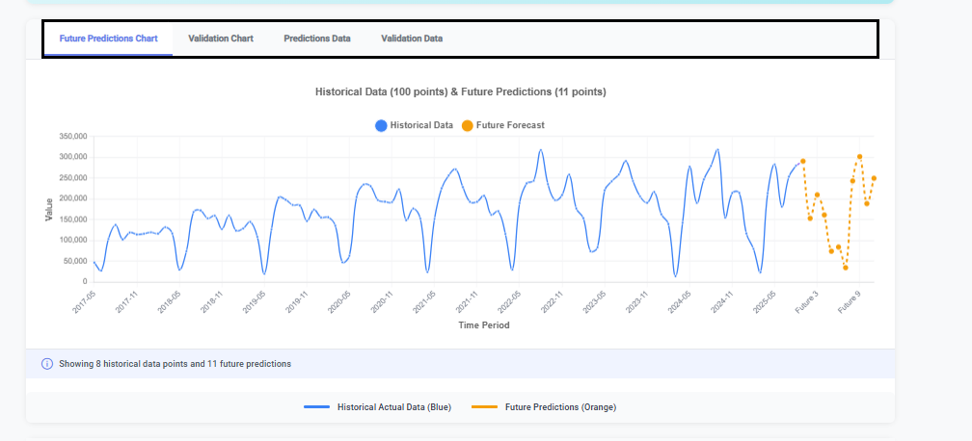

This chart displays:
- Blue solid line - Your actual historical data
- Orange dashed line - AI-generated future predictions
- Red vertical line - Marks 'today' (historical to future transition)

Validation Chart

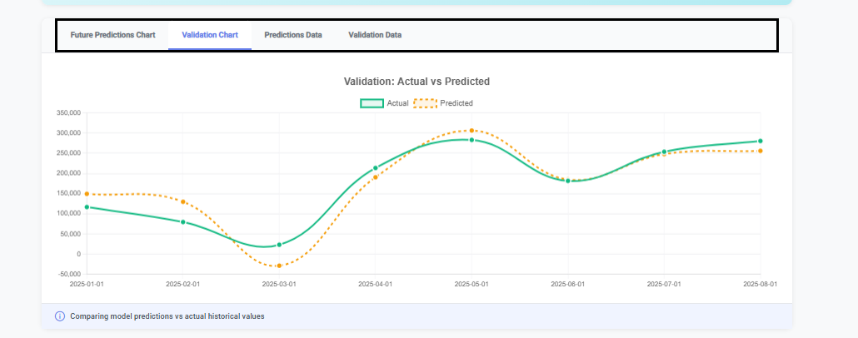

Shows model performance on historical data:
- Green line - Actual values from your data
- Orange dashed line - Model's predictions
- Close alignment = Better accuracy

6.3 Predictions Data Table
Future predictions in detailed table:
- Period number (Period 1, Period 2, etc.)
- Predicted value for each period
- Easy to export for reports

6.4 Model Hyperparameters
Technical parameters used by AI. Automatically optimized, reviewable by data scientists.

7. Best Practices for Accurate Forecasts

7.1 Data Quality
- Use clean, consistent data without gaps
- Ensure dates in correct format
- Include 2-3 years of historical data when possible
- Remove outliers that don't reflect normal patterns

7.2 Choosing the Right Model
- LSTM - Long-term trends and memory effects
- TCN - Seasonal patterns (monthly, quarterly cycles)
- TSMixer - Good starting point if unsure

Tip: Try multiple models and compare MAPE scores.

7.3 Setting Forecast Horizon
- Short-term (1-3 months) - More accurate
- Medium-term (3-12 months) - Good balance
- Long-term (12+ months) - Strategic planning, less precise

7.4 Validation and Trust
- Review validation chart for model performance
- Lower MAPE = more reliable predictions
- Consider external factors not in historical data
- Update forecasts regularly as new data arrives

7.5 Using Results Effectively
- Download results for business reports
- Compare predictions with actual outcomes
- Share visual charts with stakeholders
- Use predictions as one input, not the only factor

8. Administrator Features

This section is for users with Administrator access.

8.1 User Management

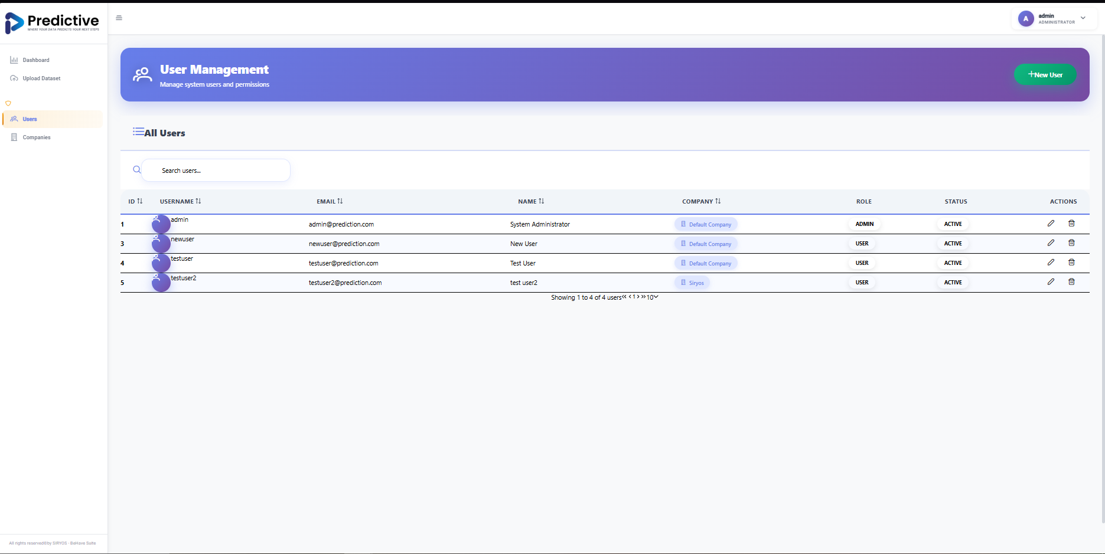

Administrators can:

- View all users with roles and companies
- Create new user accounts
- Edit user information and permissions
- Activate or deactivate accounts
- Assign administrator privileges

Creating a New User
- Navigate to 'Users' from admin menu
- Click 'Create New User'
- Fill in required information
- Select user's company
- Set user status (Active/Inactive)
- Grant administrator privileges if needed
- Click 'Create User'

8.2 Company Management

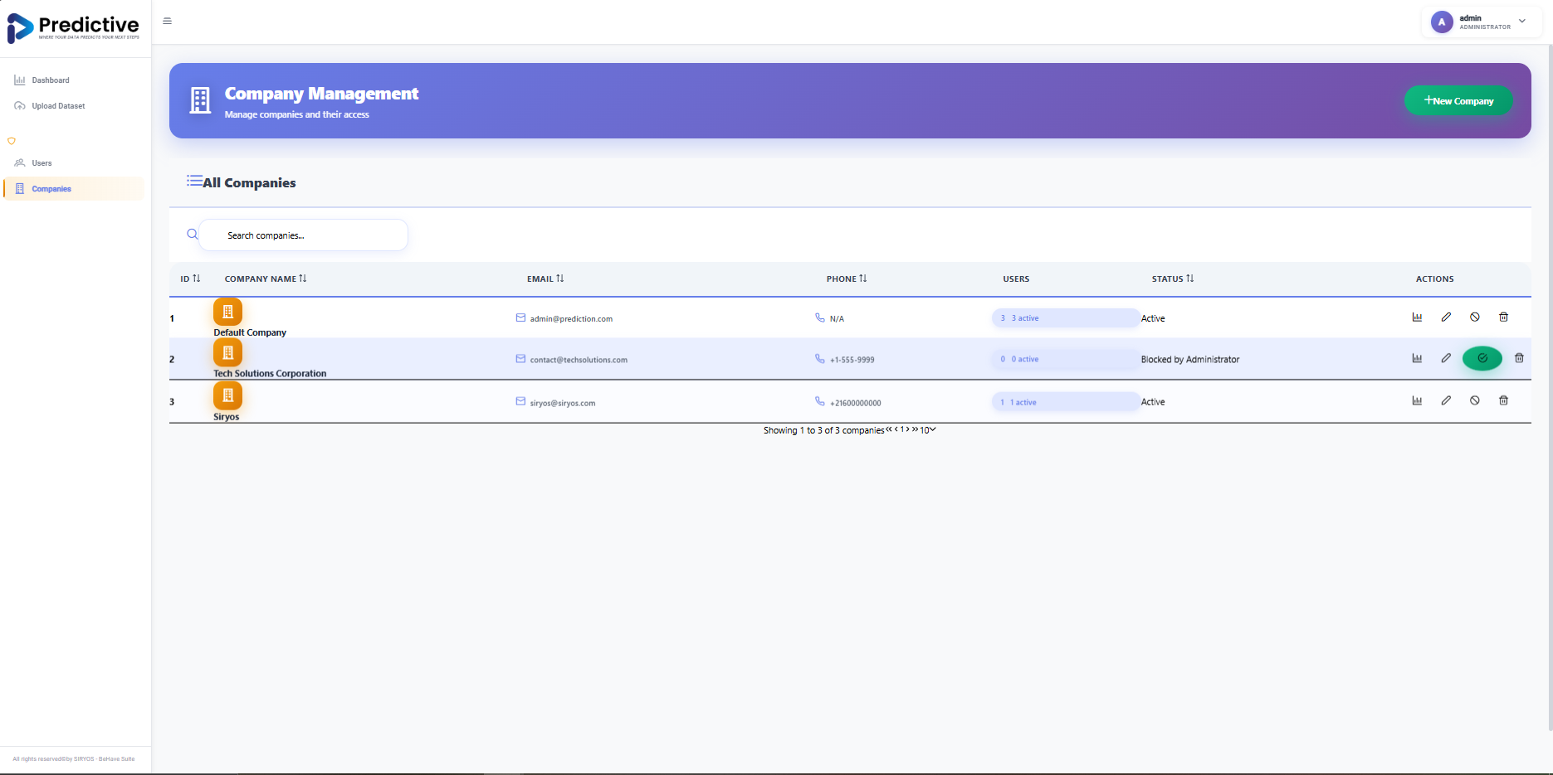

Manage companies:

- View all companies and their status
- Create new company records
- Edit company information
- View user statistics per company
- Block or activate companies

Company Status Types
- Active - Normal system use
- Blocked - Access temporarily disabled
- Invalid License - License expired

8.3 Monitoring All Forecasts
Administrators can:
- View forecasts from all users/companies
- See who created each forecast
- Track usage patterns
- Generate usage reports

9. Troubleshooting Common Issues

9.1 Upload Issues

Problem: File won't upload
Solutions:
- Ensure file is CSV format
- Verify file isn't corrupted or open elsewhere
- Try different browser

Problem: Columns not showing correctly
Solutions:
- Ensure CSV uses comma separators
- Check column names in first row
- Remove special characters from column names

9.2 Training Issues

Problem: Job stays in 'Pending'
Solutions:
- Wait a few minutes - system processing other jobs
- Refresh the page
- Contact administrator if >10 minutes

Problem: Training fails
Solutions:
- Check data quality - no missing values
- Verify date format
- Ensure sufficient data points (min 50)
- Try different model

9.3 Results Issues

Problem: High MAPE score
Solutions:
- Try different AI model
- Enable hyperparameter optimization
- Check for irregular patterns or anomalies
- Increase training data if possible
- Consider external factors

Problem: Charts not displaying
Solutions:
- Refresh the page
- Clear browser cache
- Try different browser (Chrome/Firefox)

9.4 General Issues

Problem: Cannot log in
Solutions:
- Verify username and password
- Check Caps Lock is off
- Contact administrator for password reset
- Ensure account is active

Problem: Slow performance
Solutions:
- Check internet connection
- Close unnecessary browser tabs
- Clear browser cache and cookies
- Try during off-peak hours

10. Frequently Asked Questions

Q: How long does it take to generate a forecast?
A: Depends on the size of data and whether optimization was selected or not.

Q: Can I forecast multiple variables at once?
A: Currently, each forecast focuses on one target variable. Create separate forecasts for different variables.

Q: How often should I update forecasts?
A: Best practice is monthly or quarterly as new data becomes available.

Q: What data format is required?
A: CSV format with at least two columns: dates and values to forecast.

Q: How much historical data do I need?
A: Minimum 50 data points, but 100-200+ points (2-3 years monthly data) provides better accuracy.

Q: Can I download forecast results?
A: Yes, use 'Download Results' button to export data.

Q: What if I get a failed job?
A: Check data quality first - no missing values, correct date format, sufficient data. If issues persist, contact support.

Q: Which model should I choose?
A: If unsure, start with TSMixer or enable 'Optimize Hyperparameters'. LSTM for long-term trends, TCN for seasonal patterns.

Q: Can I see forecasts from other users?
A: Regular users only see own forecasts. Administrators view all forecasts.

Q: How accurate are the predictions?
A: Varies based on data quality. MAPE <10% indicates excellent accuracy. Validation chart shows historical performance.

11. Glossary of Terms

AI (Artificial Intelligence)
Technology enabling computers to learn from data and make predictions.

CSV (Comma-Separated Values)
Simple file format for storing data in rows and columns, easily created in Excel.

Forecast Horizon
Number of future time periods to predict (e.g., 12 months ahead).

Hyperparameters
Settings controlling how AI model learns. Automatic optimization finds best settings.

LSTM (Long Short-Term Memory)
AI model type excelling at learning long-term patterns in time series data.

MAPE (Mean Absolute Percentage Error)
Accuracy metric as percentage. Lower scores = better predictions.

Model
AI algorithm analyzing patterns and generating forecasts. Different models for different data types.

RMSE (Root Mean Square Error)
Accuracy metric in same units as data. Measures average prediction error.

TCN (Temporal Convolutional Network)
AI model particularly good at detecting seasonal patterns and cycles.

Time Series
Data points collected over time, such as daily sales or monthly revenue.

Training
Process where AI model learns patterns from historical data.

TSMixer
Modern AI model with balanced performance across various scenarios.

Validation
Testing model accuracy on historical data before generating future predictions.

12. Support & Contact Information

12.1 Getting Help
If you encounter issues:

- Check Troubleshooting section (Section 9)
- Review FAQ (Section 10)
- Contact your system administrator
- Reach out to SIRYOS support team

12.2 Contact Information
SIRYOS Support Team
For technical support and inquiries:

- Email:
- Website:
- Phone:

12.3 Feedback
We value your feedback! Share your experience, suggestions, and feature requests with our team.

12.4 Training & Resources
Need additional training? Contact SIRYOS for:

- On-site training sessions
- Webinars and online tutorials
- Custom documentation
- Best practices consulting

Thank you for choosing Behave Predictive!

Empowering Business Decisions with AI

© 2024 SIRYOS. All rights reserved.
Version 1.0 - December 2024

