1) Installation
- Clone or download the repository from: https://tscore-git.creatio.com/all/remoteshell
- In the root directory of the project, run the installation script: deploy_remote_shell.ps1
- (Optional) Edit appsettings.json according to your needs. After deployment, the file can be found at: RemoteShell\deployment\RemoteShellApp\appsettings.json (Detailed explanation of its parameters is provided in appsettings.json Configuration Overview)
To update, simply pull or download the latest version (step 1) and re-run the script deploy_remote_shell.ps1 (step 2).
After installation, a shortcut named "Remote Shell" will appear on your desktop.

2) appsettings.json Configuration Overview:
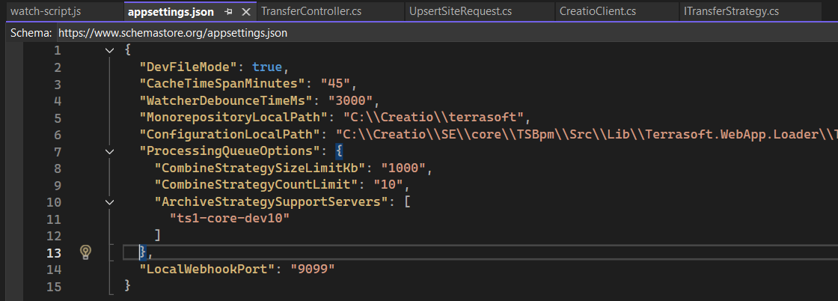
Description of the Parameters:
- DevFileMode:
true – Stores files directly in the repository.
false – Stores files in the /deployment/... directory.
- CacheTimeSpanMinutes: The cache lifetime (in minutes) for the Quick Transfer feature for unregistered site history.
- WatcherDebounceTimeMs: Debounce time for the file system watcher, in milliseconds.
Prevents excessive triggering when files are updated rapidly.
Used only if FileSystemWatcher is enabled.
- MonorepositoryLocalPath: Path to your local monorepository (optional).
Used as the default path in settings forms — helps save time during configuration.
- ProcessingQueueOptions.CombineStrategySizeLimitKb: Maximum total size (in kilobytes) of content files for applying the combination strategy during transfer.
- ProcessingQueueOptions.CombineStrategyCountLimit: Maximum number of files for applying the combination strategy.
- ProcessingQueueOptions.ArchiveStrategySupportServers: List of server names that are allowed to use the archive transfer strategy.
- LocalWebhookPort — the port to which metrics will be sent from the client’s Node process running in NodeWatch mode in the VS Code terminal.
By default, the port is 9099.
If you want to change it, make sure to also update it in the watch-script.js file.
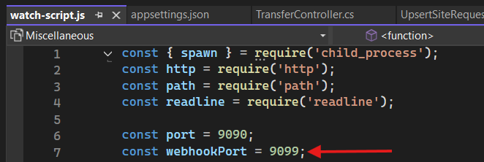

3) Quick setup with default settings
After installation, click the Remote Shell shortcut — this will launch the API service and open a browser window.
On the first launch, there will be no data, and you’ll see a simple setup screen to fill in the initial configuration.
If you specified the MonorepositoryLocalPath in appsettings.json, the monorepository path field will be filled in automatically.
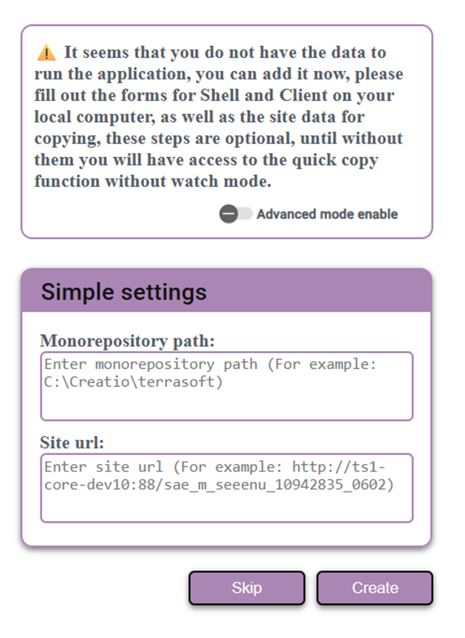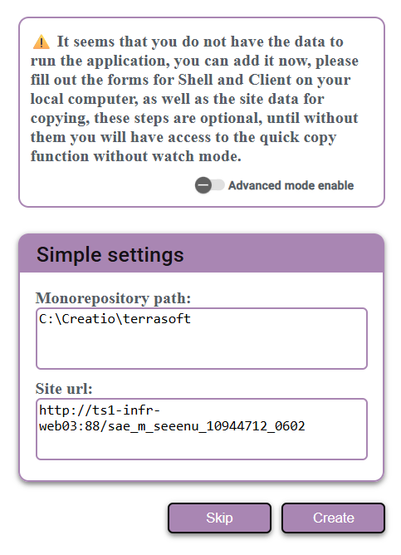
Fill in the following fields:
- Monorepository path — the local path where your monorepository project (Terrasoft) is located
- Site URL — the URL of the remote deployed site where changes will be copied
Then click Create. This will create two configurations: one for the local shell and one for the system-designer. Additionally, one site instance will be created for each configuration to handle copying for the shell and system-designer respectively.
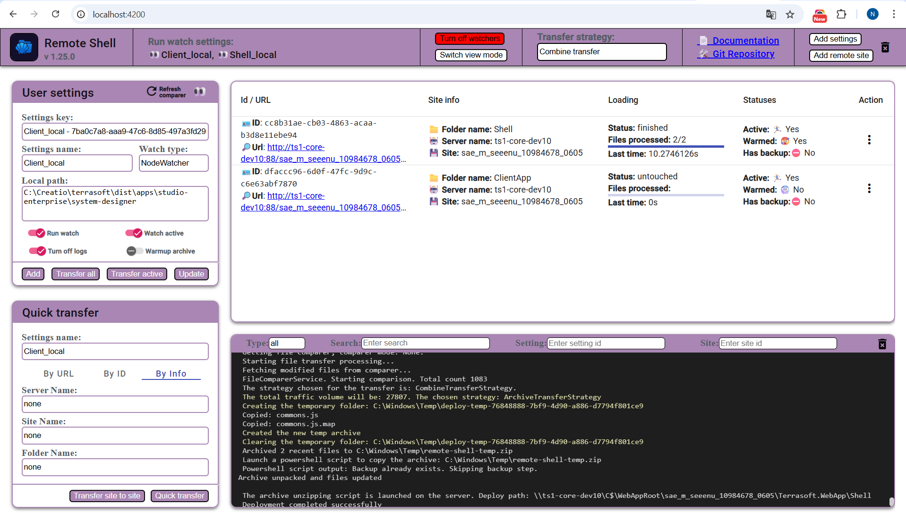
Next, you’ll be taken to the main screen, which will be described in more detail in the following section.
Both configurations are now active in watch mode and are ready to send data to the remote server at any time.
Now, open your monorepository (Terrasoft) in your IDE. In the root of the project, you’ll find a file named watch-script.js.
To launch Angular in watch mode with automatic file tracking, run the following command:
node watch-script.js <your_settings_name>
For example: node watch-script.js Shell_local
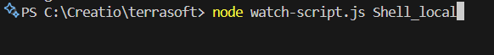
You can find the settings name on the main screen in the browser. By default, these are:
Shell_local and Client_local.
Running this script is equivalent to the standard npm run build-watch:shell command.
However, after each rebuild, it will also automatically send a command to transfer the modified files to the remote server.
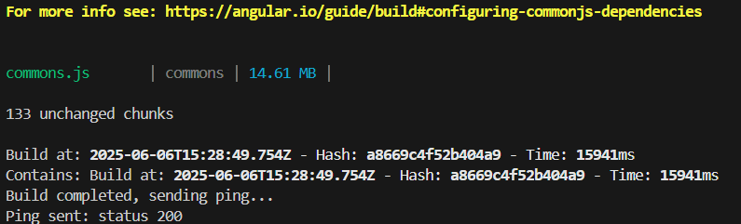
The transfer process is indicated in two places: In the open browser window, within the list of sites and console log output
This allows you to monitor the file transfer status both visually and through the terminal.
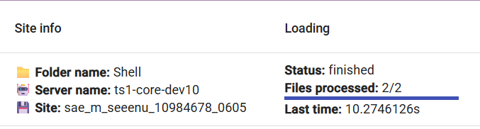
If you’re done experimenting or want to reset everything and start over, you can clear all settings with a single click using the Reset button in the top-right corner of the main page.
Alternatively, you can edit the current settings directly on the main page — more details on that will be covered in the next section.
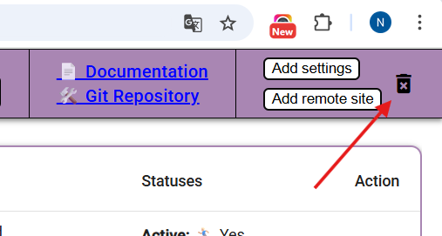

4) Advanced setup
After installation, click the Remote Shell shortcut — this will launch the API service and open a browser window.
On the first launch, there will be no data, and you’ll see a basic setup screen to enter the initial configuration.
To switch to advanced setup mode, click the Advanced mode enabled toggle.
After that, you’ll see three forms to fill out: Shell, ClientApp, and RemoteSite.
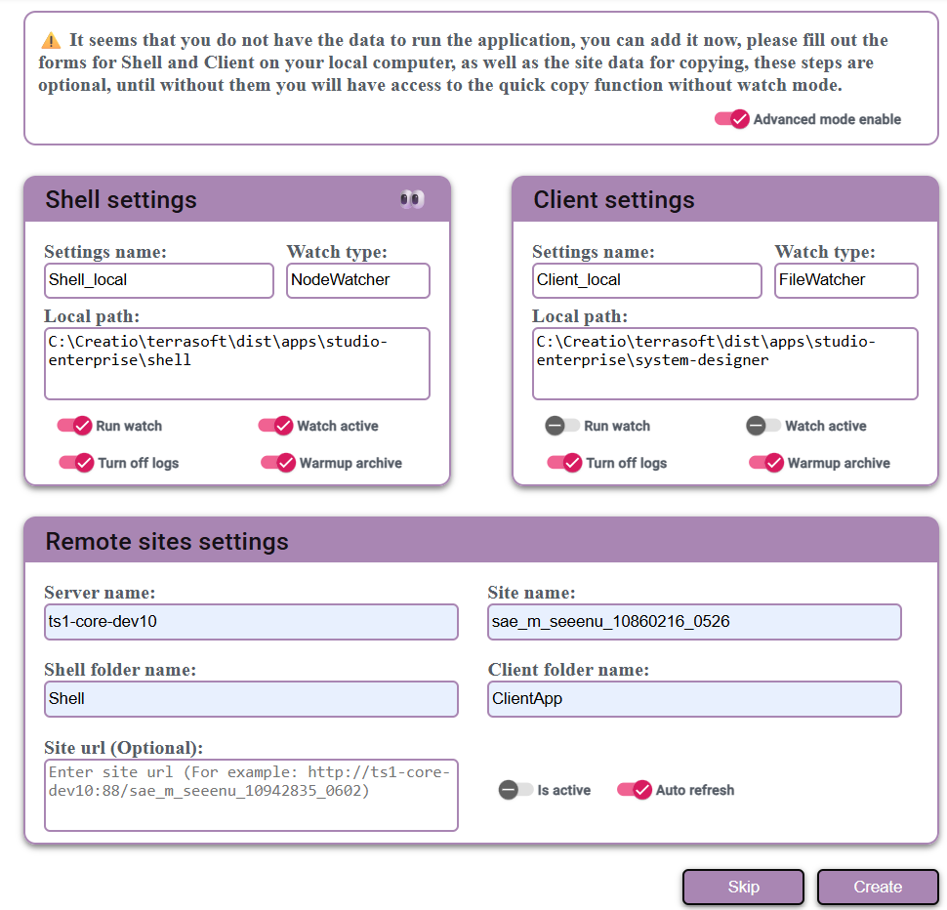
The Shell and ClientApp forms are similar — in both, you need to specify a setting name that will be used to call or search for the console.
Then, select a watch type from the following options:
- NodeWatcher — uses the native nx watch command in VS Code. It runs similarly but automatically sends updated files to the remote server. This is the recommended option.
- FileWatcher — based on FileSystemWatcher, it listens to changes in the directories where your source code is located (e.g., the dist directory). This is an older and less accurate option, intended as a fallback if NodeWatcher doesn't work.
- Configuration — currently under development and should not be selected. It's used internally for quick configuration bootstrapping.
After selecting the watch type, you’ll also need to specify the paths to the source code directories (dist folders) for both the Shell and the ClientApp.
Next, configure the following flags:
- Run watch — enables file change monitoring for this setting.
- Watch active — when enabled, updates will be sent only to active remote sites. If disabled, updates will be broadcast to all sites linked to this setting.
- Turn on logs — enables logging on the client side for this setting.
- Warmup archive — if enabled, creates a backup archive of the site's contents before copying new files to it.
