Instruction Types and Format

OPCODE : Operation Code
rs: Source Register
rt: Temporary Register
rd: Destination Register
shamt: Shift Amount (To be implemented in future update)

R-type Instruction:

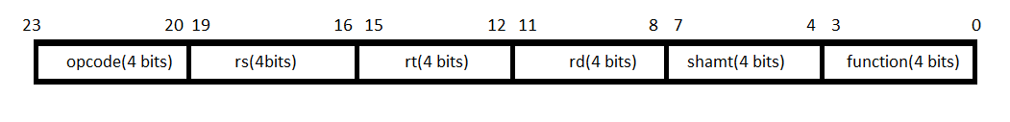

I-type Instruction:
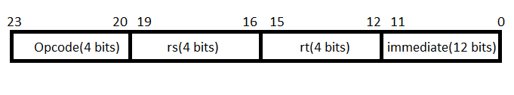

J-type Instruction:

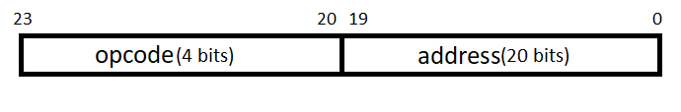

We have chosen this instruction format so that each part of the instruction consists of 4 or multiple of 4 bits which makes it easier to convert into comprehensible HEXA codes.

Instructions Set:
R-Type
Instruction | Name |  | Action |  | opcode |  | funct
ADD rd, rs, rt | Addition |  | rd = rs + rt |  | 0000 |  | 0000
SUB rd, rs, rt | Subtraction |  | rd = rs – rt |  | 0000 |  | 0001
AND rd, rs, rt | AND |  | rd = rs & rt |  | 0000 |  | 0010
OR rd, rs, rt | OR |  | rd = rs | rt |  | 0000 |  | 0011
NOR rd, rs, rt | NOR |  | rd = ~(rs | rt) |  | 0000 |  | 0100
NAND rd, rs, rt | NAND |  | rd = ~(rs & rt) |  | 0000 |  | 0101
I-Type
Instruction |  | Name |  | Action |  | opcode
SW rt, offset(rs) |  | Store Word |  | M[offset + rs] = rt |  | 0001
LW rt, offset(rs) |  | Load Word |  | rt = M[offset + rs] |  | 0010
BEQ rs, rt, offset |  | Branch On Equal |  | if(rs==rt) than pc = pc + offset |  | 0011
J-Type
Instruction |  | Name |  | Action |  | opcode
J target |  | Jump |  | pc = target[0-11]; |  | 0100

ALU CONTROL:
ALU Control Lines | Function
0000 | AND
0001 | OR
0010 | NOR
0011 | NAND
0100 | ADD
0101 | XOR
1100 | SUB

ALU Control Truth Table:

ALUOP1 | ALUOP0 | FUNCT FIELD |  |  |  | OPERATION
 |  | F3 | F2 | F1 | F0 | OPERATION
0 | 0 | X | X | X | X | 0100
X | 1 | X | X | X | X | 1100
1 | X | 0 | 0 | 0 | 0 | 0100
1 | X | 0 | 0 | 0 | 1 | 1100
1 | X | 0 | 0 | 1 | 0 | 0000
1 | X | 0 | 0 | 1 | 1 | 0001
1 | X | 0 | 1 | 0 | 0 | 0011
1 | X | 0 | 1 | 0 | 1 | 0010

Control Unit:

Instruction | Reg Dst | Op1 | Op0 | ALU  Src | Branch | MemRead | Mem Write | Reg Write | MemTo Reg | Jump
R-  Type | 1 | 1 | 0 | 0 | 0 | 0 | 0 | 1 | 0 | 0
lw | 0 | 0 | 0 | 1 | 0 | 1 | 0 | 1 | 1 | 0
sw | 0 | 0 | 0 | 1 | 0 | 0 | 1 | 0 | 0 | 0
beq | 0 | 0 | 1 | 0 | 1 | 0 | 0 | 0 | 0 | 0
bne | 0 | 0 | 1 | 0 | 0 | 0 | 0 | 0 | 0 | 0
j | 0 | 0 | 0 | 0 | 0 | 0 | 0 | 0 | 0 | 1

SAMPLE PROGRAM:
Add two numbers from memory:
1) lw $r1, 0[1]
2) lw $r2, 0[2]
3) add $r1, $r2, $r3
4) sw $r3, 0[3]

0001 0000 0001 0000 0000 0001 101001(Hex)
0001 0000 0010 0000 0000 0010 102002(Hex)
0000 0001 0010 0011 0000 0000 012300(Hex)
0010 0000 0011 0000 0000 0011 203003(Hex)

Datapath:

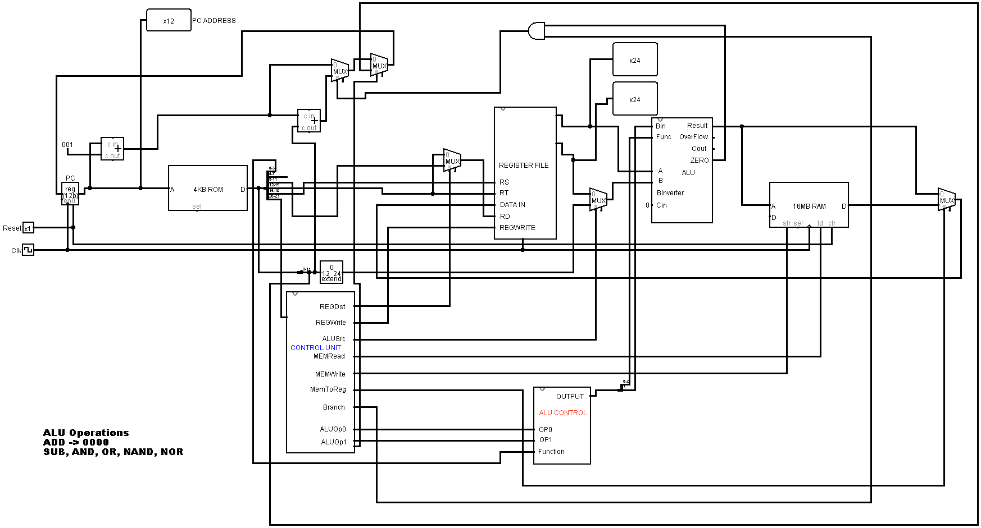
1 Bit Alu
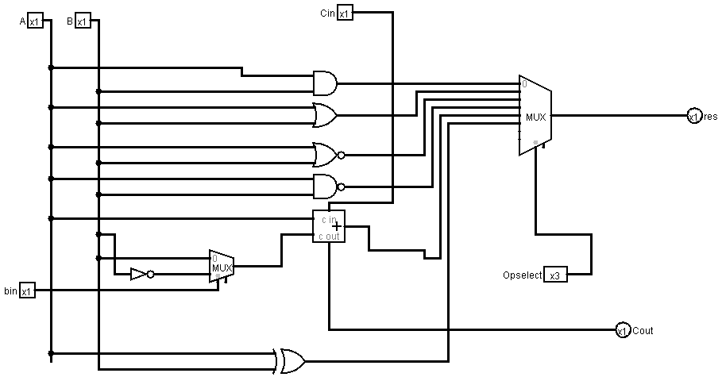

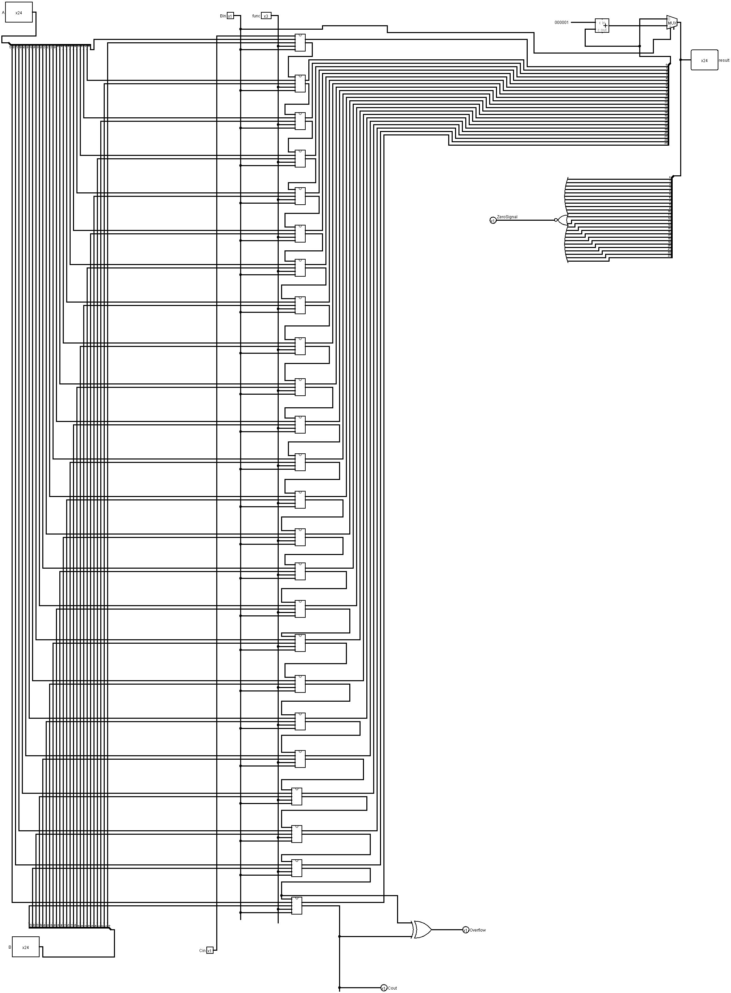
24 bit ALU:

REGISTER FILE:
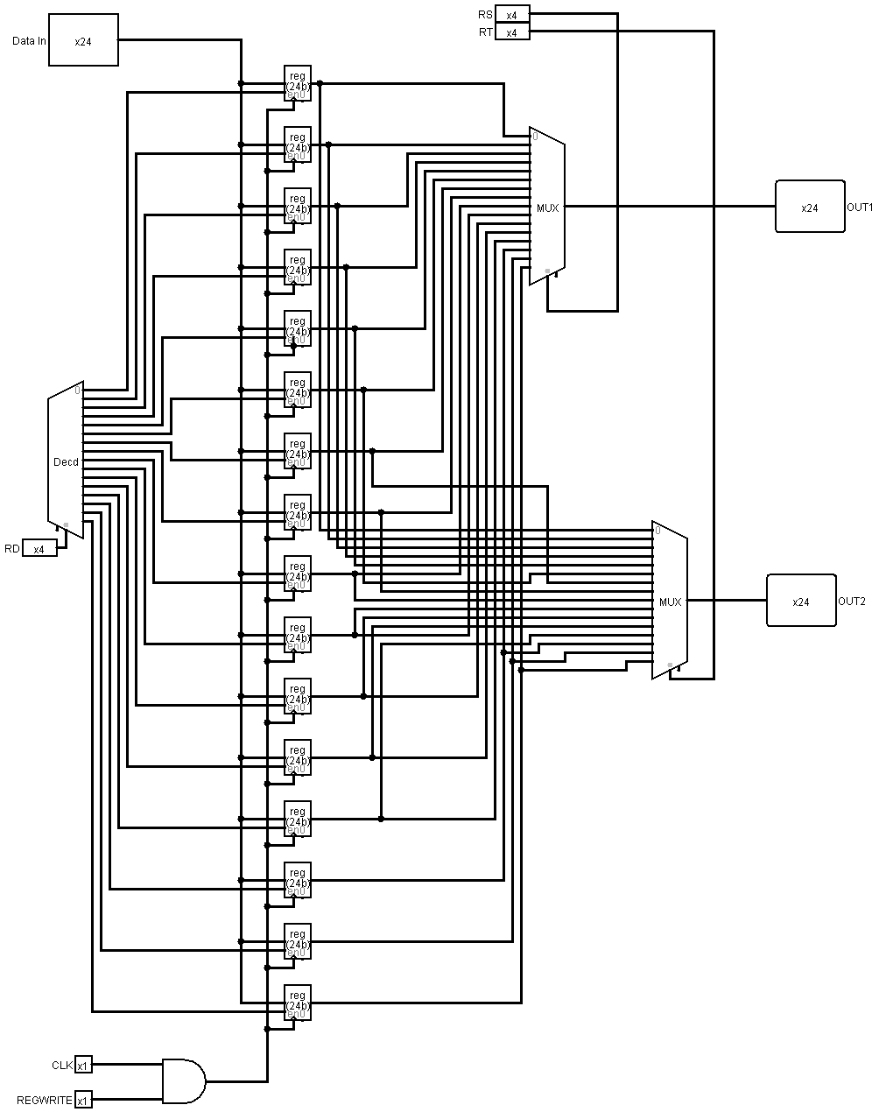

Control Unit
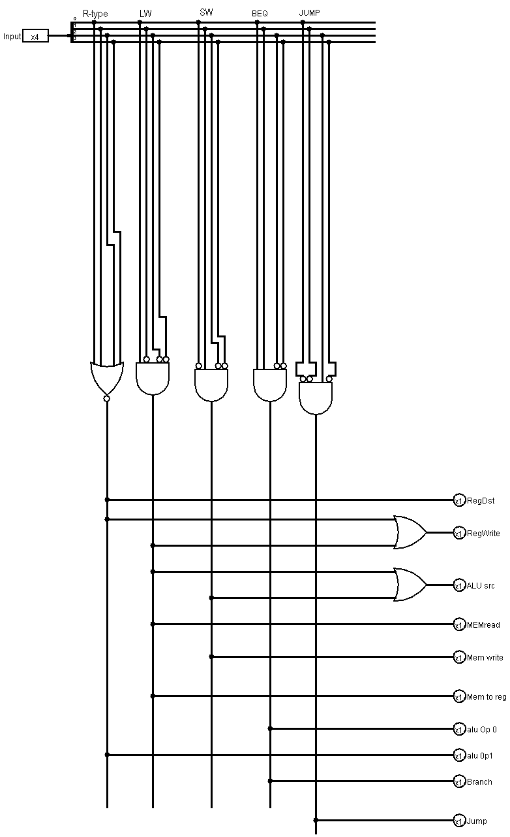

ALU Control:
