CS783 Enterprise Architecture:

**Term project**

Swissport International AG



Contents

1. Overview 3

2. Background 3

3. Major objective 4

4. Company Structure 4

5. Metrics: 4

6. Swissport Operating Model 5

7. Service Oriented Architecture (SOA) 4

3. Baggage Tracing; 4

4. Lost property; 4

8. Data analytics: 5

9. ERP System for the Business 5

10. Customer Relationship Management (CRM) system 6

11. Legacy System security 6

11.1. List of legacy systems: 6

11.2. Potential high risks legacy systems 7

11.3. Security Measures: 8

12. Best fit technology selection 10

***13.*** *Proposed Core Diagram:* ***Unification*** 14

14. OUTSOURCING 15

15. Service Level Agreement (SLA) 16

16. Financial analysis 1

16.1 Cost estimation 1

16.2 Project NPV, RIO 18

17. User does/system does 19

Bibliography 21

## Overview

With overall number of enterprise architecture related projects are increased each year at different Enterprises to integrated core and shared customer data and standardize its business processes. The goal of this project is to develop a blueprint/EA of Swissport International company which helps as a road map to its business process. After accomplishing this project, Swissport can provide both airport ground services and air cargo handling in a more integrated and standardized way of service delivery to its potential customers. IT leader and professionals can measure metrics and manage IT security issues in high response rate and ensure IT systems and programs to be implemented in synchronization way as per the company goal. Total cost of IT will be reduced. There by therefore, Swissport increases its competitive advantage then economic of scale can be achieved.

## Background

Based on the company profile report (2019), Swissport operates at 310 airports in 49 countries and has a broader global presence than any of its competitors. Clients get benefit from the industry’s widest single-source service portfolio. Swissport serves their passengers and handles their air cargo with consistent service quality, the highest levels of safety and globally standardized procedures. In 1966, it was incorporated in Zurich, Geneva, Basel. Between 1996 and 2000 it was a global expansion period: expansion to Africa and Turkish. Within 6-years interval, Swissport got expand

its brunch to different continents: currently it has brunches in 6 contentment.

## Major objective

* *The Aviation Industry’s Most Trusted Single- Source Ground Service and Cargo Handling.*

## Company Structure

Swissport gives airport ground services and air cargo handling to it potential customers at local and as well as worldwide services.

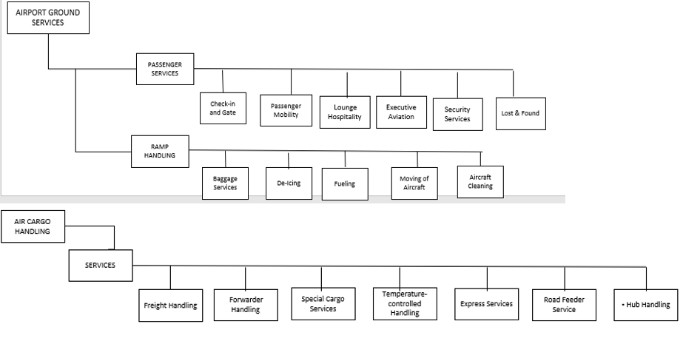

Figure 1: Swissport organization structure

## Metrics:

Based on company IT responsiveness and risk management characteristics, the company architecture can reach at business modularity architecture maturity level. It has core, standardized processes and can be used by local business units as a foundation. Server maintenance cost reduction and customer satisfaction are identified as metrics of EA.

Table 1:Metrics Tracker

|  |  |  |  |  |  |  |  |  |  |
| --- | --- | --- | --- | --- | --- | --- | --- | --- | --- |
| Metric | Unit | Type | Target Achieved | | | | | | |
| Year | | | | | | |
| 2020 | 2011 | 2022 | 2023 | 2024 | 2025 | 2026 |
| Reduced cost of Server maintenance | number | product |  |  |  |  |  |  |  |
| Customer Satisfaction | scores | product |  |  |  |  |  |  |  |
| Improvement |  |  |  |  |  |  |  |  |  |

## Swissport Operating Model

The company has its own operational model called Swissport Formula. But it does not show the two dimensions of operation model of the business. Therefore, this project will provide the complete business foundation for execution.

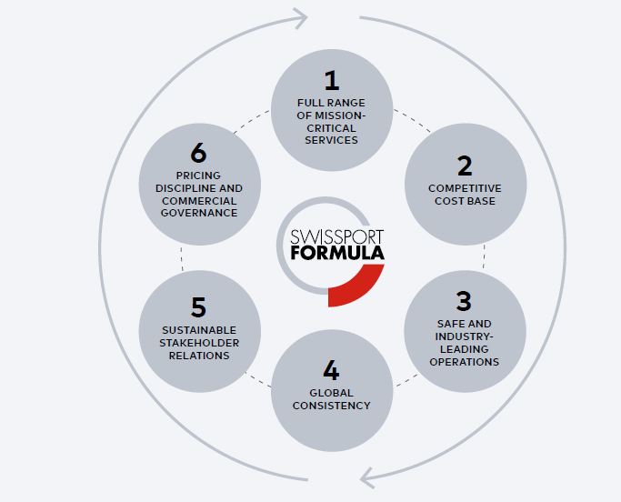

Figure 2: Operating model description

## Service Oriented Architecture (SOA)

Data from the data warehouse is analyzed for financial and air flight performance. Customers/users request information on the browser, and the business logic accept the request and send the request to database server, if the request is approved, then data fitch and send back to the user. Third party integration with the company is for cookies and sessions. If the user visits the company website, his information is sent to google and oracle servers. The SOA depicted as follow:

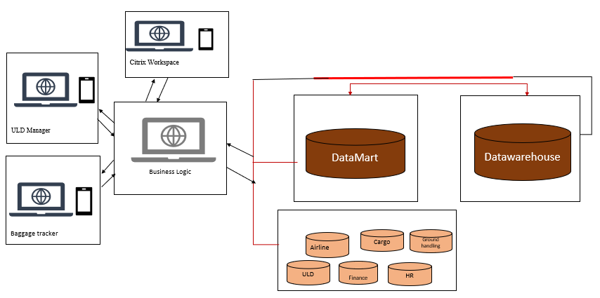

Figure 3: SOA

**User Interfaces**

Swissport has an interface to interact between the user and the web server. ([www.swisport.com](http://www.swisport.com)). Customer can interact to access data from the server.

1. Agent Awb Tracking: this shows the status of the flight;
2. Citrix Workspace app;

# Baggage Tracing;

# Lost property;

1. Cargospot Handling;
2. ULD Manager;
3. Customer portal: Customers track their commodity through the app.

## Data analytics:

The company has its own business intelligence. They use cargo spot for data analytics. The figure is depicted below: The data which is stored on the database and analyzed at Datawarehouse is relational. But it doesn’t have big data analytics environment. I suggest Swissport cargo should use big data environment for non-relational data: like data from Facebook, LinkedIn, twitter and Gmail. Due to large volume, velocity, varsity, veracity and value this project suggests Swissport can use big data analytics environment.

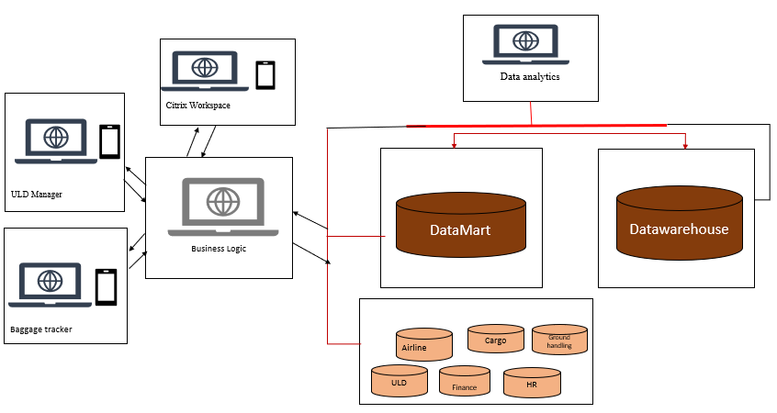

Figure 4: Data analytics

## ERP System for the Business

The company uses SAP ERP for customer relationship management, finical analysis, human resource planning, supply chain management, procurement, business intelligence, dashboards, project management.

## Customer Relationship Management (CRM) system

Swissport has a customer relationship via Facebook, LinkedIn, Gmail, phone, and twitter and giving training for employees to give services for their customers. The relationship is depicted bellow:

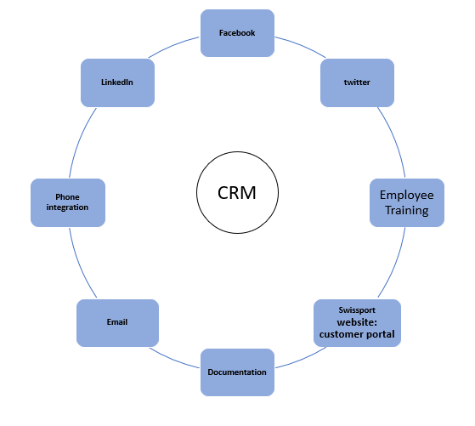

Figure 5: CRM

## Legacy System security

## List of legacy systems:

To secure the system first all legacy system of the company should be listed

Swissport has the following list of legacy systems:

* Cargospot: it is an saas used for cargo system dashboard that manages Cargo business.
* Freight finder:  used follow the statues of the freight.
* Hand-Held Terminals: Swissport’s customers benefit from real-time status.
* SHIELD Document Imaging System: flight data capturing to check missing documents.

## Potential high risks legacy systems

Based on www.us.cert.gov, potentially high risks legacy systems can be identified according to the following selection criteria: high severity should be selected.

This project suggests some security measures should be taken for the company data security.

**Selection Criteria:**

1. Data sensitivity;
2. Accessibility;
3. Functional criticality;
4. Internal versus external users;
5. Extent of security testing;

This project finds out some data privacy issue of the company. The company website privacy says there is a security issue on customer portal. Based on this information high risks potential are amused with tabular form. The yellow row indicates potentially high-risk legacy system:

Table 2: potentially high risks legacy systems

|  |  |  |  |  |
| --- | --- | --- | --- | --- |
| **Legacy systems** | **Severity of risk** | | | Remark |
| **low** | **medium** | **high** |
| Cargospot | yes | no | no |  |
| Freight finder | yes | no | no |  |
| Handheld terminals | yes | no | no |  |
| Shelled image documenting system | yes | no | no |  |
| Customer poral | no | no | yes | Message on text box and chat room |

## Security Measures:

To secure client data or client sensitive data via the website, some security measures should be included in the source code.

Swissport website has a problem on sending messages via the message box and chat room. Third parties may breach client’s data and harms customers privacy. To make the company website more secure and confidential and protect customers from cyber attaches, best preventive measures should put in place. Let’s compare the system before and after the system security improvement has put in place. I suggest evolutionary rather than revolutionary: code refactoring and session on the original code is the best solution to keep the legacy system leave alone.

In general; eliminate code bugs on source code (include encryption algorithms) and add sessions on the client’s browser is the best solution.

* 1. Swissport customer portal work fulfillment

Table 3:System does/user does Swissport customer portal

|  |  |  |  |  |
| --- | --- | --- | --- | --- |
| **Time** | **Workflow** | | **Comparison** | |
| **User does** | **System does** | **Before security improvement** | **After security improvement** |
| Identify code smile, Debug code, Create sessions on client/server | | | | |
| T1 | User open the message text box. | System opens the text box | Data breach: the company has no full confidence on data security. Client activity on the Swissport website is sent to google and oracle. | Data secured because it is encrypted |
| T2 | User write message on message box | System process the user’s message | Security issue arise. | Data secured because it is encrypted |
| T3 | User submit the message via customer portal to the server. | System register the submitted message on the database tables via server. | Data breach happen corporate frighten about data security. | No security issues. The original code is not changed; just refactoring and adding some code. |
| T4 | User open the chat box. | System display chat room to send the message. | Data breach happen: Client activity on the Swissport website is sent to google and oracle and recorded on their server. | No security issues. Some original code is refactored and tested. |
| T5 | User write the message on chat room | System register the message | Data insecurity: every activity on the Swissport website is sent to oracle and google. | Security issue eliminated: |
| T6 | User submit the message | System register the message to the server | Data breach happen: every information sent by the user is sent to google and oracle server. | Security issue eliminated: |

## Best fit technology selection

Swissport has already used ERP/SAP but now this project recommends the company to use ESB and MOM.

Based on the given selection criteria both ESB and MOM are added as a linking technology. Extensibility, ease-of-use, maintainability, cost, flexibility is considered as selection criteria.

Table 4: Description of best fit technology selection

| **Alternative** | **Linking Technology** | **Pros/cons** |
| --- | --- | --- |
| 1 | Mule ESB | Ease to connect with CRM system easily to both Salesforce and Data Warehouse for faster analytics and access to historical customer interactions. Implementing a CI/CD (DevOps) environment for Mule ESB is a very easy task and it is easy to write and generates coverage reports in various formats. |
| 2 | Oracle Service Bus / Fusion Middleware | **It helps in building reusable, well-defined services. It is lightweight, and one can easily integrate with different applications, databases, JMS, or Web services through various protocols. It provides support for synchronous and asynchronous transport protocols.** *It needs to support more adapters because the integration points keep changing, and new things keep coming up. It also needs to be more scalable. Service implementation is not agile like microservices. The architecture is so complex and could result in higher latency with so many layers to traverse. Deployment of multiple web services in one session.* |
| 3 | WSO2 ESB | **It reduces silo development of services. WSO2 ESB has a very nice Graphical UI for managing deployment of services and monitoring services. It uses Apache Synapse to manage the message mediation and can make changes within the UI at runtime and deploy it on-demand if necessary. It is open source and free and can be connected with SAP systems. When there is a conversion required between XML to JSON and JSON to XML.** |
| 4 | Message-oriented middleware: Tibco EMS | It Uses for transactions like Customers, Orders, Invoices etc. It is very good fault tolerance capability and works seamlessly. Supports Queues and topics well. It can also proceed asynchronously. Effective handling of messages if hard disk is corrupted for data storage and then EMS is very efficient to send data across all data centers. |

## *Proposed Core Diagram:* ***Unification***

Swissport is local and global joint ventures unites shared customer, IT designed by cargo people for cargo people: Cargospot. The digital innovation reduces waiting times and increases the quality of the air freight documentation. Standardization and global alignment guarantee Swissport quality around the globe regardless of local conditions or cultural differences. The company currently gives the following services for customers and it makes the company’s execution for foundation coupled with IT strategy reach at modularity architecture maturity level:

* + Improved choice and access to innovative services globally;
  + Consistent quality and reliability;
  + Well-trained management and staff;
  + Optimized solutions for global and local needs;
  + Savings made through application of standards;
  + Global Framework Agreements

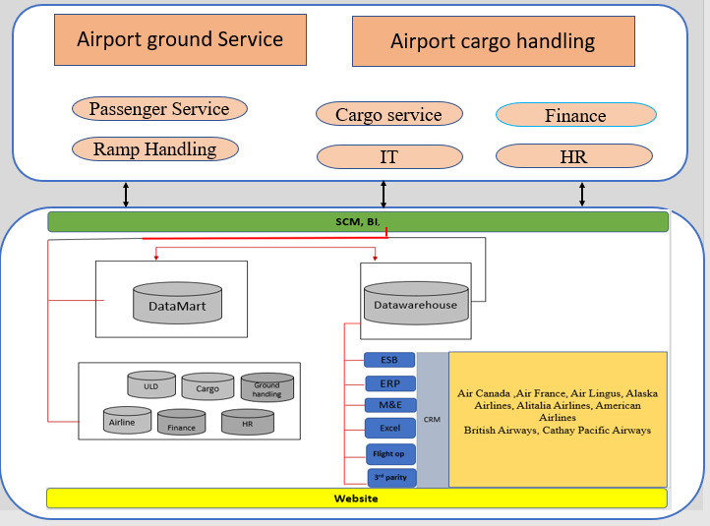

Figure 6: New core diagram

## OUTSOURCING

Because of unlimited want of the company, but limited IT resource, large amount of data, then high demand on data analytics on the data warehouse can exist. To satisfy this condition the company can make an agreement with 3rd party for cloud computing to deploy real-time and operational data to the cloud based on demand-based contract. As long as the company focuses on outsourcing key roles in the airport ground services and air cargo handling industry, it can outsource IT process to the cloud as well. Before signing the contract, the IT leaders should follow some basic procedure.

## Service Level Agreement (SLA)

The company can make a legal contract to 3rd party for service delivery based on the agreement. IT leaders should follow on metrics before signing the agreement.

To avoid some confusions and excessive cost for both parties, metrics selection should be focused on the scheme level (at macro level).

During metrics selection, it is better to examine the main operation and decide the main important one.

The more complex on scheme, the less likely to be effective, because no one will have time to analyze the data.

Azure, AWS and e cargo cloud compared and e cargo cloud from IBM can be selected on the following SLA selection metrics criteria:

Table 5: SLA

|  |  |  |  |
| --- | --- | --- | --- |
| **No.** | **SLA Metrics** | **Measurement** | **Definition** |
| 1 | Service Availability | Time slot | the amount of time service is available to use. |
| 1 | Technical quality | program size, coding defects | It is measurement of technical quality by commercial analysis tools. |
| 3 | Security | anti-viruses’ updates | measuring controllable security measures. |

## Financial analysis

## Cost estimation

To get project operational expense, a prefeasibility study has conducted at Swissport. Past, present and future expenses have analyzed. The major costs are labor and IT. The company fact sheet is analyzed since it has financial report per year.

Fact sheet:

1. Activities: add additional code to legacy code
2. Testing
3. Data deploying to the cloud
4. Software purchase
5. Labor;

*Better Buys (2020) and eCargo.Cloud(2018)*

Table 6:cost estimation

|  |  |  |  |  |  |  |  |  |  |  |  |
| --- | --- | --- | --- | --- | --- | --- | --- | --- | --- | --- | --- |
| Major Activity | Performance Indicator | Target | | Time and finical plan | | | | | | | |
| plan | finance | Activity | Expense | Activity | Expense | Activity | Expense | Activity | Expense |
| 2020 |  | 2021 |  | 2022 |  | 2023 |  |
| IT | | | | | | | | | | | |
| add additional code to legacy code | % | 100 | $50, 000.00 | 50 | $25, 000.00 | 50 | $25, 000.00 |  |  |  |  |
| Testing | number | 2 | 4 hours | 1 | 2 hours | 1 | 2 hours |  |  |  |  |
| Deploy data to the cloud | % | 100 | $21, 603, 400.00 | 100 | $5,400,850.00 | 100 | $5,400,850.00 | 100 | $5,400,850.00 | 100 | $5,400,850.00 |
| Software  ERP SAP: | $ |  | $3, 213.00 |  | $3, 213.00 |  | $3, 213.00 |  | $3, 213.00 |  | $3, 213.00 |
| **Sub total** |  |  | **$21,661,400.00** |  | **$5,427,850.00** |  | **$5,427,850.00** |  | **$5,404,063.00** |  | **$5,404,063.00** |
| HR | | | | | | | | | | | |
| Employee salary | $ |  |  |  |  |  |  |  |  |  |  |
| **Permanent** | $ | -- | $20,000,000.00 |  | $5,000,000 |  | $5,000,000 |  | $5,000,000 |  | $5,000,000 |
| **Temporary** | $ | -- | $10,000,000.00 |  | $2,000,000 |  | $2,000,000 |  | $2,000,000 |  | $2,000,000 |
| Training | Number of employees | 10000 | $15,500, 000.00 | 2500 | $3, 875, 000 | 2500 | $3, 875, 000 | 2500 | $3, 875, 000 | 2500 | $3, 875, 000 |
| **Sub total** |  |  | **$45,000,000.00** |  | **$10,875,000.00** |  | **$10,875,000.00** |  | **$10,875,000.00** |  | **$10,875,000.00** |
| **Grand total** |  |  | **$66,661,400.00** |  | **$16,304,063.00** |  | **$16,304,063.00** |  | **$16,281,063.00** |  | **$16,281,063.00** |
| **Contingency (10%)** |  |  | **$6,666,140.00** |  | **$16,304,06.30** |  | **$16,304,06.30** |  | **$1,628,106.30** |  | **$1,628,106.30** |
| **Total cost** |  |  | **$139,988,940.00** |  | **$17,934,469.30** |  | **$17,934,469.30** |  | **$17,909,169.30** |  | **$17,909,169.30** |

## Project NPV, RIO

|  |  |  |  |  |
| --- | --- | --- | --- | --- |
| Description | Time frame | | | |
| 2020 | 2021 | 2022 | 2023 |
| Benefit: reduced cost of server maintenance | $6,810,231.00 | $6,810,231.00 | $6,911,231.00 | $6,911,231.00 |
| Total expense | $5,427,850.00 | $5,427,850.00 | $5,404,063.00 | $5,404,063.00 |
|  |  |  |  |  |
| RIO | 25.47 % | 25.47 % | 27.89 % | 27.89 % |
| **NPV** | **$40,120,539.57** | | | |

**Discounting**

NPV= $\sum_{i=0}^{years}{ \frac{future benefits}{{(1 + 0.05)}^{4}}- future expenses}$

## User does/system does

| **Time/**  **Step** | **User Does** | **System Does** | **ESB Solution** | **ERP Solution** | **Messaging (MOM) Solution** |
| --- | --- | --- | --- | --- | --- |
| T1 | User receives a call/email | system open the dashboard | MULE  includes JSON |  | Tibco  Support XML |
| T2 | User receives AWB documents from customer | System displays the document | MULE  includes JSON |  | Tibco  Support XML |
| T3 | User check AWB/License document validation | System highlights invalid/expired date documents | MULE  includes JSON |  |  |
| User notifies invalid documents to the customer/driver. | System send message to customer |  | SAP S/4HANA | Tibco  Support XML |
| T4 | User fill out the form (both item list and driver form). | System receive, save and prints the file. | MULE  includes JSON |  | Tibco  Support XML |
| T5 | User collect the printed document and let the driver sign on it |  |  |  |  |
| T6 | User put the document to the location where the porch is located |  |  |  |  |
| T7 | User manifests AWB, ULD weight and fly | System store data |  | SAP S/4HANA |  |
| T8 | User print the flight clearing document | system print the file |  | SAP S/4HANA |  |
| T9 | User views item list and measure the weight, length and fill the form | System open the dashboard and record facts |  | SAP S/4HANA |  |
| User notifies unshipped goods to the customer due to physical property of goods | system sends the message to the customer. |  |  | Tibco  Support XML |
| T10 |  | Manifest scanner scans the freight |  |  |  |
| T11 | User lets the customer pay fee for the contract. | System verifies the payment and print the receipt | MULE  includes JSON | SAP S/4HANA | Tibco  Support XML |
| T12 | User lets ramp driver load goods |  |  |  |  |

Table 7: The User Does/System Does workflow of cargo service

## Bibliography

Better Buys, How Much Does an ERP System Cost? 2020 Pricing Guide , [**https://www.betterbuys.com/erp/erp-pricing-guide/**](https://www.betterbuys.com/erp/erp-pricing-guide/), 2020.

Business Intelligence,

[**https://www.champ.aero/media/1080/cargospot_business_intelligence.**](https://www.champ.aero/media/1080/cargospot_business_intelligence.)[**pdf**](https://www.champ.aero/media/1080/cargospot_business_intelligence.pdf)

eCargo.Cloud Pricing Overview, [**https://www.capterra.com/p/160374/eCargo-Cloud/**](https://www.capterra.com/p/160374/eCargo-Cloud/),2018

Jeanne W. Ross, Peter Weill, and David C. Robertson*, Enterprise Architecture as Strategy* by Jeanne W. Ross, Peter Weill, and David C. Robertson,2006.

Selecting an Enterprise Operating Model Based on the Business Model Design, [**SERGIO COMPEAN**](https://labs.sogeti.com/author/sergio-compean/), [**https://labs.sogeti.com/selecting-an-enterprise-operating-model-based-on-the-business-model-design/**](https://labs.sogeti.com/selecting-an-enterprise-operating-model-based-on-the-business-model-design/), 2016.

Swissport profile, [**www.swisport.com**](http://www.swisport.com/), 2019

[**https://www.capterra.com/p/160374/eCargo-Cloud/**](https://www.capterra.com/p/160374/eCargo-Cloud/),2018