Mollee Beck
Assignment 3.2
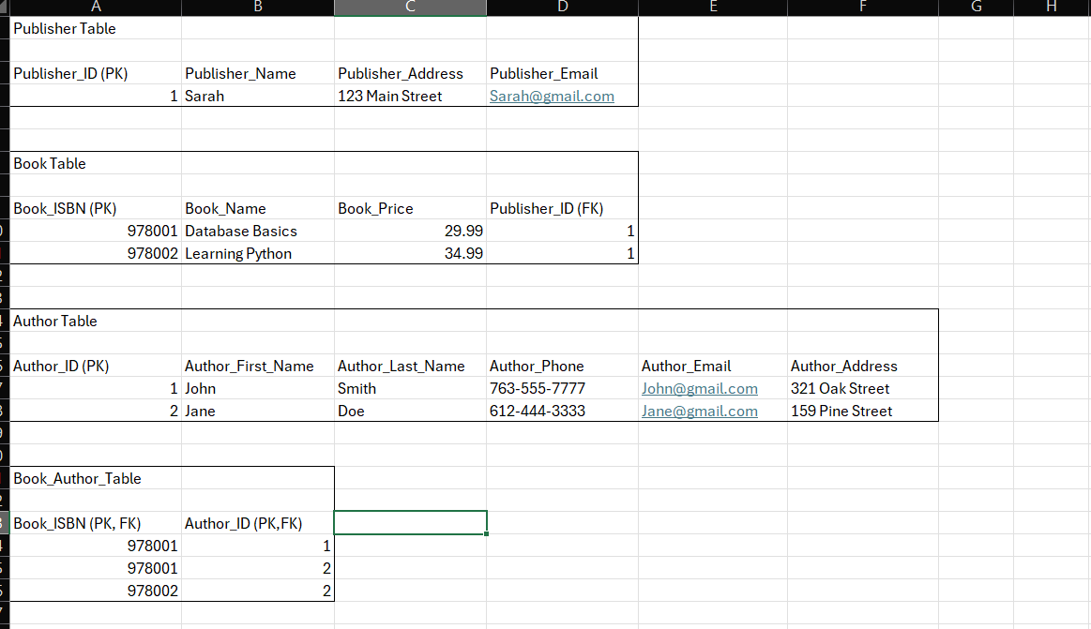

Assumptions
- Each book has a unique ISBN that identifies the book.
- Each book is published by one publisher, but a publisher can publish multiple books.
- An author can write multiple books, and a book can have multiple authors.
- Each publisher and author is assigned a unique ID to identify their records in the database.
These assumptions helped determine how the information was separated into four tables

