Mollee Beck
Assignment 1.2
GitHub Repository Setup

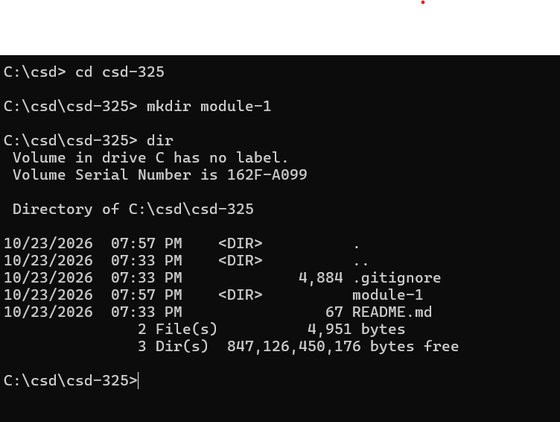

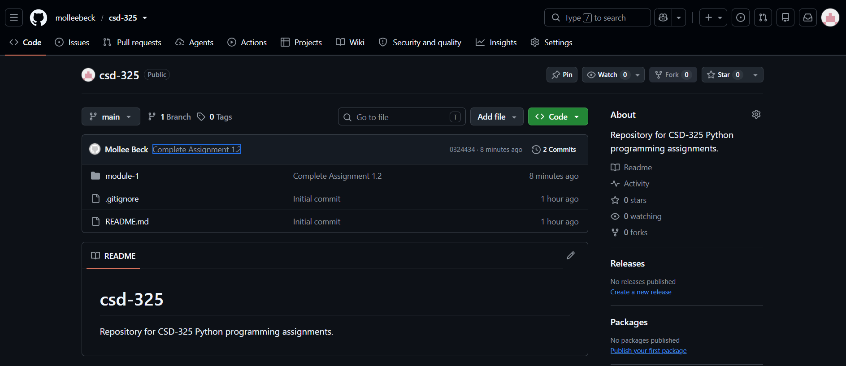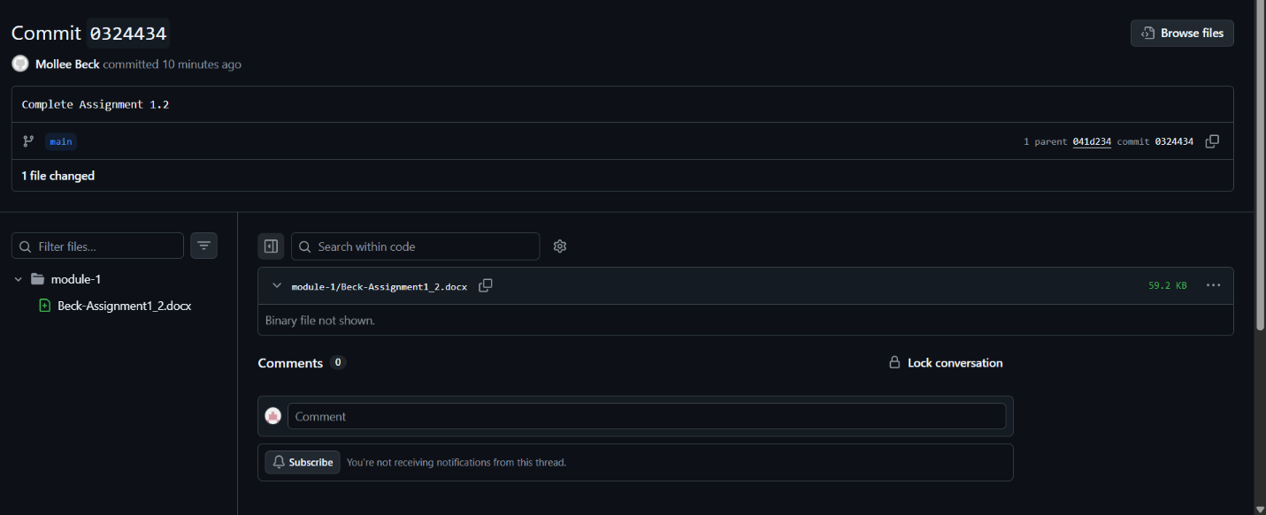

https://github.com/molleebeck/csd-325.git

