Mollee Beck
Assignment Documented debugging and flowcharts
Course: CSD-325

Breakpoint
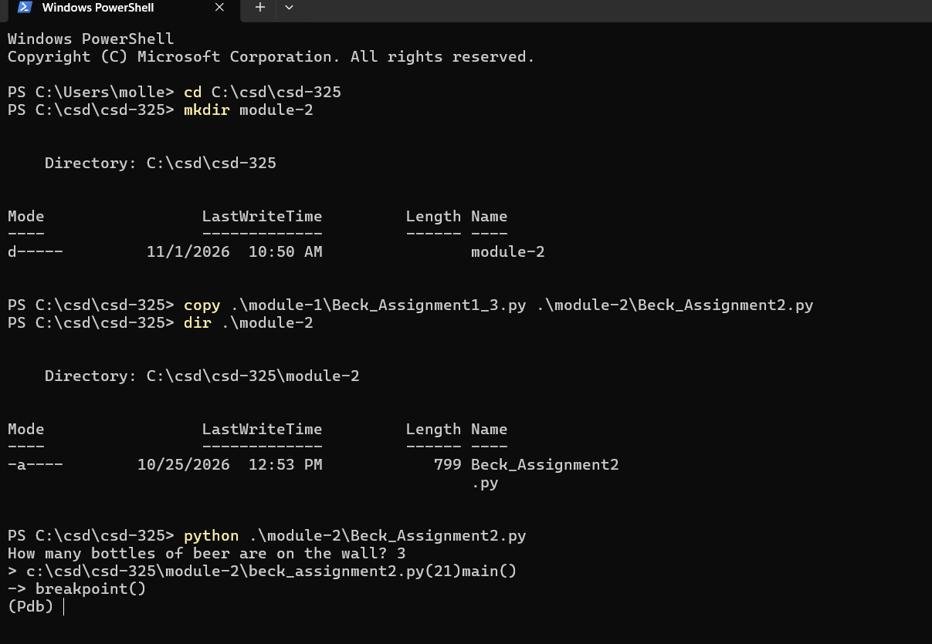

Stepping into the function
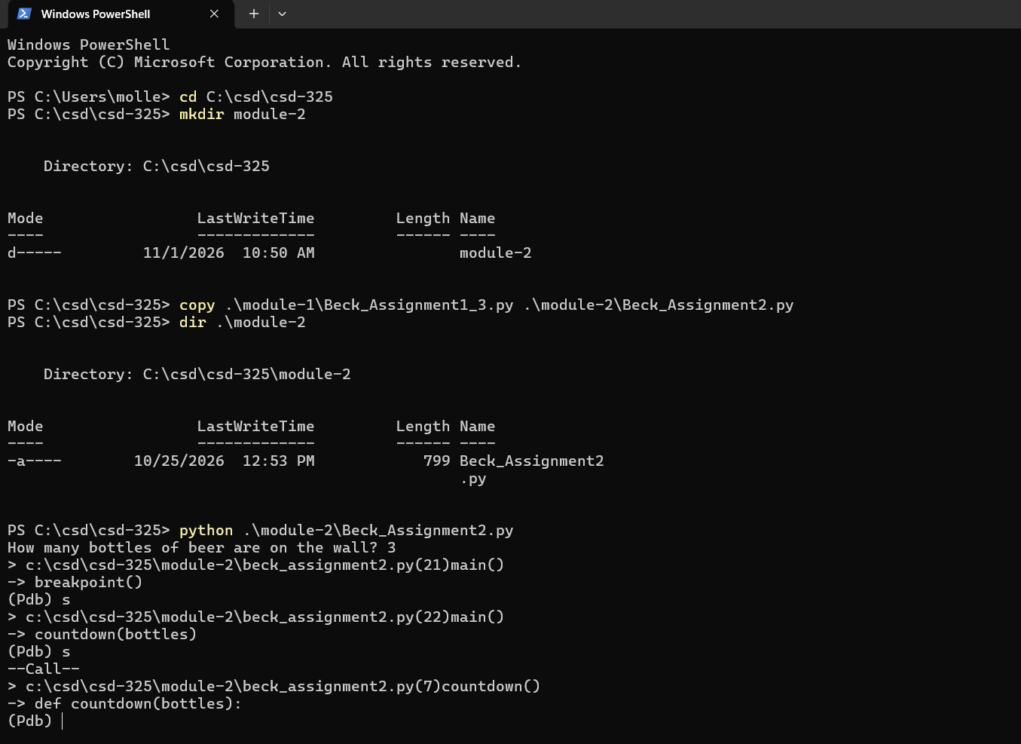

Variable Inspection


