Internship Assignment

Tittle: Image Identification in an Image

Table of Contents

Problem Statement ………………………………………………………......3
- Image identification Using OpenCV………………………………………...4
  - Introduction …………………………………………………………......4
  - Installation……………………………………………………………….4
  - Input Dataset…………………………………………………………......4
  - Implementation of OpenCV in Problem Statement……………………...4
  - Instructions for Program Execution……………………………………...5
  - Outputs in Screenshots…………………………………………………..6
- Image identification using K Means…….…………………………………...7
  - Introduction ……………………………………………………………..7
  - Introducing k-Means …………………………………………………....7
  - Elbow Method…………………………………………………………...7
  - Input……………………………………………………………………...8
  - Implementing KMeans in Problem Statement …………………………..9
  - K-Means + Proportion display ………………………………………...10
3. Conclusion ………………………………………………………………...12

Problem Statement

The Input is Given as an Image and the task is to Identify/Recognise the colours in that image

CHAPTER 1
Image identification using OpenCV

1.1 Introduction
OpenCV is a cross-platform library using which we can develop real-time computer vision applications. It mainly focuses on image processing, video capture and analysis including features like face detection and object detection.

1.2 Installation:
OpenCV can be Installed using below Command
# pip install pandas opencv-python

1.3 Dataset:
All the Colours are saved in a CSV file which includes their HEX Value Representation and RGB values individually.

1.4 Implementation of OpenCV in Problem Statement

#Importing Libraries
import cv2
import pandas as pd

# --------------------------------------------------------------------------
img_path = 'U14.png'
csv_path = 'colors.csv'

# reading csv file
index = ['color', 'color_name', 'hex', 'R', 'G', 'B']
df = pd.read_csv(csv_path, names=index, header=None)

# reading image
img = cv2.imread(img_path)
img = cv2.resize(img, (800,600))

#declaring global variables
clicked = False
r = g = b = xpos = ypos = 0

#function to calculate minimum distance from all colors and get the most matching color
def get_color_name(R,G,B):
minimum = 10000
for i in range(len(df)):
d = abs(R - int(df.loc[i,'R'])) + abs(G - int(df.loc[i,'G'])) + abs(B - int(df.loc[i,'B']))

if d <= minimum:
minimum = d
cname = df.loc[i, 'color_name']

return cname

#function to get x,y coordinates of mouse double click
def draw_function(event, x, y, flags, params):
if event == cv2.EVENT_LBUTTONDBLCLK:
global b, g, r, xpos, ypos, clicked
clicked = True
xpos = x
ypos = y
b,g,r = img[y,x]
b = int(b)
g = int(g)
r = int(r)

# creating window
cv2.namedWindow('image')
cv2.setMouseCallback('image', draw_function)

while True:
cv2.imshow('image', img)
if clicked:
#cv2.rectangle(image, startpoint, endpoint, color, thickness)-1 fills entire rectangle
cv2.rectangle(img, (20,20), (600,60), (b,g,r), -1)

#Creating text string to display( Color name and RGB values )
text = get_color_name(r,g,b) + ' R=' + str(r) + ' G=' + str(g) + ' B=' + str(b)
#cv2.putText(img,text,start,font(0-7),fontScale,color,thickness,lineType )
cv2.putText(img, text, (50,50), 2,0.8, (255,255,255),2,cv2.LINE_AA)

#For very light colours we will display text in black colour
if r+g+b >=600:
cv2.putText(img, text, (50,50), 2,0.8, (0,0,0),2,cv2.LINE_AA)

if cv2.waitKey(20) & 0xFF == 27:
break

cv2.destroyAllWindows()

1.5 Instructions for Program Execution:
- Double Click on Image portion to display respective Image Colour
- Press Esc button to close the window

1.6 Outputs in Screenshots: After performing Mouse Operation then its respective Name will be displayed on top
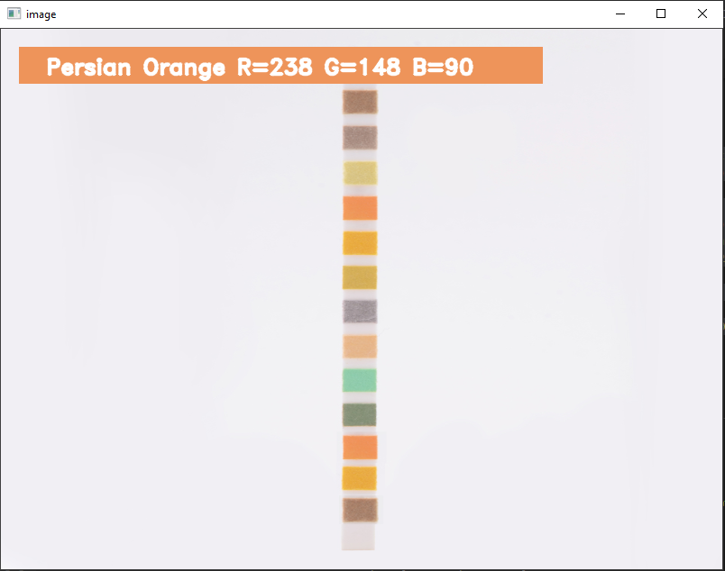
CHAPTER 2
Image identification using K Means

2.1 Introduction

Clustering algorithms seek to learn, from the properties of the data, an optimal division or discrete labelling of groups of points.
Many clustering algorithms are available in Scikit-Learn and elsewhere, but perhaps the simplest to understand is an algorithm known as k-means clustering, which is implemented in sklearn.cluster.KMeans.

2.2 Introducing k-Means
The k-means algorithm searches for a pre-determined number of clusters within an unlabeled multidimensional dataset. It accomplishes this using a simple conception of what the optimal clustering looks like:
- The "cluster center" is the arithmetic mean of all the points belonging to the cluster.
- Each point is closer to its own cluster center than to other cluster centers.
Those two assumptions are the basis of the k-means model.

2.3 Elbow Method:
A fundamental step for any unsupervised algorithm is to determine the optimal number of clusters into which the data may be clustered. The Elbow Method is one of the most popular methods to determine this optimal value of k.We now demonstrate the given method using the K-Means clustering technique using the Sklearn library of python

wcss = []
for i in range(1, 11):
kmeans = KMeans(n_clusters=i, init='k-means++', max_iter=3000, n_init=10, random_state=0)
kmeans.fit(image.reshape(-1,3))
wcss.append(kmeans.inertia_)
plt.plot(range(1, 11), wcss)
plt.title('Elbow Method')
plt.xlabel('Number of clusters')
plt.ylabel('WCSS')
plt.show()

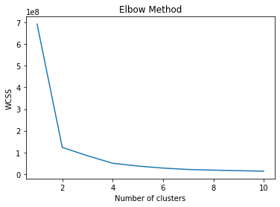

2.4 Input
OpenCV is used to read the images in the below format. OpenCV reads the image in BGV format so conversion is required from BGV to RGG
img = cv2.imread("/content/U14.png")
image = cv2.cvtColor(img, cv2.COLOR_BGR2RGB)
plt.imshow(image)
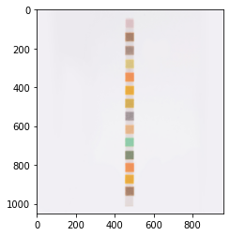

2.5 Implementing KMeans in Problem Statement

from sklearn.cluster import KMeans
import matplotlib.pyplot as plt
import numpy as np
import cv2
from collections import Counter
from skimage.color import rgb2lab, deltaE_cie76
import os
import pandas as pd

%matplotlib inline

from sklearn.cluster import KMeans

clt = KMeans(n_clusters=13)
clt.fit(image.reshape(-1,3))

An image with a height of 50, and a width of 300 pixels is created to display the colour groups/palette. And for each colour cluster, it is assigned to palette.

def palette(clusters):
width=300
palette = np.zeros((50, width, 3), np.uint8)
steps = width/clusters.cluster_centers_.shape[0]
for idx, centers in enumerate(clusters.cluster_centers_):
palette[:, int(idx*steps):(int((idx+1)*steps)), :] = centers
return palette

Method to Display the results
def show_img_compar(img_1, img_2 ):
f, ax = plt.subplots(1, 2, figsize=(10,10))
ax[0].imshow(img_1)
ax[1].imshow(img_2)
ax[0].axis('off') #hide the axis
ax[1].axis('off')
f.tight_layout()
plt.show()

clt_1 = clt.fit(image.reshape(-1, 3))
show_img_compar(image, palette(clt_1))
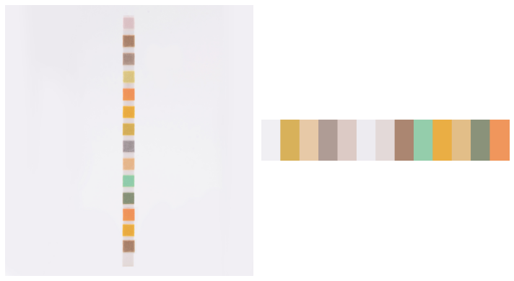

K-Means clustering gives great results in terms of the most common colours in the images. In the image, too many shades of Gray in the palette are visible. This is most likely because algorithm picked too many clusters. But result can still improve upon these results plus still solve the number of cluster issues by showing the proportion of the clusters towards the whole image

2.6 K-Means + Proportion display
This step involves the modification in palette function. Instead of using fixed steps, width of each cluster is changed to be proportionate to how many pixels are in that cluster.

from collections import Counter

def palette_perc(k_cluster):
width = 300
palette = np.zeros((50, width, 3), np.uint8)

n_pixels = len(k_cluster.labels_)
counter = Counter(k_cluster.labels_) # count how many pixels per cluster
perc = {}
for i in counter:
perc[i] = np.round(counter[i]/n_pixels, 2)
perc = dict(sorted(perc.items()))

#for logging purposes
print(perc)
print(k_cluster.cluster_centers_)

step = 0

for idx, centers in enumerate(k_cluster.cluster_centers_):
palette[:, step:int(step + perc[idx]*width+1), :] = centers
step += int(perc[idx]*width+1)

return palette

clt_1 = clt.fit(image.reshape(-1, 3))
show_img_compar(image, palette_perc(clt_1))



Chapter 3

Conclusion
Several techniques have been covered to get the most common colours in images using Python and Kmeans. So far, finding the most common colours using K-Means with k > 1 is one of the best solutions to finding the most frequent colours in images

