Genetic Algorithm

1 Objective
Students are required to understand the essential idea and the processing steps of genetic algorithm，to know how to implement the fitness function, to know how to solve mathematical optimization problems using genetic algorithm. Students are also required to know how to tune super-parameters of GA to get a good performance.

2 Environment

Python 3.5 or later, numpy and matplotlib packages

3 Experiment and Result
Objective: Compute the minimal value for the Rastrigin function below with genetic algorithm:
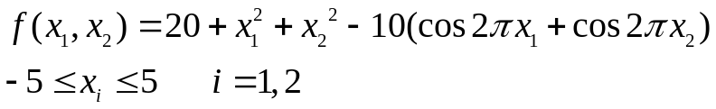

- Complete the functions “mutate(individual)” and “create_population()” in main.py
- After you finished task 1), run main.py to get the result after a while. Please a) provide the final results of x₁, x₂ and the found best value of the objective function f(x₁,x₂); b) is the found solution optimal (and reason)? c) attach the performance plot in your report, and explain the meanings of best Best curve and the Average curve within the plot.
- Try to play the super-parameters of GA by modifying the values of them. These parameters include SIZE_OF_POPULATION, CHANCE_OF_MUTATION, CHANCE_OF_CROSSOVER and NUMBER_OF_ITERATIONS, and see the changes of the solution and the performance plot. Try to explain these changes based on your understanding to genetic algorithm. NOTE: DO NOT HAVE STANDARD ANSWERS TO THIS TASK. YOU CAN DO ANYTHING YOU WANT BUT YOU SHOULD TRY TO EXPLAIN THE RESULT RATIONALLY.

4 Submission Information
Submit to the course platform in Chaoxing

