Topic:
Name:
Student ID:
Major:
Teacher:
Date:
（For the whole report, the font is Times New Roman, the size of level 1 title is 18, the size for level 2 title is 14, and the size of content is 12.）

Introduction
Handwriting recognition relates to written character identification. In order to select the best acceptable character, this challenge may be seen as a classification problem. We don't know how the author composed the letter. This goes against the online approach for the identification of characters where data can be sampled during writing. A character with a pointing device is an example of this writing on a touch screen. The full scene of the character we need to recognize is provided as an input in offline mode. The recognition complexity is normally linked to the size of the given language. If the language has more characters, it would be more harder to identify than if the language contains less characters. Likewise, we need to look at how different characters are written and how the characters differ. The performance of the handwriting detection system is always influenced.
  - The basic idea of the topic
We suggest in this work that genetic algorithms be used to solve this challenge. The main notion of a genetic algorithm is that it may be utilized as a great way to combine different typing styles with new types. In studying closely the capacity of the human mind to recognize manuals we discover that people are capable of recognizing characters, albeit for the first time they might view that style. This is feasible due to its capacity to depict the unknown nature of sections of the known styles. We strive to show the same power in the machines in this document.
The existing works and the reasoning behind the method are discussed in Section 2. The algorithm and its specifics are described in Section 3. Section 4 discusses the application of genetic algorithms. The testing of the algorithm and its results are covered in Section 5. Lastly, we provide the conclusion to section 6.
  - The development history (selective content)
Online handwriting acknowledgement research began in the 1960s and received considerable interest since the 1980s. Tappert e. al. (Tappert., 1988) (Tappert, 1990) examined the state of research and application before to 1990, while an assessment of the near current position, both online as well as offline, is provided, in the recent survey by Plamondon and Srihari (Plamondon, 2000). Nakagawa, (Nakagawa, 1990) and Wakahara, (Wakahara, 1992) offer insights on early works of recognition for Japanese character. Liu et al. (Liu, 2004) provided an online survey of the recognition of Chinese nature (OLCCR). Handwriting researchers also addressed online handwriting at the level of both character and sentence. Character methods can be employed at a higher level since they are made up of fundamental entities of low levels. The author examines the developments at all levels in this paragraph.
  - The research difficulties in this topic
In recent years, several investigators have carried out study on the identification of handwriting. While several issues have been resolved, many problems still exist. The handwriting system recognition is still unrivaled to human recognition despite the availability of computing capacity and the advances accomplished so far. As already noted, no two people have the same manuscript and no two sets of same person's manuscripts with the same 12 words are precisely the same. The diversity might include the leaning between persons, the size of characters, the form and how the characters in hand writing are cursive or disjunctive. Handwriting changes can be defined as well. Handwriting changes may also apply in terms of the applications, even though handwriting is typically controlled by boxes for off-line handwriting applications such as forms processing. A random handwriting sample obtained from the IRONOFF database reveals these variations in Figure 1.8. Additional variants are presented in Figure 1.9 modified (Tappert, 1994).
For broader lexicons, it is impossible to recognize the entire term. Because the recognition information they carry can not be shared across words because, as each word is processed separately, the more the lexicon size, the bigger the recognition model is. Due to this restriction, several words recognition systems utilize smaller units, either a character or a character less than one character, as the fundamental model (sometimes termed as pseudo character or grapheme). The model utilized with words is the combination of the fundamental character or subcharacter model. The model used for word recognition Thus, a greater number of word models does not equal a larger lexicon. It simply implies building the new word model from the small-scale model that exists. The words must then be separated into smaller parts. This generates a number of additional difficulties. Certain words are highly cursively written while certain authors prefer to write unassembled characters when writing a word. Yet, as can be seen in Figures 1.8 and 1.9, some blend between cursive and disjointed without any specific pattern or order. The lexicon plays a vital part in the segmentation process as the recognition process decide the optimal and final segmentation points in the segmentation-based words recognition system.
  - The effect or the meanings or applications of this research

Offline handwriting recognition applications are numerous: postal addresses, bank check amounts and forms are read. Moreover OCR plays a vital function for digital libraries, which makes it possible, via digitisation, image restore and recognition procedures, to enter textual image information on computers.

2. The Common Approaches

2.1 General Procedure
The recognition of handwriting is a renowned problem, involving the recognition of any input provided via picture, scanned paper, etc. Handwriting recognition includes the following stages in general:
• Segmentation: The breakdown of lines, words and eventually all characters is addressed in this stage. This phase includes identifying and isolating the limits of the character for subsequent processing. We presume this step has already been taken in this algorithm. Therefore, the input to our system is one feature.

Preprocessing: this phase comprises the first processing of the picture, so that the recognition system may be utilized as an input. We presume that some of this step has been taken in this algorithm. We suppose that the segmented character is narrow in the thickness of one unit. For this aim, different algorithms may be employed. Our algorithm does further processing.

• Acknowledge: when the input picture is readily available, it may be processed for acknowledgment. Identifying the character is a role of the recognition system. As an input for the same, our algorithm utilizes an image.

2.2 Procedure

Once the requirements have been satisfied, the system will receive the picture input. The algorithm recognizes this. As seen below, the algorithm is.

2.2.1 HandwritingRecognition(Language,TrainingData,Inpu tImage)
Step1: For every character python in language
Step2: For every input i for the character c in test data
Step3: Generate Graph g_{ci} of i
Step4: Generate graph t of input image
Step5: For every character python in language
Step6: Use Genetic Algorithm to generate hybrid graphs
Step7: Return character corresponding to graph with the minimum most fitness function (out of the graphs generated in any genetic operation)

2.3 Genetic Algorithm

Genetic algorithms are an excellent way to optimize certain issues. By creating hybrid solutions from existing solutions, you optimize the desired property. The solution pool is supplemented with these hybrid solutions and may be utilized to produce more hybrids. These solutions can be superior than the already created ones. The genetic operators, who define and apply the problem, perform all this. We have previously produced a collection of graphs for each character from training data. Genetic algorithms are used to mix 2 graphs of this type and to create new graphs. These graphs can fit the character more well than the previous graphs.

4 Fitness Function
The fitness function in genetic algorithms is used to assess the quality of the result. This function shows the amount of goodness when applied to any solution from the solution pool. We utilized fitness function in our issue to assess the difference in the diagram of the answer to the unknown input. The variance would be little if the two graphs were highly similar, and the fitness function value would be small.
2.4.1 Deviation between two edges: : We construct the function D(e1,e2), which determines the deviation of any edges of the chart, with any edge of the other chart in order to discover the deviation between the two rand (e2). The curve or line might be an edge here. However, the starting point of e1 may correspond to the beginning point of e2 and the end point of e1 might match e2. The conversation may also be feasible. The start point of e1 can match e2's end point and e1's end point can equal e2's starting point. Figure 5(a)- shows this (c). Therefore the deviation is calculated using two individual examples (D1 and D2) and the minimum of two is the actual deviation. D₁ represents the case where the start vertex of e₁ matches with the start vertex of e₂. The end vertex of e₁ matched with the end vertex of e₂.
In general
D₁(e₁,e₂)=square of distance of start points of e₁ and e₂ +
square of distance of end points of e₁ and e₂
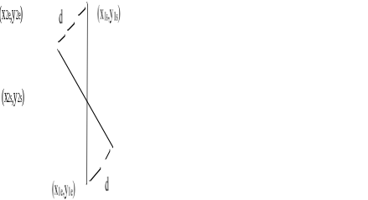
If e1 is a line, however, while e2 is a curve or vice versa, an additional μg cost is applied. If both e1 and e2 are curves and the start and end points of e1 are fewer than β units apart (it is almost circular), then instead of the end points in the preceding calculation you take the point of greatest distance. The maximum point of distance here is the place in the curve that is at the highest distance from the curve starting point. Figures 1 and 2 illustrate this.

Figure 1: Calculating D1 with 2 lines
D2 is where the beginning vertex of e1 corresponds with the end vertex of e2. The top end of e1 corresponded with the top end of e2. e2. Similarly, the following formula calculates D2(e1,e2)
D2(e1,e2)=distance square to e1 starting point and e2 ending point + ending point square to e1 end and to e2 startingpoint

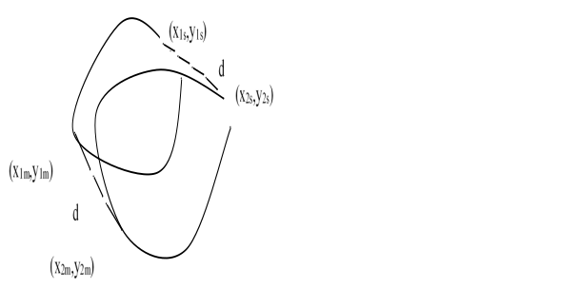

Figure 2: Calculating D1 with 2 curves
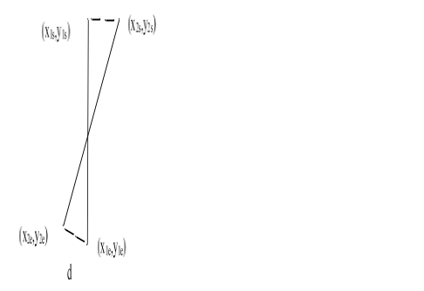
d

Figure 3: Calculating D2
Additional criteria remain the same as in D1 calculation (e1,e2). Figure 5 illustrates how (c). The difference between two edges is computed by a formula as follows:
D(e1,e2)=min
{D1(e1,e2),D2(e1,e2)}
If either e1 or e2 is zero, we even generalize the formulation. This implies we can identify a line or curve that is deviating without anything. This is a characteristic that is helpful in the detection of graphic differences when two graphs have uneven borders. The formula is: In these cases:
D(e1,null) or D(null,e1) = Distance from line/curve start and finish.
If e1 is curve and the beginning and end points of e1 are less than a β-unit apart (it is almost circular), then in lieu of the end points in the calculation above we will pick a maximum distance. The maximum point of distance here is the place in the curve that is at the highest distance from the curve starting point. Assume the rim e1 has beginning points (x1s,y1s) and end points as in the first graph (x1e,y1e).
Similarly assume, in the second graph, edge e2 have beginning points (x2s,y2s) and ending points (x2e,y2e). The greatest distance between the e1 and e2 is (x1m,y1m) (x2m,y2m). The above formula may alternatively be described as:
D1(e1,e2) = (x1s-x2s)2+(y1s-y2s)2+(x1e-x2e)2+(y1e-y2e)2 if (e1 is line and e₂ is line) or (e₁ is curve and e₂ is curve and the
distance between (x_{1s},y_{1s}) and (x_{1e},y_{1e}) is less than β units)
D1(e1,e2) = (x1s-x2s)2+(y1s-y2s)2+(x1e-x2e)2+(y1e-y2e)2 + η if
(e₁ is line and e₂ is curve) or (e₁ is curve and e₂ is line)

D1(e1,e2)= (x1s-x2s)2+(y1s-y2s)2+(x1m-x2m)2+(y1m-y2m)2 if
(e₁ is curve and e₂ is curve and the distance between
(x_{1s},y_{1s}) and (x_{1e},y_{1e}) is less than β units)

D2(e1,e2) = (x1s-x2e)2+(y1s-y2e)2+(x1e-x2s)2+(y1e-y2s)2 if
(e1 is line and e₂ is line) or (e₁ is curve and e₂ is curve and the distance between
(x_{1s},y_{1s}) and (x_{1e},y_{1e}) is more than β units)

D2(e1,e2) = (x1s-x2e)2+(y1s-y2e)2+(x1e-x2s)2+(y1e-y2s)2 + η if
(e₁ is line and e₂ is curve) or (e₁ is curve and e₂ is line)

D2(e1,e2)= (x1s-x2m)2+(y1s-y2m)2+(x1m-x2s)2+(y1m-y2s)2 if
(e₁ is curve and e₂ is curve and the distance between
(x_{1s},y_{1s}) and (x_{1e},y_{1e}) is less than β units)

D(e₁,e₂)=min{D₁(e₁,e₂),D₂(e₁,e₂)} if both e₁ and e₂ are not null
D(e1,e2)= (x1s-x1e)2+(y1s-y1e)2 if e2 is null
D(e1,e2)= (x2s-x2e)2+(y2s-y2e)2 if e1 is null
2.4.2 Deviation of a graph: After we know the edge deviation with a different edge, the graph deviation may simply be discovered. This deviation is detected when the edges are paired and iterated across all the edges. As seen below, the algorithm is.
Deviation(G₁,G₂)
Step1: dev ← 0
Step2: While G₁ has no edges or G₂ has no edges
Step3: Find the edges e₁ from first graph and e₂ from second graph such that deviation between e₁ and e₂ is the
minimum for any pair of e₁ and e₂ Step4: Add its deviation to dev
Step5: Remove e₁ from first graph and e₂ from
second graph
Step6: For all edges e₁ left in first graph
Step7: Add deviation of e₁ and null to dev
Step8: For all edges e₂ left in second graph
Step9: Add deviation of null and e₂ to dev
Step10: Return dev
We can see here that the overall deviation is minimized. For this purpose the pair of edges is selected, one of each graph is so little their difference. We continue to pick these pairs until a graph is empty. We thus continue to maintain the minimal overall deviation. Finally, all left edges or curve deviations will be included. This shows the smallest difference between the two graphs.

Crossover

CrossOver(G₁,G₂)
Step1: match ← MatchPoints(G₁,G₂) (Find points in G₁
corresponding to G₂ and vice versa)
Step2: W₁ ← GenerateAdjacency(G₁) (Generates the
Adjacency Matrix of the Graph)
Step3: W₁ ← GenerateAdjacency(G₂)
Step4: if W₁ ≠ W₂
Step5: FindPaths(W₁) (Finds the paths of all lengths between any pair of points)
Step6: FindPaths(W₂)
Step7: p₁ ← path between vertices v₁ and v₂ in
G₁ of length l, for all v₁, v₂ in W₁ and length l= 1 or 2 or 3 or 4
Step8: p₂ ← path between vertices match[v₁] and match[v₂] in G₂ of length l₂=1 or 2 or 3 or 4
Step9: If p₁ exists and p₂ exists and p₁ ≠ p₂ Step10: Remove all edges from W₁ that
are found in p₁
Step11: Add all edges in W₁ that are
found in p₂
Step12: g ← MakeGraph(W₁,W₂)
(Generate graph out of Adjacency matrix of W₁)
Step13: Add g to solution set
Step14: else g ← MakeGraph(W₁,W₂)
Step13: Add g to solution set
Each of the steps is discussed below in the further sections
4.2.3 Matching of points: The algorithm for points matching in both graphs is defined first. If a point in graph 1 is stated to correspond to a point in graph 2, the equivalent reference in graph 1 to that of the matching point in graph 2 may be assumed. Assume that both chart 1 and chart 2 represent the two styles in which I have written. Assume that point s1 in graph 1 is the top left point. When we state that point s1 matches the point s2 in figure 2, we can infer that point s2 in diagram 2 is the top line's leftest point. Figure 4 illustrates this. As seen below, the algorithm is.
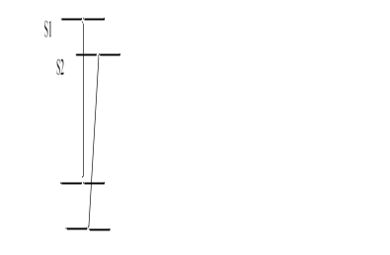

Figure 6: The matching of points in 2 graphs

MatchPoints(G₁,G₂)
Step1: ver₁← all unique points in first graph which are at least β units distance apart from each other Step2: ver₂← all unique points in second graph which are at least β units distance apart from each other
Step3: match ← null
Step3: While ver₁ is not null or ver₂ is not null
Step4: match[s₂] ← s₁ such that s₁ is a vertex in ver₁ and s₂ is a vertex in ver₂ and distance between s₁ and s₂ is least for any combination of vertices in ver₁ and ver₂
and distance between s₁ and s₂ is less than 2β units
Step5: Remove s₁ from ver₁
Step6: Remove s₂ from ver₂
Step7: For all vertex v in ver1
Step8: match[v] ← v
Step9: For all vertex v in ver₂
Step10: match[v] ← v
4.2.4 Generate Adjacency Matrix: The next step is to change the diagram after the spots are recognized and matched. For this problem, we utilize the graphic representation adjacency matrix method. We know that, since the path from a node x to a node y is a non-directional characteristic of the node y to the node x. That indicates that the last matrix of adjacence (W) is symmetric. We also know that a curve and/or a line can link any two locations simultaneously. For each pair of vertices I and j we thus use the following convention to represent a cell of Wij in the adjacent matrix.
W_{ij} = 0 (If the node i is not directly connected by the node
W_{ij} = 1 (If the node i is directly connected by the node j by only 1 line)
W_{ij} = 2 (If the node i is directly connected by the node j by only 1 curve)
W_{ij} = 3 (If the node i is directly connected by the node j by only 1 line and 1 curve)
All other states are invalid. The algorithm for the generation of the adjacency matrix is given below.

Generate Adjacency(G)
Step1: W ←0
Step2: For all edges e in graph joining points i and j
Step3: W_{ij} ← W_{ij}+1 (if e is a line)
Step4: W_{ij} ← W_{ij}+2 (if e is a curve)
Step5: W_{ji} ← W_{ij}
Step6: Return W
4.2.5 Find Paths: The next step is to identify the route of all distances between all pairs of locations once we have produced the adjacence matrix. This is necessary for the algorithm to function. This phase makes the data generated directly into the next stage. To overcome this difficulty, we employ the notion of dynamic programming.
We know we've got a diagram. There are several vertices here. We are limited to roads with a maximum length of four for this challenge. This leads to the problem of finding a path p, from a summit I to a summit j at exactly l distance. In this case I and j can accept values of 1, 2, 3 or 4. We define a F(i,j,l) variable that saves the route. It retains the latest spinal cord passed by through route l from I to j. If a path cannot be found, it keeps zero
We also know that paths are only feasible with single length (i=1) if the edges between vertex I and vertex j are direct. Hence
F(i,j,l) is defined as follows
F(i,j,0)=i, if edge (i,j) exists or edge (j,i) exists
F(i,j,0)=null, otherwise
And
F(i,j,l)= null, if there is no path possible of length l (l ≠ 0) between vertex i and vertex j.
F(i,j,l)= k, if there is a path possible of length (l-1) between vertex i and vertex k and j is directly connected to
j(l≠0)
This can also be written as
F(i,j,l)= k, if F(i,k,l-1) exists and (vertex (k,j) exists or
vertex (j,k) exists), l ≠ 0
F(i,j,l)= null, otherwise
- Therefore we may discover using this connection whether the length path l exists between the I and j nodes. If it is present, it is not zero in F(i,j,l). If the path exists, the path may be found by iterating the value of F(i,j,t) from l to 0. We may thus identify the exact route connecting the two vertices.
However, we need to address the following points throughout the execution of the algorithm:
• Maximum once in each route, any vertex may occur. We must make sure that we do not add a point two times throughout the whole way from I to j before making any decision for k in the preceding formula of F(i,j,l).
• The preceding formula of F can be satisfied by various k values (i,j,l). In that case, all these potential k values are first identified and then randomly selected.
4.2.6 Removing and adding edges: As stated above in the crossover approach, we use the aforementioned data to discover routes between two locations in the first and second graphs. If both pathways are discovered, the first path edges are removed and the second path edges are added from G1. We may therefore blend two separate diagrams and get a new one.
Various additions or removals may nonetheless be available. We take care of the following requirements while deleting an edge from vertex I to a j vertex in the chart to keep the diagram consistent.
If W_{ij}=0, or in other words there exists no edge from i to j, we break the operation
If W_{ij}=1 or in other words there exists a line from i to j, we remove the line
If W_{ij}=2 or in other words there exists a curve from i to j,
we remove the curve
Wij is equivalent to Wji after the procedure
In this case, Wij refers to the graph 1 adjacence matrix for the removal operation. Here we ensured that Wij is between 0 and 3, which are the only permissible values that it may take, once the transaction is complete.
We also make sure after the operation Wij should be between 0 and 3 and Wij should be identical to Wji while added a rib from vertex I to a vertex j on the chart.
Mixing graphs may produce numerous unlikely graphs. We save the solution from obtaining incorrect data by properly inspecting and splitting down activities.
4.2.7 Generation of graph: The final step is to transform the graphs into the edges list in the form of adjacency matrix. Here another type of optimisation must be taken into account. This is the algorithm's distance optimisation. As previously, we discovered the corresponding vertices between the two graphs in the method. We match the top of the first diagram to the next of the second diagram and vice versa in this procedure. The objective was to say that the corresponding vertices on both diagrams are similar to each other. We therefore said that if the first graph of a vertex s1 matches a two-group vertex s2, it indicates s2 is played in the second diagram in the first diagram.
GenerateGraph(W)
Step1: for all vertex i W
Step2: | for all vertex j in W that come after or at i
Step3: | if W_{ij} > 2
Step4: | add a curve from x to y
Step5: | W_{ij} ← W_{ij} - 2
Step6: | if W_{ij} =1
Step7: | add a line from x to y
Here x=mean of vertices i in first graph and the corresponding matching vertex of i in second graph
(vertex k such that match[k] ← i)
y=mean of vertices j in first graph and the corresponding matching vertex of j in second graph (vertex k such that match[k] ← i)

Results
We coded the algorithm to check the algorithm's functioning. As a language, Python was utilized. The entry in the form of the photographs was supplied. In the form of pictures, the test data were also preserved. We used the method for the English language's major letters. There are 26 characters in the language. We initially wrote every letter twice in order to build the database. When we first wrote the letter properly, we are taught how. We utilized a raw hand for the second time to introduce some flaw. Letters like A were connected with various kinds of styles. We have thus written these letters more than needed. The input data set was created in numerous ways by writing each character many times. The hand movements was shook when the test data was written in order to create unforeseen flaws. The initial processing of the training data was the algorithm. Then the test data was executed by iterating one by one through the test data.
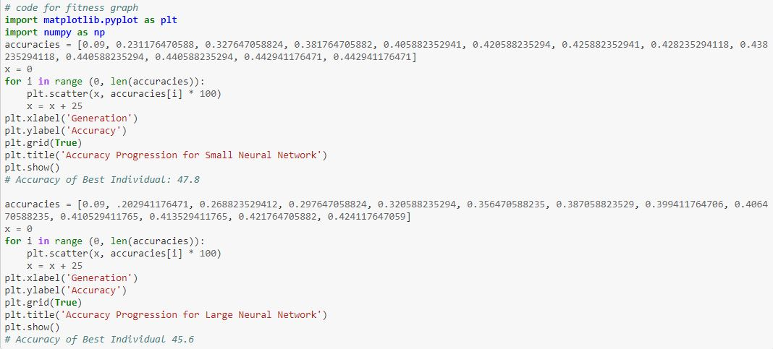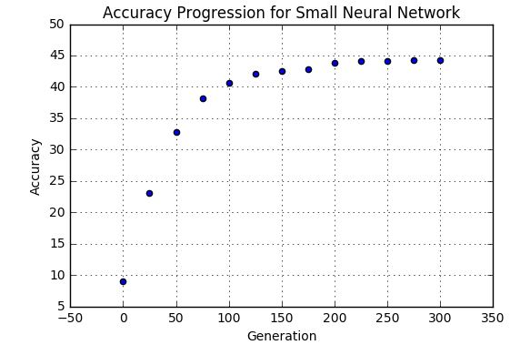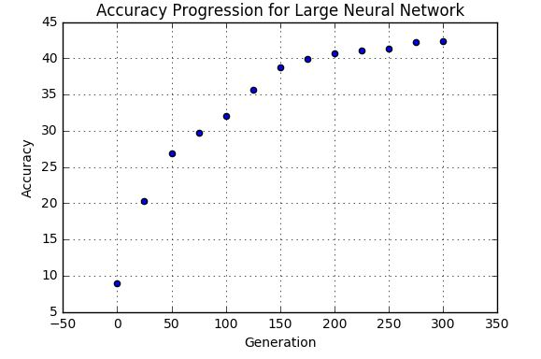

Style Optimization
We have already spoken about how efficient the algorithm is to blend two styles and create a combination of styles. This algorithm feature is very helpful for the operation of the algorithm in order to create newer and newer styles. We gave two different Bs in the training data of B in the training data set. Without genetic algorithms, the two could not match the data entry. On the other hand, a large departure from the letter S was determined to be the best match. However, the B matched correctly when the same was done with genetic Algorithms. The diagrams, training data and the outcomes obtained by genetic engineering are presented in Figure 8. Here the top curve of first training data was added to the second training data’s top set of lines. The genetic algorithm was applied across the vertical top line.
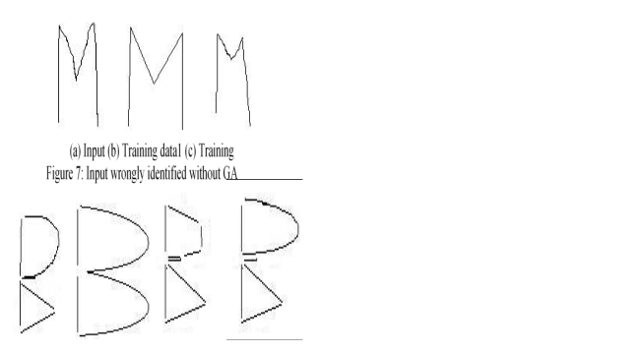

Figure 8: Input identified wrong without genetic algorithm

3. Discussion
We suggested that evolutionary algorithms and graph theory be used in this work to solve the offline handwriting recognition challenge. In the form of pictures, we provided the input. The algorithm has been trained on the first training data in the database. There were at least two training data sets per language character. In order to transform pictures to graphs, we have utilized graph theory and geometry coordinate. We observed that the whole challenge of handwriting recognition has transformed to the problem of graph matching. Appropriate results have been achieved when a pure graph matches. The algorithm could recognize unknown characters given as input. But the efficiency improved drastically when we applied genetic algorithms. Unknown characters can be recognized as an input by the algorithm. However, the effectiveness of genetic algorithms has dramatically increased. This method helps to optimize styles as well as distance. It enabled us to blend two separate styles in order to create a new one between the two types. The result was a mixture of two graphs across two points. We have seen how it helped character B identify. We have also seen how the algorithm has helped optimize the distance. The start and end point of the vertices were converted so that they could match the unknown data input more effectively. This was done through the use of mean parent vertical coordinates. We have seen how it contributed to letter M identification. In total, we have 98.44 percent efficiency, which demonstrates that in most situations this algorithm works and has matched the unknown input with their character.

