LAB Logbook

Lab 1
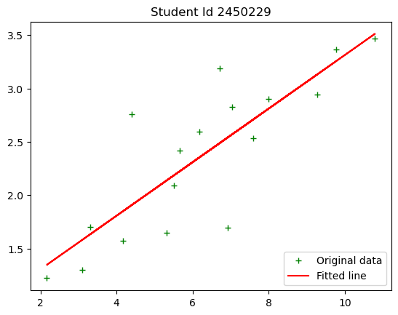
Lab 2
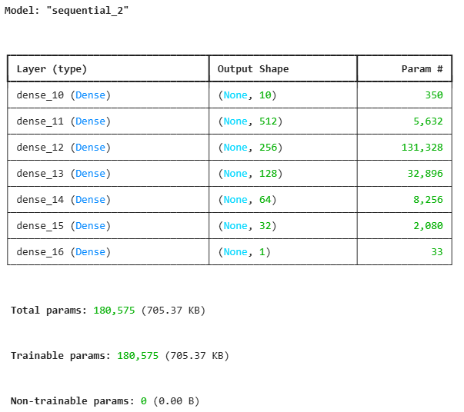
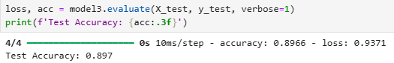
O1=0.823895641
O2=0.823895641
Lab 3
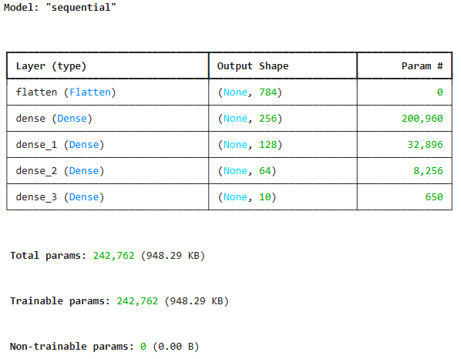

Lab 4

Lab 5

Lab 6

Lab 7

Lab 8

Lab 9

Lab 10

Lab 11

Lab 12

