The term ‘eigenface’ is commonly used within facial recognition and detection, <https://towardsdatascience.com/eigenfaces-recovering-humans-from-ghosts-17606c328184> , and can be described as a key facial feature, but to be used to it’s full potential there is typically a collection of eigenfaces, each representing key features of a face, for example one has bushy eyebrows, one has a thin nose, but most importantly in this case, one or more can represent having a moustache. Each eigenface is just an eigenvector ascribed to their own ‘face’, with their selection based on their difference from the average face.

To calculate or ‘find’ these eigen faces, the provided face data is converted into the form of columns within a matrix. This matrix’s rows are then averaged, providing the average face with the given data set, the visualisation can be seen as Fig. 4.

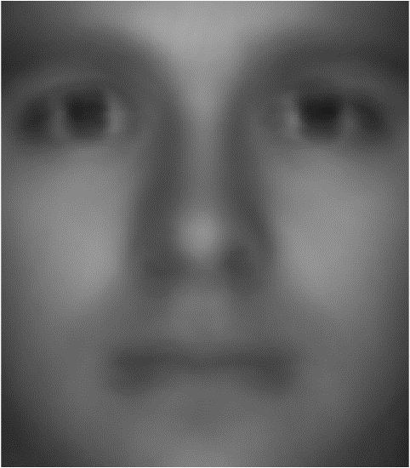

Figure 1, The average or 'mean' face of the data

Typically, a compact, or economical singular value decomposition (SVD) is then applied to the difference between the average face and face data matrix, giving us U, Sigma and V and reducing the matrix and ordering each face from most to least visually different, based on the values of sigma, but for this data set there are 36 different faces from different angles, so the process is slightly tweaked. Each ‘person’ a collection of 29 image, so these 29 images are averaged, and these averages are attributed to their own columns in matrix ‘B’. The compact SVD is applied to the difference between matrix B and the average face, creating our data sets eigen faces. A visual array is then created of the first 20 eigenfaces, see Fig 5.

Report: Present the mathematical explanation of how to build a rudimentary moustache detector by projecting onto -dimensional "eigenface space". (~1/2 -- 1 page).

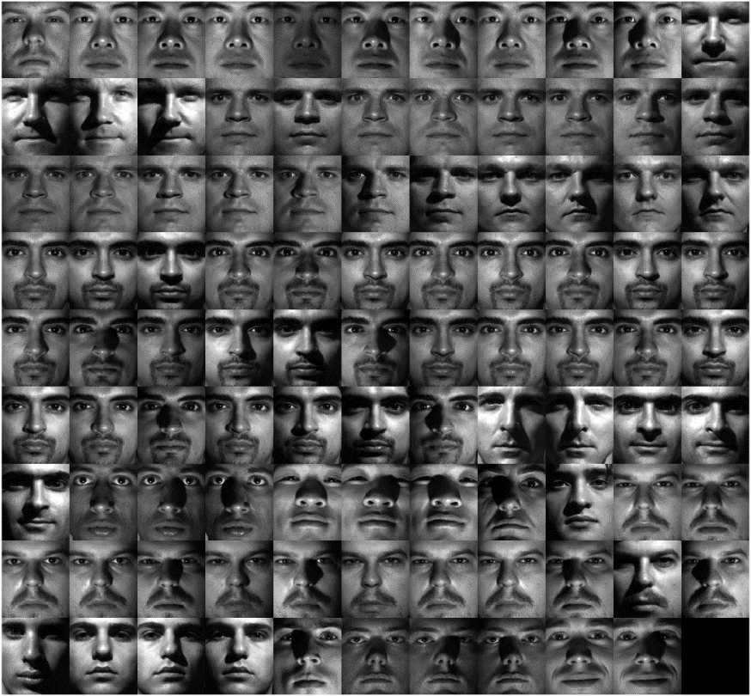To create a moustache detector, two values must first be defined. The first being how much darker the moustache area is compared to the mean face ‘x’, for this program a value of 5 is used, and a value for how much darker the moustache area is compared to the rest of the individual face ‘y’, for this a value of 8 is used, bear in mind the brightness is on a scale of 0 to 255. For each face the average brightness of the pre-determined moustache area, the average brightness of the particular face, the difference between the average brightness of the moustache area and face, and the difference between the average brightness of the moustache area and average face are all calculated. If the moustache and mean face have a difference greater than x and the moustache and particular face have a difference grater than y, then the face is counted as having a moustache and added to an array, see complete array in fig 6