Part I:

1)



2)

| **Season** | **fdensity** | | **fit** | | **lwr** | | **upr** | |
| --- | --- | --- | --- | --- | --- | --- | --- | --- |
|  |  |  | |  | |  | |  |
| **1** | spring | 6 | | 1.1113333 | | 0.6354950 | | 1.587172 |
| **2** | summer | 6 | | 3.8866667 | | 3.4108283 | | 4.362505 |
| **3** | spring | 12 | | 1.1110000 | | 0.6351616 | | 1.586838 |
| **4** | summer | 12 | | 2.8866667 | | 2.4108283 | | 3.362505 |
| **5** | spring | 24 | | 0.6946667 | | 0.2188283 | | 1.170505 |
| **6** | summer | 24 | | 2.0000000 | | 1.5241616 | | 2.475838 |

3)

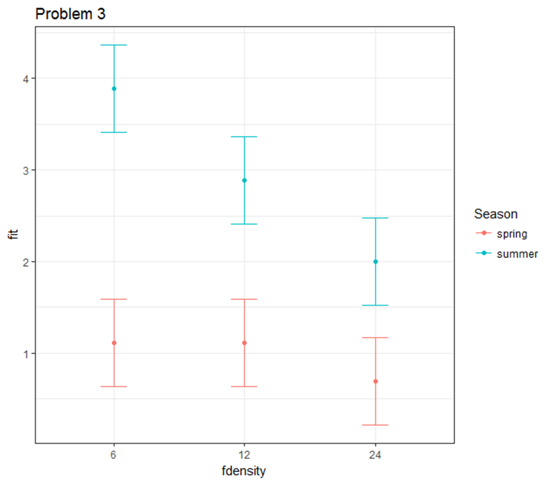

Part II:

####Jenkins A2####

#ENEC563

#Assignment 2

# 02/10/2017

#Generate an "effects" graph for your final egg count model from Assignment 1 paralleling the example done in class.

#Plot all the regression parameter estimates (except the intercept) along with 95% confidence intervals.

#Using your final egg count model from Assignment 1 obtain estimates of the "treatment" means, their standard errors,

#and 95% confidence intervals for the means.

#Use the information you calculated in Question 2 to produce an interaction graph of your model like the one done in class.

#Place "Density" on the x-axis and show two mean profiles, one for each "Season".

#Add 95% confidence intervals for the means and include a legend that clearly identifies which profile corresponds to which season.

#setwd("C:/git/core-transient/")

#ref answer key from A1; needed to overlay pred from models on obs

library(wesanderson)

library(dplyr)

library(car)

library(ggplot2)

####Pre-assignment analysis prep (from Assignment 1, corrected)####

quinn1 = read.csv("https://sakai.unc.edu/access/content/group/7d7a0e1c-4adb-4ee2-ace8-490a89313a59/Data/quinn1.csv", header = TRUE)

quinn1$total_eggs = quinn1$Eggs*quinn1$Density

spr_mean = mean(quinn1$Eggs[quinn1$Season == "spring"])

spr_median = median(quinn1$Eggs[quinn1$Season == "spring"])

sumr_mean = mean(quinn1$Eggs[quinn1$Season == "summer"])

sumr_median = median(quinn1$Eggs[quinn1$Season == "summer"])

quinn1$fdensity = as.factor(quinn1$Density)

mod1 = lm(Eggs~Season*fdensity, data = quinn1) #straight vs curved -> curved better bc was simpler model

mod2 = lm(Eggs~Season+fdensity, data = quinn1) #adding nonlinearity to model doesn't increae overfitting by much

mod3 = lm(Eggs~Season, data = quinn1)

mod4 = lm(Eggs~fdensity, data= quinn1)

summary(mod1)

anova(mod1)

summary(mod2)

anova(mod2)

summary(mod3)

anova(mod3)

summary(mod4)

anova(mod4)

quinn1$modelpreds = predict(mod1,newdata=quinn1)

theme_set(theme_bw())

ggplot(quinn1,aes(x=fdensity,y=modelpreds,color=Season))+geom_point()+

geom_line(aes(group=Season))+labs(y="Eggs laid",x="Limpet density")

coefs = coef(mod1)

#overall # of eggs does go down with density but is also much greater in the summer compared to spring

####Assignment 2 unique work####

#Problem 1

parests = coef(mod1)

vcov(mod1)

par.se <- sqrt(diag(vcov(mod1)))

upper95 <- parests+par.se*qt(.975,df.residual(mod1))

lower95 <- parests-par.se*qt(.975,df.residual(mod1))

parplotframe <- data.frame(varlabels=factor(names(parests), levels=names(parests)),

parests,lower95, upper95)

parplotframe2 = parplotframe[2:length(parplotframe$varlabels),] #removing intercept

theme_set(theme_bw())

ggplot(parplotframe2,aes(y=varlabels,xmin=lower95,x=parests,xmax=upper95))+labs(title = "Problem 1")+

geom_errorbarh(height=.2)+

geom_point()+geom_vline(xintercept=0,linetype=2)+

labs(y="",x="Estimated Effect")

#Problem 2

predparms <- with(quinn1,expand.grid(levels(Season),levels(fdensity)))

predparms

names(predparms) <- c("Season","fdensity")

plotframe3 <- data.frame(predparms,predict(mod1,newdata=predparms,

interval="confidence", level = .95))

#Problem 3

theme_set(theme_bw())

ggplot(plotframe3,aes(x=fdensity,y=fit,ymin=lwr,ymax=upr,color=Season))+labs(title = "Problem 3")+

geom_errorbar(width=.2)+

geom_point()

+geom_line()

round(summary(mod1)$coefficients,3)