**INSTRUCTIONS TO CREATE A YEAR’S WORTH OF CBOC SIGNIN SHEETS AT ONCE**

* Open “CBOC_sign_in_sheet_project” folder
* Open “dist” folder
* Open “cbocSigninSheetCreator” folder
* Double click on “cbocSigninSheetCreator.exe”
* If windows defender pops up saying the app is unrecognized, click on "More info”. This application is harmless (all code written by myself), it is just not recognized because I am not a known publisher/it’s not “signed” as such.

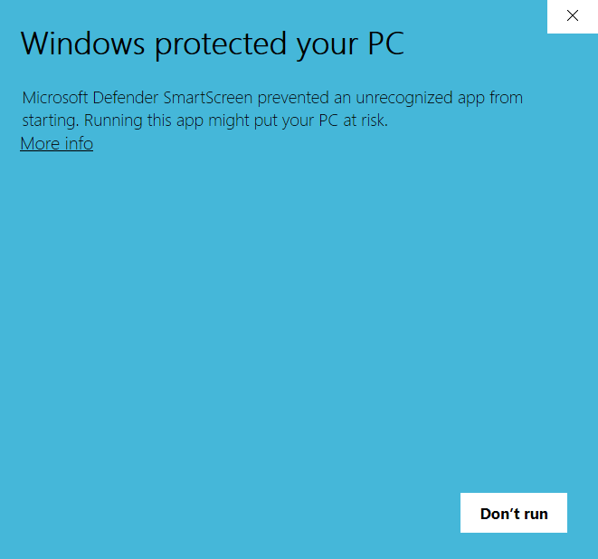

* Now click “Run Anyway” as seen below

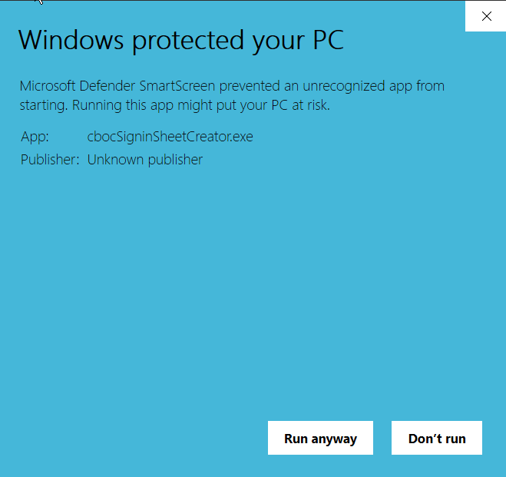

* Follow the instructions in the console window that will pop up
* Will create a new folder within the “cbocSigninSheetCreator” folder where your entire year’s worth of cboc sign in sheets can be found. Print as usual.