GamePlan Updated Admin Manual
This manual is for GamePlan administrators. It uses the athletic trainer guide as a starting point, then expands it with admin-specific responsibilities like role handling, app settings management, calendar blocks, and open availability windows.

1. Admin Overview
Administrators have the highest access level in GamePlan. In practice, that means you can usually:
- View and manage all reservations
- Edit or delete reservations when needed
- Review schedule blocks and calendar availability
- Manage user roles and pending approvals
- Manage equipment, equipment types, and app settings
- Resolve access issues when a user’s role changes

2. Signing In

2.1 Open the app
- Open the GamePlan website in your browser (http://gameplan.carroll.edu).
- Select the sign-in option.
- Log in with your school Okta account.
- Wait for the app to finish loading your profile and permissions.

2.2 Confirm your role
After sign-in, check your profile or dashboard to confirm that GamePlan recognizes your administrator access.
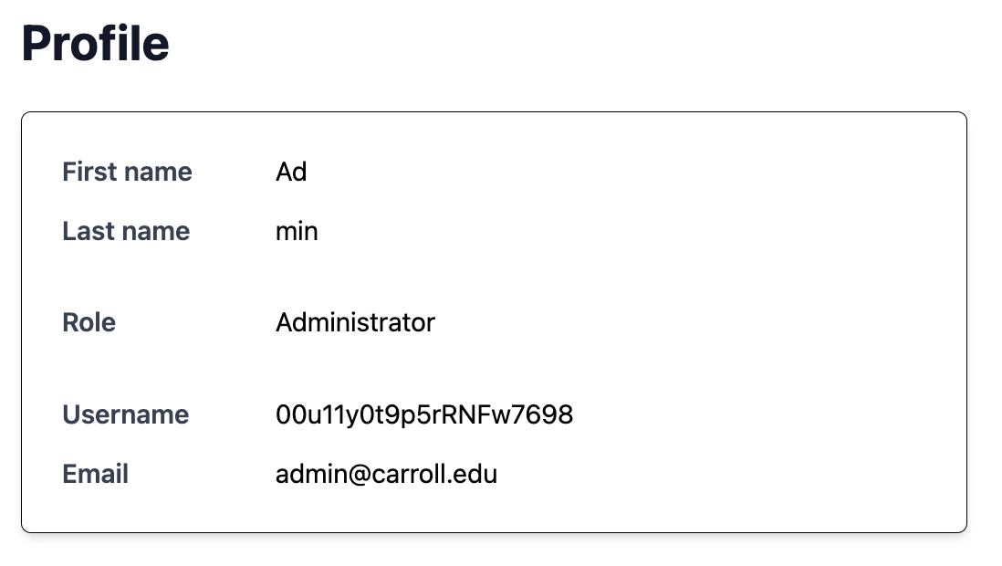

3. Home Dashboard
The Home page is your main operational view.
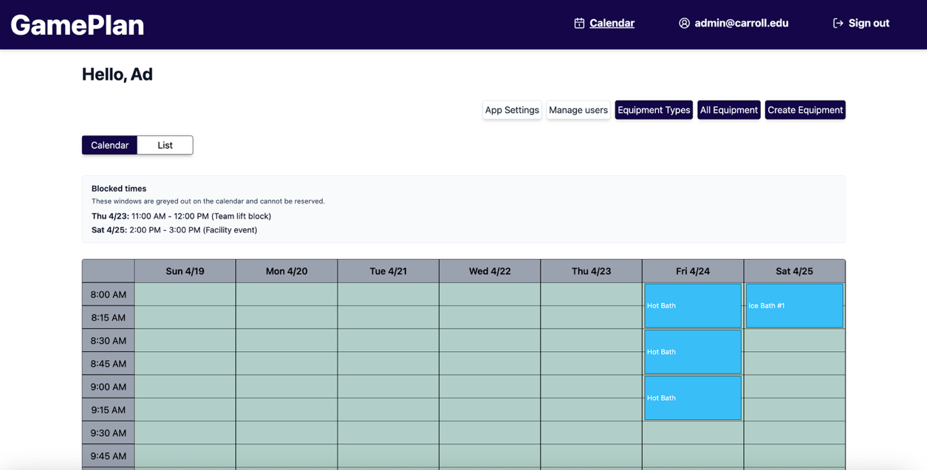

What you can do here
- See the current calendar or list view
- Review all active reservations
- Edit reservation times
- Delete reservations when needed
- Switch between calendar and list layouts
- Review pending students
- Jump to admin-only pages such as user management and app settings

How to use it
- Review the top summary and current date range.
- Use the calendar view if you want a visual schedule.
- Use the list view if you want reservation details in a compact format.
- Click a reservation to edit or delete it if needed.
- Use the admin shortcut buttons to move into user management, app settings, or equipment tools.

4. Viewing Reservations
Admin access includes a full reservation view for active bookings.

Calendar view

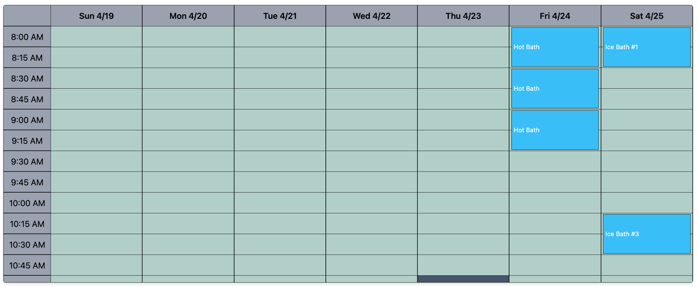
Use the calendar to:
- Spot schedule conflicts
- Compare reservations across the day
- See blocked times and availability windows

List view

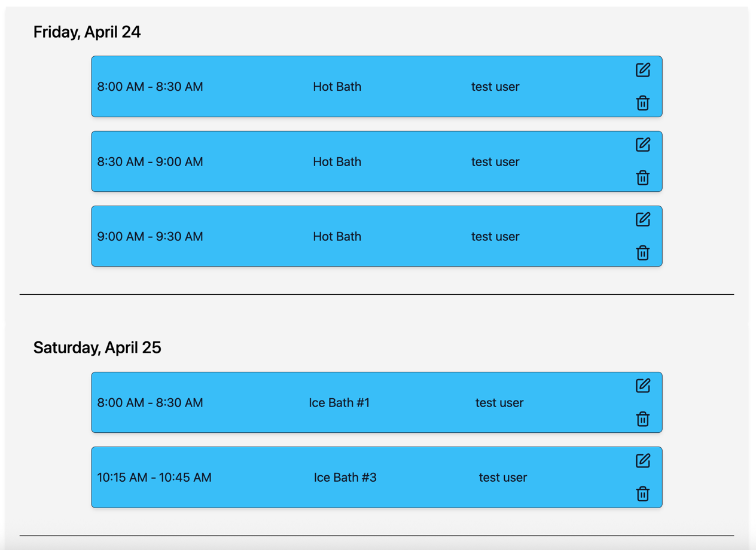
Use the list to:
- Read reservation details quickly
- Review reservations in date order
- Edit or delete reservations more efficiently

5. Editing a Reservation
Trainers can adjust reservation times when a change is needed.

Steps
- Open the reservation you want to change.
- Select the edit option.

- Choose a new start time.
- Choose a new end time.

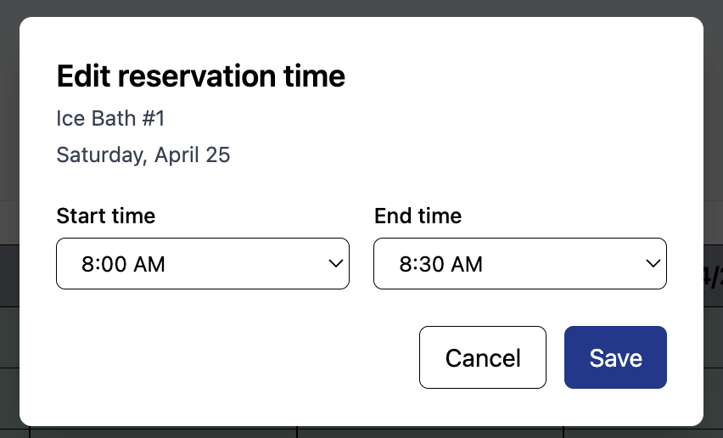

- Make sure the new time does not overlap another reservation or blocked period.

- Save the change.

6. Deleting a Reservation
If a reservation must be removed, trainers can delete it from the reservation view.

Steps
- Open the reservation.
- Select delete.
- Confirm the deletion in the dialog box.
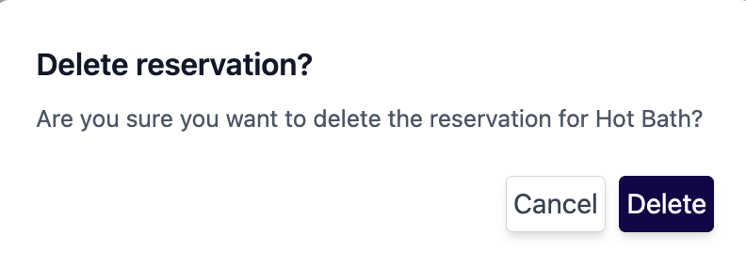
- Verify the reservation disappears from the list or calendar.

7. Working With Calendar Blocks
GamePlan uses blocks to represent times that are unavailable.

Block types you may see
- Athletic trainer or admin blocked time
- Weekend blocks
- Open availability windows
- Maintenance or other schedule restrictions

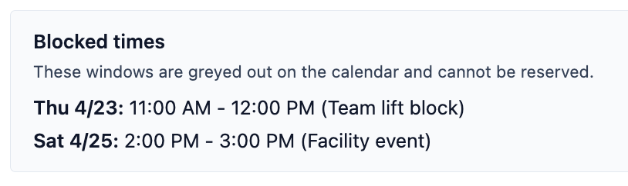

What to do
- Check blocks before editing or approving schedules.
- Avoid creating reservations that overlap blocked time.
- Use the app settings or block management tools if you need to change shared scheduling behavior.

8. Notifications
Admins may see a notification in the home dashboard on the Manage Users toggle when there is a new pending student who want to be approved as an athlete.
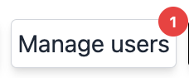

9. User Management and Role Handling
This is one of the main admin responsibilities in GamePlan.

What you can do
- Review pending student requests
- Promote users to athlete, athletic trainer, student, or admin
- Revert users to athlete, student, or athletic trainer
- Move students in and out of pending approval
- Filter users by role
- Change roles when staff responsibilities shift

Typical workflow
- Open the user management page.
- Review pending requests first.

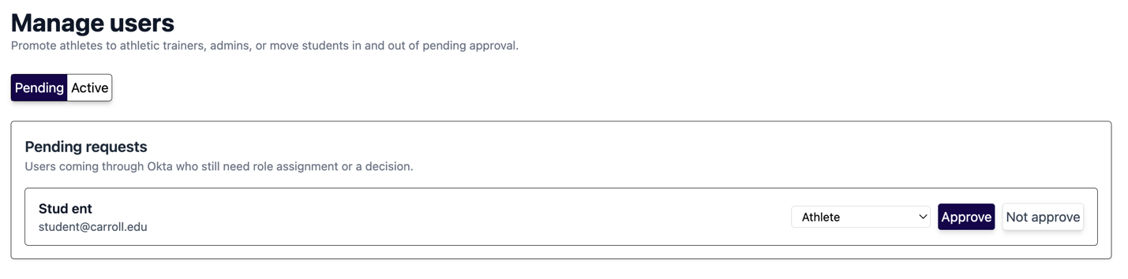

- Select a role or approval action.
- Confirm the change.
- Wait for the app to refresh the updated user data.

Important role-handling notes
- If you change a user’s role, the app should refresh their session data, so the navigation and permissions stay accurate.
- A user whose role changes will need to sign back in.
- Role changes will affect what pages the user can see immediately after refresh.

Common admin role actions
- Make an athlete into an athletic trainer
- Make an athletic trainer into an admin
- Revert a user back to athlete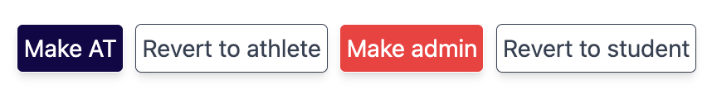

- Approve a student request and remove pending status
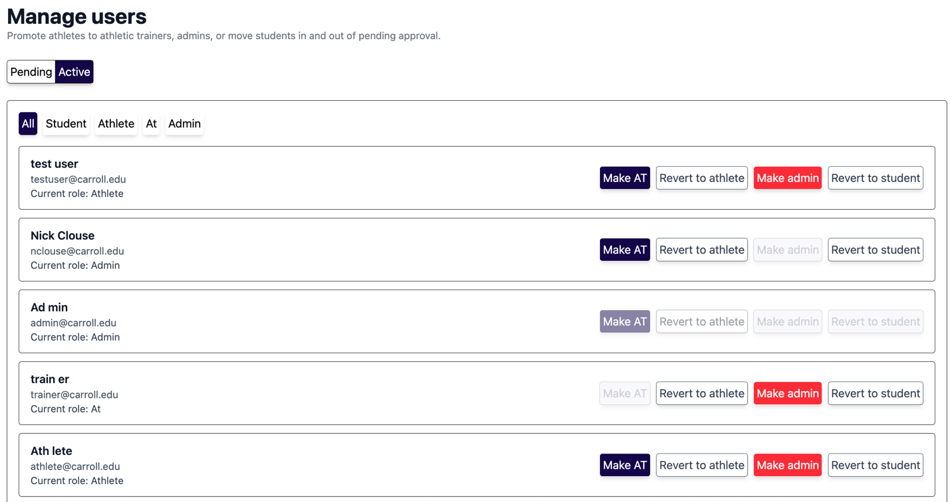

- Admin can toggle between the different roles to see what accounts are associated with each role.

10. App Settings
Admins can access shared app settings that control reservation behavior and calendar layout.
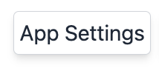

These settings may include
- Calendar start day
- Daily schedule start and end time
- Time step
- Maximum reservation length
- Number of days shown
- Weekend auto-block behavior
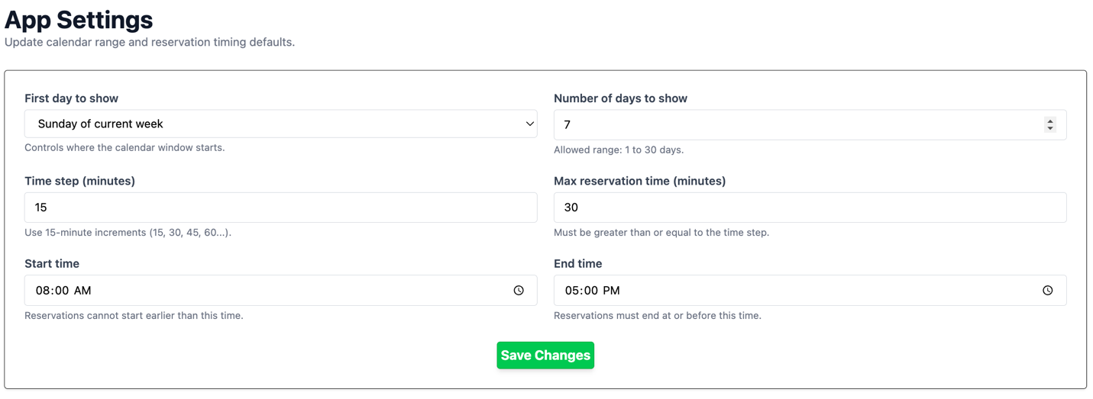

How to change a setting
- Open the settings page.
- Adjust the value you need.
- Save the change.
- Refresh the calendar or reservation page to confirm the update.

What to watch for
- A setting change may alter how many days appear on the calendar.
- Reservation availability can change immediately after settings are saved.
- If blocks are created or removed by the settings change, the reservation view should refresh.

11. Calendar Blocks
Administrators can add and manage calendar blocks from the App Settings page. Blocks are used to mark time as unavailable or to define special open windows that override a blocked period.
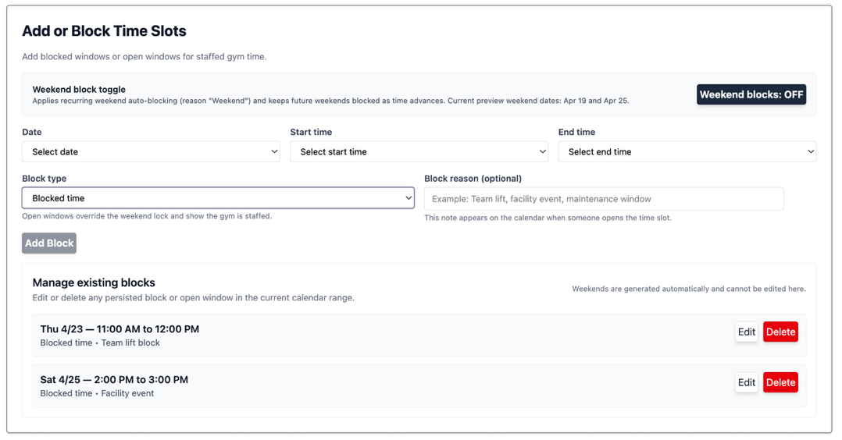

Block types
- Blocked Time creates a blocked time window
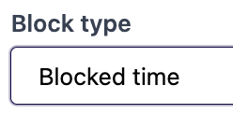
- Open Window creates an availability window inside a blocked or restricted period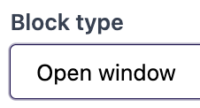

What blocks are used for
- Staff meetings
- Practice windows
- Facility closures
- Maintenance periods
- Weekend blocking
- Temporary open windows for staffed access

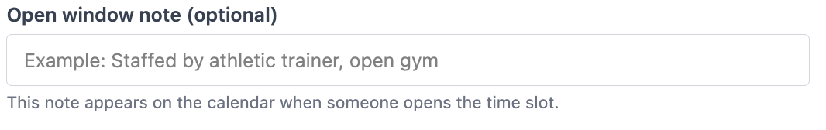

How to create a block
- Open the App Settings page.
- Find the calendar block editor.
- Choose the Block Type (open, or blocked)
- Choose the start date and time.
- Choose the end date and time.
- Enter a reason if needed.
- Save the block.
- Confirm that it appears on the calendar.

How to edit a block
- Open the existing block from the block list or calendar.
- Select edit.
- Adjust the start or end time.
- Update the reason or type if needed.
- If you want this block to appear consistently you can choose to apply it to additional days.

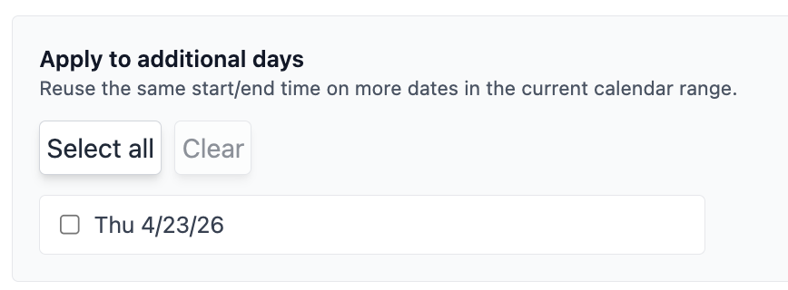

- Save the change.

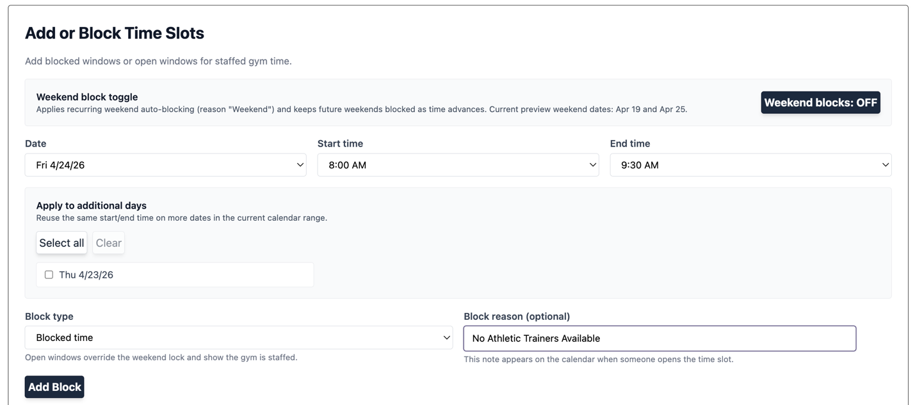

- Confirm the block appears on the home screen.

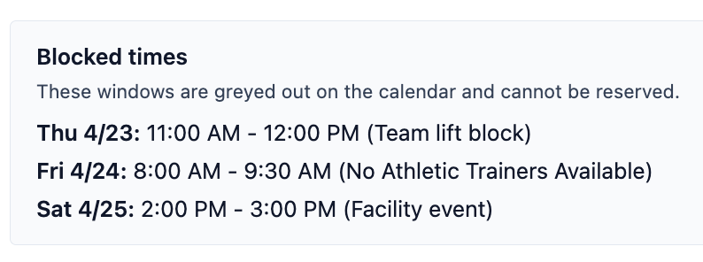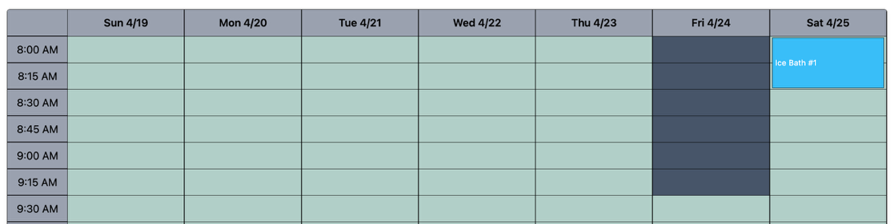

How to delete a block
- Open the block you want to remove.
- Select delete.
- Confirm the deletion.
- Refresh the calendar to verify that it is gone.

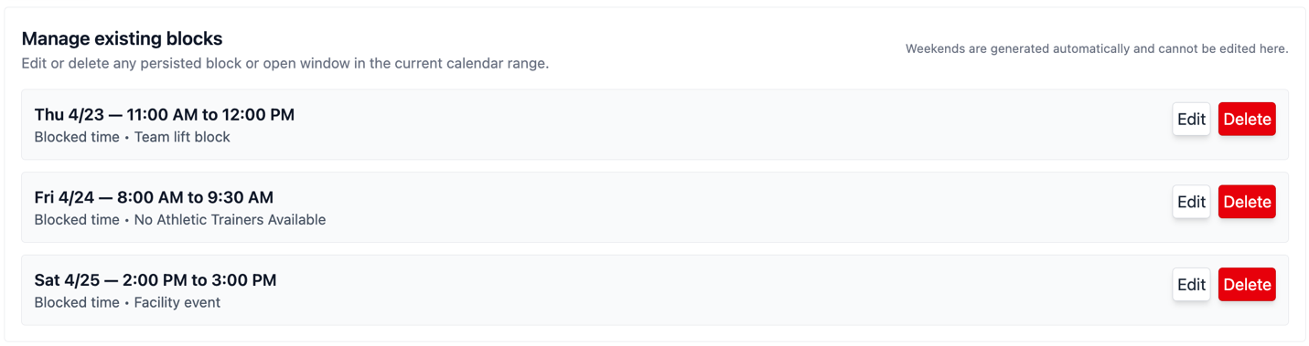

Weekend Toggle
You can toggle to have weekends available or unavailable. The toggle applies recurring weekend auto-blocking and keeps future weekends blocks as time advances.
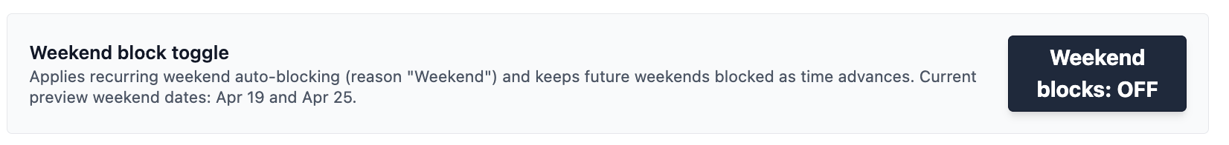

12. Available Time Blocks
Open time blocks are used when you want to allow reservations inside a period that would otherwise be blocked. In the app, these are the OPEN blocks.

When to use an open block
- To allow a staffed gym session on a normally blocked day (ex. A Saturday morning)
- To create a temporary reservation window during a closure (ex. Any time before 8am or after 5pm)
- To make a small section of a blocked period available again

How to add an available time block
- Open the App Settings page.
- Go to the calendar block editor.
- Set the block type to Open Window.
- Choose the start and end time for the window.
- Add a short reason if you want the calendar to show why the window exists.
- Save the block.
- Verify that the block appears as an open availability on the description box. This available window will not render on the calendar but will be on the message display.

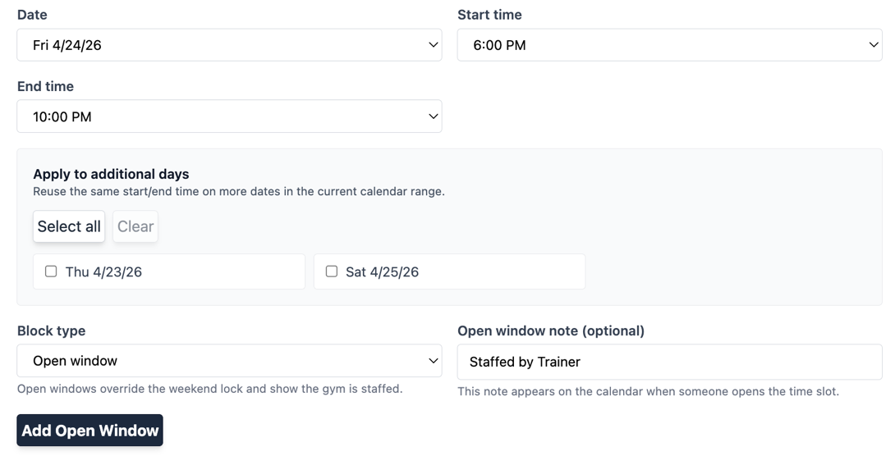

What to check after saving
- The open window appears in the right date range
- The window is long enough for the reservation you want to allow
- The window does not overlap a conflicting blocked period
- Users can now reserve equipment inside the open window
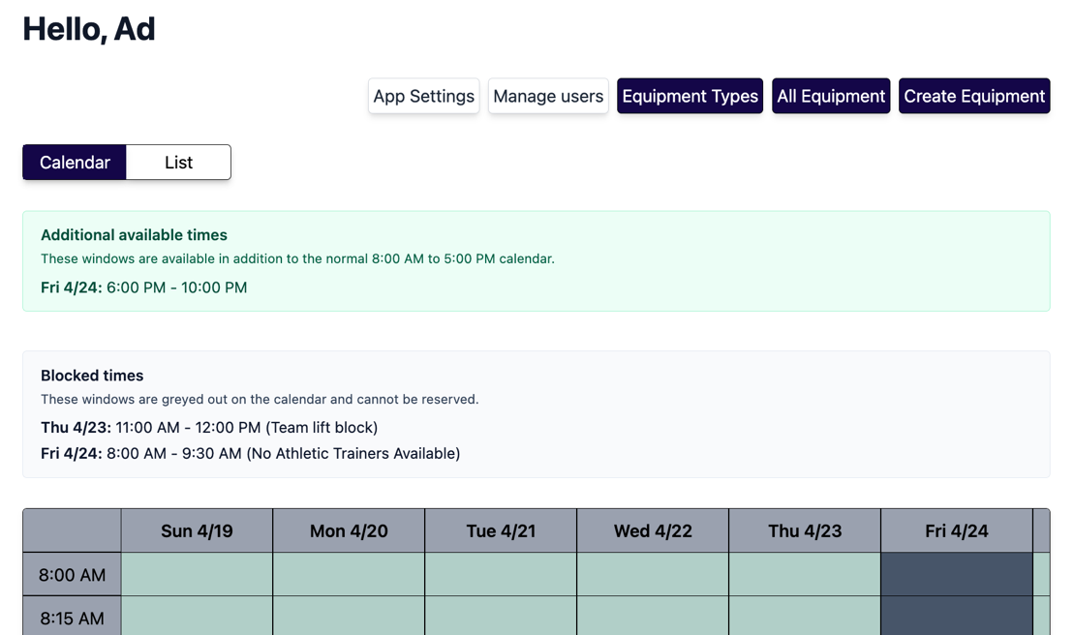

13 Equipment Tools
As a trainer you can manage equipment and equipment types.

Common pages
- Equipment types
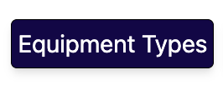
- Create equipment
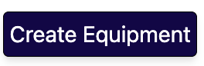
- All equipment
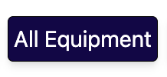

13.1 Equipment Types

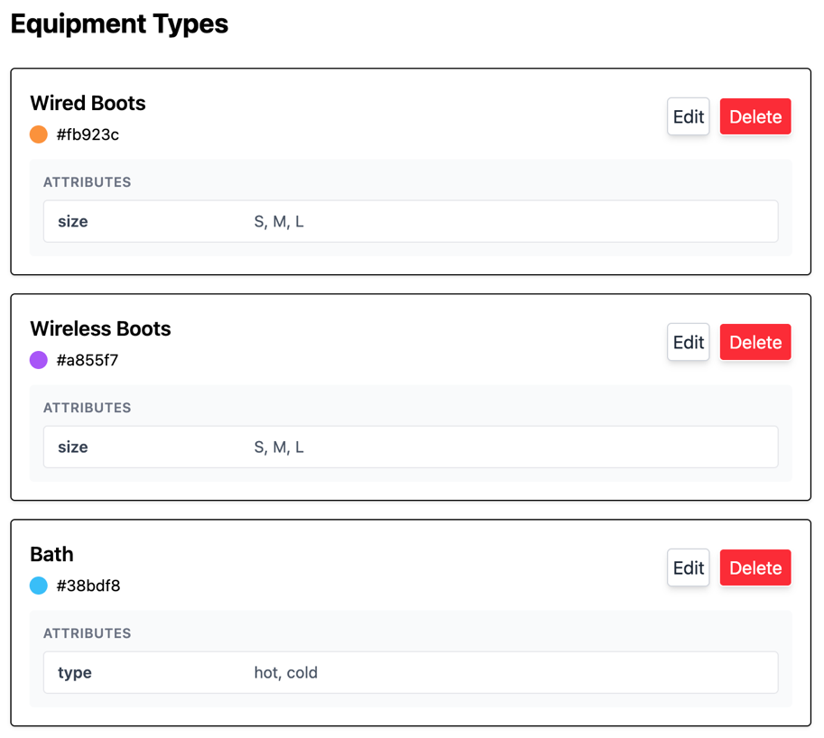

In the Equipment Types page, you can view all current equipment types and delete or make edits to them.

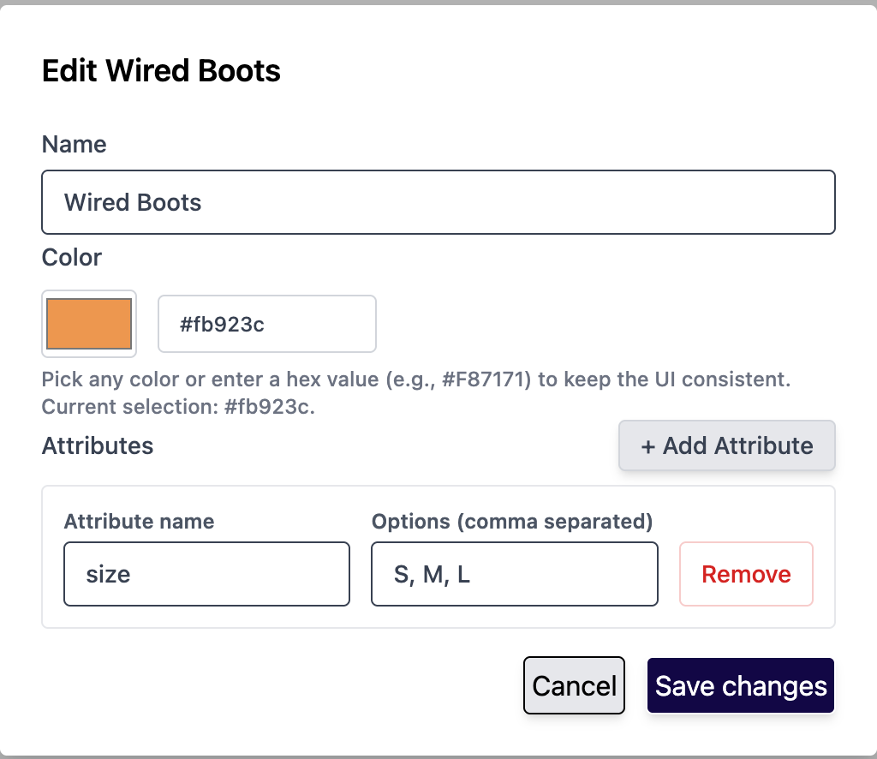

If you want to delete an equipment type it will delete every piece of equipment tied to it as well as any reservations. To delete, you must type ‘confirm’ to successfully complete the removal. Be cautious deleting equipment types.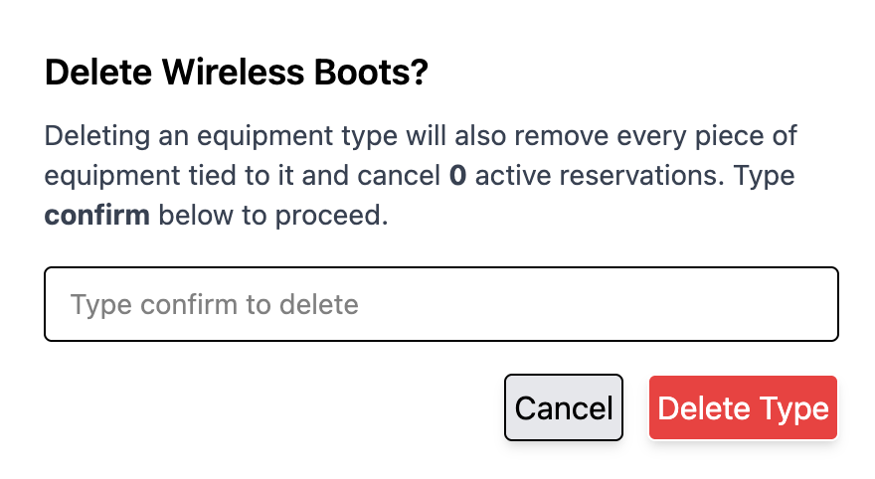

13.2 Equipment
In the equipment page you can view the inventory of all current equipment. You have the option to change an equipment’s status to maintenance as well as edit or delete a piece.
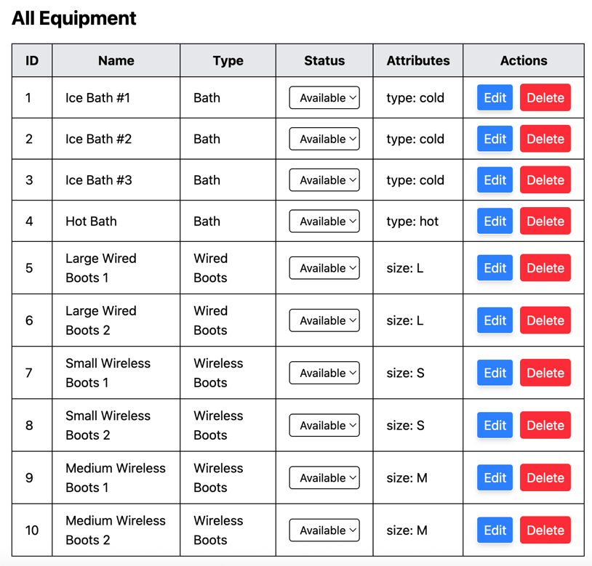
If you choose to edit a piece of equipment, you can change the name or the associated attribute.
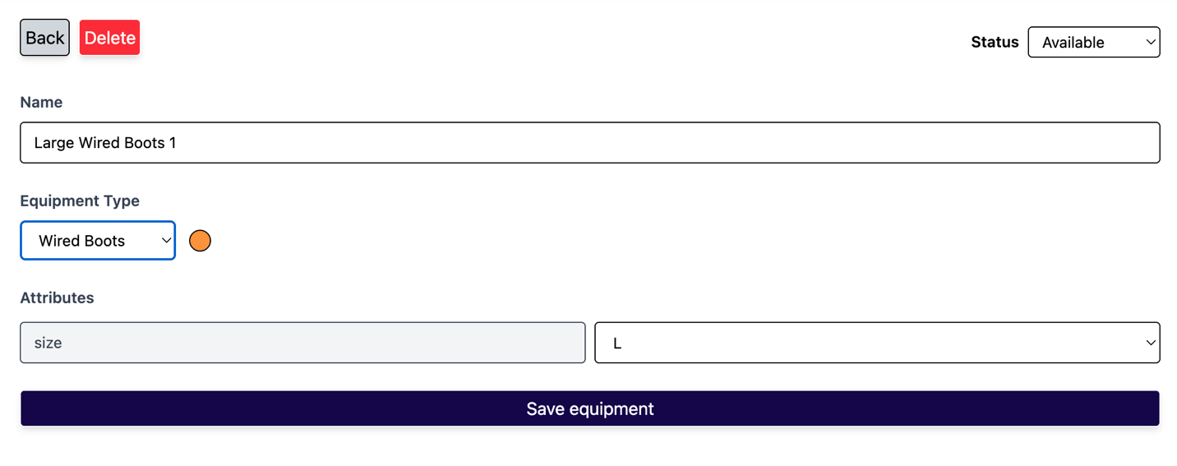

13.3 Creating new Equipment Types
When creating a new equipment type you must specify the following:
- Type Name
- Attributes
- Attribute Options
- Color
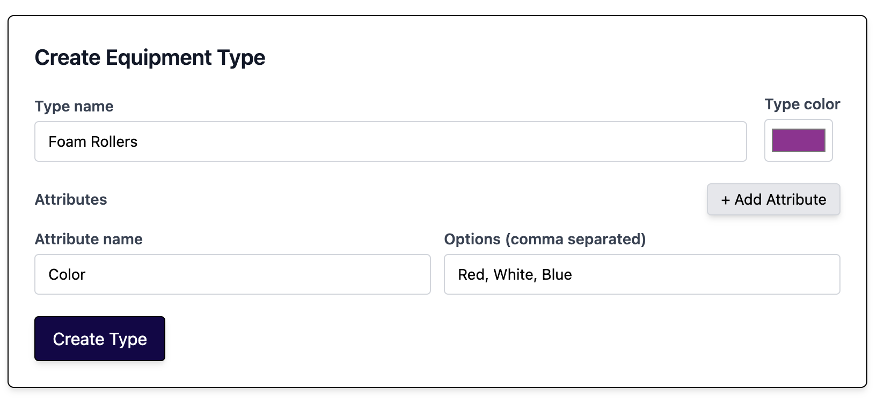
Confirm type was created by going to the Equipment Type Page. After a new type is created you can add equipment pieces under the type.

13.4 Creating new Equipment
When creating a new piece of equipment you must specify the following:
- The type it belongs to
- Equipment Name
- Attribute. If you don’t see the attribute you need, you must first edit the attributes in the Equipment Type page (ex. If you got a new pair of wired boots that is a size XL, you must first edit the wired boots equipment type to have XL as an option for attributes).
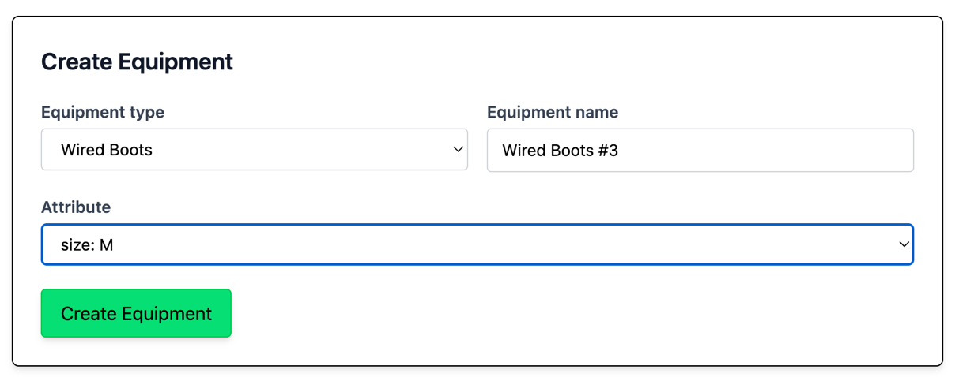

14. Reservation Troubleshooting

A reservation is missing
- Refresh the page.
- Switch between calendar and list views.
- Check whether a filter is hiding the reservation.
- Confirm the reservation was saved successfully.

A reservation is blocked
- Look for the blocked time indicator.
- Try a different time window.
- Verify there is not already an overlapping booking.

The page looks outdated
- Refresh the browser.
- Leave and return to the tab.
- Sign out and sign back in if permissions recently changed.

A role change is not showing
- Wait for the app to refresh.
- Sign out and sign back in.
- Check the Profile page to confirm the current role.

15. Best Practices for Admins
- Review reservations before making schedule changes
- Use list view when you need to process multiple bookings quickly
- Watch for conflicts before saving edits
- Refresh after user or role changes
- Confirm app settings after making changes

