GamePlan User Manual
This document is a user-facing guide for the GamePlan application.

1. What GamePlan Does
GamePlan is a web application for managing athletic equipment, reservations, schedule blocks, and user access roles. The app supports different roles:
- Student users can browse equipment and request reservations.
- Athlete users can reserve equipment and manage their own bookings.
- Athletic Trainer (AT) users can review reservations, manage blocks, and oversee users.
- Admin users can manage every part of the system, including settings and user roles.
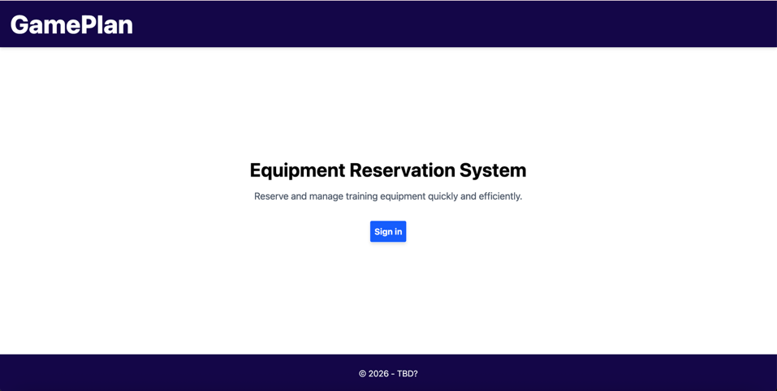

2. Getting Started

2.1 Open the application
- Open the GamePlan website in your browser (http://gameplan.carroll.edu)
- If you are not already signed in, select the sign-in option.
- You will be redirected to the school Okta login page.
- After logging in, you will return to the GamePlan app.
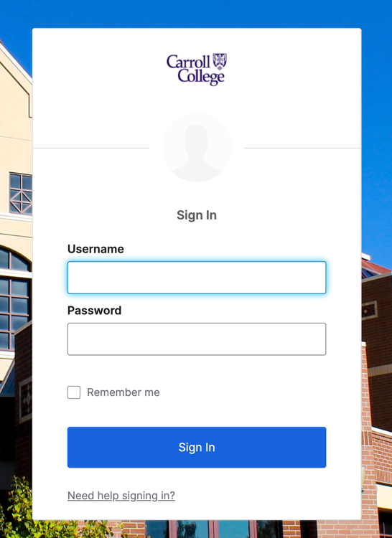

2.2 First-time login
If this is your first time using the app:
- Sign in with your school account.
- Wait for GamePlan to finish loading your profile.
- Confirm that your name, email, and role appear correctly.
If your account has not been approved yet, you may see a student or pending-access message instead of the full app.
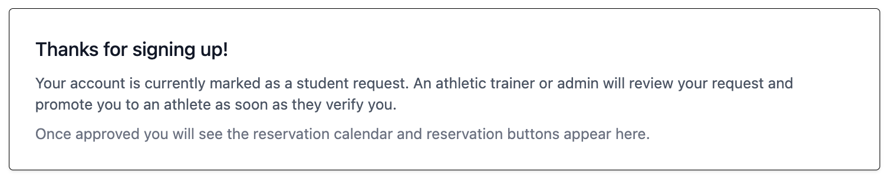

3. Main Layout
Most pages in GamePlan use the same basic layout:
- A top navigation bar for moving between pages.
- A main content area for the page you are using.
- A footer at the bottom of the screen.
The exact links you see depend on your role.
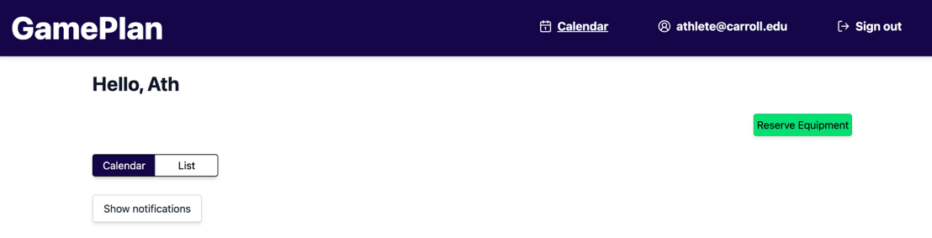

4. Home Page
The Home page is the main landing area after sign-in.

What you can do here
- View your reservation calendar or reservation summary.
- See notifications and updates.
- Jump to the pages your role is allowed to access.
- Review your current access level and account status.

How to use it
- Read the top summary to confirm your account is signed in.
- Review the dashboard cards or calendar view.
- Use the navigation options to move to reservations, profile, or admin areas.
- If you are an athletic trainer or admin, you may also see management shortcuts.

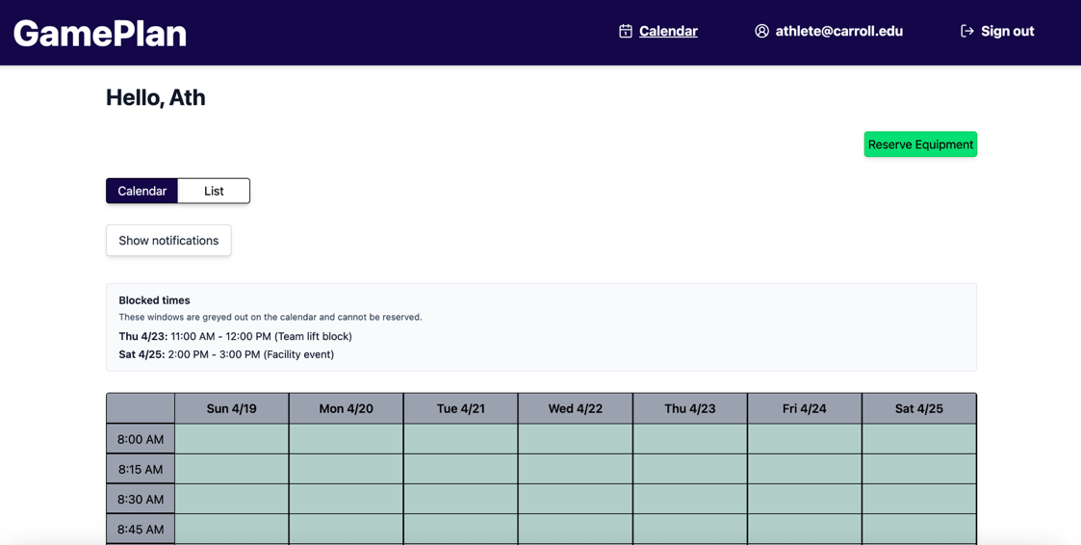

5. Reserving Equipment
This section applies to athletes and other non-privileged users who can make reservations.

5.1 Open the reservation page
- Select the equipment reservation page from navigation.
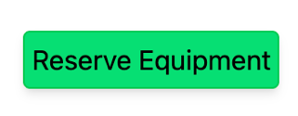

5.2 Choose equipment
- Select the equipment item you want to reserve.
- Review any attributes or notes shown on the item.

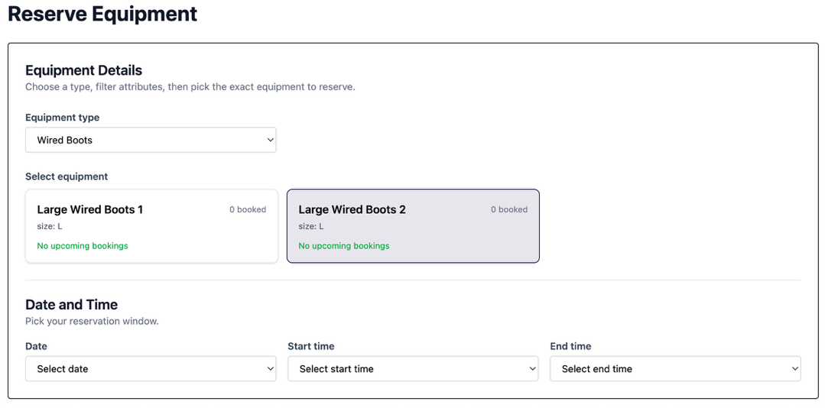

- Confirm the item is available for the date and time you need.

5.3 Pick a date and time
- Use the date selector to choose your reservation day.
- Select a start time.
- Select an end time.

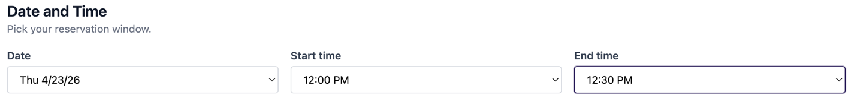

5.4 Check for conflicts
Before submitting, look for:
- Existing reservations
- Schedule blocks
- Weekend restrictions

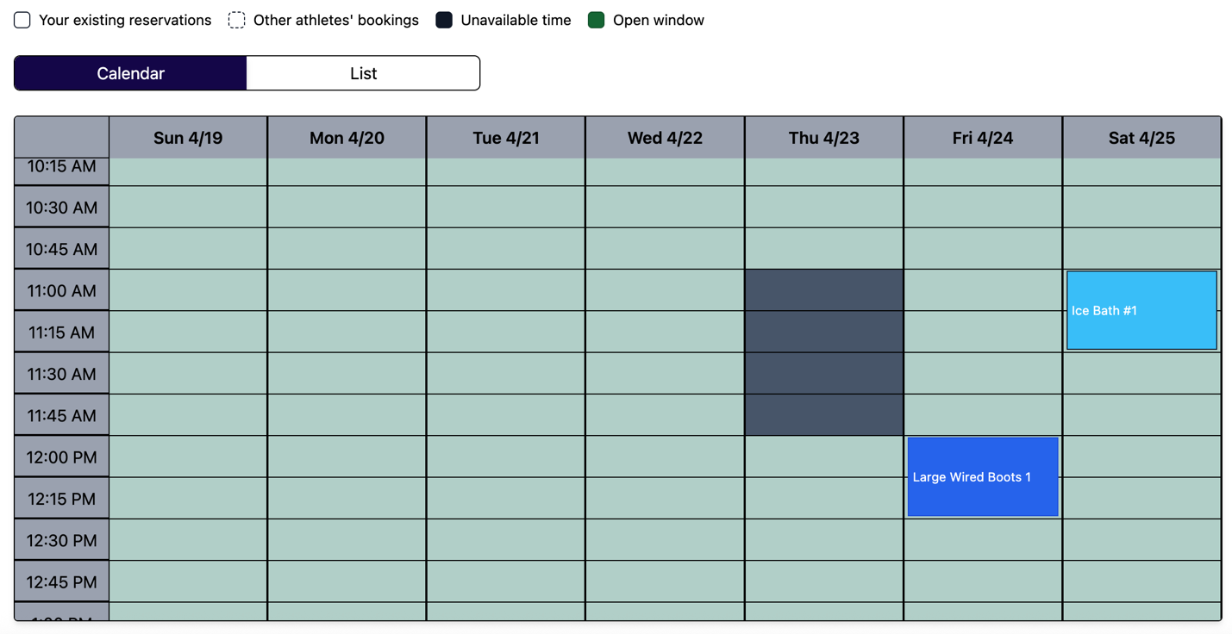
- Any warning messages shown by the app
If the app shows a conflict, choose another time or another item.
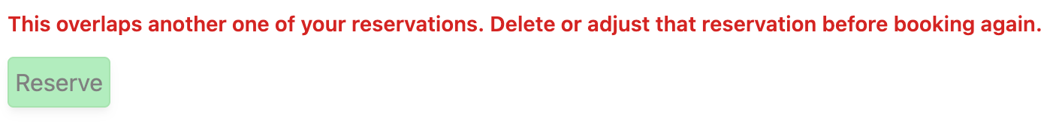

5.5 Submit the reservation
- Review all details one last time.
- Submit the reservation.
- Wait for the confirmation message.

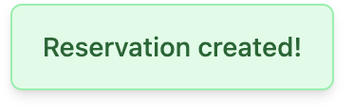

- Refresh the page if needed to confirm the reservation appears in your list.

6. Viewing Your Reservations
After you create a reservation, it should appear in your reservation list and your calendar.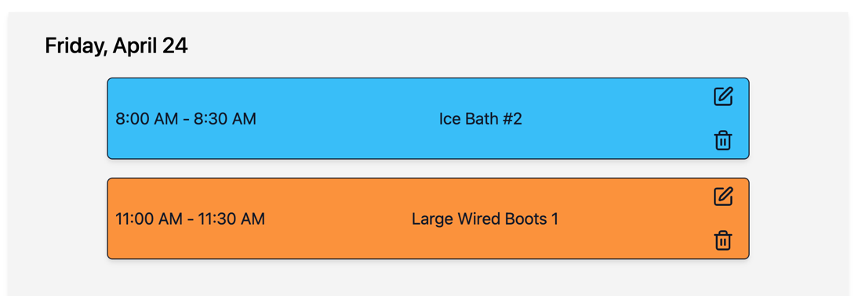
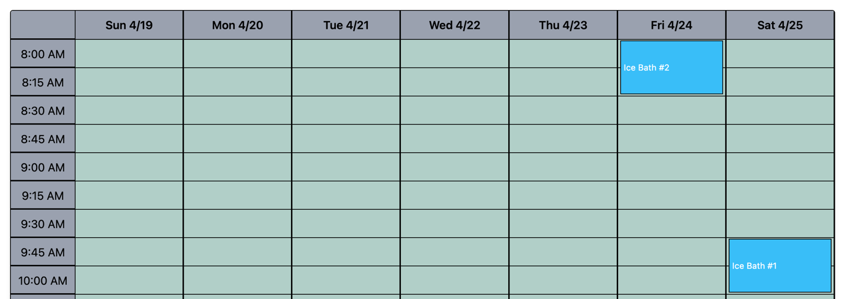

What to look for
- Reservation title or equipment name
- Date and time

Click on a reservation
Clicking on a reservation on the calendar home page will give you the details of the reservation along with the option to edit or delete the reservation.
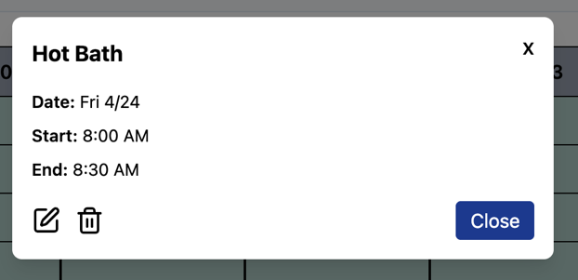

What to do if something looks wrong
- Refresh the page.
- Confirm that the reservation was submitted.
- If necessary, contact an athletic trainer or admin.

7. Profile Page
The Profile page shows your account details.

It may include
- Name
- Email address
- Username or OIDC identity
- Current role

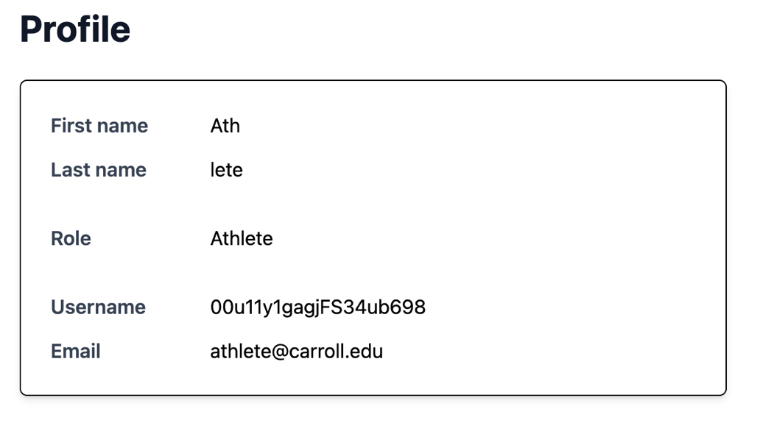

Why it matters
Use this page to confirm that GamePlan has recognized your correct school account and assigned the expected role.

8. Notifications and Updates

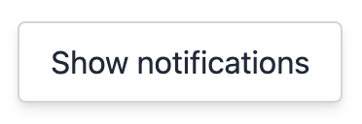
GamePlan may show notifications for:
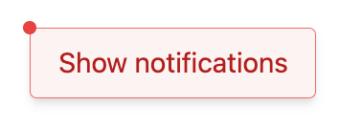
- Reservation changes
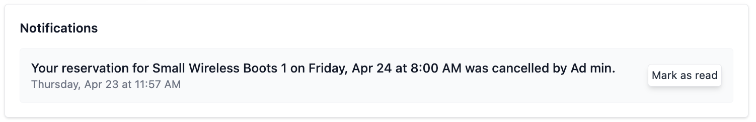

- Other account-related activity
Check notifications regularly if you rely on the app for scheduling or approvals. Notifications will stay read until you click “Mark as read”.
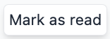
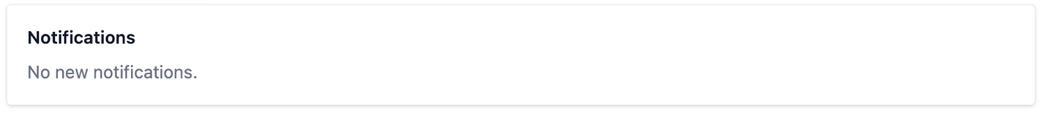

8. Common Problems

I cannot sign in
- Make sure you are using your school Okta account.
- Check that the login page finishes redirecting.
- Try refreshing the browser.
- If the problem continues, contact support.

I do not see the expected menu items
- Confirm your role on the Profile page.
- Log out and sign back in.
- Wait for any pending role changes to take effect.

A reservation is blocked
- Look for the block message shown by the app.
- Choose a different time slot.
- Try a different item if available.

The page is not updating
- Refresh the browser.
- Leave and return to the tab.
- Sign out and sign back in if your role recently changed.

