GamePlan Athletic Trainer Manual
This manual is for athletic trainers who use GamePlan to manage reservations, review schedules, and help maintain equipment and access across the system.

1. Trainer Overview
Athletic trainers have elevated access in GamePlan. In practice, that means you can usually:
- View all active reservations
- Edit or delete reservations when needed
- See schedule blocks and calendar availability
- Manage equipment and equipment types.

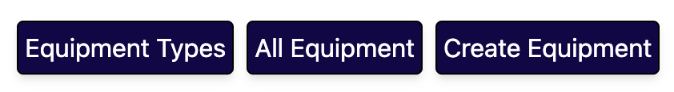

2. Signing In

2.1 Open the app
- Open the GamePlan website in your browser (http://gameplan.carroll.edu).
- Select the sign-in option.
- Log in with your school Okta account.
- Wait for the app to finish loading your profile and permissions.

2.2 Confirm your role
After sign-in, check your profile or dashboard to confirm that GamePlan recognizes your trainer access.
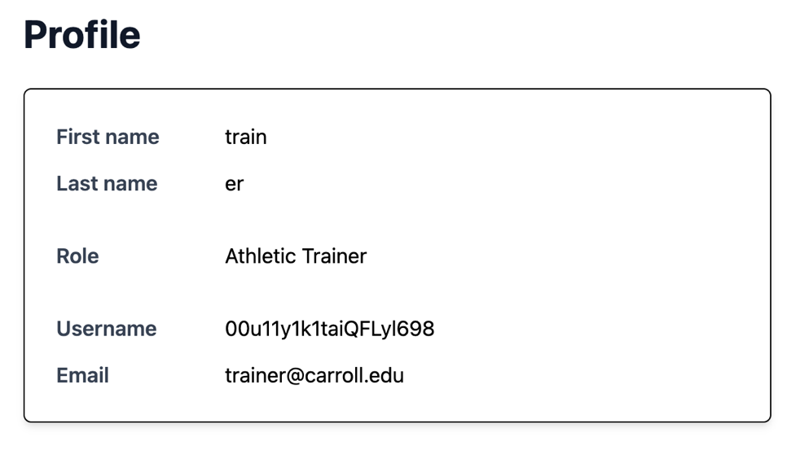

3. Home Dashboard
The Home page is your main operational view.

What you can do here
- See the current calendar or list view
- Review all active reservations
- Edit reservation times
- Delete reservations when needed
- Switch between calendar and list layouts
- Review notifications

How to use it
- Review the top summary and current date range.
- Use the calendar view if you want a visual schedule.

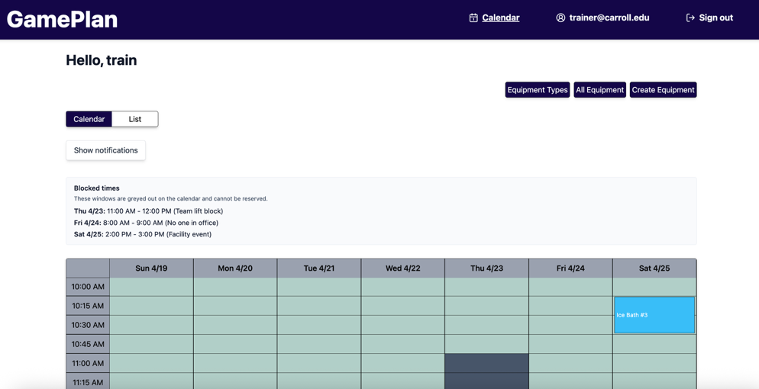

- Use the list view if you want reservation details in a compact format.

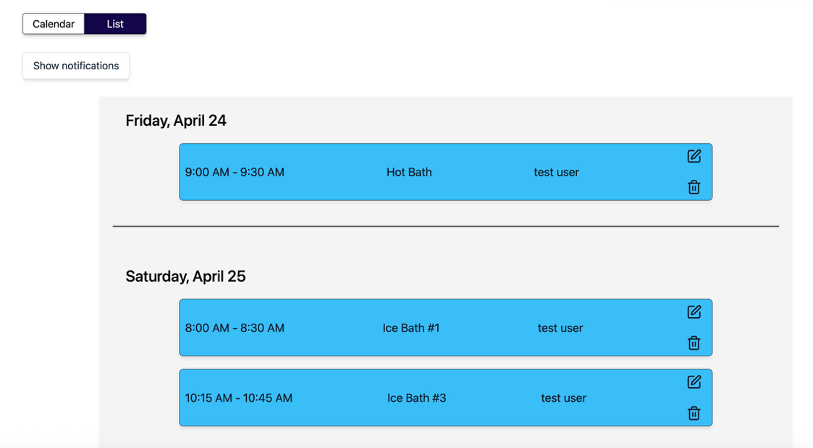

- Click a reservation to edit or delete it.
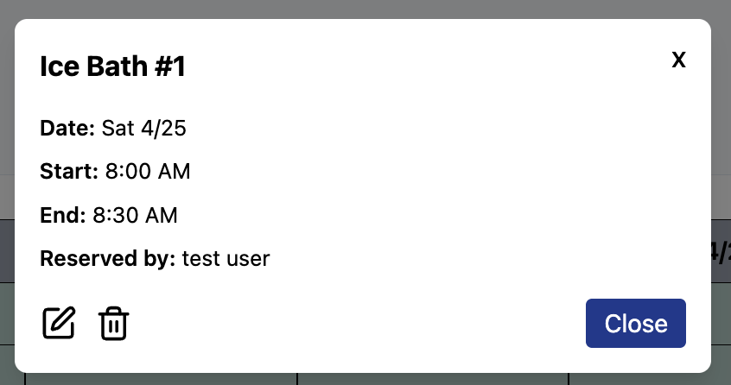

4. Viewing Reservations
Trainer access includes a full reservation view for active bookings.

Calendar view
Use the calendar to:
- Spot schedule conflicts
- Compare reservations across the day
- See blocked times and availability windows

List view
Use the list to:
- Read reservation details quickly
- Review reservations in date order
- Edit or delete reservations more efficiently

5. Editing a Reservation
Trainers can adjust reservation times when a change is needed.

Steps
- Open the reservation you want to change.
- Select the edit option.

- Choose a new start time.
- Choose a new end time.

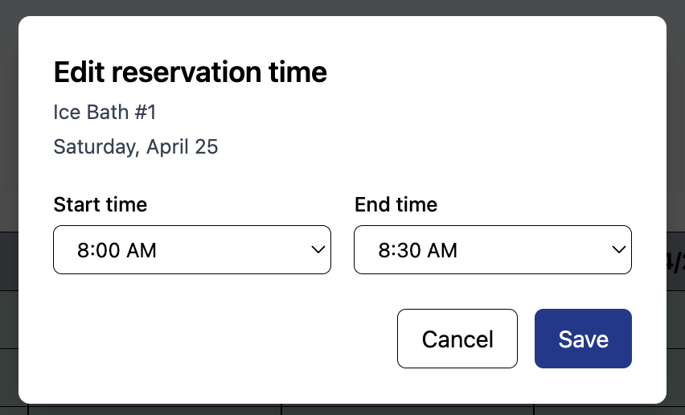

- Make sure the new time does not overlap another reservation or blocked period.

- Save the change.

6. Deleting a Reservation
If a reservation must be removed, trainers can delete it from the reservation view.

Steps
- Open the reservation.
- Select delete.
- Confirm the deletion in the dialog box.
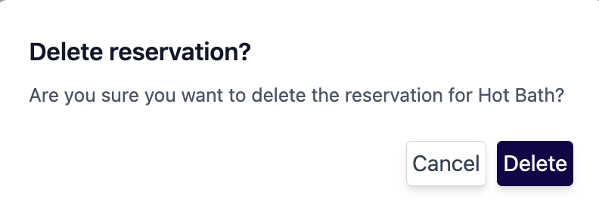
- Verify the reservation disappears from the list or calendar.

7. Working With Calendar Blocks
GamePlan uses blocks to represent times that are unavailable.

Block types you may see
- Athletic trainer or admin blocked time
- Weekend blocks
- Open availability windows
- Maintenance or other schedule restrictions

What to do
- Check blocks before editing or approving schedules.
- Avoid creating reservations that overlap blocked time.

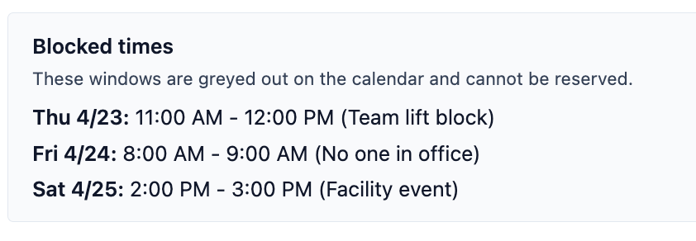
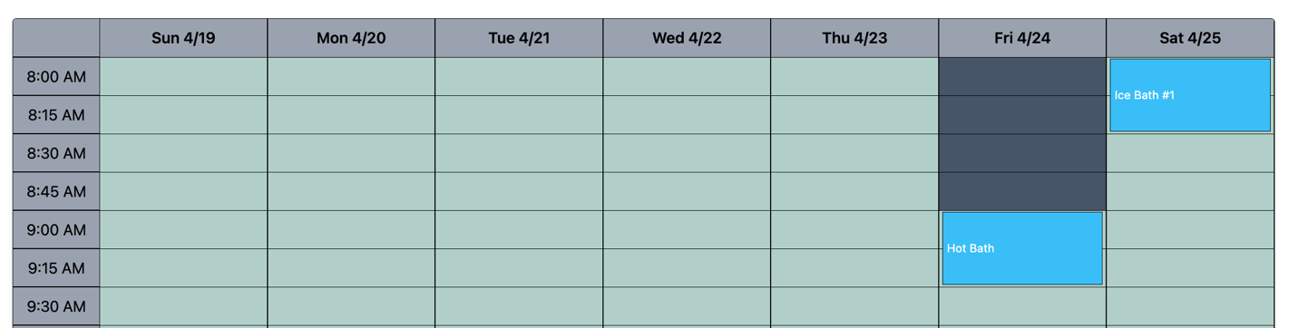

8. Equipment Tools
As a trainer you can manage equipment and equipment types.

Common pages
- Equipment types
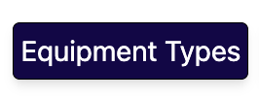
- Create equipment
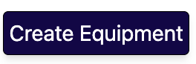
- All equipment
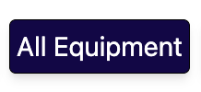

8.1 Equipment Types

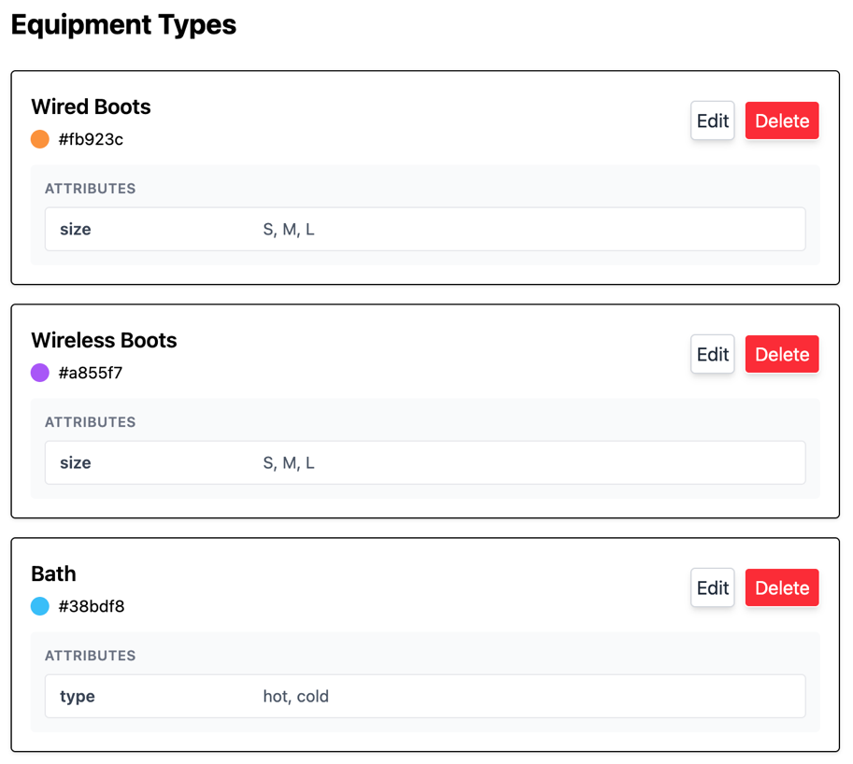

In the Equipment Types page, you can view all current equipment types and delete or make edits to them.

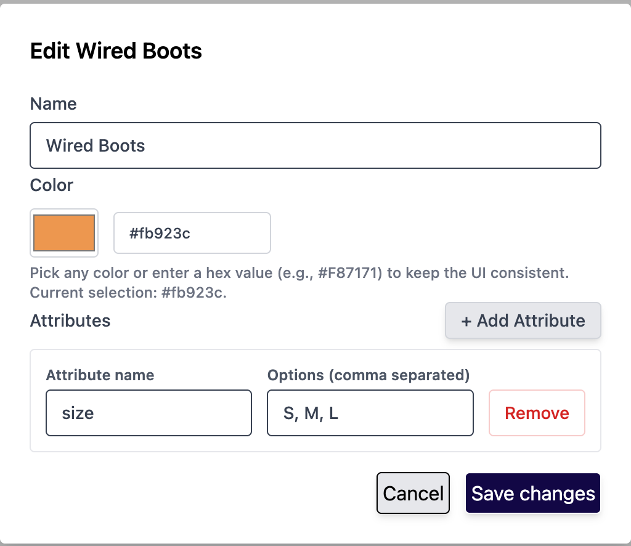

If you want to delete an equipment type it will delete every piece of equipment tied to it as well as any reservations. To delete, you must type ‘confirm’ to successfully complete the removal. Be cautious deleting equipment types.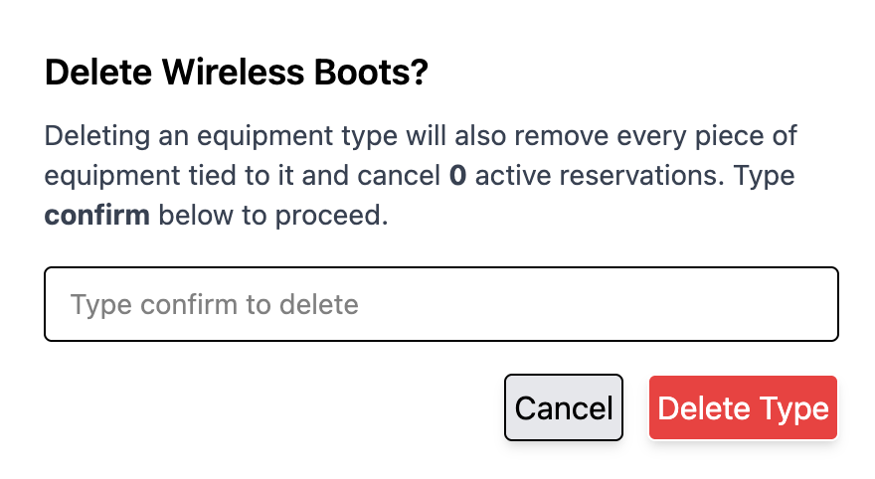

8.2 Equipment
In the equipment page you can view the inventory of all current equipment. You have the option to change an equipment’s status to maintenance as well as edit or delete a piece.
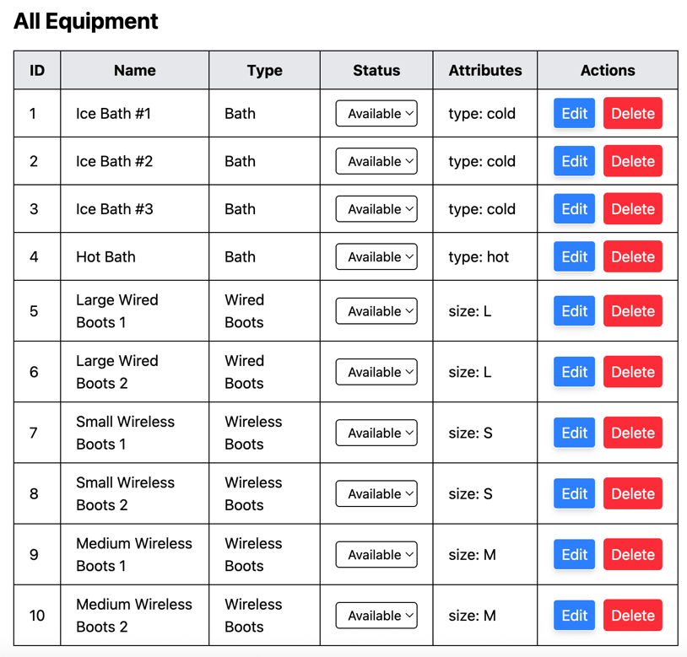
If you choose to edit a piece of equipment, you can change the name or the associated attribute.
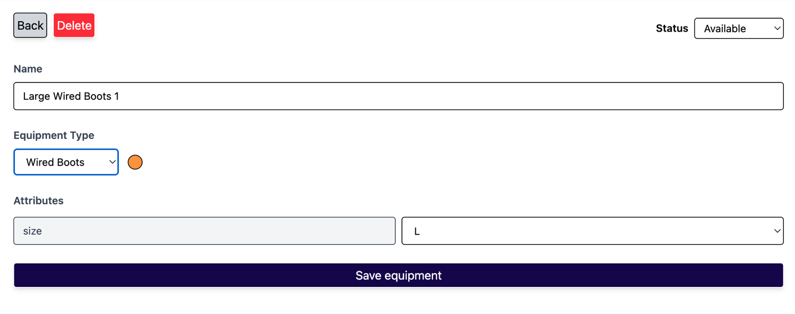

8.3 Creating new Equipment Types
When creating a new equipment type you must specify the following:
- Type Name
- Attributes
- Attribute Options
- Color
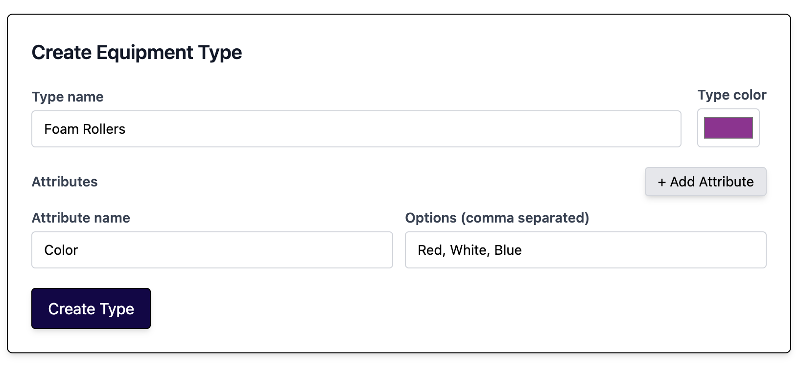
Confirm type was created by going to the Equipment Type Page. After a new type is created you can add equipment pieces under the type.

8.4 Creating new Equipment
When creating a new piece of equipment you must specify the following:
- The type it belongs to
- Equipment Name
- Attribute. If you don’t see the attribute you need, you must first edit the attributes in the Equipment Type page (ex. If you got a new pair of wired boots that is a size XL, you must first edit the wired boots equipment type to have XL as an option for attributes).
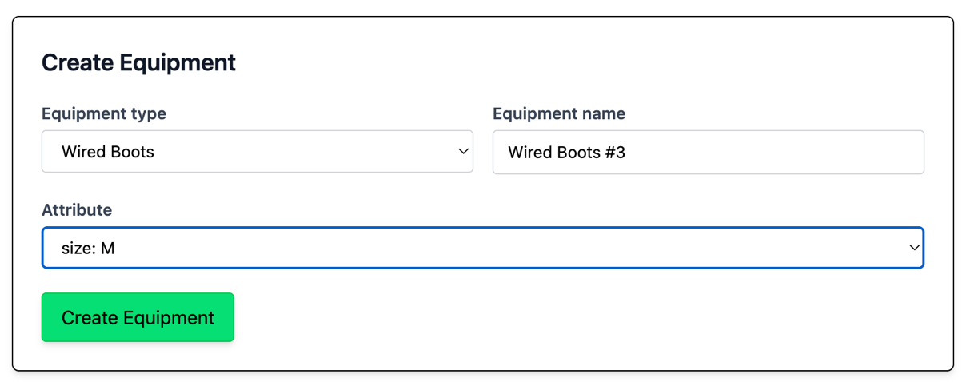

9. Reservation Troubleshooting

A reservation is missing
- Refresh the page.
- Switch between calendar and list views.
- Confirm the reservation was saved successfully.

The page looks outdated
- Refresh the browser.
- Leave and return to the tab.
- Sign out and sign back in if permissions recently changed.

10. Best Practices for Athletic Trainers
- Review reservations before making schedule changes
- Use list view when you need to process multiple bookings quickly
- Watch for conflicts before saving edits.

