



**2017**

**2017**

**FRE-GY 5990**

**Capstone Project Report**

**Project Advisor: Prof. Edith Mandel**

**Project Member: Xingyue Huang, Mengyang Liu**

**Contents**

1. Introduction 3

2. Monte Carlo simulation for SABR 4

2.1 Monte Carlo standard error 4

2.2 Monte Carlo schemes 4

2.2.1 Euler scheme 4

2.2.2 Milstein scheme 8

3. Validation of Hagan et al. approximation 10

3.1 Validation of c.d.f 10

3.2 Validation of lognormal implied volatility 14

3.2.1 Using lognormal Hagan 14

3.2.2 Using Monte Carlo simulation 16

3.3 The performance of Hagan et al. approximation 17

4. SABR calibration in practice 20

4.1 Over-specification test for Hagan et al. approximation 20

4.1.1 fixed *k* 20

4.1.2 fixed *k* 21

4.1.3 fixed *k* 21

4.1.4 fixed *k* and *k* 22

4.1.5 fixed *k* and *k* 23

4.1.6 fixed *k* and *k* 23

4.2 Collinearity test for Hagan et.al approximation 24

5. Alternative SABR approximations 25

5.1 Obloj SABR 25

5.1.1 Obloj calibration 25

5.1.2 Validation of c.d.f 26

5.1.3 Over-specification and collinearity test 30

6. Conclusion 34

7. Code structure 35

8. References 36

# Introduction

This capstone project is aimed to investigate the quality of the popular SABR approximation introduced by Hagan et al. in 2002, and figure out an optimal way of calibrating the model.

We first discuss Monte-Carlo simulation method in section2, which is our benchmark to evaluate approximation of SABR model. In this section, we introduce two Monte-Carlo simulation schemes and explore the simulation convergence in generating implied volatilities given different simulation time steps and SABR parameters. Then we perform validation for Hagan el al. SABR model in section3 using Monte-Carlo simulation. We first plot the implied cumulative distribution of Hagan el al. model to identify the negative probability of low strike OTM receivers and then conduct an accuracy test for implied volatility prediction. In section4 we perform an over-specification test and collinearity test on Hagan et al. SABR model and explore an optimal way of model calibration. After this, we introduce and analyze Obloj SABR model in section6 and draw conclusions in section7. Lastly, we list our code structure and reference in section8 and section9 respectively.

# 2. Monte Carlo simulation for SABR

We first introduce Monte Carlo simulation, which is our benchmark to evaluation SABR approximation and explore its convergence in predicting implied volatilities with different simulation time steps and SABR parameters.

## 2.1 Monte Carlo standard error

Let’s denote Monte Carlo average estimator as

where is the total number of paths simulated and is the forward interest rate generated by the i-th simulation. The quantity

is used to determine the Monte Carlo standard error. The lower the standard error the better the accuracy of the tested Monte Carlo scheme.

## 2.2 Monte Carlo schemes

In this section we discuss two of most commonly used Monte Carlo schemes: Euler scheme and Milstein scheme and their simulations of Hagan et al. lognormal approximation.

### 2.2.1 Euler scheme

In Euler scheme, the SABR process can be rewritten as

where and are discrete versions of and respectively.

Here we implement a zero absorbing boundary for the forward process when as only in this case will SABR remain a martingale.

There is a risk that Euler scheme may fail to reach convergence in simulating the implied volatility. Therefore we have performed Monte Carlo simulations with different combinations of time step size and SABR parameters. The tests shown below are classified in three different groups based on :

For each of them we have tested five different values of :

and five different time step numbers:

for all cases: =100000, =10Y and =0.25. And time steps are chosen based on how long we want the discrete steps be. For example, if we choose we are dealing with discrete steps that are about 60 trading days long considering we have 252 trading days in a year. We put a cap at as we have not seen any considerable improvement in the convergence for higher values.

Table: Equivalence between the total and the actual per year

|  |  |
| --- | --- |
| Simulation time step | Equivalent time step per year |
| 1 | 0.1 |
| 40 | 4 |
| 240 | 24 |
| 480 | 48 |
| 960 | 96 |

Black implied volatilities (%)by Euler scheme for =0 and various combinations of . For all cases: =10Y, =0.25

|  |  |  |  |  |  |  |  |  |  |  |
| --- | --- | --- | --- | --- | --- | --- | --- | --- | --- | --- |
|  |  | Strike spreads (bps) | | | | | | | | |
|  | Steps | -150 | -100 | -50 | -25 | 0 | 25 | 50 | 100 | 150 |
| =0 | 1 | 30.11 | 26.70 | 24.14 | 23.10 | 22.18 | 21.35 | 20.59 | 19.28 | 18.17 |
| =0 | 40 | 32.31 | 28.10 | 25.15 | 24.01 | 23.03 | 22.20 | 21.49 | 20.38 | 19.60 |
| =0.25 | 240 | 32.72 | 28.43 | 25.43 | 24.27 | 23.28 | 22.44 | 21.73 | 20.62 | 19.83 |
|  | 480 | 32.67 | 28.38 | 25.37 | 14.19 | 23.20 | 22.35 | 21.64 | 20.53 | 19.74 |
|  | 960 | 33.18 | 28.75 | 25.65 | 24.46 | 23.45 | 22.59 | 21.87 | 20.72 | 19.93 |
|  |  |  |  |  |  |  |  |  |  |  |
| =0.3 | 1 | 29.83 | 26.52 | 24.05 | 23.04 | 22.13 | 21.31 | 20.56 | 19.26 | 18.15 |
| =0 | 40 | 28.67 | 26.00 | 24.06 | 23.30 | 22.67 | 22.13 | 21.67 | 20.97 | 20.48 |
| =0.25 | 240 | 28.54 | 23.86 | 23.95 | 23.21 | 22.60 | 22.08 | 21.64 | 20.97 | 20.52 |
|  | 480 | 28.41 | 25.76 | 23.85 | 23.12 | 22.50 | 21.98 | 21.55 | 20.90 | 20.45 |
|  | 960 | 28.30 | 25.68 | 23.78 | 23.04 | 22.41 | 21.89 | 21.45 | 20.78 | 20.33 |
|  |  |  |  |  |  |  |  |  |  |  |
| =0.5 | 1 | 29.76 | 26.51 | 24.08 | 23.08 | 22.18 | 21.37 | 20.63 | 19.33 | 18.22 |
| =0 | 40 | 27.78 | 25.50 | 23.92 | 23.32 | 22.94 | 22.44 | 22.10 | 21.64 | 21.34 |
| =0.25 | 240 | 26.84 | 24.84 | 23.41 | 22.86 | 22.41 | 22.05 | 21.77 | 21.36 | 21.13 |
|  | 480 | 27.08 | 24.97 | 23.51 | 22.96 | 22.50 | 22.14 | 21.84 | 21.42 | 21.16 |
|  | 960 | 26.68 | 24.69 | 23.32 | 22.80 | 22.37 | 22.02 | 21.73 | 21.32 | 21.06 |
|  |  |  |  |  |  |  |  |  |  |  |
| =0.7 | 1 | 30.31 | 26.91 | 24.41 | 23.36 | 22.43 | 21.59 | 20.82 | 19.51 | 18.39 |
| =0 | 40 | 25.96 | 24.34 | 23.27 | 22.89 | 22.59 | 22.36 | 22.19 | 21.97 | 21.88 |
| =0.25 | 240 | 25.91 | 24.30 | 23.26 | 22.89 | 22.61 | 22.39 | 22.23 | 22.05 | 21.99 |
|  | 480 | 25.76 | 24.19 | 23.18 | 22.82 | 22.55 | 22.35 | 22.20 | 22.05 | 22.02 |
|  | 960 | 25.88 | 24.29 | 23.26 | 22.91 | 22.64 | 22.44 | 22.29 | 22.11 | 22.06 |
|  |  |  |  |  |  |  |  |  |  |  |
| =1 | 1 | 30.60 | 27.11 | 24.53 | 23.47 | 22.52 | 21.67 | 20.90 | 19.56 | 18.43 |
| =0 | 40 | 24.62 | 23.66 | 23.16 | 23.04 | 22.98 | 23.00 | 23.00 | 23.16 | 23.41 |
| =0.25 | 240 | 23.82 | 22.97 | 22.55 | 22.45 | 22.42 | 22.49 | 22.49 | 22.67 | 22.93 |
|  | 480 | 22.57 | 22.11 | 21.90 | 21.86 | 21.87 | 21.99 | 21.99 | 22.21 | 22.48 |
|  | 960 | 22.58 | 22.15 | 21.93 | 21.90 | 21.91 | 22.05 | 22.05 | 22.27 | 22.54 |

Black implied volatilities (%)by Euler scheme for =0.8 and various combinations of *.* For all cases: =10Y, =0.25

|  |  |  |  |  |  |  |  |  |  |  |
| --- | --- | --- | --- | --- | --- | --- | --- | --- | --- | --- |
|  |  | Strike spreads (bps) | | | | | | | | |
|  | Steps | -150 | -100 | -50 | -25 | 0 | 25 | 50 | 100 | 150 |
| =0 | 1 | 30.72 | 27.35 | 24.86 | 23.83 | 22.90 | 22.06 | 21.30 | 19.96 | 18.81 |
| =0.8 | 40 | 25.87 | 24.53 | 23.75 | 23.49 | 23.28 | 23.12 | 22.99 | 22.81 | 22.69 |
| =0.25 | 240 | 25.31 | 24.16 | 23.52 | 23.31 | 23.15 | 23.03 | 22.94 | 22.81 | 22.73 |
|  | 480 | 25.77 | 24.45 | 23.72 | 23.49 | 23.31 | 23.16 | 23.05 | 22.91 | 22.83 |
|  | 960 | 24.89 | 23.84 | 23.25 | 23.05 | 23.05 | 22.79 | 22.71 | 22.59 | 22.51 |
|  |  |  |  |  |  |  |  |  |  |  |
| =0.3 | 1 | 30.52 | 27.08 | 24.53 | 23.48 | 22.54 | 21.70 | 20.94 | 19.59 | 18.45 |
| =0.8 | 40 | 23.55 | 23.26 | 23.29 | 23.36 | 22.45 | 23.56 | 23.66 | 23.87 | 20.08 |
| =0.25 | 240 | 22.27 | 22.33 | 22.56 | 22.69 | 22.83 | 22.98 | 23.12 | 23.39 | 23.63 |
|  | 480 | 23.25 | 23.00 | 23.08 | 23.18 | 23.29 | 23.41 | 23.53 | 23.78 | 24.02 |
|  | 960 | 23.10 | 22.94 | 23.08 | 23.19 | 23.31 | 23.44 | 23.57 | 23.82 | 24.06 |
|  |  |  |  |  |  |  |  |  |  |  |
| =0.5 | 1 | 29.68 | 26.43 | 24.02 | 23.03 | 22.14 | 21.33 | 20.59 | 19.31 | 18.22 |
| =0.8 | 40 | 22.30 | 22.56 | 23.06 | 23.33 | 23.60 | 23.85 | 24.10 | 24.56 | 24.96 |
| =0.25 | 240 | 21.30 | 21.83 | 22.49 | 22.81 | 23.12 | 23.41 | 23.71 | 24.24 | 24.73 |
|  | 480 | 22.86 | 22.88 | 23.32 | 23.59 | 23.85 | 24.12 | 24.37 | 24.84 | 25.29 |
|  | 960 | 22.76 | 22.77 | 23.18 | 23.44 | 23.70 | 23.96 | 24.21 | 24.70 | 25.15 |
|  |  |  |  |  |  |  |  |  |  |  |
| =0.7 | 1 | 29.62 | 26.28 | 23.82 | 22.80 | 21.90 | 21.08 | 20.33 | 19.03 | 17.94 |
| =0.8 | 40 | 22.05 | 22.57 | 23.43 | 23.88 | 24.31 | 24.73 | 25.13 | 25.86 | 26.53 |
| =0.25 | 240 | 20.08 | 21.16 | 22.29 | 22.81 | 23.31 | 23.78 | 24.41 | 25.00 | 25.73 |
|  | 480 | 20.46 | 21.40 | 22.48 | 23.01 | 23.51 | 23.99 | 24.44 | 25.26 | 25.29 |
|  | 960 | 21.53 | 22.12 | 23.06 | 23.54 | 24.00 | 24.44 | 24.86 | 25.65 | 25.15 |
|  |  |  |  |  |  |  |  |  |  |  |
| =1 | 1 | 28.74 | 25.50 | 23.11 | 22.13 | 21.24 | 20.45 | 19.73 | 18.47 | 17.40 |
| =0.8 | 40 | 31.95 | 30.36 | 30.66 | 31.07 | 31.55 | 32.08 | 32.61 | 33.67 | 34.68 |
| =0.25 | 240 | 13.97 | 17.89 | 20.25 | 21.22 | 22.09 | 22.89 | 23.62 | 24.93 | 26.07 |
|  | 480 | 12.10 | 17.14 | 19.65 | 20.66 | 21.56 | 22.38 | 22.13 | 24.46 | 25.62 |
|  | 960 | 10.00 | 15.45 | 18.36 | 19.44 | 20.38 | 21.22 | 21.98 | 23.30 | 24.45 |

Black implied volatilities (%) by Euler scheme for =-0.8 and various combinations of *.* For all cases: =10Y, =0.25

|  |  |  |  |  |  |  |  |  |  |  |
| --- | --- | --- | --- | --- | --- | --- | --- | --- | --- | --- |
|  |  | Strike spreads (bps) | | | | | | | | |
|  | Steps | -150 | -100 | -50 | -25 | 0 | 25 | 50 | 100 | 150 |
| =0 | 1 | 31.16 | 27.63 | 25.03 | 23.96 | 23.02 | 22.16 | 21.39 | 20.03 | 18.88 |
| =-0.8 | 40 | 37.46 | 31.32 | 26.73 | 24.82 | 23.10 | 21.54 | 20.13 | 17.66 | 15.61 |
| =0.25 | 240 | 37.68 | 31.45 | 26.79 | 24.86 | 23.12 | 21.55 | 20.12 | 17.63 | 15.57 |
|  | 480 | 37.86 | 31.58 | 26.88 | 24.93 | 23.17 | 21.57 | 20.12 | 17.60 | 15.50 |
|  | 960 | 37.89 | 31.59 | 26.89 | 24.94 | 23.19 | 21.60 | 20.16 | 17.64 | 15.57 |
|  |  |  |  |  |  |  |  |  |  |  |
| =0.3 | 1 | 32.89 | 29.14 | 26.38 | 25.24 | 24.23 | 23.33 | 22.51 | 21.07 | 18.85 |
| =-0.8 | 40 | 32.60 | 28.55 | 25.31 | 23.90 | 22.61 | 21.41 | 20.30 | 18.34 | 16.66 |
| =0.25 | 240 | 32.49 | 28.51 | 25.29 | 23.87 | 22.57 | 21.37 | 20.25 | 18.27 | 16.58 |
|  | 480 | 32.05 | 28.20 | 25.06 | 23.69 | 22.42 | 21.24 | 20.15 | 18.19 | 16.53 |
|  | 960 | 32.02 | 18.18 | 25.05 | 23.67 | 22.40 | 21.23 | 20.14 | 18.19 | 16.52 |
|  |  |  |  |  |  |  |  |  |  |  |
| =0.5 | 1 | 33.28 | 29.56 | 26.81 | 25.68 | 24.67 | 23.76 | 22.94 | 21.49 | 20.27 |
| =-0.8 | 40 | 30.81 | 27.55 | 24.89 | 23.72 | 22.64 | 21.64 | 20.71 | 19.02 | 17.57 |
| =0.25 | 240 | 30.77 | 27.46 | 24.78 | 23.62 | 22.53 | 21.53 | 20.60 | 18.93 | 17.51 |
|  | 480 | 31.02 | 27.64 | 24.91 | 23.72 | 22.62 | 21.61 | 20.68 | 19.00 | 17.54 |
|  | 960 | 30.92 | 27.59 | 24.87 | 23.68 | 22.58 | 21.57 | 20.63 | 18.93 | 17.47 |
|  |  |  |  |  |  |  |  |  |  |  |
| =0.7 | 1 | 34.73 | 30.86 | 28.00 | 26.81 | 25.75 | 24.80 | 23.92 | 22.39 | 21.08 |
| =-0.8 | 40 | 29.90 | 27.12 | 24.84 | 23.84 | 22.91 | 22.05 | 21.26 | 19.82 | 18.57 |
| =0.25 | 240 | 29.73 | 26.96 | 24.70 | 23.71 | 22.79 | 21.94 | 21.15 | 19.73 | 18.49 |
|  | 480 | 30.01 | 27.15 | 24.82 | 23.81 | 22.87 | 22.01 | 21.20 | 19.76 | 18.51 |
|  | 960 | 29.62 | 26.86 | 24.60 | 23.61 | 22.70 | 21.86 | 21.07 | 19.65 | 18.43 |
|  |  |  |  |  |  |  |  |  |  |  |
| =1 | 1 | 37.28 | 32.99 | 29.83 | 28.54 | 27.38 | 26.35 | 25.41 | 23.77 | 22.39 |
| =-0.8 | 40 | 28.56 | 26.50 | 24.83 | 24.10 | 23.43 | 22.80 | 22.22 | 21.18 | 20.28 |
| =0.25 | 240 | 28.49 | 26.41 | 24.73 | 24.00 | 23..32 | 22.70 | 22.13 | 21.10 | 20.22 |
|  | 480 | 27.86 | 25.98 | 24.42 | 23.73 | 23.09 | 22.50 | 21.95 | 20.96 | 20.11 |
|  | 960 | 27.72 | 25.88 | 24.35 | 23.68 | 23.05 | 22.46 | 21.91 | 20.91 | 20.04 |

It’s evident from the tables above that the case =-0.8 shows a generally good convergence of the Monte Carlo simulation under Euler scheme: the implied volatilities with different values of enjoy a low variance of 9.86%. The convergence is excellent especially for =0 and =0.5. For =0, the results are good for =0.7; we have the worst performance for =0.8, especially when =1.

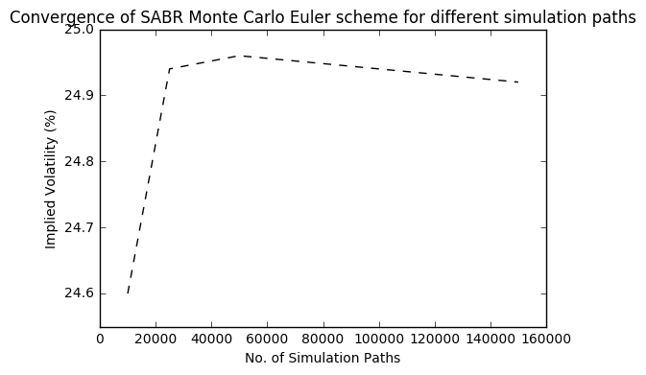

### 2.2.2 Milstein scheme

Compared with Euler scheme, Milstein scheme increases the accuracy of a stochastic process discrete approximation by adding higher order terms. The Milstein scheme for a stochastic differential equation of the type

is

where is the first derivative of the term b with respect to x. For the SABR forward process we take x= and we have

Its Milstein discretization is

For the SABR volatility process we take x= and we have

which leads to the following Milstein discretization equation:

For Milstein scheme, we don’t repeat the discussion of simulation results for different simulation time step sizes and sets of . Here we only provide simulation results for =40 and =-0.8.

Table: Black implied volatilities (%) by Milstein scheme for various combinations of . For all cases: =10Y, =0.25, =0.8, =40

|  |  |  |  |  |  |  |  |  |  |
| --- | --- | --- | --- | --- | --- | --- | --- | --- | --- |
|  | Strike Spreads (bps) | | | | | | | | |
|  | -150 | -100 | -50 | -25 | 0 | 25 | 50 | 100 | 150 |
| =0 | 37.69 | 31.50 | 26.86 | 24.93 | 23.20 | 21.63 | 20.21 | 17.75 | 15.71 |
| =0.3 | 32.35 | 28.42 | 25.24 | 23.86 | 22.59 | 21.42 | 20.33 | 18.39 | 16.73 |
| =0.5 | 30.88 | 27.61 | 24.95 | 23.78 | 22.71 | 21.72 | 20.80 | 19.16 | 17.75 |
| =0.7 | 29.44 | 26.80 | 24.63 | 23.68 | 22.80 | 21.99 | 21.23 | 19.85 | 18.66 |
| =1 | 28.12 | 26.20 | 24.63 | 23.94 | 23.31 | 22.72 | 22.17 | 21.19 | 20.35 |

Compared with Euler scheme, Milstein scheme enjoys a gain in accuracy of simulation and lower Monte Carlo standard error but it has much longer computation time. In general it doesn’t have much benefit over Euler scheme.

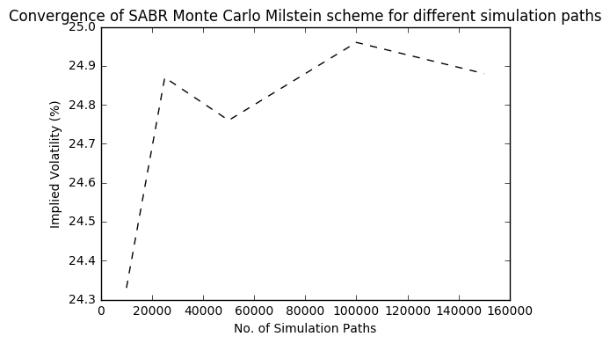

# 3. Validation of Hagan et al. approximation

## 3.1 Validation of c.d.f

We generate cumulative distribution plots for the same parameter sets by Monte Carlo simulation as a benchmark for c.d.f results by Hagan lognormal model.

We compare the 5-year and 10-year option with the same forward rate to see how Hagan approximation performed in short and long maturity.

Case1: =0.25, =0, =0.1

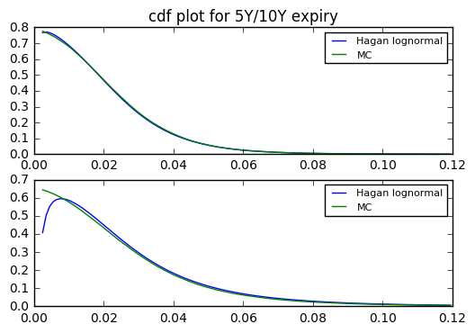

Case2: =0.25, =0, =0.9

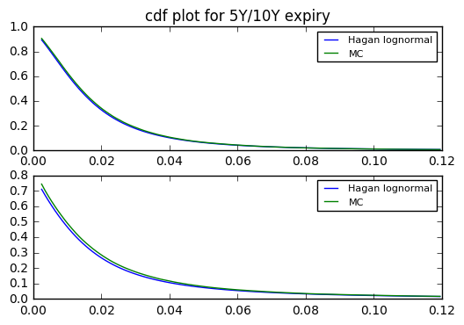

Case3: =0.25, =0.8, =0.1

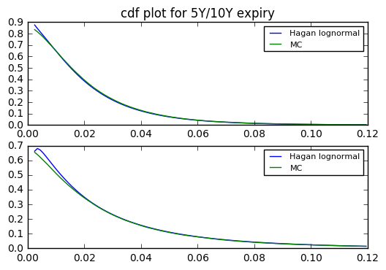

Case4: =0.25, =0.8 =0.9

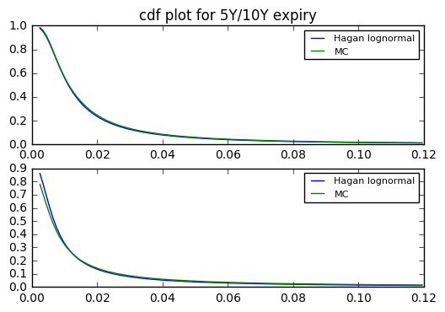

Case5: =0.25, =-0.8, =0.1

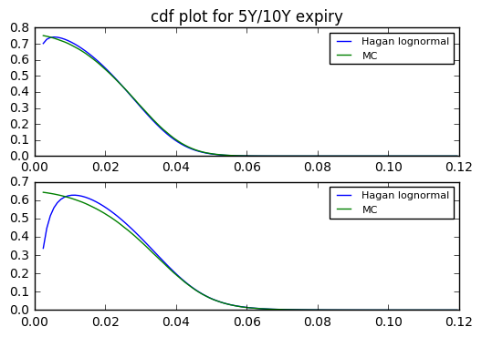

Case6: =0.25, =-0.8 =0.9

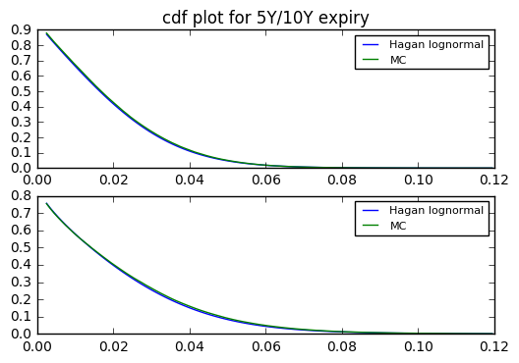

Case7: =0.4, =0, =0.1

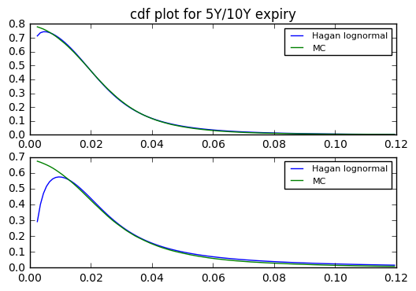

Case8: =0.4, =0, =0.9

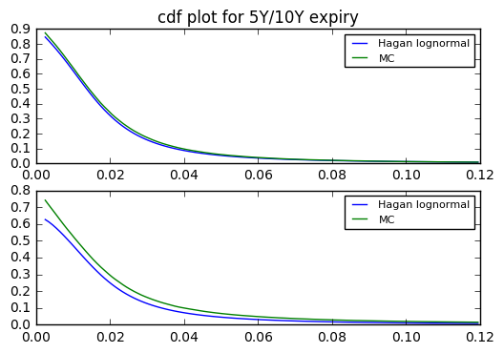

Case9: =0.4, =0.8, =0.1

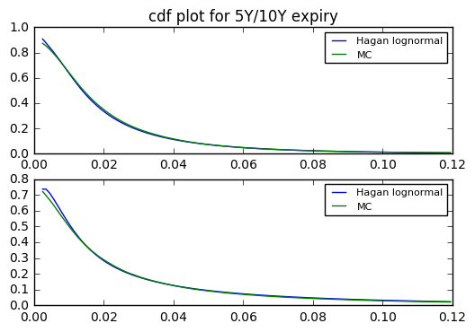

Case10: =0.4, =0.8, =0.9

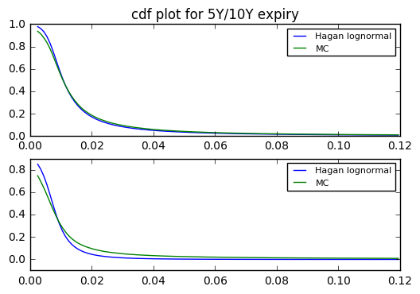

Case11: =0.4, =-0.8, =0.1

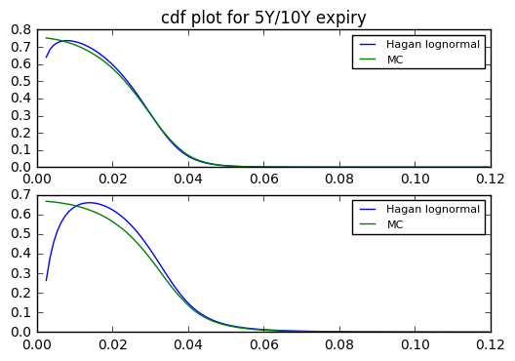

Case12: =0.4, =-0.8, =0.9

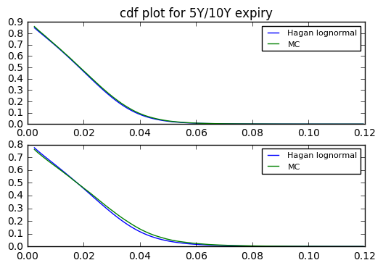

From the above we can see, Hagan formula breaks down in most of the cases for 10-year expiry when =0.25 while for =0.4 it even fails for 5-year expiry. Since the c.d.f plot by Hagan model suffers an increasing trend for low strike especially with low beta of 0.1 and negative rho of -0.8, which implies the arbitrage opportunity for low strike OTM receiver options with Hagan pricing.

## 3.2 Validation of lognormal implied volatility

We first investigate Hagan approximation and Monte Carlo simulation results in =0 case with =10Y, = {0, 0.8, -0.8}. Then we explore more general cases with = {0, 0.3, 0.5, 0.7, 1}, = {0, 0.8, -0.8}, =0.25.

### 3.2.1 Using lognormal Hagan

Table: Black implied volatilities (%) by Hagan approximation for various combinations of . For all cases: =10Y, =0, =0

|  |  |  |  |  |  |  |  |  |  |
| --- | --- | --- | --- | --- | --- | --- | --- | --- | --- |
|  | Strike Spreads (bps) | | | | | | | | |
|  | -150 | -100 | -50 | -25 | 0 | 25 | 50 | 100 | 150 |
| =0 | 31.08 | 27.61 | 25.05 | 23.99 | 23.04 | 22.19 | 21.41 | 20.06 | 18.91 |
| =0.3 | 28.32 | 26.10 | 24.40 | 23.69 | 23.04 | 22.45 | 21.91 | 20.96 | 20.13 |
| =0.5 | 26.69 | 25.17 | 24.00 | 23.50 | 23.04 | 22.62 | 22.24 | 21.55 | 20.95 |
| =0.7 | 25.17 | 24.29 | 23.61 | 23.31 | 23.04 | 22.79 | 22.56 | 22.14 | 21.78 |
| =1 | 23.04 | 23.04 | 23.04 | 23.04 | 23.04 | 23.04 | 23.04 | 23.04 | 23.04 |

Table: Black implied volatilities (%) by Hagan approximation for various combinations of . For all cases: =10Y, =0, =0.8

|  |  |  |  |  |  |  |  |  |  |
| --- | --- | --- | --- | --- | --- | --- | --- | --- | --- |
|  | Strike Spreads (bps) | | | | | | | | |
|  | -150 | -100 | -50 | -25 | 0 | 25 | 50 | 100 | 150 |
| =0 | 31.08 | 27.61 | 25.05 | 23.99 | 23.04 | 22.19 | 21.41 | 20.06 | 18.91 |
| =0.3 | 28.32 | 26.10 | 24.40 | 23.69 | 23.04 | 22.45 | 21.91 | 20.96 | 20.13 |
| =0.5 | 26.69 | 25.17 | 24.00 | 23.50 | 23.04 | 22.62 | 22.24 | 21.55 | 20.95 |
| =0.7 | 25.17 | 24.29 | 23.61 | 23.31 | 23.04 | 22.79 | 22.56 | 22.14 | 21.78 |
| =1 | 23.04 | 23.04 | 23.04 | 23.04 | 23.04 | 23.04 | 23.04 | 23.04 | 23.04 |

Table: Black implied volatilities (%) by Hagan approximation for various combinations of . For all cases: =10Y, =0, =-0.8

|  |  |  |  |  |  |  |  |  |  |
| --- | --- | --- | --- | --- | --- | --- | --- | --- | --- |
|  | Strike Spreads (bps) | | | | | | | | |
|  | -150 | -100 | -50 | -25 | 0 | 25 | 50 | 100 | 150 |
| =0 | 31.08 | 27.61 | 25.05 | 23.99 | 23.04 | 22.19 | 21.41 | 20.06 | 18.91 |
| =0.3 | 28.32 | 26.10 | 24.40 | 23.69 | 23.04 | 22.45 | 21.91 | 20.96 | 20.13 |
| =0.5 | 26.69 | 25.17 | 24.00 | 23.50 | 23.04 | 22.62 | 22.24 | 21.55 | 20.95 |
| =0.7 | 25.17 | 24.29 | 23.61 | 23.31 | 23.04 | 22.79 | 22.56 | 22.14 | 21.78 |
| =1 | 23.04 | 23.04 | 23.04 | 23.04 | 23.04 | 23.04 | 23.04 | 23.04 | 23.04 |

Table: Black implied volatilities (%) by Hagan approximation for various combinations of , , . For all cases:

|  |  |  |  |  |  |  |  |  |  |  |  |  |
| --- | --- | --- | --- | --- | --- | --- | --- | --- | --- | --- | --- | --- |
|  |  |  |  | -150 | -100 | -50 | -25 | 0 | 25 | 50 | 100 | 150 |
| 0.007 | 0 | 0 | 0.25 | 32.29 | 28.11 | 25.16 | 24.01 | 23.04 | 22.22 | 21.53 | 20.46 | 19.72 |
| 0.020 | 0.3 | 0 | 0.25 | 29.65 | 26.64 | 24.52 | 23.71 | 22.04 | 22.48 | 22.02 | 21.33 | 20.88 |
| 0.040 | 0.5 | 0 | 0.25 | 28.09 | 25.73 | 24.12 | 23.52 | 23.04 | 22.65 | 22.34 | 21.91 | 21.67 |
| 0.079 | 0.7 | 0 | 0.25 | 26.64 | 24.87 | 23.73 | 23.34 | 23.04 | 22.82 | 22.65 | 22.49 | 22.47 |
| 0.219 | 1 | 0 | 0.25 | 24.62 | 23.64 | 23.17 | 23.07 | 23.04 | 23.07 | 23.14 | 23.37 | 23.69 |
| 0.008 | 0 | 0.8 | 0.25 | 25.27 | 24.04 | 23.39 | 23.19 | 23.04 | 22.92 | 22.83 | 22.71 | 22.63 |
| 0.020 | 0.3 | 0.8 | 0.25 | 22.64 | 22.56 | 22.76 | 22.89 | 23.04 | 23.19 | 23.33 | 23.62 | 23.87 |
| 0.040 | 0.5 | 0.8 | 0.25 | 21.01 | 21.60 | 22.33 | 22.69 | 23.04 | 23.37 | 23.67 | 24.24 | 24.74 |
| 0.077 | 0.7 | 0.8 | 0.25 | 19.44 | 20.65 | 21.91 | 22.49 | 23.04 | 23.55 | 24.03 | 24.89 | 25.65 |
| 0.208 | 1 | 0.8 | 0.25 | 17.21 | 19.25 | 21.26 | 22.18 | 23.04 | 23.84 | 24.58 | 25.93 | 27.11 |
| 0.008 | 0 | -0.8 | 0.25 | 37.13 | 31.25 | 26.71 | 24.78 | 23.04 | 21.45 | 20.00 | 17.46 | 15.35 |
| 0.022 | 0.3 | -0.8 | 0.25 | 33.82 | 29.43 | 25.93 | 24.42 | 23.04 | 21.77 | 20.59 | 18.51 | 16.74 |
| 0.044 | 0.5 | -0.8 | 0.25 | 31.95 | 28.36 | 25.47 | 24.20 | 23.04 | 21.97 | 20.97 | 19.19 | 17.66 |
| 0.091 | 0.7 | -0.8 | 0.25 | 30.29 | 27.40 | 25.03 | 24.00 | 23.04 | 22.15 | 21.33 | 19.85 | 18.58 |
| 0.265 | 1 | -0.8 | 0.25 | 28.16 | 26.12 | 24.45 | 23.72 | 23.04 | 22.41 | 21.83 | 20.79 | 19.89 |
| 0.007 | 0 | 0 | 0.4 | 36.54 | 31.06 | 27.27 | 25.88 | 24.79 | 23.95 | 23.34 | 22.63 | 22.37 |
| 0.019 | 0.3 | 0 | 0.4 | 32.22 | 27.99 | 25.13 | 24.14 | 23.40 | 22.88 | 22.56 | 22.32 | 22.44 |
| 0.037 | 0.5 | 0 | 0.4 | 30.30 | 26.69 | 24.33 | 23.55 | 23.01 | 22.67 | 22.51 | 22.54 | 22.87 |
| 0.073 | 0.7 | 0 | 0.4 | 28.88 | 25.81 | 23.89 | 23.31 | 22.96 | 22.79 | 22.77 | 23.05 | 23.58 |
| 0.203 | 1 | 0 | 0.4 | 27.02 | 24.67 | 23.39 | 23.10 | 23.01 | 23.08 | 23.29 | 23.96 | 24.80 |
| 0.008 | 0 | 0.8 | 0.4 | 24.65 | 23.93 | 24.12 | 24.35 | 24.61 | 24.88 | 25.15 | 25.65 | 26.21 |
| 0.020 | 0.3 | 0.8 | 0.4 | 20.91 | 21.12 | 22.26 | 22.90 | 23.54 | 24.14 | 24.70 | 25.72 | 26.60 |
| 0.039 | 0.5 | 0.8 | 0.4 | 19.29 | 19.92 | 21.60 | 22.49 | 23.35 | 24.16 | 24.91 | 26.26 | 27.42 |
| 0.074 | 0.7 | 0.8 | 0.4 | 17.69 | 18.58 | 20.77 | 21.91 | 23.00 | 24.02 | 24.97 | 26.66 | 28.12 |
| 0.198 | 1 | 0.8 | 0.4 | 16.04 | 17.20 | 20.09 | 21.60 | 23.04 | 24.38 | 25.63 | 27.87 | 29.82 |
| 0.008 | 0 | -0.8 | 0.4 | 42.93 | 35.35 | 29.43 | 26.90 | 24.61 | 22.51 | 20.61 | 17.35 | 14.93 |
| 0.022 | 0.3 | -0.8 | 0.4 | 36.46 | 30.98 | 26.52 | 24.57 | 22.78 | 21.12 | 19.60 | 16.98 | 14.99 |
| 0.046 | 0.5 | -0.8 | 0.4 | 34.44 | 29.88 | 26.11 | 24.45 | 22.92 | 21.50 | 20.19 | 17.89 | 16.09 |
| 0.097 | 0.7 | -0.8 | 0.4 | 32.64 | 28.86 | 25.73 | 24.34 | 23.05 | 21.86 | 20.75 | 18.80 | 17.23 |
| 0.301 | 1 | -0.8 | 0.4 | 30.16 | 27.33 | 24.99 | 23.96 | 23.01 | 22.13 | 21.32 | 19.89 | 18.70 |

### 3.2.2 Using Monte Carlo simulation

Table: Black implied volatilities (%) by Euler scheme for various combinations of . For all cases: =10Y, =0, =0, =40，=100000

|  |  |  |  |  |  |  |  |  |  |
| --- | --- | --- | --- | --- | --- | --- | --- | --- | --- |
|  | Strike Spreads (bps) | | | | | | | | |
|  | -150 | -100 | -50 | -25 | 0 | 25 | 50 | 100 | 150 |
| =0 | 31.78 | 28.09 | 25.41 | 24.31 | 23.34 | 22.45 | 21.65 | 20.25 | 19.07 |
| =0.3 | 28.11 | 25.91 | 24.22 | 23.51 | 22.87 | 22.29 | 21.76 | 20.82 | 20.01 |
| =0.5 | 26.72 | 25.18 | 23.98 | 23.47 | 23.01 | 22.58 | 22.19 | 21.50 | 20.90 |
| =0.7 | 25.86 | 24.78 | 23.97 | 23.62 | 23.32 | 23.03 | 22.77 | 22.30 | 21.89 |
| =1 | 23.98 | 23.72 | 23.57 | 23.51 | 23.47 | 23.43 | 23.40 | 23.33 | 23.28 |

Table: Black implied volatilities (%) by Euler scheme for various combinations of . For all cases: =10Y, =0, =0.8, =40, =100000

|  |  |  |  |  |  |  |  |  |  |
| --- | --- | --- | --- | --- | --- | --- | --- | --- | --- |
|  | Strike Spreads (bps) | | | | | | | | |
|  | -150 | -100 | -50 | -25 | 0 | 25 | 50 | 100 | 150 |
| =0 | 31.30 | 27.58 | 25.04 | 23.99 | 23.04 | 22.19 | 21.42 | 20.07 | 18.92 |
| =0.3 | 28.49 | 26.21 | 24.46 | 23.72 | 23.06 | 22.45 | 21.90 | 20.92 | 20.07 |
| =0.5 | 27.37 | 25.65 | 24.36 | 23.81 | 23.32 | 22.87 | 22.46 | 21.73 | 21.09 |
| =0.7 | 25.17 | 24.28 | 23.57 | 23.26 | 22.98 | 22.71 | 22.47 | 22.04 | 21.65 |
| =1 | 23.07 | 23.09 | 23.07 | 23.05 | 23.04 | 23.02 | 23.00 | 22.99 | 22.97 |

Table: Black implied volatilities (%) by Euler scheme for various combinations of . For all cases: =10Y, =0, =-0.8, =40, =100000

|  |  |  |  |  |  |  |  |  |  |
| --- | --- | --- | --- | --- | --- | --- | --- | --- | --- |
|  | Strike Spreads (bps) | | | | | | | | |
|  | -150 | -100 | -50 | -25 | 0 | 25 | 50 | 100 | 150 |
| =0 | 31.26 | 27.73 | 25.12 | 24.04 | 23.08 | 22.21 | 21.43 | 20.07 | 18.91 |
| =0.3 | 28.59 | 26.27 | 24.49 | 23.75 | 23.09 | 22.48 | 21.93 | 20.94 | 20.10 |
| =0.5 | 26.56 | 25.08 | 23.92 | 23.43 | 22.98 | 22.56 | 22.18 | 21.50 | 20.90 |
| =0.7 | 25.57 | 24.56 | 23.80 | 23.48 | 23.18 | 22.91 | 22.66 | 22.20 | 21.80 |
| =1 | 22.58 | 22.76 | 22.82 | 22.83 | 22.83 | 22.83 | 22.83 | 22.82 | 22.81 |

Table: Black implied volatilities (%) by Euler scheme for various combinations of , , . For all cases: =40, =100000

|  |  |  |  |  |  |  |  |  |  |  |  |  |
| --- | --- | --- | --- | --- | --- | --- | --- | --- | --- | --- | --- | --- |
|  |  |  |  | -150 | -100 | -50 | -25 | 0 | 25 | 50 | 100 | 150 |
| 0.007 | 0 | 0 | 0.25 | 32.54 | 28.29 | 25.31 | 24.14 | 23.15 | 22.32 | 21.61 | 20.51 | 19.72 |
| 0.020 | 0.3 | 0 | 0.25 | 28.43 | 25.79 | 23.91 | 23.18 | 22.56 | 22.04 | 21.60 | 20.93 | 20.47 |
| 0.040 | 0.5 | 0 | 0.25 | 27.67 | 25.45 | 23.91 | 23.33 | 22.84 | 22.44 | 22.11 | 21.65 | 21.35 |
| 0.079 | 0.7 | 0 | 0.25 | 26.51 | 24.74 | 23.59 | 23.19 | 22.88 | 22.64 | 22.46 | 22.23 | 22.12 |
| 0.219 | 1 | 0 | 0.25 | 24.70 | 23.70 | 23.18 | 23.05 | 22.98 | 22.97 | 22.99 | 23.15 | 23.39 |
| 0.008 | 0 | 0.8 | 0.25 | 25.53 | 24.31 | 23.62 | 23.38 | 23.20 | 23.05 | 22.94 | 22.79 | 22.70 |
| 0.020 | 0.3 | 0.8 | 0.25 | 24.09 | 23.62 | 23.57 | 23.61 | 23.69 | 23.78 | 23.88 | 24.07 | 24.26 |
| 0.040 | 0.5 | 0.8 | 0.25 | 21.74 | 22.16 | 22.72 | 23.01 | 23.29 | 23.56 | 23.82 | 24.30 | 24.73 |
| 0.077 | 0.7 | 0.8 | 0.25 | 21.14 | 21.93 | 22.89 | 23.36 | 23.81 | 24.24 | 24.64 | 25.40 | 26.07 |
| 0.208 | 1 | 0.8 | 0.25 | 35.73 | 33.39 | 33.31 | 33.61 | 34.02 | 34.48 | 34.97 | 35.96 | 36.94 |
| 0.008 | 0 | -0.8 | 0.25 | 37.33 | 31.23 | 26.65 | 24.74 | 23.03 | 21.48 | 20.08 | 17.61 | 15.57 |
| 0.022 | 0.3 | -0.8 | 0.25 | 32.39 | 28.42 | 25.24 | 23.86 | 22.58 | 21.41 | 20.33 | 18.38 | 16.72 |
| 0.044 | 0.5 | -0.8 | 0.25 | 31.25 | 27.80 | 25.02 | 23.81 | 22.70 | 21.67 | 20.72 | 19.02 | 17.56 |
| 0.091 | 0.7 | -0.8 | 0.25 | 29.83 | 27.04 | 24.77 | 23.77 | 22.86 | 22.01 | 21.22 | 19.79 | 18.55 |
| 0.265 | 1 | -0.8 | 0.25 | 28.64 | 26.60 | 24.93 | 24.20 | 23.52 | 22.90 | 22.31 | 21.26 | 20.35 |
| 0.007 | 0 | 0 | 0.4 | 34.62 | 29.34 | 25.75 | 24.43 | 23.37 | 22.55 | 21.92 | 21.14 | 20.78 |
| 0.019 | 0.3 | 0 | 0.4 | 28.95 | 25.54 | 23.21 | 22.37 | 21.72 | 21.23 | 20.89 | 20.55 | 20.49 |
| 0.037 | 0.5 | 0 | 0.4 | 28.39 | 25.32 | 23.32 | 22.63 | 22.14 | 21.79 | 21.58 | 21.43 | 21.54 |
| 0.073 | 0.7 | 0 | 0.4 | 27.27 | 24.70 | 23.08 | 22.58 | 22.23 | 22.02 | 21.93 | 22.00 | 22.28 |
| 0.203 | 1 | 0 | 0.4 | NaN | NaN | NaN | NaN | NaN | NaN | NaN | NaN | NaN |
| 0.008 | 0 | 0.8 | 0.4 | 23.82 | 22.93 | 22.95 | 23.09 | 23.29 | 23.51 | 23.73 | 24.18 | 24.61 |
| 0.020 | 0.3 | 0.8 | 0.4 | 23.61 | 23.07 | 23.58 | 23.99 | 24.43 | 24.88 | 25.31 | 26.14 | 26.88 |
| 0.039 | 0.5 | 0.8 | 0.4 | 21.22 | 21.44 | 22.60 | 23.27 | 23.93 | 24.57 | 25.18 | 26.30 | 27.30 |
| 0.074 | 0.7 | 0.8 | 0.4 | 21.95 | 22.07 | 23.44 | 24.26 | 25.07 | 25.86 | 26.61 | 27.98 | 29.18 |
| 0.198 | 1 | 0.8 | 0.4 | NaN | NaN | NaN | NaN | NaN | NaN | NaN | NaN | NaN |
| 0.008 | 0 | -0.8 | 0.4 | 41.75 | 33.94 | 28.14 | 25.73 | 23.57 | 21.63 | 19.88 | 16.97 | 14.90 |
| 0.022 | 0.3 | -0.8 | 0.4 | 33.14 | 28.57 | 24.85 | 23.22 | 21.71 | 20.31 | 19.02 | 16.78 | 15.03 |
| 0.046 | 0.5 | -0.8 | 0.4 | 32.31 | 28.23 | 24.89 | 23.42 | 22.06 | 20.80 | 19.63 | 17.58 | 15.94 |
| 0.097 | 0.7 | -0.8 | 0.4 | 31.44 | 27.94 | 25.07 | 23.80 | 22.61 | 21.51 | 20.49 | 18.68 | 17.21 |
| 0.301 | 1 | -0.8 | 0.4 | NaN | NaN | NaN | NaN | NaN | NaN | NaN | NaN | NaN |

## 3.3 The performance of Hagan et al. approximation

Based on research we have done in previous sections, we compared the Hagan approximation results with Monte Carlo simulation as a benchmark. The approximation errors are shown as following:

Table: Black implied volatilities approximation error (%) for various combinations of . For all cases: =10Y, =0, =0, =40，=100000

|  |  |  |  |  |  |  |  |  |  |  |
| --- | --- | --- | --- | --- | --- | --- | --- | --- | --- | --- |
|  | Strike Spreads (bps) | | | | | | | | |  |
|  | -150 | -100 | -50 | -25 | 0 | 25 | 50 | 100 | 150 | sqr_sum |
| =0 | -2.20 | -1.71 | -1.42 | -1.32 | -1.29 | -1.16 | -1.11 | -0.94 | -0.84 | 0.17 |
| =0.3 | 0.75 | 0.73 | 0.74 | 0.77 | 0.74 | 0.72 | 0.69 | 0.67 | 0.60 | 0.05 |
| =0.5 | -0.11 | -0.04 | 0.08 | 0.13 | 0.13 | 0.18 | 0.23 | 0.23 | 0.24 | 0.002 |
| =0.7 | -2.67 | -1.98 | -1.50 | -1.31 | -1.20 | -1.04 | -0.92 | -0.72 | -0.50 | 0.19 |
| =1 | -3.92 | -2.87 | -2.25 | -2.00 | -1.83 | -1.66 | -1.54 | -1.24 | -1.03 | 0.44 |
| total |  |  |  |  |  |  |  |  |  | 0.81 |

Table: Black implied volatilities approximation error (%) for various combinations of . For all cases: =10Y, =0, =0.8, =40，=100000

|  |  |  |  |  |  |  |  |  |  |  |
| --- | --- | --- | --- | --- | --- | --- | --- | --- | --- | --- |
|  | Strike Spreads (bps) | | | | | | | | |  |
|  | -150 | -100 | -50 | -25 | 0 | 25 | 50 | 100 | 150 | sqr_sum |
| =0 | -0.7 | -0.11 | -0.04 | -0.00 | -0.00 | -0.00 | -0.05 | -0.05 | -0.05 | 0.01 |
| =0.3 | 0.75 | 0.73 | 0.74 | 0.77 | 0.74 | 0.72 | 0.69 | 0.67 | 0.60 | 0.01 |
| =0.5 | -0.11 | -0.04 | 0.08 | 0.13 | 0.13 | 0.18 | 0.23 | 0.23 | 0.24 | 0.18 |
| =0.7 | -2.67 | -1.98 | -1.50 | -1.31 | -1.20 | -1.04 | -0.92 | -0.72 | -0.50 | 0.01 |
| =1 | -3.92 | -2.87 | -2.25 | -2.00 | -1.83 | -1.66 | -1.54 | -1.24 | -1.03 | 0.003 |
| total |  |  |  |  |  |  |  |  |  | 0.21 |

Table: Black implied volatilities approximation error (%) for various combinations of . For all cases: =10Y, =0, =-0.8, =40，=100000

|  |  |  |  |  |  |  |  |  |  |  |
| --- | --- | --- | --- | --- | --- | --- | --- | --- | --- | --- |
|  | Strike Spreads (bps) | | | | | | | | |  |
|  | -150 | -100 | -50 | -25 | 0 | 25 | 50 | 100 | 150 | sqr_sum |
| =0 | -0.58 | -0.43 | -0.28 | -0.21 | -0.17 | -0.09 | -0.09 | -0.05 | -0.00 | 0.01 |
| =0.3 | -0.94 | -0.65 | -0.37 | -0.25 | -0.22 | -0.13 | -0.09 | 0.10 | 0.15 | 0.02 |
| =0.5 | 0.49 | 0.36 | 0.33 | 0.30 | 0.26 | 0.27 | 0.27 | 0.23 | 0.24 | 0.009 |
| =0.7 | -1.56 | -1.10 | -0.80 | -0.72 | -0.60 | -0.52 | -0.44 | -0.27 | -0.09 | 0.06 |
| =1 | -2.04 | -1.23 | -0.96 | -0.92 | -0.92 | -0.92 | -0.92 | -0.96 | -1.01 | 0.12 |
| total |  |  |  |  |  |  |  |  |  | 0.22 |

Table: Black implied volatilities approximation error (%) for various combinations of , , . For all cases: =40, =100000

|  |  |  |  |  |  |  |  |  |  |  |  |  |  |
| --- | --- | --- | --- | --- | --- | --- | --- | --- | --- | --- | --- | --- | --- |
|  |  |  |  | -150 | -100 | -50 | -25 | 0 | 25 | 50 | 100 | 150 | Sqr_sum |
| 0.007 | 0 | 0 | 0.25 | -0.77 | -0.64 | -0.59 | -0.54 | -0.48 | -0.45 | -0.37 | -0.24 | -0.00 | 0.02 |
| 0.020 | 0.3 | 0 | 0.25 | 4.29 | 3.30 | 2.55 | 2.29 | -2.30 | 2.00 | 1.94 | 1.91 | 2.00 | 0.62 |
| 0.040 | 0.5 | 0 | 0.25 | 1.52 | 1.10 | 0.88 | 0.81 | 0.88 | 0.94 | 1.04 | 1.20 | 1.50 | 0.11 |
| 0.079 | 0.7 | 0 | 0.25 | 0.49 | 0.53 | 0.59 | 0.65 | 0.70 | 0.80 | 0.85 | 1.17 | 1.58 | 0.49 |
| 0.219 | 1 | 0 | 0.25 | -0.32 | -0.25 | -0.04 | 0.09 | 0.26 | 0.44 | 0.65 | 0.95 | 1.28 | 0.03 |
| 0.008 | 0 | 0.8 | 0.25 | -1.02 | -1.11 | -0.97 | -0.81 | -0.69 | -0.56 | -0.48 | -0.35 | -0.31 | 0.05 |
| 0.020 | 0.3 | 0.8 | 0.25 | -6.02 | -4.49 | -3.44 | -3.05 | -2.74 | -2.48 | -2.30 | -1.87 | -1.61 | 1.03 |
| 0.040 | 0.5 | 0.8 | 0.25 | -3.36 | -2.53 | -1.72 | -1.39 | -1.07 | -0.81 | -0.63 | -0.25 | 0.04 | 0.25 |
| 0.077 | 0.7 | 0.8 | 0.25 | -8.04 | -5.84 | -4.28 | -3.72 | -3.23 | -2.85 | -2.48 | -2.01 | -1.61 | 1.62 |
| 0.208 | 1 | 0.8 | 0.25 | -51.83 | -42.35 | -36.18 | -34.01 | -32.28 | -30.86 | -29.71 | -27.89 | -26.61 | 113.08 |
| 0.008 | 0 | -0.8 | 0.25 | -0.54 | 0.06 | 0.23 | 0.16 | 0.04 | -0.14 | -0.40 | -0.85 | -1.41 | 0.03 |
| 0.022 | 0.3 | -0.8 | 0.25 | 4.41 | 3.55 | 2.73 | 2.35 | 2.04 | 1.68 | 1.28 | 0.71 | 0.12 | 0.54 |
| 0.044 | 0.5 | -0.8 | 0.25 | 2.24 | 2.01 | 1.80 | 1.64 | 1.50 | 1.38 | 1.21 | 0.89 | 0.57 | 0.22 |
| 0.091 | 0.7 | -0.8 | 0.25 | 1.54 | 1.33 | 1.05 | 0.97 | 0.79 | 0.64 | 0.52 | 0.30 | 0.16 | 0.08 |
| 0.265 | 1 | -0.8 | 0.25 | -1.68 | -1.80 | -1.93 | -1.98 | -2.04 | -2.14 | -2.15 | -2.21 | -2.26 | 0.37 |
| 0.007 | 0 | 0 | 0.4 | 5.55 | 5.86 | 5.90 | 5.94 | 6.08 | 6.21 | 6.48 | 7.05 | 7.65 | 3.61 |
| 0.019 | 0.3 | 0 | 0.4 | 11.30 | 9.59 | 8.27 | 7.91 | 7.73 | 7.77 | 7.99 | 8.61 | 9.52 | 7.00 |
| 0.037 | 0.5 | 0 | 0.4 | 6.73 | 5.41 | 4.33 | 4.07 | 3.93 | 4.04 | 4.31 | 5.18 | 6.17 | 2.25 |
| 0.073 | 0.7 | 0 | 0.4 | 5.90 | 4.49 | 3.51 | 3.23 | 3.28 | 3.50 | 3.83 | 4.77 | 5.83 | 1.72 |
| 0.203 | 1 | 0 | 0.4 | - | - | - | - | - | - | - | - | - | - |
| 0.008 | 0 | 0.8 | 0.4 | 3.48 | 4.36 | 5.10 | 5.46 | 5.67 | 5.83 | 5.98 | 6.08 | 6.50 | 2.68 |
| 0.020 | 0.3 | 0.8 | 0.4 | -11.44 | -8.45 | -5.60 | -4.54 | -3.64 | -2.97 | -2.41 | -1.61 | -1.04 | 2.86 |
| 0.039 | 0.5 | 0.8 | 0.4 | -9.10 | -7.09 | -4.42 | -3.35 | -2.42 | -1.67 | -1.07 | -0.15 | 0.44 | 1.74 |
| 0.074 | 0.7 | 0.8 | 0.4 | -19.41 | -15.81 | -11.39 | -9.69 | -8.26 | -7.12 | -6.16 | -4.72 | -3.63 | 10.43 |
| 0.198 | 1 | 0.8 | 0.4 | - | - | - | - | - | - | - | - | - | - |
| 0.008 | 0 | -0.8 | 0.4 | 2.83 | 4.15 | 4.58 | 4.55 | 4.41 | 4.07 | 3.67 | 2.24 | 0.20 | 1.21 |
| 0.022 | 0.3 | -0.8 | 0.4 | 10.02 | 8.44 | 6.72 | 5.81 | 4.93 | 3.99 | 3.05 | 1.19 | -0.27 | 3.01 |
| 0.046 | 0.5 | -0.8 | 0.4 | 6.59 | 5.84 | 4.90 | 4.40 | 3.90 | 3.37 | 2.85 | 1.76 | 0.94 | 1.60 |
| 0.097 | 0.7 | -0.8 | 0.4 | 3.82 | 3.29 | 2.63 | 2.27 | 1.95 | 1.63 | 1.27 | 0.64 | 0.12 | 0.46 |
| 0.301 | 1 | -0.8 | 0.4 | - | - | - | - | - | - | - | - | - | - |

We can see from the charts above, the parameter set beta = 1, rho=0.8, nu=0.25 generates the worst approximation with the sum of square errors of 113.08%. While beta=0, nu=0, rho=8 and rho=-8 both generates the closest results with the sum of square errors of 0.01% compared with Monte Carlo.

Also, the results we get from nu=0.4 generates much higher error compared with nu=0.25.

# 4. SABR calibration in practice

## 4.1 Over-specification test for Hagan et al. approximation

In this section we have conducted an over-specification test for Hagan et al. approximation. This test is aimed to examine the calibration quality of the Hagan approximation, and how the particular k will have an effect on it. Our tests are run with different sets of SABR parameters kept fixed and the remaining parameters calibrated based on the minimization algorithm and then ATM volatility recovered. Our subject data here is the data with expiry Tk-1=1Y.

### 4.1.1 fixed *k*

The calibration has been performed with k keeping fixed and calibrating the other two parameters k, k. We have repeated the calibration exercise using:

According to the plot below, all approximations provide excellent fit to market quotes except . Generally the smile slope gets more pronounced as moves closer to 1, which represents a switch from normal approximation to lognormal approximation.

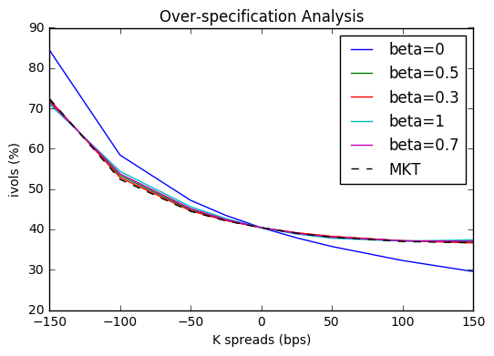

### 4.1.2 fixed *k*

We also present an assessment for the calibration where is kept fixed. We have repeated the calibration using:

We can see that =0, -0.3, -0.5 all give good approximations from the plot below while =-0.7, -0.9 do not fit well for out-of-the-money options. It’s also straightforward that has a similar effect on the smile shape as does: the smile slope becomes steeper as gets more negative.

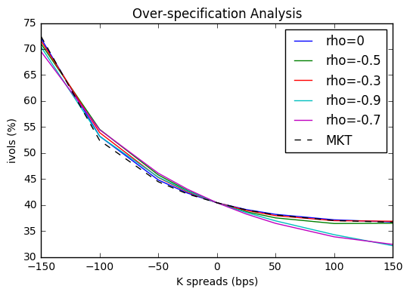

### 4.1.3 fixed *k*

The same calibration procedure is run for parameter k using:

And it can be seen from the plot below that the effect of is to increase or decrease its curvature: higher leads to increased volatility for out of the money (OTM) and in the money (ITM) options. Of these three values, the best performance is given by and also give good approximations.

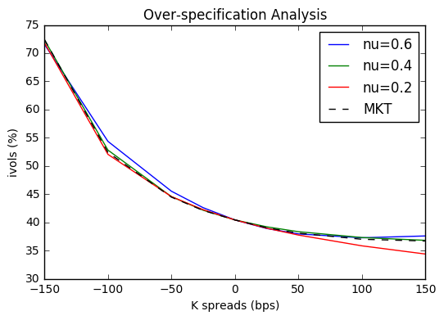

### 4.1.4 fixed *k* and *k*

We repeat the calibration procedure where parameter k and k kept fixed and k calibrated using:

All combinations of and yield good approximations except =0, =-0.8, as can be seen from the plot below. In other words, a sound approximation of Hagan et al. lognormal SABR model does not require all three parameters , and to be calibrated at once. Setting two of them fixed and calibrating the remaining one can be more computationally efficient without harming the quality of calibration.

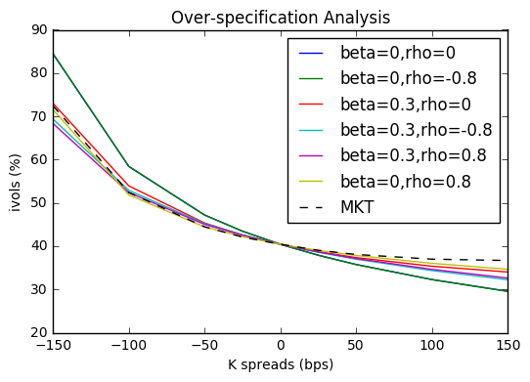

### 4.1.5 fixed *k* and *k*

Then again we repeat the calibration procedure where parameter k and kept fixed and k calibrated using:

When is fixed to 0.25, closer to 0 gives better performance while a high such as 0.7 and 1 do not fit well either for in-the-money options or for out-of-the-money options. For other values of , in general their ability to fit market data does not vary too much from each other.

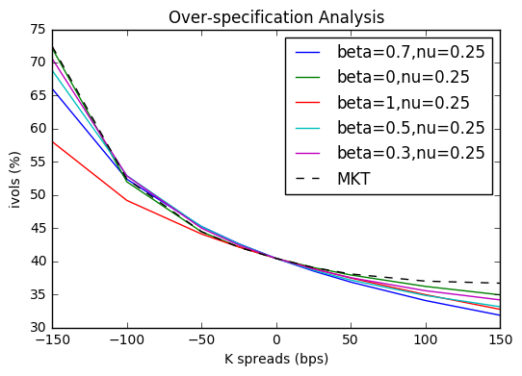

### 4.1.6 fixed *k* and *k*

We repeat the calibration procedure where parameter k and kept fixed and k calibrated using:

Of the three combinations given here, =0.8,=0.25 has the best performance for out-of-the-money options while =-0.8,=0.25 gives the worst.

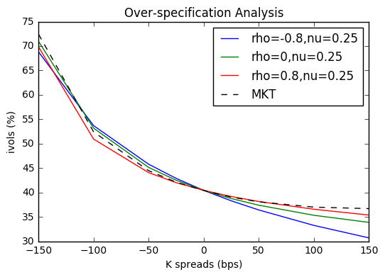

## 4.2 Collinearity test for Hagan et.al approximation

To further explore the quality of Hagan SABR approximation, we calculate the condition number of the calibration Jacobian matrix to detect collinearity.

Table: Collinearity test for Hagan et al. implementation

|  |  |
| --- | --- |
| Hagan et al. SABR | Condition number of Jacobian matrix |
| Calibrate , and | 1277 |
| Fix , calibrate and | 437 |
| Fix -0.3, calibrate and | 878 |
| Fix, calibrate and | 3950 |
| Fix =0 and =0.8, calibrate | 72 |
| Fix =0.5 and =0.25, calibrate | 260 |
| Fix =0.8 and =0.25, calibrate | 29 |

We can see from the table above that 1) with one or two parameters fixed in calibration, SABR model has less collinearity as the condition number of the transposed Jacobian matrix of calibration has reduced from 1277 to around 1000 or even 100 below; 2) Of these different calibrations, fixing and one more factor or can reduce collinearity most. However, keeping aspecific parameters fixed to different values can give very different condition numbers. For example, the condition number rises to 14767 when we calibrate with fixed to 0.

# 5. Alternative SABR approximations

## 5.1 Obloj SABR

### 5.1.1 Obloj calibration

We have plotted implied volatility smile curves by Obloj lognormal SABR against Obloj SABR for expiry of 10Y, 5Y, 2Y, 1Y, 0.5Y and 0.25Y. We can see that for options with short maturities within one year, Obloj model provides a slightly lower approximation for deep in-the-money options that Hagan lognormal does while their estimation for at-the-money options and out-of-the-money options are extremely close; they have nearly the same smile curve for maturities over 1 year. Here Hagan lognormal SABR fits better to our market data sample.

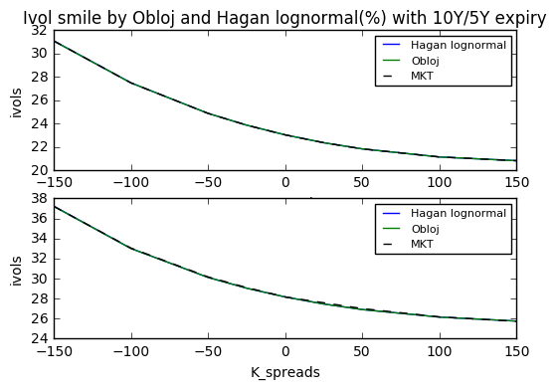

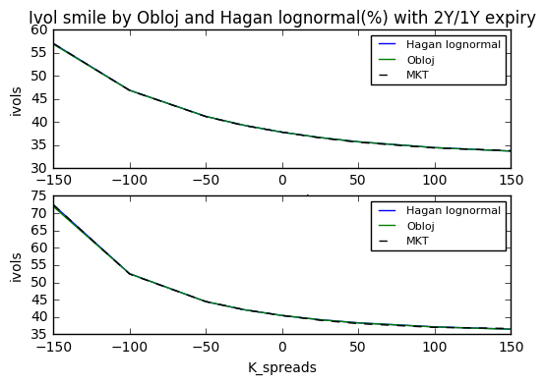

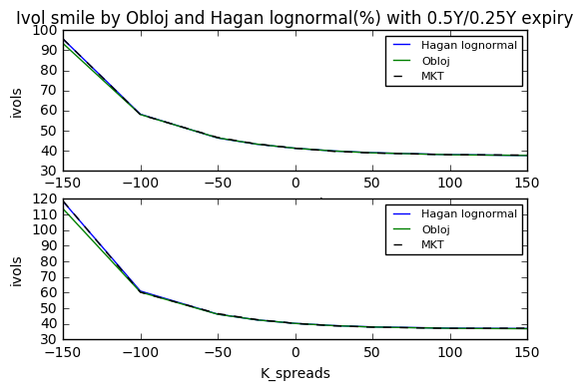

### 5.1.2 Validation of c.d.f

We repeat the c.d.f generation step for Obloj SABR model. Generally, cumulative distribution plots by Obloj model is slightly higher than those by Hagan model and this subtle difference can be neglected compared with the cumulative distribution plot by simulation. Therefore, Obloj model suffers from the same negative p.d.f problem for low strike options and we still have to explore other alternative SABR models.

Case1: =0.25, =0, =0.1

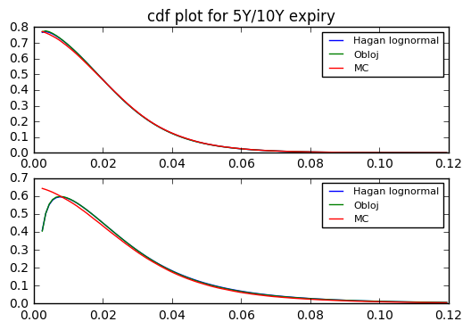

Case2: =0.25, =0, =0.9

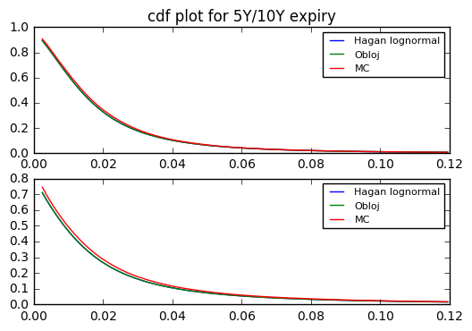

Case3: =0.25, =0.8, =0.1

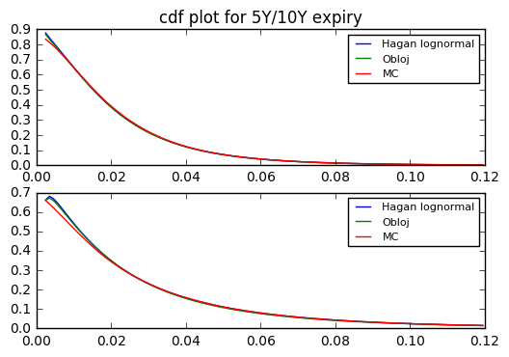

Case4: =0.25, =0.8 =0.9

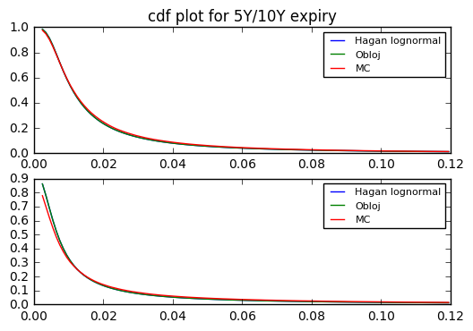

Case5: =0.25, =-0.8, =0.1

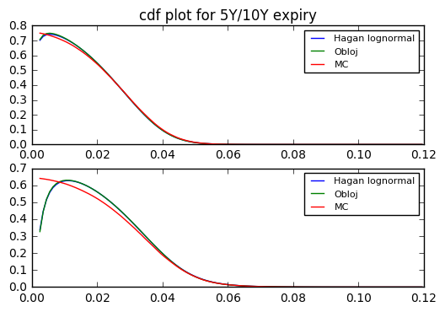

Case6: =0.25, =-0.8 =0.9

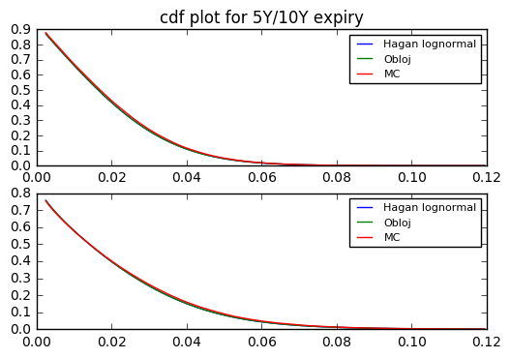

Case7: =0.4, =0 =0.1

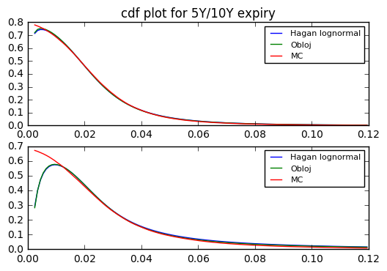

Case8: =0.4, =0 =0.9

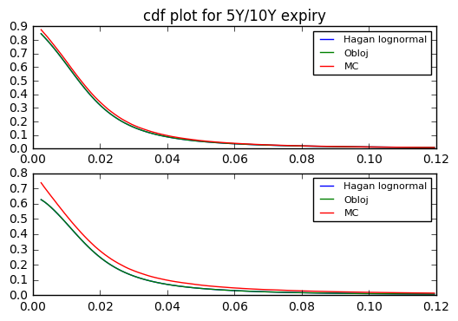

Case9: =0.4, =0.8 =0.1

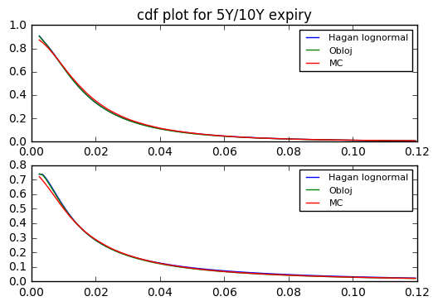

Case10: =0.4, =0.8 =0.9

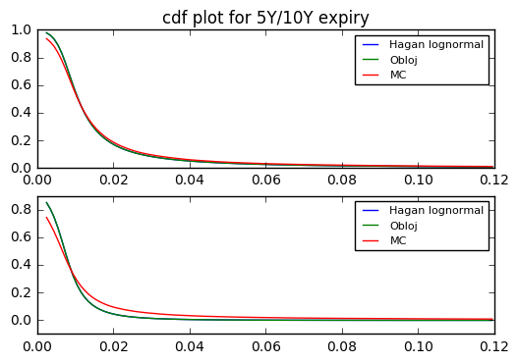

Case11: =0.4, =-0.8 =0.1

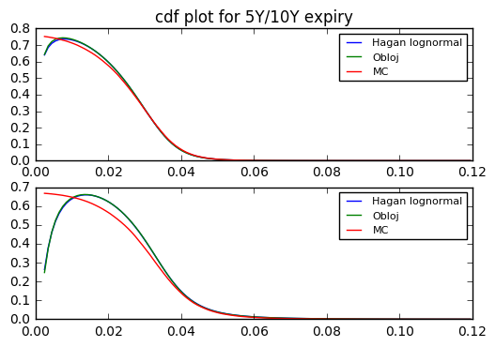

Case12: =0.4, =-0.8 =0.9

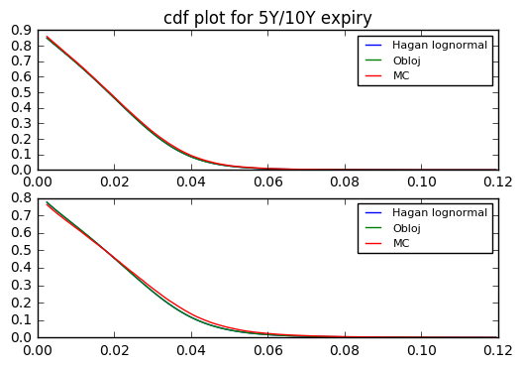

### 5.1.3 Over-specification and collinearity test

We repeat the same procedure for over-specification and collinearity test for Obloj SABR implementation and the results are listed below. Again our subject data here is the data with expiry Tk-1=1Y. It is straightforward that Obloj model and Hagan et al model give very close results for each calibration. Moreover, Obloj model has more potential for collinearity reduction with one or two SABR parameters fixed in calibration.

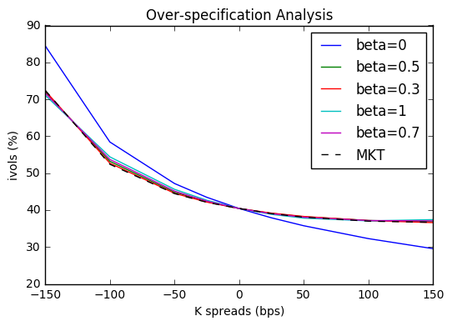

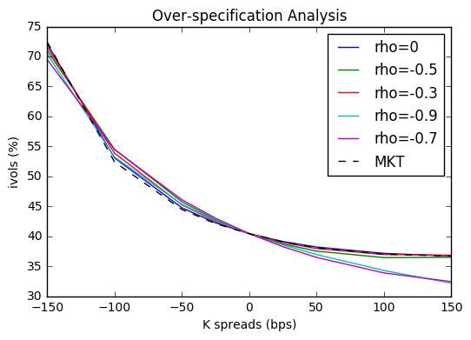

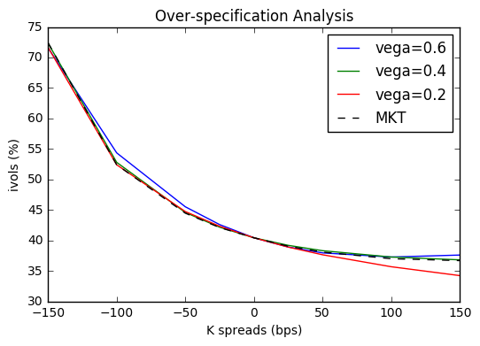

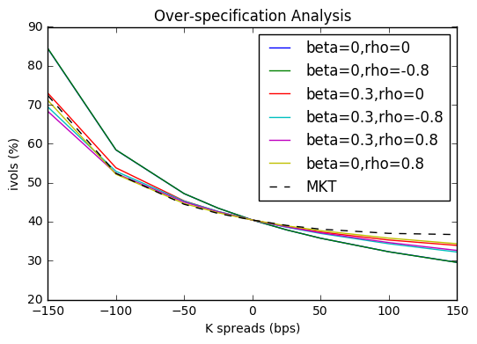

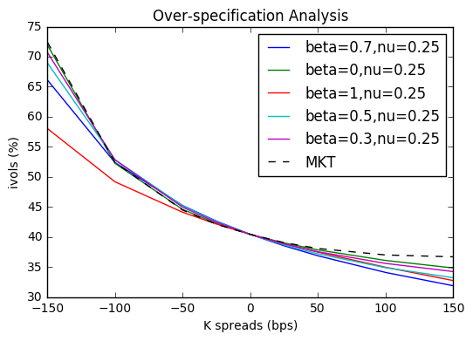

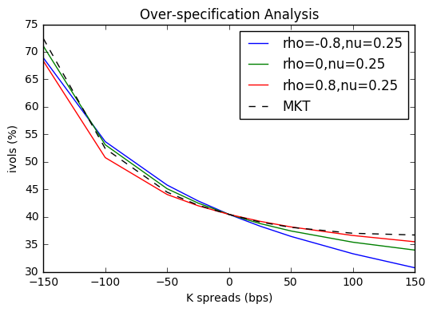

Table: Collinearity test for Obloj implementation

|  |  |
| --- | --- |
| Obloj SABR | Condition number of Jacobian matrix |
| Calibrate , and | 2711 |
| Fix , calibrate and | 1496 |
| Fix -0.9, calibrate and | 9 |
| Fix, calibrate and | 2140 |
| Fix =0 and =0.8, calibrate | 40 |
| Fix =0 and =0.25, calibrate | 878 |
| Fix =0.8 and =0.25, calibrate | 22 |

# 6. Conclusion

Our conclusions are based on the assumption that Monte-Carlo simulations converge well in all cases of simulation path, simulation time steps and SABR parameter sets. We applied Euler scheme for Monte-Carlo simulation to generate SABR process as a benchmark for Hagan et al. approximation and we set simulation path to 100000 and simulation time steps to 40. According to our results in section 2, the Euler scheme produces oscillatory results given different simulation paths and it converges well when rho=-0.8, in which case Hagan et al model does not generate good approximations while simulation results oscillate to a greater extend and have higher Monte-Carlo errors when Hagan el al produces sound approximations.

From the plots in section 3.1 and the tables in section 3.3, we can see the Hagan approximation performs ok with low nu, beta=0 or around 0.5 and rho around 0 for option with short expiry and high strike.

However, Hagan starts losing precision from 10-year and longer maturity for low strike. In our case , the strike range where Hagan formula breaks down is when strike is below F.

Also, Hagan provides poor approximation when rho is negative even when strike is close to the forward rate.

In section 3.3, we also compare the results for rho=0.25 and rho=0.4. We can see the results from rho=0.4 has obviously higher error than when rho=0.25.

We think Hagan et al. SABR model suffer from three major drawbacks:

* For options with long maturities, the implied probability density function can become negative when strikes are low, which implies arbitrage-able option prices. This can be seen in our section 3.1.
* For high and values, the Hagan approximation can exhibit an explosive behavior: the implied volatility for high-strike options can be super high.
* There is a tradeoff between collinearity and accuracy. With , and calibrated at once, the model may suffer from strong collinearity but if we fix one or two of SABR parameters and calibrate the remaining, the model may lose its accuracy.

# 7. Code structure

We code in Python and manage version controls on Github platform. The full codes are available at <https://github.com/gsallc/CapstoneFall2017.git>.

For more efficient coding and review, we have structured our codes into six folders: Pricing, Fitter, Bin, Inputs Test and Documentation and below is a summary of them.

* Pricing: library codes for various SABR models including Hagan SABR model and Obloj SABR model, Black Scholes, Monte Carlo simulation
* Fitter: library codes for over-specification test and multi-collinearity test of SABR calibration
* Bin: driver codes for both pricing and fitter parts
* Inputs: market data of options
* Test: unit tests and doc tests
* Documentation: project plans and reports

# 8. References

[1] Hagan P, D Kumar, A Lesniewski and D Woodward, “Managing smile risk”, Wilmott Magazine, pages 84-108 (2002)

[2] Jan Obloj, “Fine-tune your smile: Correction to Hagan et al.”, Wilmott Magazine, pages 102-104 (2008)

[3] Antonov, A., Spector, M. “Free Boundary SABR”, RISK (2015)

[4] Giovanni Travaglini. “SABR Calibration in Python”, SSRN (2016)

[5] Joerg Kienitz, Daniel Wetterau. “Financial Modeling- Theory, Implementation and Practice with MATLAB Source” (2012)

[6] Christian Crispoldi, Gerald Wigger, Peter Larkin. “SABR and SABR LOBOR Market Models in Practice” (2015)