Email Template Screenshots
Certificate Portal Backend
Generated with sample data on 5/6/2026.

Assessment Results - Pass
Subject: Assessment Results - Basic Maritime Safety Training
Sample data: Post Course assessment, passing score.

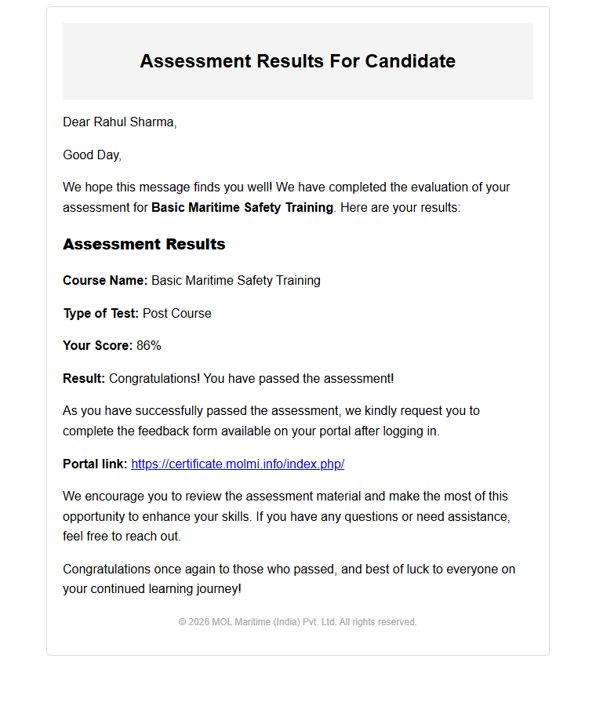

Assessment Results - Fail
Subject: Assessment Results - Basic Maritime Safety Training
Sample data: Post Course assessment, failing score with retest information.

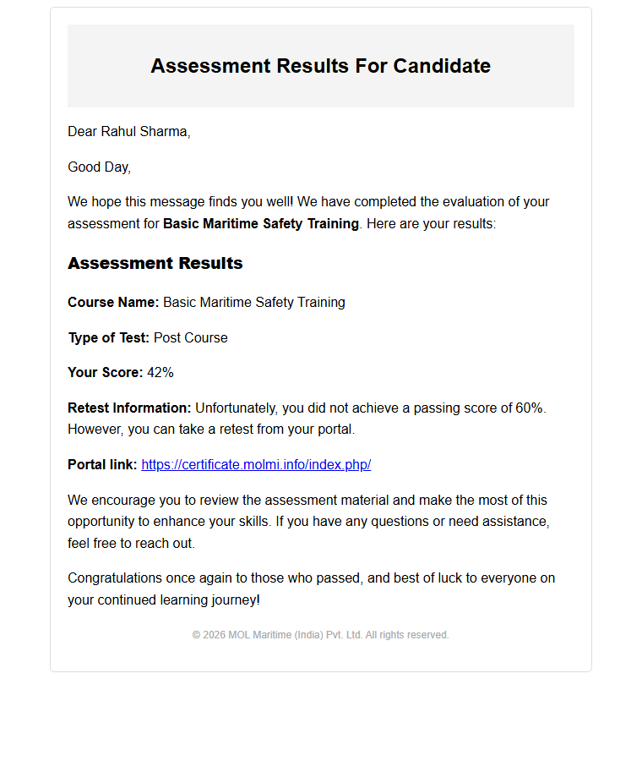

New Assessment Assigned
Subject: Assessment Assigned - Basic Maritime Safety Training
Sample data: Assessment creation notification for a candidate.

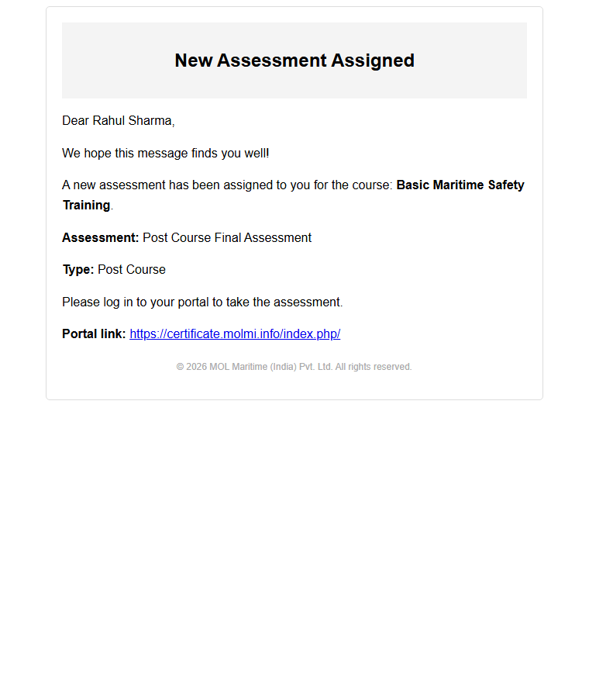

Certificate Generated
Subject: Certificate Generated - Basic Maritime Safety Training
Sample data: Certificate availability notification.

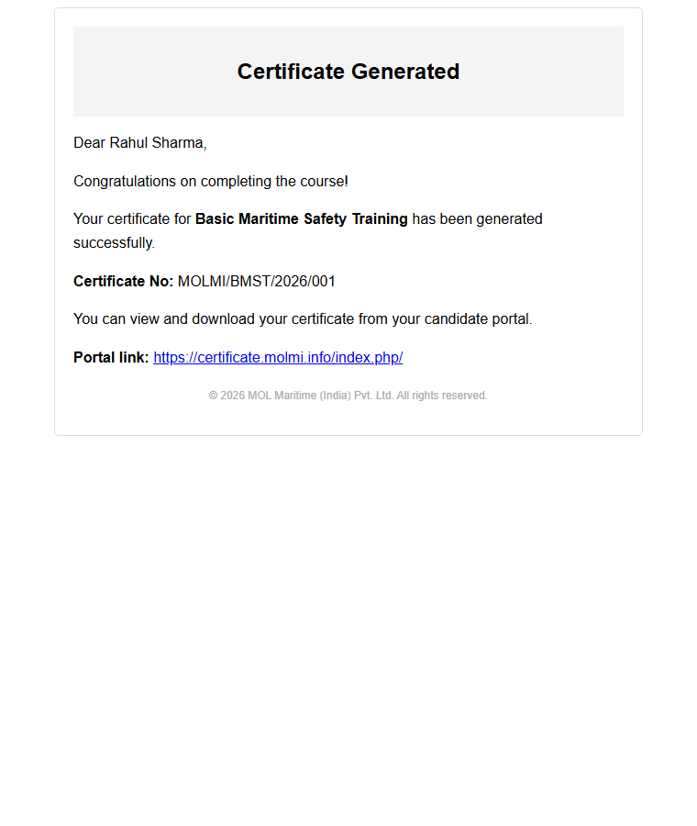

Course Feedback Request
Subject: Course Feedback Request - Basic Maritime Safety Training
Sample data: Feedback request after course participation.

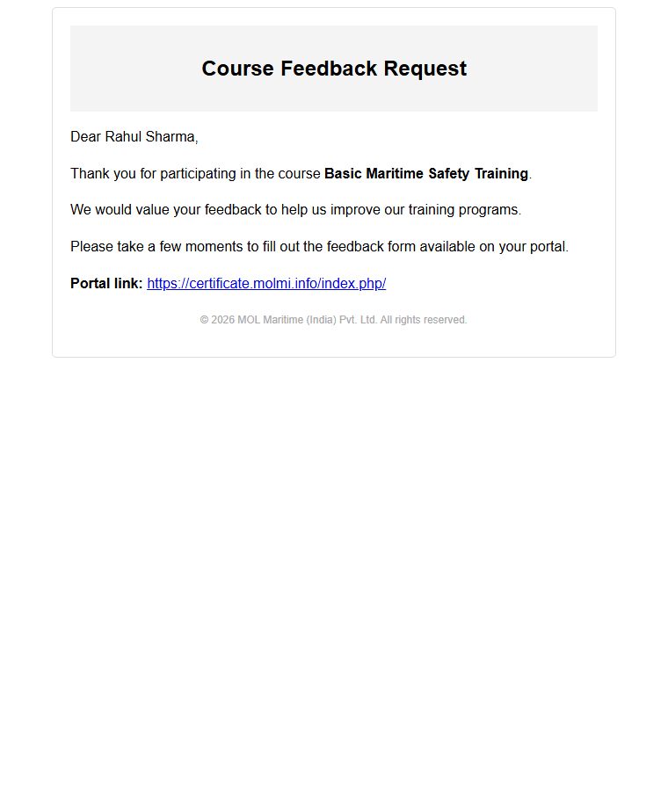

Reimbursement Approved
Subject: Reimbursement Approved - RC-00042
Sample data: Candidate reimbursement approval notification.

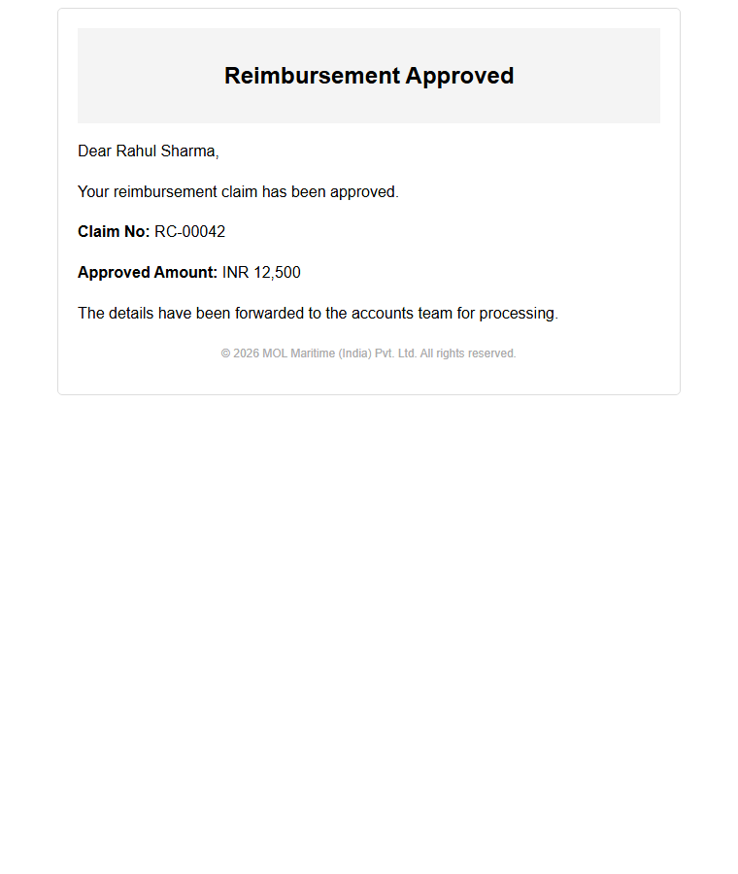

Reimbursement Disapproved
Subject: Reimbursement Disapproved - RC-00042
Sample data: Candidate reimbursement disapproval notification.

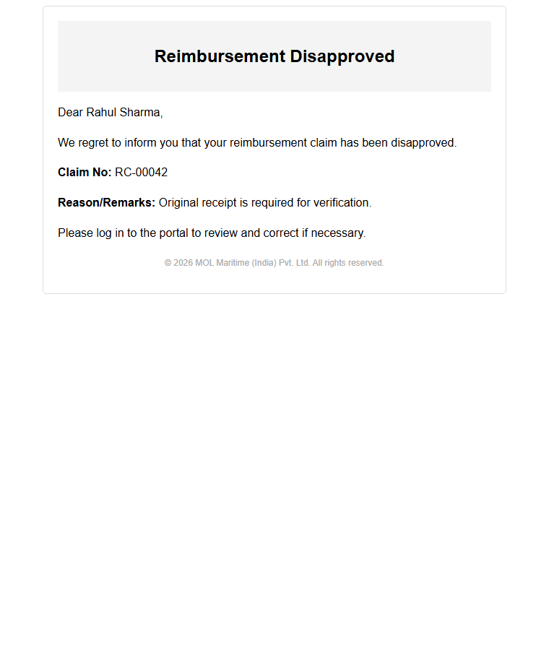

Reimbursement Resubmission Requested
Subject: Reimbursement Resubmission Requested - RC-00042
Sample data: Candidate reimbursement return-for-edit notification.

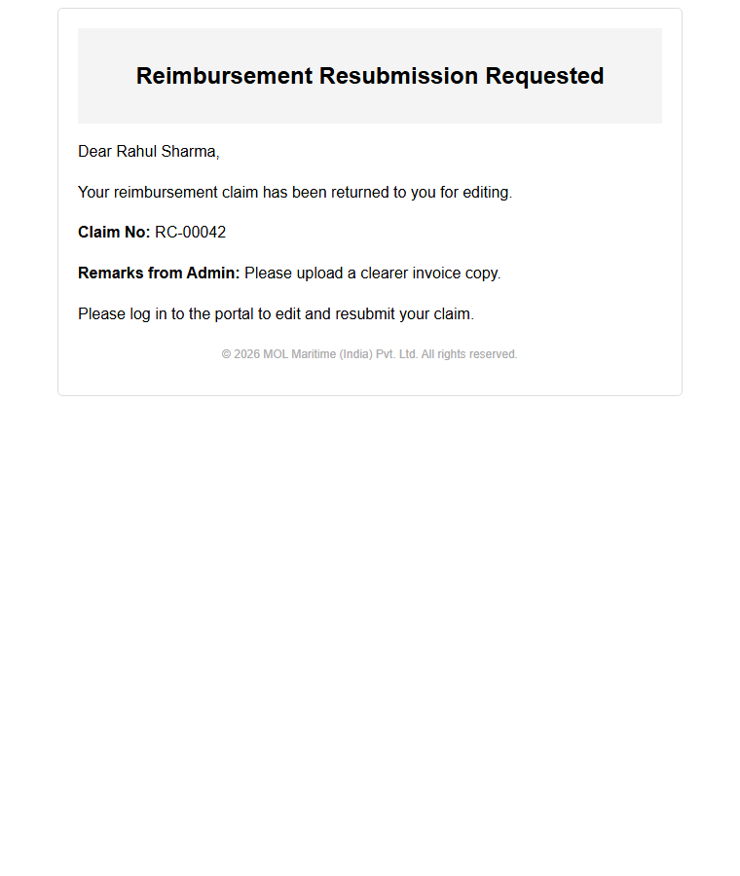

Candidate Registration - Self Registration
Subject: Welcome Aboard! Your Registration Details
Sample data: Candidate must set a password using the reset link.

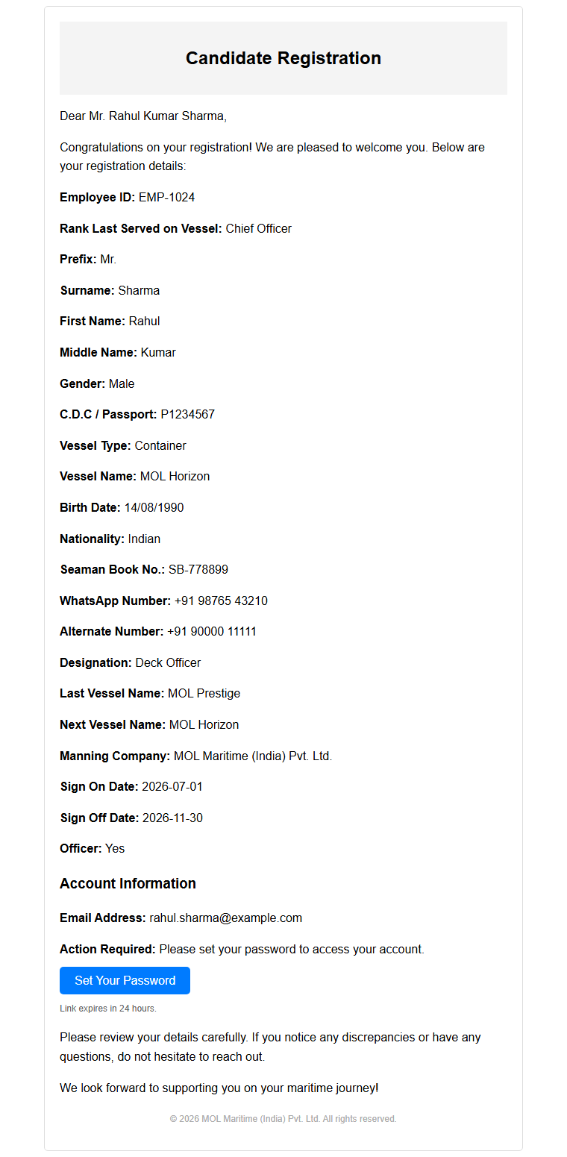

Candidate Registration - Admin Created
Subject: Welcome Aboard! Your Registration Details
Sample data: Candidate account created by admin with password set separately.

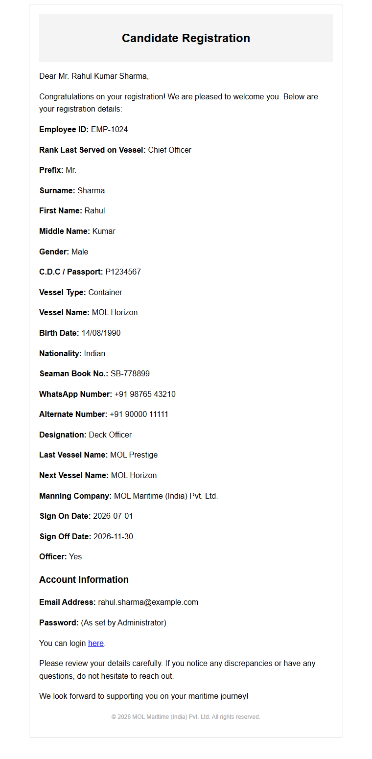

Forgot Password
Subject: Reset Password Link
Sample data: Password reset request email.

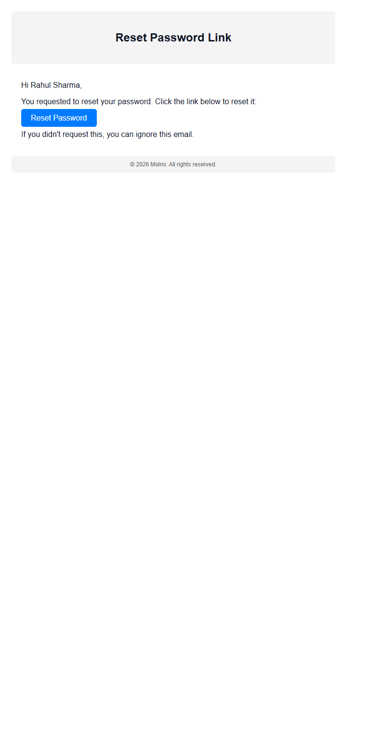

Password Reset Successful
Subject: Password Reset Successful
Sample data: Confirmation email after password update.

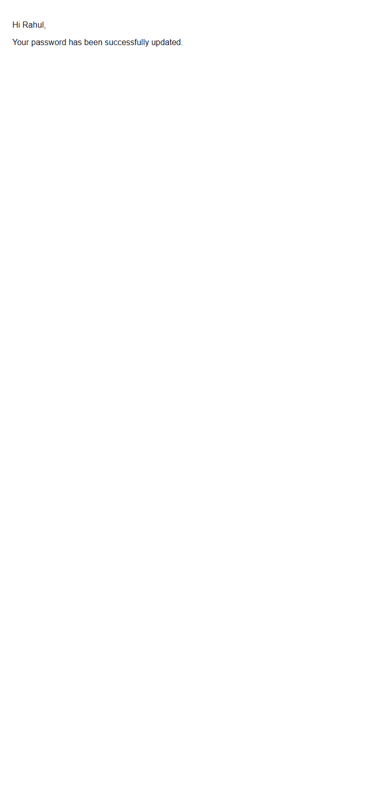

Admin Account Created
Subject: Welcome - Admin Account Created
Sample data: New admin account credentials notification with sample-only password.

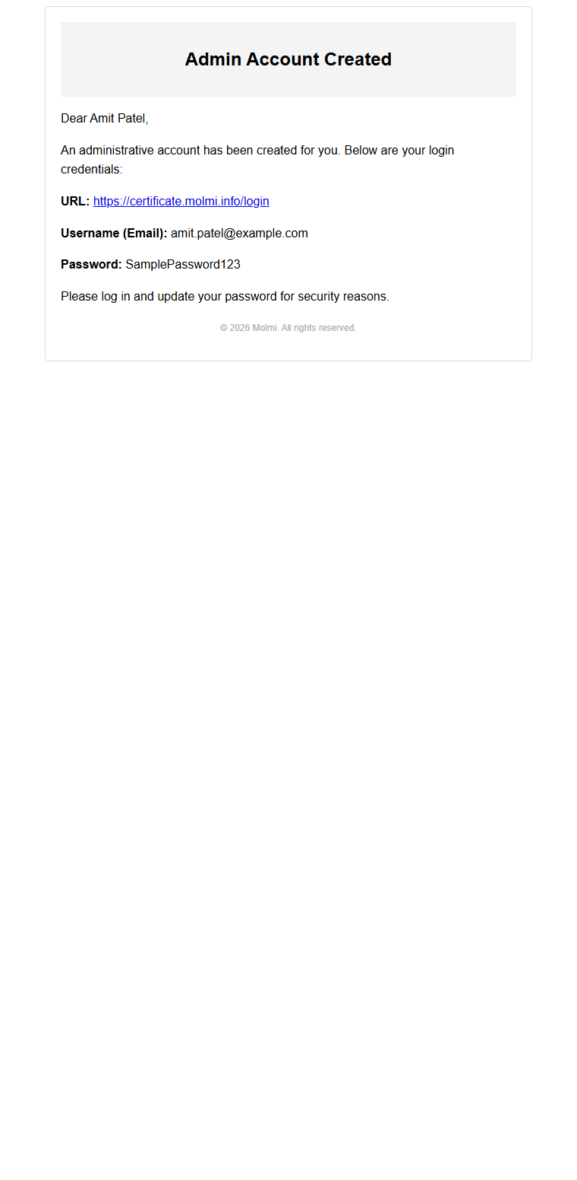

Trainer Course Assignment Notification
Subject: Course Assignment Notification - Basic Maritime Safety Training
Sample data: Trainer assignment email with candidate table.

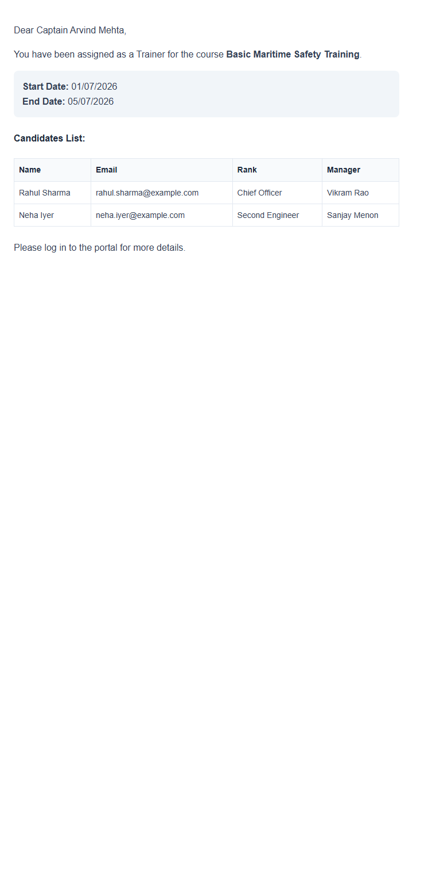

Active Course Enrollment - Online
Subject: Course Enrollment - Basic Maritime Safety Training
Sample data: Candidate enrollment email with Zoom link and acknowledgment actions.

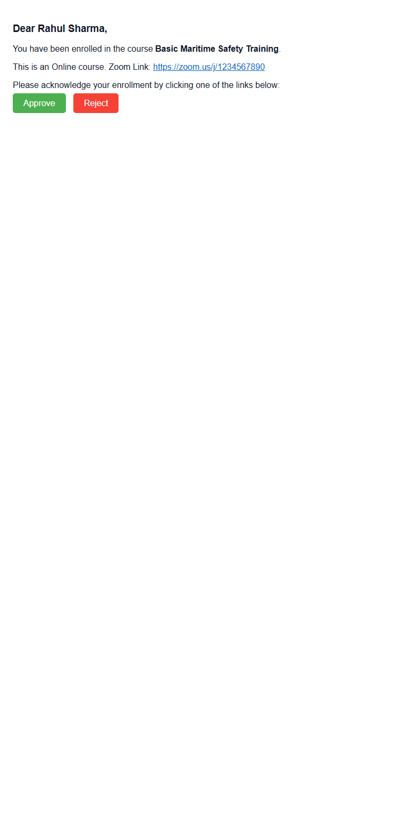

Active Course Enrollment - Offline
Subject: Course Enrollment - Basic Maritime Safety Training
Sample data: Candidate enrollment email with venue summary and acknowledgment actions.

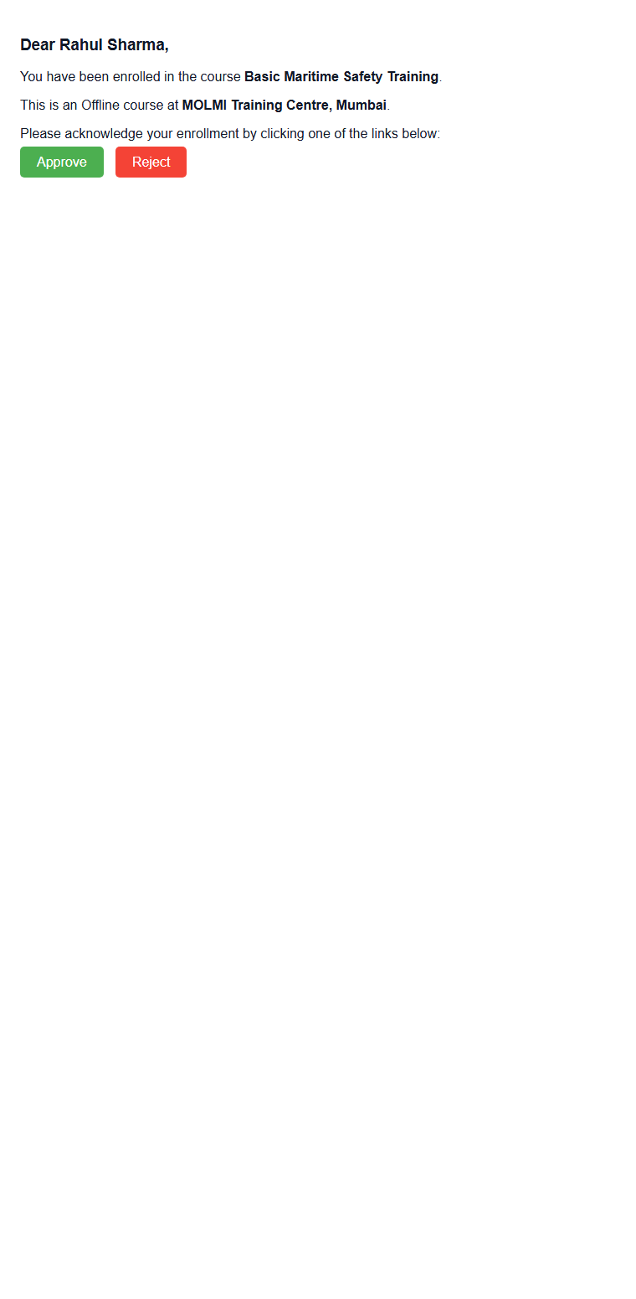

Pre-Active Nominator Nomination Request
Subject: Nomination Request for Course: Basic Maritime Safety Training
Sample data: Nominator invitation to submit candidate nominations.

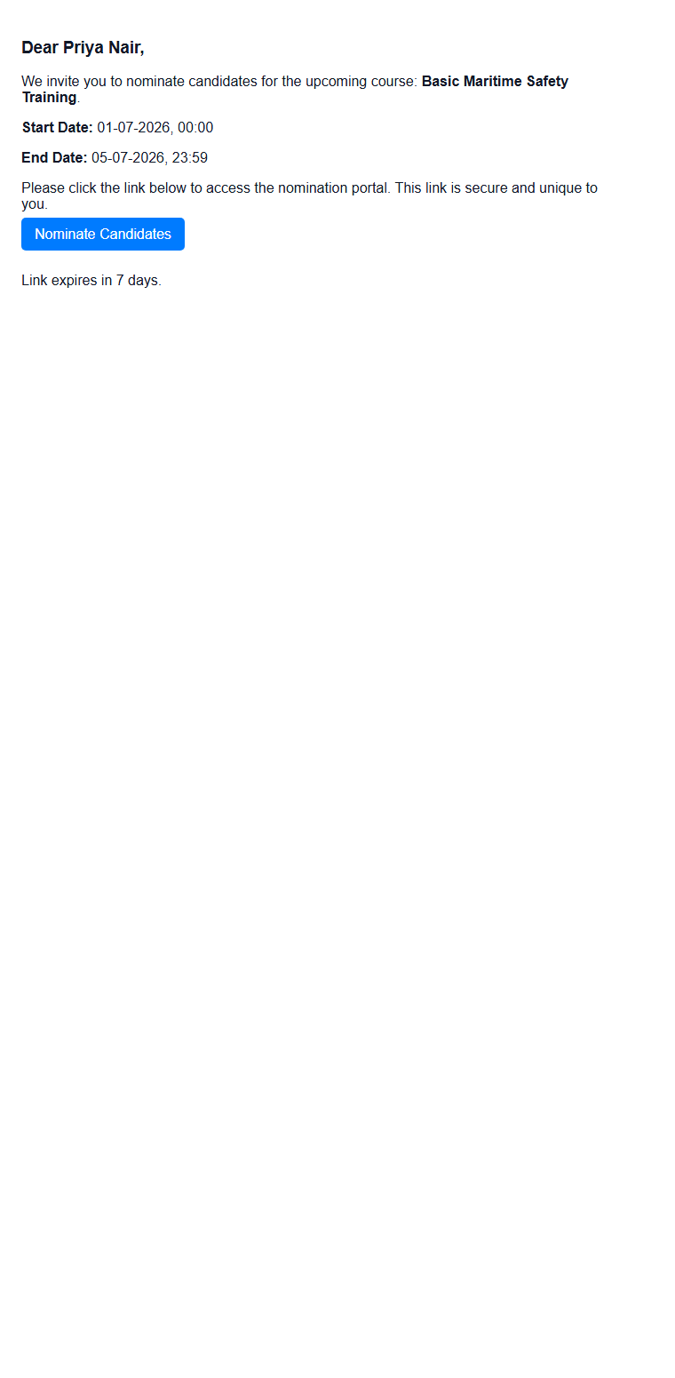

Pre-Active Candidate Nomination Approval
Subject: Course Nomination Approval - Basic Maritime Safety Training
Sample data: Candidate approval request for pre-active course nomination.

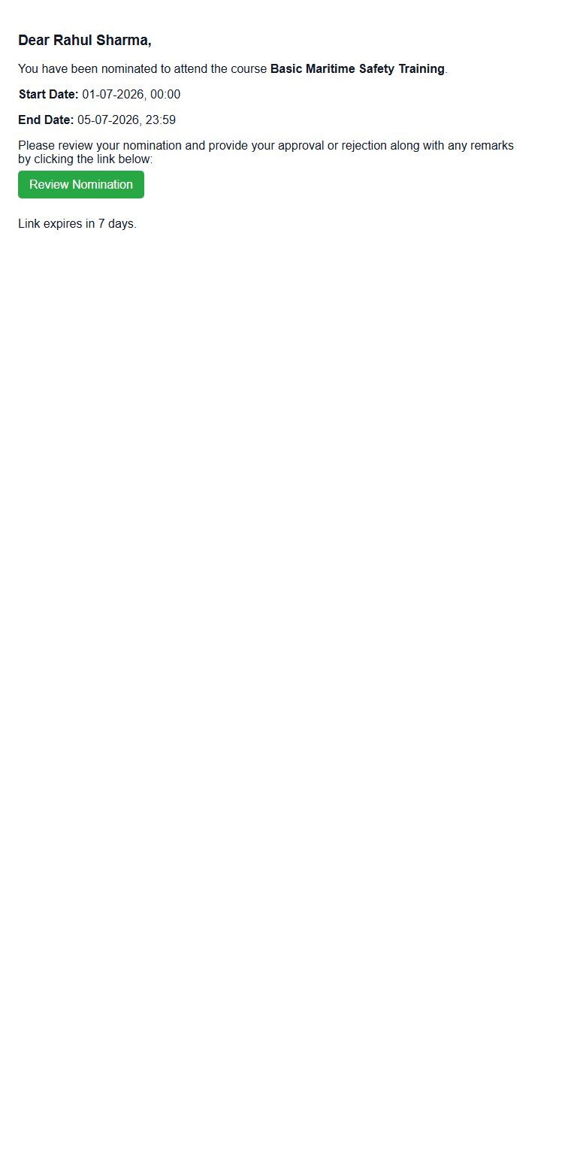

Certificate Expiry Reminder
Subject: Certificate Expiry Reminder - Basic Maritime Safety Training
Sample data: Certificate renewal reminder from dashboard expiry alerts.

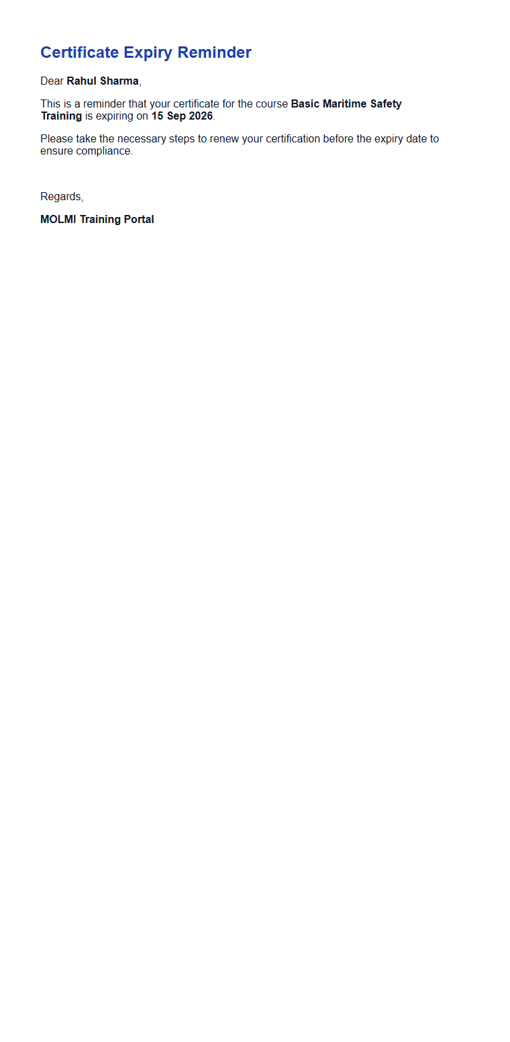

Outhouse Welcome Letter - Online
Subject: Welcome Letter - Basic Maritime Safety Training
Sample data: Outhouse online course welcome letter.

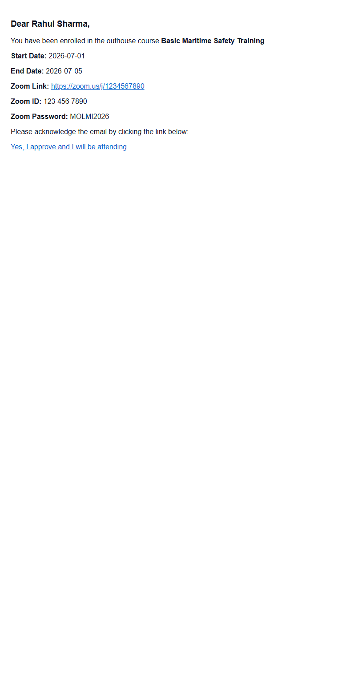

Outhouse Welcome Letter - Offline
Subject: Welcome Letter - Basic Maritime Safety Training
Sample data: Outhouse offline course welcome letter with venue details.

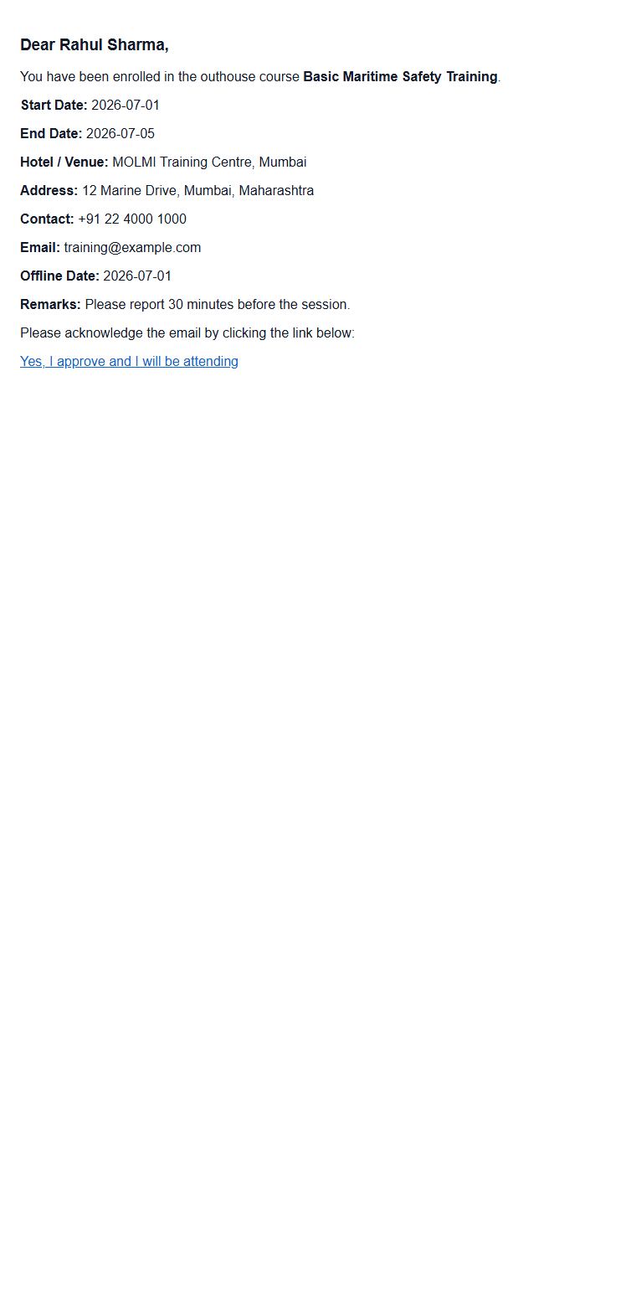

Accounts Team Approved Reimbursement
Subject: Approved Reimbursement - RC-00042
Sample data: Accounts team notification with approved reimbursement PDF attachment in live flow.

