Application of Molecular Dynamics Simulations to Study of Membrane Related Structures

K.V. Shaitan, Ye.V. Tourleigh, A.K. Shaytan, K.B. Tereshkina, O.V. Levtsova, M.P. Kirpichnikov

M.V. Lomonosov Moscow State University

Abstract: The paper gives an overview of approaches for applying molecular dynamics (MD) simulations to study of membranes and biomembrane systems developed at the Department of Bioengineering of the Biological Faculty. With reference to dynamic approaches to molecular modeling and design of complex structures the following is discussed: biomembranes dynamics, direct in silico free energy calculations. Diffusion phenomena in membrane structures are surveyed; procedure of determination of aminoacid residues hydrophobicity at the phase boundary is discussed. Methods for free energy estimates through molecular dynamics simulations are discussed.

Index Terms – CAMD, molecular dynamics, membranes, free energy calculation

Introduction

MD At present, MD and molecular modeling play an important role in the advancement of science and improvement of technologies [1, 2]. The system containing a large number of classical equations of motion for atomic particles is solved, as a rule, with the use of the Verlet difference scheme [3]. The force field is set by a system of atom-atomic pair potentials, which are specially gauged for particular type of molecular objects (biopolymers, minerals, alloys and so forth). Normally, special algorithms for maintaining a constant temperature and pressure (or volume) are used in addition. By applying special techniques free energy estimates can be performed with MD simulations [4]. In general, it is rather relevant application of molecular modeling techniques for biotechnology, drug design etc. In our case we can measure solvation free energies to determine the interaction properties of molecules in various media, for instance with water or inner layers of membranes, and thus we can determine hydrophobicity properties.
Along with the equilibrium MD, i.e. MD only under the effect of interatomic interactions, the nonequilibrium (or steered) MD (SMD, [5]) under the action of additional forces and/or special boundary conditions is applied. Usage of the nonequilibrium MD in application to complex and heterogeneous molecular systems is now rather perspective. An overview of MD methods in application to study of membrane molecular systems is given in the next sections.

Dynamics of Biomembranes

A. Membrane anisotropy and viscous properties
Biological membranes are a subject of rapt studying in recent years [6–10]. However, data on kinetic characteristics of the phospholipid bilayer with account to its anisotropy and heterogeneity are quite few. Below the problem of heterogeneity and anisotropy of a phospholipid bilayer is discussed with respect to diffusion processes. A membrane consisting of 1-palmitoyl-2-oleoyl-sn-glycero-3-phosphatidylcholine (POPC) bilayer is considered in details. The degree of solvation is 44 water molecules per one lipid molecule. TIP3P water model is used; the valence bonds and valence angles in water molecules are not fixed, but are instead determined by the corresponding potentials. The surface density of lipids is close to the experimental values (62-68 Å², [11–14]).
The molecular dynamics was calculated with the PUMA software package [15], which was specially modified to include SMD [7, 8]. The system of classical equations for atom movement was solved in the Amber 1999 force field [16]. Periodic boundary conditions, collisional thermostat [15] (T=300 K) and Berendsen barostat [17] were applied. Fluctuations of volume, pressure and temperature were used to verify that the system has reached a local equilibrium [7].
For computation of parameters which determine diffusion of molecules in the membrane, the SMD method was used. External forces (constant and alternating) were applied to some parts of the system. Trial spheres of 18 Da with radii of 2 and 4 Å (i.e., an order of the radius of the carbon atom and a small functional group, respectively), which interact with the other atoms only by van der Waals forces (interaction constant ε, 0.15 kcal/mol). A constant external force F_{ext} of 0.3 to 4 kcal/mol⋅Å⁻¹ was applied to the spheres along the normal to the membrane plane (Fig. 1).
At molecular level essential deviations from the hydrodynamic Stokes formula are observed, and that is quite natural, since the continuous medium approximation for the particles of such a size almost does not hold. The Stokes equation can provide valid only qualitative estimates.
Also cases with a laterally applied force F_{ext} of 1, 2, 4 and 10 kcal/mol⋅Å⁻¹ were studied. The coefficient of viscous friction γ was defined as the ratio of external force to the velocity of particle drift.
Formally, the friction coefficient could be redefined in terms of diffusion coefficient, using the known Einstein relation, and in terms of microviscosity of the medium using the Stokes equation.
Currently, limited data are available on the viscosity when a particle moves along the normal to membrane surface or in the lateral direction in the middle of the bilayer. Experimental averaged viscosities of the surface layer range from 30 to 190 cP in various lipid membranes [18–20]. The experimental estimate of the mean viscosity of POPC is about 18 cP [21]. Since the microviscosities are not the same in different regions of the membrane, it is reasonable to define several structurally and dynamically inhomogeneous regions. In the first approximation, one can distinguish the regions of lipid headgroups and alkyl chains. Data on the friction coefficient in terms of microviscosity for several parts of the system at various values of the external force are given in [7, 8].
Calculated values of effective viscosity of water for a 2-Å sphere are 0.3–0.4 cP, which is two to three times lower than the experimental values. These data agree with the known estimates of water viscosity for the TIP3P model [22]. Transverse viscosity of the membrane does not exceed 6 cP. Viscosity of the central part of the bilayer is several times lower than this value.
Studying lateral movement of a sphere under the influence of a force results in the values of viscosity which are close to those measured in the region of alkyl tails in the direction of the normal.
In general, the results suggest a non-Newtonian character of the medium and a weakly nonequilibrium state of this system at movement velocities of 1–1-10 Å/ps.
The velocity of penetration of the molecule under the influence of external force also depends on the chemical properties of the molecule. For comparison, the dynamics of penetration of tryptophan (effective radius, 4.8 Å) and alanine residues (effective radius, 3.1 Å), as well as of the 2-Å van der Waals sphere, into the bilayer was calculated.
It should be noted that a more polar tryptophan residue has a higher velocity in the region of lipid headgroups than the alanine residue, which, consequently, provides a lower value of microviscosity. In the region of hydrophobic alkyl chains, the situation is the reverse, with velocities differing by a factor of 15. The region of lipid headgroups is most sensitive to the nature of a molecule moving through the membrane. Conversely, the hydrophobic core of the bilayer with a larger free volume is sensitive to the size of particles.

B. Lateral self-diffusion of lipids in bilayer
Far more detailed experimental information on lateral diffusion coefficients of lipids in membranes is available. These data can be used for testing an MD technique. Lateral self-diffusion coefficient D_{xy} of lipids is determined according to the known relation
,
where mean squared deviation of lipids’ centers of mass in the plane of the bilayer is in angle brackets The averaging is done for all the lipids. A trajectory 3 ns long is divided into 12 parts 250 ps long each. Dependence of squared displacement (Fig. 2) was obtained after averaging over all 12 parts.
The value of D_{xy} = 2.4ּ10⁻⁷ cm²/s calculated for POPC is close to that from the data on quasi-elastic neutron scattering on dipalmitoylphosphatidylcholine (1×10⁻⁷ см²/с [23]) and dioleoylphosphatidylcholine (2×10⁻⁷ cm²/s [24]) bilayers. The results of pulsed NMR for POPC bilayer provide with values of 2.0×10⁻⁷ cm²/s at 298 K and 2.5×10⁻⁷ cm²/s at 303 K [25], which practically coincide with the value obtained in the simulation. Let us note that the obtained value of lateral diffusion coefficient turned out to be closer to the experimental values than the coefficients out from MD simulations conducted according to other techniques (3±0.6×10⁻⁷ cm²/s [26], 4.0-4.5ּ10⁻⁷ cm²/s [27] for dipalmitoylphosphatidylcholine bilayers and 7.3ּ10⁻⁵ cm²/s [10] for POPC bilayer).

Estimation of Aminoacid Residues Hydrophobic Properties at the Water-Membrane Interface

Let us consider an example of technique of special boundary conditions. The behavior of single aminoacid residues at the interface between water and a non-polar solvent was studied by means of SMD.
Simulation was carried out both for the water-hexane interface and for a model system water-vacuum. In the latter case the aqueous layer was separated from vacuum by a flat virtual wall serving as an additional repulsive potential for water molecules. At that, the wall remained permeable for aminoacid residues. Collisional thermostat was applied to molecules, including those in vacuum. Thus, the absence of hydrophobic environment was partly compensated.
Aminoacid residues were taken in the form of biradical monomer unit -NH-CH (R)-CO-, that is as uncharged monomers with formally unsaturated bonds. PUMA software was used. Periodic boundary conditions, Amber 1999 force field and TIP3P water model with non-fixed internal degrees of freedom were chosen. Berendsen barostat was used along the axis perpendicular to the phase boundary in the water-hexane system. The water-vacuum system was simulated in NVT-ensemble, the density of water corresponded to standard conditions.
For estimation of hydrophobic properties of aminoacid residues, statistical handling of trajectories was done and space and orientation distributions of residues were analyzed. A comparison of these two models follows below.
Let us consider the behavior of a phenylalanine molecule at the water-hexane phase boundary (Fig. 3). Distributions of the centers of mass of the phenylalanine’s backbone and side chain are shown on Fig. 4. It is seen that the phase boundary represents a transition layer about 5 Å thick. Maxima of the distributions practically correspond to the middle of the interfacial layer, that is the molecule reveals surface-active properties. The distribution plots for the hydrophobic side chain and the polar backbone are shifted towards the hexane and the aqueous phase, respectively. Analysis of molecular orientations shows that the side chain is predominantly directed towards the hexane. The vector connecting the centers of mass of the backbone and the side chain is at an angle of 30 degrees with respect to the phase boundary, as if the molecule almost laid on the interface.
Let us proceed with the dynamics of the phenylalanine in the system with a virtual repulsive wall. For such a system, the steepness of the water phase density profile is more than in the water-hexane system. However, the absence of non-polar hexane phase insignificantly changes the shape and width of the aminoacid residues distributions. The most probable positions of the centers of mass of the backbone and the side radical are shifted towards the aqueous phase in comparison with the case of the water-hexane interface. Thus, the most probable position of the molecule is in the water layer adjacent to the interface but not at the interface itself. The dynamics of molecular orientation in the water-vacuum and water-hexane systems differs insignificantly.
The model of virtual repulsive plane can be used for fast estimation of hydrophobic and surface-active properties of molecular structures. This model was also used for analysis of properties and classification of hydrophobic properties of the majority of aminoacid residues. The estimation of hydrophobic parameters is used for plotting hydrophobicity profiles of proteins [28, 29] as well as it is applied to pharmacokinetics [30]. Hydrophobicity is one of the major parameters in reactions catalyzed by enzymes. Binding sites of the latter are rather sensitive to hydrophobic areas of substrate molecules [31]. While analyzing the distributions, it was found that residues of all main types of amino acids can be split, to a first approximation, into two groups. The first one reveals evident surface-active properties. All residues with non-polar side chains, including glycine, belong to this group. The residues of the second group desorbe from the surface and leave to the aqueous phase. This group is comprised of the residues, the side groups of which are either polar or charged. We underline that the developed approach allows developing a system of quantitative indicators characterizing hydrophobic properties of molecules.

Free Energy Calculations for Molecular Modeling

Theoretical description of processes taking place in many-particle (thermodynamic) systems is based on the concepts of entropy and free energy. In fact, a certain value of free energy can be attributed to every state of a thermodynamical system so that it would be somewhat equivalent to the probability of finding the system in this particular state. Free energy is widely used as a quantitative measure of affinity between substances. For instance, free energy of solvation for a given solvent in a given solute determines the affinity of solute to this or that liquid. Imagine we put to immiscible liquids in a contact and solvate small amount of substance in this biphasic system, then, provided we know solvation free energies for each solvent/solute pair, we can determine the concentration of this substance in each liquid. Generally, the dissolved substance will tend to concentrate in that phase, where its solvation free energy is lower. Determination of hydration free energy will give us information about the interaction of the substance with water at the macroscopic level; this can be used for design of new hydrophobic materials and surfaces. The derived interaction properties can be further used in coarse-grained models for prediction of behavior of more complex compounds, such as polymeric systems, and design of smart polymers.
Analogous processes, but much more complicated ones, take place in biological systems. Of utmost importance for biomedical applications is determination of binding affinity between ligands and proteins/receptors which is actually the basis of rational drug design [32]. Drug design is often reduced to finding a ligand that binds with the specific protein site. The binding strength is actually the binding free energy. Provided we know binding free energies for different substances, then we can decide what substance would perform better.
All the above stated examples suggest that a technique enabling us to determine precise free energy estimations just in silico, by means of computer simulations, would greatly facilitate design of technologically and biologically relevant compounds as well as serve a good means of scientific investigation.
Today the computational power has developed to such extent that we can speak about determining the free energy properties from molecular dynamics simulations with statistical error compared to experimental one.
In general precise free energy estimates require significant computational power. But however it should be stated that the choice of algorithm for free energy estimates in MD simulations as well as the choice of force field and other simulation parameters can considerably affect accuracy of estimates and the amount of required computational resources. Study of possible methods, algorithms for free energy estimates through computer simulations and their efficacy with respect to precision/cost ratio is performed in our laboratory.
In this article we would not dwell much on the theory of free energy estimations and comparison of different methods, but rather consider a simple example just to give the reader a notion how the technique looks like and what are the computational costs. The example deals with determination of hydration free energy of a simple methane molecule.
At first step we should mention that we deal with classical MD simulations, it means that a molecular system is represented by a number of atoms (point particles) that interact with each other according to predefined potential energy functions. Definition of these energies and hence forces is taken from chosen force field parameters. For our simulation we have chosen the OPLS-AA parameter force field for treating methane molecule and water of SPC type.
From the theory we know that the problem of determining hydration free energy can be reduced to finding the free energy difference between a system of one methane molecule solvated in some amount of water and the same system where the methane molecule does not interact with water molecules at all.
So the next step is to construct this system in silico and topologies (force field parameters) for its two variations.
We will now use the “thermodynamic integration” (TI) method for determining the free energy difference. The brief theory of the method is as follows. From the statistical physics we know that we can estimate free energies F in molecular modeling using formula (1), where the integral is taken over all the phase space of the system and Hamiltonian is just the energy of the system in each particular state. Theoretically this integral can be evaluated numerically for small systems, but practically it is almost impossible.
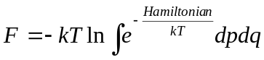 (1)
One of the methods that help to overcome this problem is the TI method. The practical implementation of the method should consist of the following steps. Suppose we would like to find the free energy differences of two different systems at equilibrium. We should construct a special parameter (λ) dependent Hamiltonian for our system, so that at one value of λ it refers to the first system and at another value in refers to the second system. Than we should make multiple MD simulation runs with Hamiltonian referring to different values of λ. During each MD run we should sample the partial derivative of Hamiltonian with respect to λ and in the end integrate the sampled function over the same parameter (2)
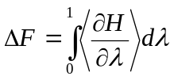 (2)
An important conclusion from this consideration is that those MD simulation runs can be made in parallel. In fact the estimation of any statistical property from MD simulation being an average over a trajectory can be split into to separate independent runs and than averaged over these runs. This makes it possible to apply parallel computing at this point.
The next important step is the choice of simulation parameters. The most important of them include treatment of non-bonded interactions (van der Waals and Coulomb terms) and temperature coupling. Using “cut-off” treatment for non-bonded interactions from one side can decrease simulation time but from the other introduces a systematic error in our measurements neglecting the “tails” of interaction. That is why highly preferable is the use of special methods such as Ewald summation, dispersion correction and others that help to treat long range interactions correctly. It should be also noted that the choice of parameterization of Hamiltonian with respect to λ is also quite important. The right choice can save computational power and improve accuracy.
After all the preparation work is done, we can run simulations in parallel for different values of λ. We use for this purpose a “beowulf” type computer cluster. It should be also noted that after measurements are done not only the value of sampled property should be estimated but its statistical and systematic uncertainty as well.
The result of the above described process performed mainly with GROMACS software package [33] is depicted on Fig. 5. The result of the simulation (after integrating the curve) is the following. The estimate for hydration free energy of methane in water, using OPLS-AA/SPC forcefield in our simulation is 2.20 kcal/mol with statistical standard deviation of 0.02 kcal/mol. The total amount of computational resources used for this estimate is approximately 30 day of processor time, processor type Intel Xeon 3.2 GHz.
Comparing with experimental value of 1.94 kcal/mol [34], we see that our result overestimates the hydration free energy a bit. The reason apparently lies in the choice of force field. For parameterization of the majority of cotemporary force field data on hydration free energies was not used, because when they were elaborated the computational resources were not enough to determine free energies with high accuracy. Now, with development of computer sciences and equipment it is becoming possible, and we can not only pose the question of free energy estimation in computer simulations but also the problem of elaboration of new force fields and parameter sets for molecular substances on the basis of this knowledge.

Conclusion

Molecular dynamics and its different variations (nonequilibrium (or steered) MD, thermodynamic integration) appears to be a useful tool for obtaining detailed and experimentally hardly accessible information on structure, dynamic, kinetic, statistical properties of heterogeneous and anisotropic systems such as biomembranes.
Available data show that the given method appears quite useful for prognosis of structural and functional properties of a broad class of molecular systems and can be used for molecular design of objects on the nanometer scale.

Acknowledgement

The authors thank the Russian Foundation for Basic Research (grant № 04-04-49645), RF Ministry of Education and Science, Rosnauka federal agency, CRDF (USA) and Moscow Government for the financial support.

References

- H. Gao, “Modelling strategies for nano- and biomaterials”, in European white book on fundamental research in materials science, Van der Woorde M.H. et al., Eds. Max Planck Gesellschaft, 2001, pp.144–148.
- K.V. Shaitan, Ye.V. Tourleigh, D.N. Golik, K.B. Tereshkina, O.V. Levtsova, I.V. Fedik, A.K. Shaytan, A. Li, and M.P. Kirpichnikov, “Dynamis and molecular design of bio- and nanostructures”, Rossiyskiy Khimicheskiy Zhurnal (in Russian), vol. 50. pp. 53–65, April 2006.
- D.Frenkel and B. Smit, Understanding molecular simulation: from algorithms to applications, 2nd ed. San Diego: Academic Press, 2002.
- K.V. Shaitan, and K.B. Tereshkina, Molekulyarnaya dinamika belkov i peptidov, Мoscow: Oykos, 2004.
- S. Park, and K. Schulten, “Calculating potentials of mean force from steered molecular dynamics simulations”, J. Chem. Phys., vol. 120, pp. 5946–5961, April 2004.
- Y.A. Chizmadzhev, “The mechanisms of lipid-protein rearrangements during viral infection”, Bioelectrochem., vol. 63, pp. 129–136, June 2004.
- Ye.V. Tourleigh, K.V. Shaitan, and N.K. Balabaev, “Molecular dynamics of a hydrated palmitoyloleoylphosphatidylcholine bilayer in collisional thermostat”, Biologicheskie Membrany (in Russian), vol. 22, pp. 491–502, December 2005.
- Ye.V. Tourleigh, K.V. Shaitan, and N.K. Balabaev, “Dynamic heterogeneity of phospholipid bilayer and diffusion of molecules at the interface”, Biophysics, vol. 50, pp. 899–904, December 2005.
- A.L. Rabinovich, N.K. Balabaev, M.G. Alinchenko, V.P. Voloshin, N.N. Medvedev, and P. Jedlovszky, “Computer simulation study of intermolecular voids in unsaturated phosphatidylcholine lipid bilayers”, J. Chem. Phys., vol. 122, pp. 84906, February 2005.
- H. Heller M., Schaefer, and K. Schulten, “Molecular dynamics simulation of a bilayer of 200 lipids in the gel and in the liquid crystal phases”, J. Phys. Chem., vol. 97, pp. 8343–8360, August 1993.
- G. Pabst, M. Rappolt, H. Amenitsch, and P. Laggner, “Structural information from multilamellar liposomes at full hydration: full q-range fitting with high quality X-ray data”, Phys. Rev. E., vol. 62, pp. 4000–4009, April 2000.
- B. Isralewitz, M. Gao, and K. Schulten, “Steered molecular dynamics and mechanical functions of proteins”, Curr.Opin. Struct. Biol., vol. 11, pp. 224–230, April 2001.
- J.M. Smaby, M.M. Mornsen, H.L. Brockman, and R.E. Brown, “Phosphatidylcholine acyl unsaturation modulates the decrease in interfacial elasticity induced by cholesterol”, Biophys. J., vol. 73, pp.1492–1505, September 1997.
- P.A. Hyslop, B. Morel, and R.D. Sauerheber, “Organization and interaction of cholesterol and phosphatidylcholine in model bilayer membrane”, Biochemistry, vol. 29, pp. 1025–1038, January 1990.
- A.S. Lemak and N.K. Balabaev, “A comparison between collisional dynamics and Brownian dynamics”, Mol. Simul., vol. 15, pp. 223–231, March 1995.
- J. Wang, P. Cieplak, and P.A. Kollman, “How well does a restrained electrostatic potential (RESP) model perform in calculating conformational energies of organic and biological molecules?”, J. Comp. Chem., vol. 21, pp. 1049–1074, July 2000.
- H.J.C. Berendsen, J.P.M. Postma, W.F. van Gunsteren, A. DiNola, and J.R. Haak, “Molecular dynamics with coupling to an external bath”, J. Chem. Phys., vol. 81, pp. 3684–3690, October 1984.
- J.F Nagle, R. Zhang, S. Tristram-Nagle, W.J. Sun, H.I. Petrache, and R.M. Suter, “X-ray structure determination of fully hydrated L_{α} phase dipalmitoylphosphatidylcholine bilayers”, Biophys. J., vol. 70, pp. 1419–1431, March 1996.
- M.C. Wiener, and S.H. White, “Structure of a fluid dioleoylphosphatidylcholine bilayer determined by joint refinement of X-ray and neutron diffraction data. III. Complete structure”, Biophys. J., vol. 61, pp. 434–447, February 1992.
- G. Reiter, M. Siam, D. Falkenhagen, W. Gollneritsch, D. Baurecht, and U.P. Fringeli, “Interaction of a bacterial endotoxin with different surfaces investigated by in situ fourier transform infrared attenuated total reflection spectroscopy”, Langmuir, vol. 18, pp. 5761–5771, June 2002.
- A. Seelig and J. Seelig, “Effect of a single cis double bond on the structures of a phospholipid bilayer”, Biochemistry, vol. 16, pp. 45–50, January 1977.
- J. Seelig and A. Seelig, “Lipid conformation in model membranes and biological membranes”, Q. Rev. Biophys., vol. 13, pp. 19–61, February 1980.
- E. Sackmann, “Structure and Dynamics of Membranes”, in Handbook of Biological Physics, vol. 1, R. Lipowsky and E. Sackmann, Eds. Amsterdam: Elsevier Sci. Pubs. B.V., 1995.
- W. Pfeiffer, T. Henkel, E. Sackmann, W. Knoll, and D. Richter, “Local dynamics of lipid bilayers studied by incoherent quasi-elastic neutron scattering”, Europhys. Lett., vol. 8, pp. 201–206, October 1989.
- A. Filippov, G. Oradd, and G. Lindblom, “The effect of cholesterol on the lateral diffusion of phospholipids in oriented bilayers”, Biophys. J., vol. 84, pp. 3079–3086, May 2003.
- U. Essmann and M.L. Berkowitz, “Dynamical properties of phospholipid bilayers from computer simulation”, Biophys. J., vol. 76, pp. 2081–2089, April 1999.
- T. Róg, K. Murzyn, and M. Pasenkiewicz-Gierula, “Molecular dynamics simulations of charged and neutral lipid bilayers: treatment of electrostatic interactions”, Acta Biochim. Polon., vol. 53, pp. 789–798, September 2003.
- J. Kyte and R.F. Doolittle, “A simple method for displaying the hydrophobic character of a protein”, J. Mol. Biol., vol. 157, pp. 105–142, May 1982.
- T.P. Hopp and K.R. Woods, “Prediction of protein antigenic determinants from amino acid sequences”, Proc. Nat. Acad. Sci. USA, vol. 78, pp. 3824–3828, June 1981.
- T. Sotomatsu-Niwa and A. Ogino, “Multiple regression analysis of the beta-sheet propensity of amino acids”, J. Mol. Struct. (Theochem), vol. 392, pp. 43–54, December 1997.
- L. Stryer, Biochemistry, 4th ed. New York: W.H. Freeman & Co., 1995.
- M.R. Reddy and M.D. Erion, Free energy calculations in rational drug design. New York: Kluwer Academic/Plenum, 2001.
- D. van der Spoel, E. Lindahl, B. Hess, G. Groenhof, A.E. Mark, and H.J.C. Berendsen, “GROMACS: fast, flexible and free”, J. Comp. Chem., vol. 26, pp. 1701–1718, December 2005.
- R. Wolfenden, L. Andersson, P.M. Cullis, C.C.B. Southgate, “Affinities of amino acid side chains for solvent water”, Biochemistry, vol. 20, pp. 849–855, February 1981.
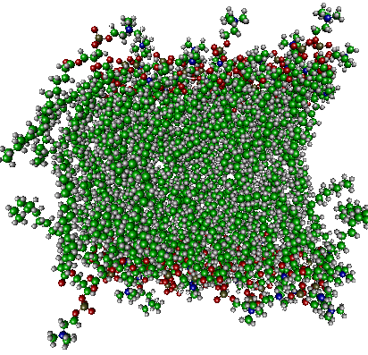
a
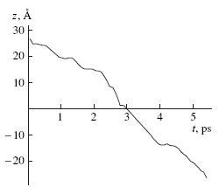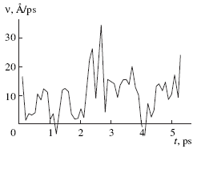
b c
Fig. 1

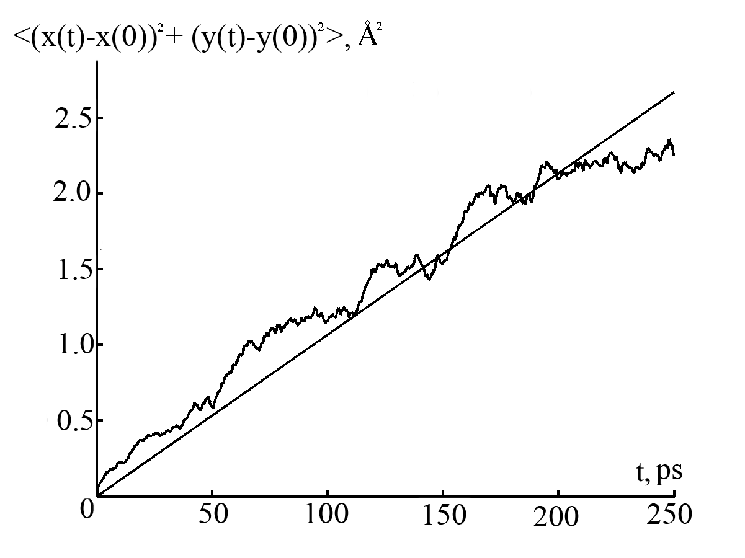
Fig. 2
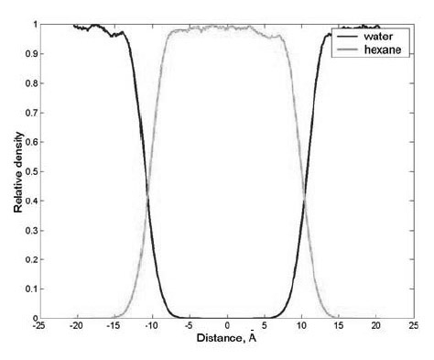
Fig. 3

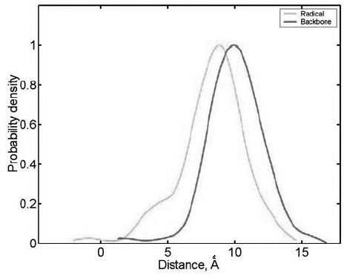
Fig. 4

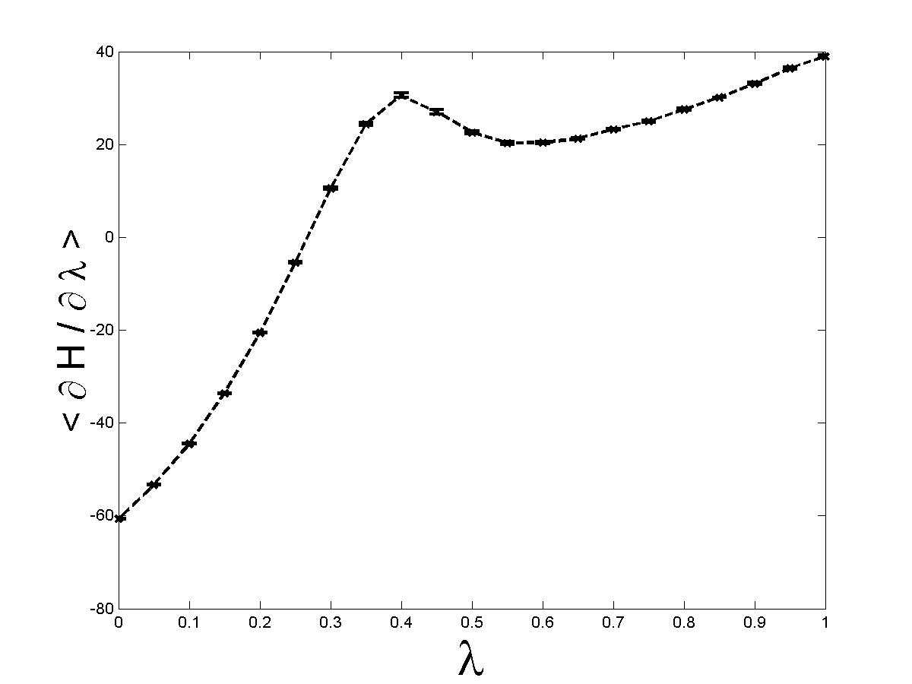
Fig. 5
FIGURE CAPTIONS
Fig. 1. (a) Structure of POPC bilayer.(b) Kinetics of movement of the trial van der Waals 2-Å sphere, subjected to a force of 10 kcal/mol⋅Å⁻¹ applied in the direction of the normal z. The center of the bilayer is located at z = 0; the borders, at z =±20 Å. (b) The velocity of sphere movement averaged over an interval of 0.1 ps.
Fig. 2. Mean squared displacement of lipid’s center of mass in the plane of the POPC bilayer. The straight line is a linear approximation.
Fig. 3. Density profiles of water and hexane along the axis perpendicular to the phase boundary. The density is normalized to unity.
Fig. 4. Probability density for position of center of mass of aminoacid residue’s backbone and side chain in the water-hexane system.
Fig. 5. The resulting plot of TI method. We obtain the averaged partial derivative of Hamiltonian with respect to λ at different values of λ. Statistical uncertainties are depicted as well.

