Molecular Dynamics and Design of Ion Channels and Nanostructures

K.V. Shaitan, K.B. Tereshkina, Ye.V. Tourleigh, O.V. Levtsova, A.K. Shaytan, M.P. Kirpichnikov

M.V. Lomonosov Moscow State University

Abstract: A brief overview of activities in molecular dynamics (MD) and design which are carried out at the Department of Bioengineering of the Biological Faculty is presented. Dynamics of ion transport through the gramicidin channel and the channels of the acetylcholine and glycine receptors is observed. Molecular dynamics of the interaction between a carbon nanotube and a biolipid membrane, self-assembly of a complex of a polyalanine and a nanotube, functioning of a molecular device for delivery of molecules through the membrane (nanosyringe) are discussed.

Index Terms – CAMD, molecular dynamics, ion channels, carbon nanotubes, nanobiotechnology, nanopharmacology

Introduction

MD methods are widely applied while studying fundamental problems of natural sciences and also applied problems of molecular bioengineering, biotechnology, nanotechnology, materials science, etc. [1-4]. In this way, according to [4], next years a huge potential of industrial development will be connected to new simulation methods of complex material systems, design of new functional materials in silico, computer-guided methods for nanotechnology and modeling of biological and biomimetic materials. Some areas of usage of steered MD (SMD, [5]) for investigation of complex enough molecular systems, which are represented at the Department of Bioengineering, are briefly overviewed in the paper.

Dynamics of Ion Channels Functioning

Ion channels formed by polypeptide structures are rather recent complex objects for molecular dynamics, that is why nonequilibrium SMD methods prove to be extremely effective here. The gramicidin channel, the acetylcholine and the glycine receptors are considered below.

A. Dynamics of the gramicidin channel
Gramicidin A is a natural antibiotic, which is active in dimeric form. After embedding into a membrane it forms a channel conducting protons and monovalent cations down the concentration gradient and causes decrease of membrane rest potential and resistance [6–8]. Two conformations of the gramicidin channel are known in the membrane: helical dimer and double helix [9]; they differ in stability and functional activity [10]. A fully-atomic structure of a complex of a POPC bilayer and a gramicidin channel consisting of two molecules of Gramicidin A in the conformation of helical dimer was considered. Calculations were carried out with the help of Gromacs 3.1.4 MD package (potential field Gromos-96) [11]. Stochastic dynamics with the time parameter of 0.02 ps, periodic boundary conditions, Berendsen barostat (along the normal to the membrane the pressure was maintained at 1 bar, perpendicularly to the normal it was -260 bar, barostating time coefficient was 10 ps), TIP3P water model, Т = 300 K, ε = 2 were set. A sodium cation was put into the aquatic environment at a distance of 5 Å above the channel pore. A hydrated shell of 6 water molecules was formed around of the cation soon afterwards. An acceleration of 25 nm/ps² along the membrane normal (equivalent to a force of 13 kcal/mol⋅Å⁻¹) was applied to the sodium ion.
The sodium cation moves atoms of polar lipid headgroups and the gramicidin molecule apart while entering into the cavity of the pore (fig. 1). At this stage four of the six water molecules leave the ion shell before the sodium finally enters into the channel pore. The decrease of the ion’s velocity corresponds to local energy minima connected with the attraction of the cation to negatively charged oxygen atoms of carbonyl groups and repulsion from positively charged hydrogen atoms of amino groups.
Mobility or effective diffusion coefficient of a single cation in a channel can be estimated based on the model of viscous friction:
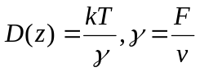,
where D(z) is diffusion coefficient along z axis, γ is friction coefficient, F is applied external force, v – mean velocity of ion movement through the channel.
This estimate gives a value of 0,6⋅10-5 cm2/s for diffusion coefficient in the gramicidin channel, which is more than 2 times less than the value of diffusion coefficient of the ion in TIP3P water obtained by the same method (1,5⋅10-5 cm2/s). It is noteworthy that the calculations carried out for a sodium cation in the channel of acetylcholine receptor and a chlorine anion in the channel of glycine receptor give similar values for diffusion coefficients.

B. Dynamics of glycine and acetylcholine receptors channels
Glycine and acetylcholine receptors belong to the family of ligand-dependent ion channels securing fast neurotransmission in various parts of the CNS [12]. The glycine receptors form inhibitory synapses along with the receptors of gamma-aminobutyric acid GABA_{A} and GABA_{C}, the acetylcholine receptors form excitatory synapses. Many of ligand-dependent receptors have pentameric structure [13].
Below we consider an example of anion channel, formed by TM2 subunits of glycine receptor [14]. The channel is formed by five transmembrane alpha-helices (Fig. 2). As in the case of gramicidin, there is a region of excess charge, but now it is positive charge from arginine residues that play the crucial role in chlorine anion transfer. Mutations in the channel part of the receptor affect the conductivity of the channel, and can even transform the channel from an anionic to cationic one.
On Fig. 3 we can see in silico reconstruction of the channel part of the receptor that we have studied. The channel is represented by a funnel formed by 5 alpha-helixes. The funnel entrance for the ion is quite wide; the funnel outlet is rather narrow. For stabilization of the system we used an alkane rim which played a role of bandage. On Fig. 3b you can see a pentameric structure of the channel, view from the outlet side.
The dynamics of chlorine anion transfer through the channel can be divided into three phases (Fig. 4). At the beginning we can observe a rather slow entering of the anion into the channel through the first belt of arginine residues. Then a rapid transfer up to the lower belt takes place. Then a rather slow phase occurs, when the anion overcomes this barrier and escapes the channel.
On Fig. 5 we can see the migration process of a sodium ion through the nicotine acetylcholine channel, a channel of the same family as glycine one [15]. It seems that the interior of ion channels is constructed in such a way that charged side chains of amino acid residues tend to form some kind of gates responsible for the channels’ selectivity.
Computer design of charge interior of the channels by means of point mutations can be very useful for design of channels with predefined properties.

Modelling Carbon Nanotubes

A. Interaction of a carbon nanotube with a phospholipids bilayer
Nanostructures and their complexes with biological macromolecular structures are a new field for application of nonequilibrium (steered) MD methods. In particular, the process of spontaneous embedding of a model nanotube into a phospholipids bilayer in coarse-grain approximations was studied in [16]. However, there have not practically been any publications on dynamics of interaction of biomembranes with carbon nanotubes in full-atomic approximation, heretofore.
In the present paper, dynamics of penetration of a carbon nanotube (diameter 13.5 Å and length 35 Å) through a hydrated POPC bilayer under the action of an external force was studied. The nanotube was oriented normally to membrane plane. A force in the direction of the normal was uniformly applied to the nanotube’s atoms. Resulting pressure made about 7⋅10⁴ bar (for comparison, detonation pressure of trotyl is much higher and about 2⋅10⁵ bar). Under such a pressure the nanotube passes through the phospholipid bilayer during the time in the order of 200 ps (fig. 6), pushing two phospholipid molecules out of the bilayer.

B. Interaction of a polypeptide with a carbon nanotube
MD methods enable forecasting the behavior of brand-new molecular systems, the prospects of which are yet to study experimentally. Study of interaction of nanotubes with biological molecules is of great practical importance in connection with the problem of selective delivery of drugs to the cells. A simulation of penetration of a one-strand DNA olygonucleotide into a carbon nanotube in aqueous medium is reported in [17].The authors of [18] studied the passage of an RNA under the action of an applied force through the holes in short nanotubes constituting a monolayer. The adsorption of amylose on a nanotube in water and the penetration of the first into the nanotube were studied in [19].
In our numerical experiments, self-assembly of a polyalanine molecule and a carbon nanotube accompanied by formation of a structure in the form of polyalanine helix inside the nanotube was revealed.
At 300 K during the period of time in the order of 200 ps adsorption (Fig. 7) of the polypeptide in alpha-helical conformation on the surface of the nanotube takes place (initially there was a distance of 30 Å between the peptide and the nantotube) [20, 21].
Further changes in the system may be traced by using the method of acceleration of over-barrier transitions at increased temperature. In such a way, the process of spontaneous penetration of the polyalanine into the nanotube was observed. Despite the fact that the benefit in energy in this case is much larger than at adsorption of the peptide on the external surface of the nanotube, the transition of the peptide from the state of being outside the nanotube to the inside-the-nanotube state requires overcoming of a certain energy barrier as the adsorption energy of the polypeptide decreases when the peptide moves to the periphery of the nanotube.
The detailed picture of the self-assembly act of the structure under investigation is presented on Fig. 8. Being on the external wall of the nanotube, the most part of the time the peptide remains in the central part of the cavity. Occasionally one of the peptide’s ends finds itself near the aperture. Gradually owing to fluctuations, the peptide molecule moves along the nanotube. Then an end of the peptide comes nearer to the hole and subsequently the whole molecule enters quickly the nanotube. This phase lasts 130 ps at 1000 K. At 2000 K the self-assembly goes with the same mechanism, however at higher temperature the process becomes more reversible. Because of that the time from the beginning until the completion of the embedding increases up to 300 ps.
Duration of the formation of a configuration which is active for self-assembly at 1000 K is 4.64 ns, at 2000 K – 0.655 ns. This gives an estimate of the activation energy about 7.8 kcal/mol. The expected time of the self-assembly at 300 K makes 43 μs. It is significant that the considered process was simulated in vacuum. For processes which take place in solvents the activation energy of the self-assembly should apparently be lower owing to the effect of solvation energy of the polypeptide and the nanotube.

C. Dynamics of functional nanostructures. Nanosyringe
The complex of the polypeptide and the capped nanotube considered above may be used for delivery of a peptide (or another molecule) through a biological membrane to a cell or a separate compartment. A common task is to selectively deliver low-molecular synthetic molecules imitating the functioning of natural biomacromolecules and having a therapeutic potential. These constructions may be also applied to studying mechanisms of molecular recognition [22].
It is worth noting that production of such systems can engender soon a new trend – nanopharmacology. Molecular dynamics appears here as a tool for design of a functional molecular construction, allowing thus to determine necessary parameters of the device. As an example, a nanosyringe pushing a peptide out from the nanotube into bilayer membrane or water was simulated.
Eight swelling model van der Waals spheres expelling the polyalanine out from the nanotube were taken as an active agent. The radius of the spheres was increasing up to the values in the order of the radius of the nanotube, thus the rate of radius’ augmentation made 0.25 and 0.5 Å/ps (extension time was 26 and 13 ps, respectively). Under such circumstances a “nanoexplosion” practically took place, and the system operated as a “nanogun”. On Figs. 9 and 10 a scenario of peptide’s ejection at such extreme parameters of the "shot" (maximum pressure in the nanotube was about 10⁵ bar) are depicted. At the moment of "shot" the nanotube gets a little deformed, but the deformations do not overpass its strength. After the termination of the process of peptide’s exclusion the nanotube completely recovers the initial conformation during the time on the order of 3 ps
In the course of the process considered above the polyalanine molecule experiences conformational changes. The initial helical conformation deformed most greatly at ejection of the polypeptide into vacuum and least of all – into the membrane. Apparently, the environment plays a deforming and structure-forming role in this process. Conformational changes of the polypetide molecule are reduced with decrease of the “nanoshot” rate.

Conclusion

Currently, SMD is an original technique applied in a large number of simulations. Two points are herein very important. At first, within the framework of this method we refuse from thermodynamically equilibrium trajectories in principle. That is we do not require the system to achieve the complete equilibrium and we refuse studying processes only within the framework of equilibrium thermodynamic fluctuations analysis. For systems containing more than 1000 particles such a way is inefficient. Secondly, within the framework of the developed nonequilibrium approach the control of local equilibrium is carried out based on the most significant parameters (fluctuations of volume, pressure, temperature). Further, a scenario of a molecular process stimulated by external action or a special boundary condition is played.

Acknowledgement

The authors thank the Russian Foundation for Basic Research (grant № 04-04-49645), RF Ministry of Education and Science, Rosnauka federal agency, CRDF (USA) and Moscow Government for the financial support.

References

- D.Frenkel and B. Smit, Understanding molecular simulation: from algorithms to applications, 2nd ed. San Diego: Academic Press, 2002.
- K.V. Shaitan, and K.B. Tereshkina, Molekulyarnaya dinamika belkov i peptidov, Мoscow: Oykos, 2004.
- K.V. Shaitan, Ye.V. Tourleigh, D.N. Golik, K.B. Tereshkina, O.V. Levtsova, I.V. Fedik, A.K. Shaytan, A. Li, and M.P. Kirpichnikov, “Dynamis and molecular design of bio- and nanostructures”, Rossiyskiy Khimicheskiy Zhurnal (in Russian), vol. 50. pp. 53–65, April 2006.
- H. Gao, “Modelling strategies for nano- and biomaterials”, in European white book on fundamental research in materials science, Van der Woorde M.H. et al., Eds. Max Planck Gesellschaft, 2001, pp.144–148.
- S. Park, and K. Schulten, “Calculating potentials of mean force from steered molecular dynamics simulations”, J. Chem. Phys., vol. 120, pp. 5946–5961, April 2004.
- J.A. Doebler, “Gramicidin toxicity in NG108-15 cells: protective effects of acetamidine and guanidine”, Cell Biol. Toxicol., vol. 15, pp. 279–289, October 1999.
- T.I. Rokitskaya, E.A. Kotova, and Y.N. Antonenko, “Membrane dipole potential modulates proton conductance through gramicidin channel: movement of negative ionic defects inside the channel”, Biophys. J., vol. 82, pp. 865–873, February 2002.
- R.J.P. Williams, “The problem of proton transfer in membranes”, J. Theor. Biol., vol. 219, pp. 389–396, December 2002.
- S.M. Pascal and T.A. Cross, “Polypeptide conformational space: dynamics by solution NMR, disorder by x-ray crystallography”, J. Mol. Biol., vol. 241, pp. 431–439, August 1994.
- B.L. Groot, D.P. Tieleman, P. Pohl, and H. Grubmüller, “Water permeation through gramicidin A: desformylation and the double helix; a molecular dynamics study”, Biophys. J., vol. 82, pp. 2934–2942, June 2002.
- E. Lindahl, B. Hess, and D. van der Spoel, “GROMACS 3.0: A package for molecular simulation and trajectory analysis”, J. Mol. Mod., vol. 7, pp. 306–317, August 2001.
- P.J. Corringer, N.N. Le, and J.P. Changeux, “Nicotinic receptors at the amino acid level”, Annu. Rev. Pharmacol. Toxicol., vol. 40, pp. 431–458, April 2000.
- D. Langosch, L. Thomas, and H. Betz, “Conserved quaternary structure of ligand-gated ion channels: the postsynaptic glycine receptor is a pentamer”, Proc. Natl. Acad. Sci. USA, vol. 85, pp. 7394–7398, October 1988.
- V.E. Yushmanov, P.K. Mandal, Z. Liu, P. Tang, and Y. Xu, “NMR structure and backbone dynamics of the extended second transmembrane domain of the human neuronal glycine receptor alpha1 subunit”, Biochemistry, vol. 42, pp. 3989–3995, April 2003.
- A. Miyazawa, Y. Fujiyoshi, and N. Unwin, “Structure and gating mechanism of the acetylcholine receptor pore”, Nature, vol. 423, pp. 949–955, June 2003.
- C.F. Lopez, S.O. Nielsen, P.B. Moore, and M.L. Klein, “Understanding nature's design for a nanosyringe”, Proc. Natl. Acad. Sci. USA, vol. 101, pp. 4431–4434, March 2004.
- H. Gao, Y. Kong, D. Cui, and C.S. Ozkan, “Spontaneous insertion of DNA oligonucleotides into carbon nanotubes”, Nano Letters, vol. 3, pp. 471–473, March 2003.
- I.-C. Yeh and G. Hummer, “Nucleic acid transport through carbon nanotube membranes”, Proc. Natl. Acad. Sci. USA, vol. 101, pp. 12177–12182, August 2004.
- Y.H. Xie and A.K. Soh, “Investigation of non-covalent association of single-walled carbon nanotube with amylose by molecular dynamics simulation”, Materials Letters, vol. 59, pp. 971–975, December 2005.
- K.V. Shaitan, Ye.V. Tourleigh, and D.N. Golik “Molecular dynamics of carbon nanotube-polypeptide complexes at the biomembrane-water interface”, NATO Science Series II: Mathematics, Physics and Chemistry, vol. 222, 233–234, April 2006.
- K.V. Shaitan, Ye.V. Tourleigh, D.N. Golik, and M.P. Kirpichnikov “Computer-aided molecular design of nanocontainers for absorption and targeted delivery of bioactive compounds”, J. Drug Deliv. Sci. Technol., accepted.
- R. Li, V. Dowd, D.J. Stewart, S.J. Burton, and C.R. Lowe, “Design, synthesis, and application of a Protein A mimetic”, Nat. Biotech., vol. 16, pp. 190–195, February 1998.
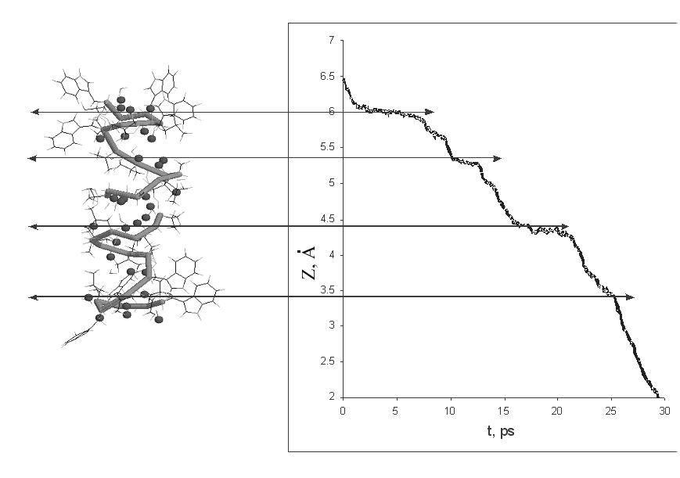
Fig. 1

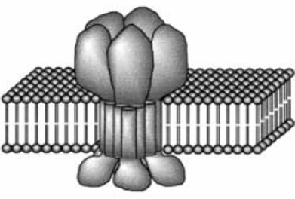
Fig. 2
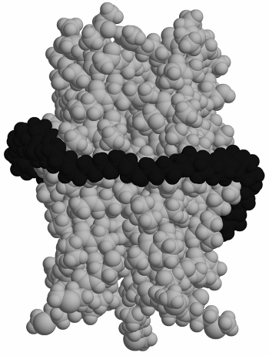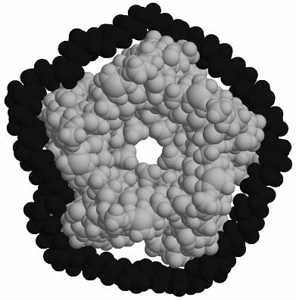
a b
Fig. 3

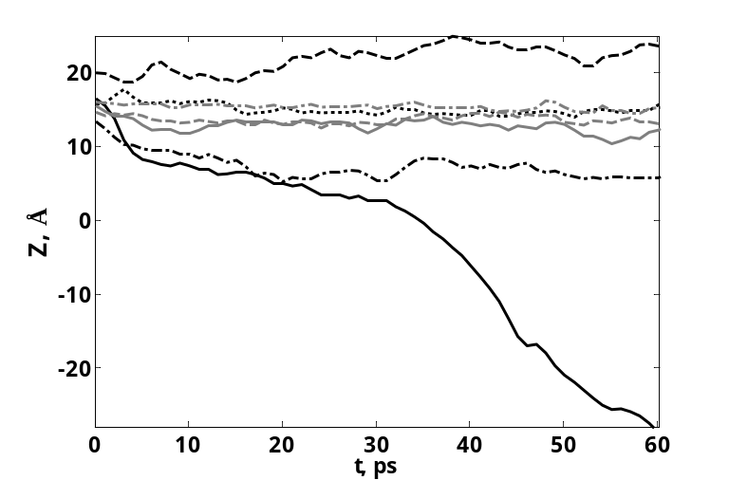
Fig. 4
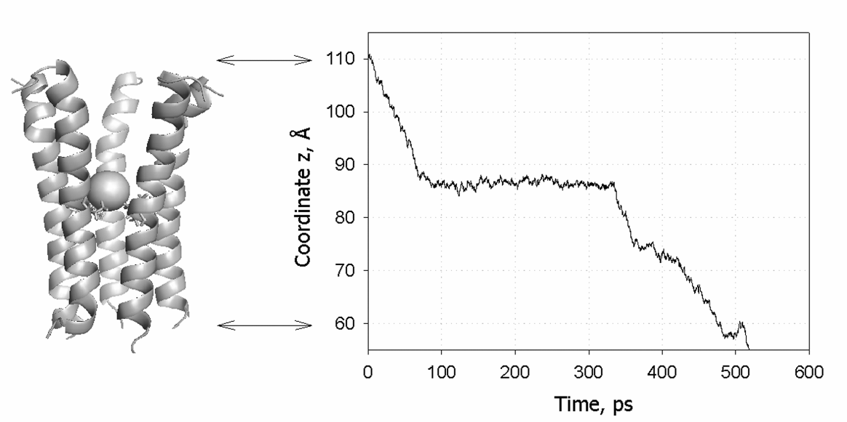
Fig. 5

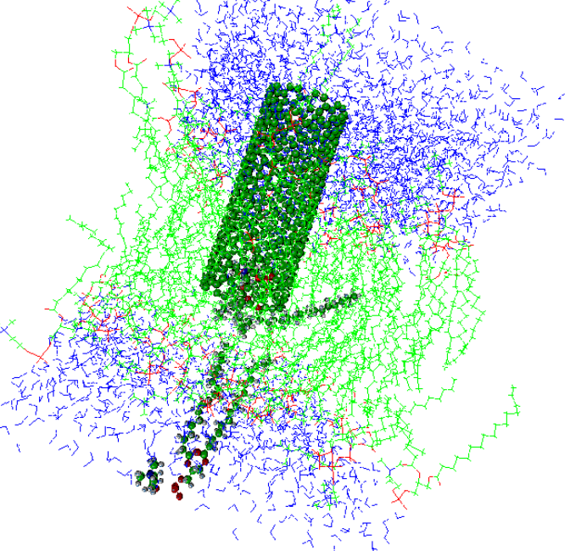
Fig. 6
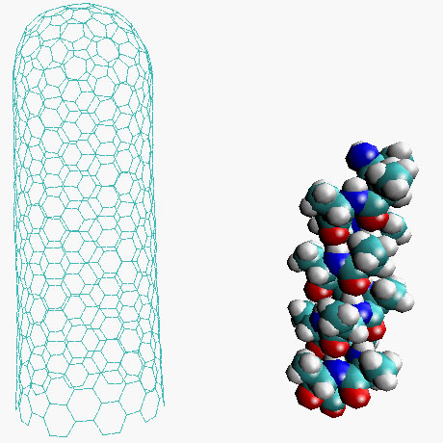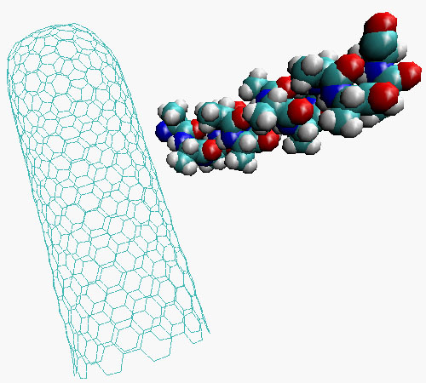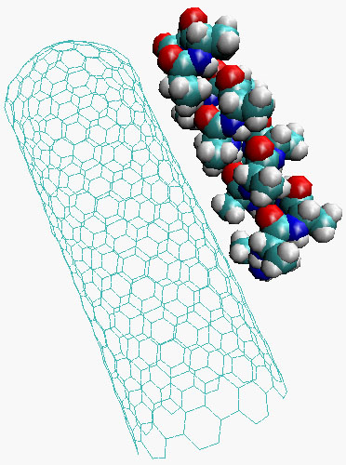
0 ps 100 ps 200 ps
Fig. 7

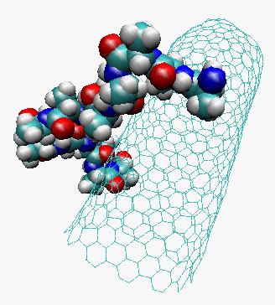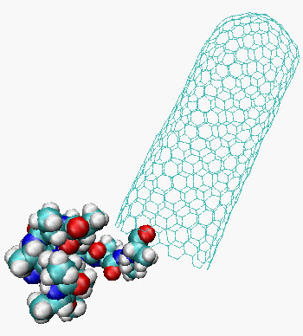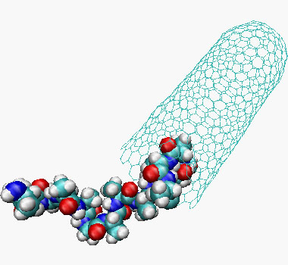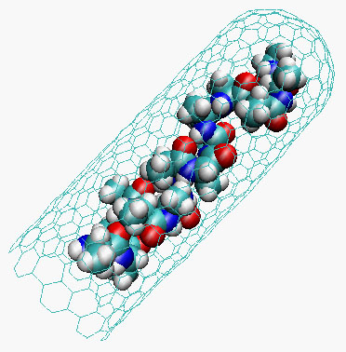
0 ps 50 ps 100 ps 150 ps
Fig. 8
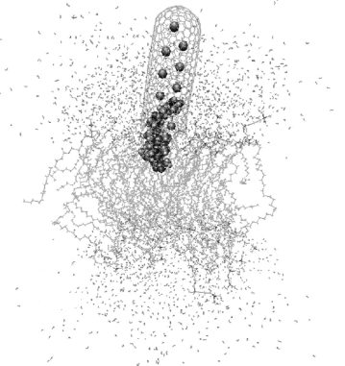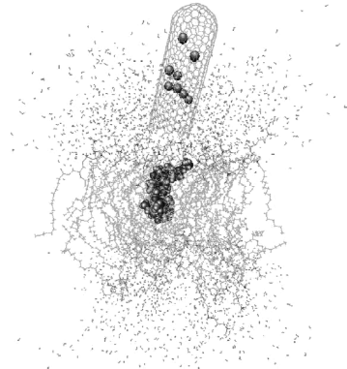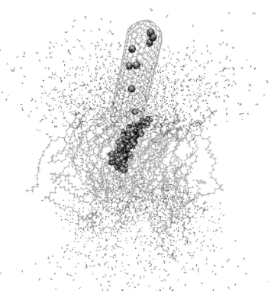
13 ps 26 ps 50 ps
Fig. 9

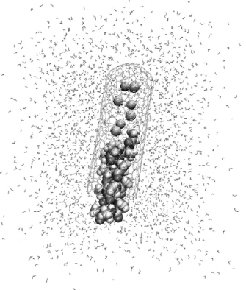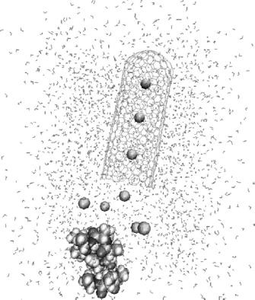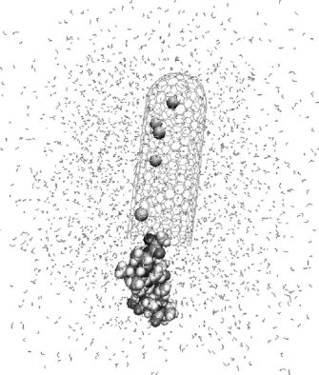
10 ps 26 ps 50 ps
Fig. 10
FIGURE CAPTIONS
Fig. 1. Dynamics of Na⁺-ion movement through the channel pore. Arrows indicate the regions where the ion transport slows down due to interactions with excess negative charge on oxygen atoms of the gramicidin backbone.
Fig. 2. Scheme of the glycine receptor.
Fig. 3. Structure of the glycine receptor (channel part) derived from homology modeling on the base of the acetylcholine receptor. Black balls – alkane rim, grey balls – channel.
Fig. 4. Dynamics of Cl⁻-ion movement through the glycine receptor channel (the position of the chloride ion is shown by a solid black line).
Fig. 5. Dynamics of Na⁺-ion movement through the acetylcholine receptor channel. Arrows indicate the beginning and the end of the process.
Fig. 6. A carbon nanotube piercing a phospholipids bilayer. POPC molecules being pushed out are depicted in more details.
Fig. 7. Subsequent stages of attachment of the polyalanine to the external surface of the nanotube.
Fig. 8. Subsequent stages of the self-assembly of the peptide-nanotube complex at 1000 K.
Fig. 9. Subsequent stages of the ejection of the peptide into the membrane.
Fig. 10. Subsequent stages of the ejection of the peptide into water.

