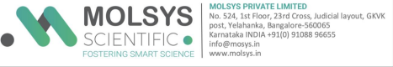

**TAX INVOICE**

Dated: {{date}} Ref: {{ref_no}}

To,

{{to_address}}

GSTIN: {{gst_number}}

| Description Of Services | Qty | Price (INR)  Per Sample |
| --- | --- | --- |
| {{service_description}} | {{quantity}} | {{unit_price}} |
| Net Total | | {{net}} |
| GST @ 18% | | {{gst}} |
| Grand Total (Round off) | | {{grand}} |

Amount (Words): {{amount_words}}

GSTIN: 29AALCM9252C1Z7 SAC: 3821

Invoice – Page 1 of 2





**Terms & Conditions**

1) 100% payment along with Raw data and Purchase Order.

2) The payment shall be through cheque/Draft in favor of “Molsys Private Limited” or to the account through NEFT/RTGS/IMPS:

Bank Name: ICICI, Sahakarnagar branch

A/c Name: Molsys Private Limited

A/c No.: 060405002959 (Current A/c)

IFSC: ICIC0000604

GSTIN: 29AALCM9252C1Z7

SWIFT CODE: ICICINBBCTS

3) No other bank charge should be deducted from the total amount. 4) If payment is not received by the due date, interest shall accrue on all unpaid amounts at the rate of 1.5% per month.

5) Please include your invoice number with your payment.

6) Data storage is a chargeable service. Kindly note delayed payments will incur additional storage charges as per the company’s policy

**Yours sincerely,** 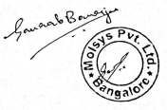

**Authorized Signature**

**Molsys Pvt. Ltd.**

**Yelahanka, Bangalore-65**

Invoice – Page 2 of 2

