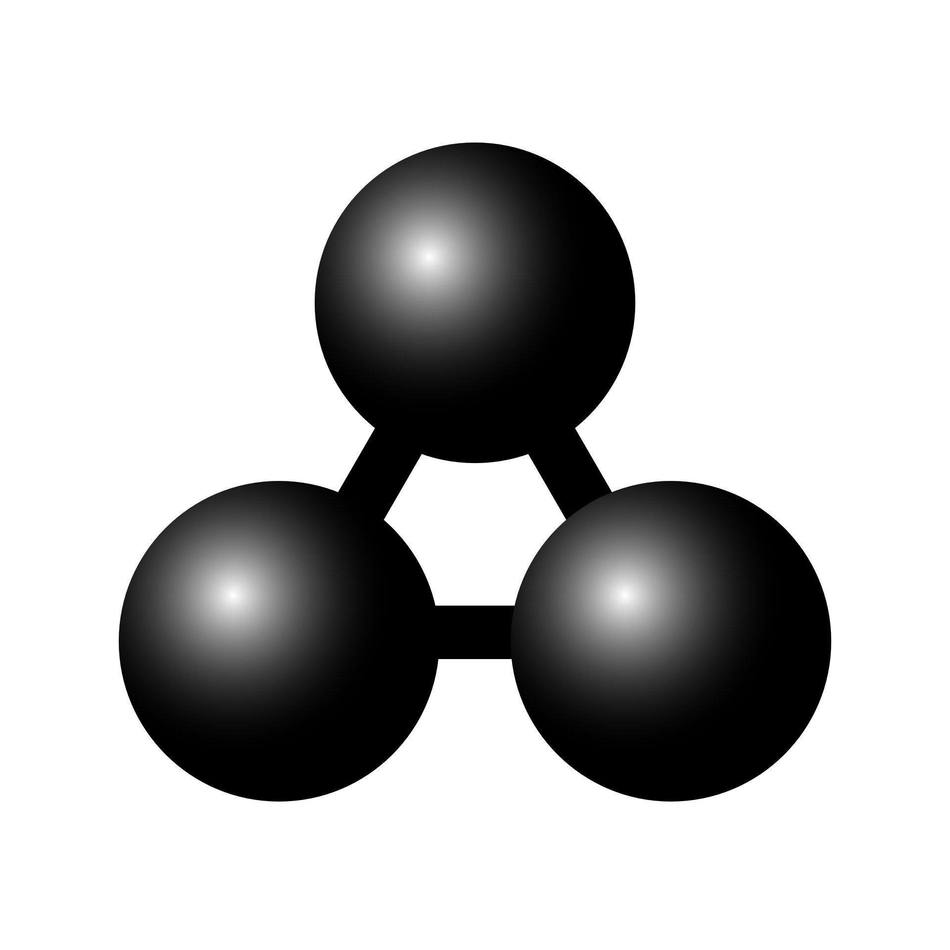

MolView manual
This is the manual for MolView version 2.3
MolView is a free web application hosted on molview.org
You can contact info@molview.org if you have any questions

Table of Contents
1. Drawing structural formulas 3
Top toolbar 3
Left toolbar 3
Right toolbar 3
2. Finding structures 4
3. Tools 5
Link 5
Export 5
Information card 5
Spectroscopy 5
3D model resource 5
Advanced search 6
4. Spectroscopy 7
Export data 7
5. 3D model 8
Reset 8
Representation 8
Background 8
Engines 8
Model transformation 9
Crystallography 9
Fog and clipping 9
6. Protein display 10
Show bio assembly 10
Chain representation 10
Chain coloring 10
7. Advanced Jmol tools 11
Clear 11
High Quality 11
Calculations 11
Measurement 11

1. Drawing structural formulas
MolView consists of two main parts, a structural formula editor and a 3D model viewer. We will start with the first one. The structural formula editor is surround by three toolbars which contain some tools you can use in the editor. Once you’ve drawn a molecule, you can click the 2D to 3D button to convert the molecule into a 3D model which is then displayed in the viewer.
Below is a list of all available editing tools.

Top toolbar
- Trash: clears the entire canvas
- Eraser: click atoms or bonds to erase them
- Drag: drag atoms and bonds around
- Undo/redo: navigate trough your edit history
- Color mode: display atoms and bonds using colors
- Full mode: displays all C and H atoms instead of skeleton display
- Center: centers the whole molecule
- Clean: cleans the structural formula using an external service
- 2D to 3D: converts the structural formula into a 3D model

Left toolbar
- Bonds: pick one of the bond types and create bonds by clicking the canvas, add bonds to atoms or modify bonds by clicking existing bonds
- Fragments: pick one of the fragments (benzene, cyclopropane, etc.) and create fragments by clicking the canvas or add fragments to atoms
- Charge: click atoms to either increment or decrement their charge

Right toolbar
Contains a number of elements and at the bottom a periodic table button which pop-ups a periodic table where you can choose from all elements. If you have selected an element, you can click existing atoms to change their element or click on an empty part of the canvas to create a new atom with the selected element.

2. Finding structures
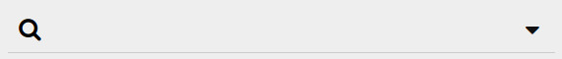
You can load molecules from large databases like PubChem and RCSB using the search form located on the left side of the menu-bar. Just type what you are looking for and a list of available molecules will appear.
You can also click on the dropdown button next to the search field to select a specific database. This will perform a more extensive search on the selected database. Currently, three big databases are supported:
- PubChem
- The RCSB Protein Data Bank
- The Crystallography Open Database

3. Tools
The Tools menu contains several utility functions which are listed below.

Link
You can embed or share a specific compound, macromolecule or crystal using the provided URL or HTML code. Note that the linked structure is the one which is currently displayed in the model window. You can also copy the URL from the address bar in order to link to the current structure.

Export
Export options:
- Structural formula image: sketcher snapshot (PNG with alpha channel)
- 3D model image: model snapshot (PNG, alpha channel in GLmol and ChemDoodle)
- SDF file: MDL Molfile from the 3D model (common molecules)
- PDB file: Protein Data Bank file from the 3D model (macromolecules)
- CIF file: Crystallographic Information File from the 3D model (crystal structures)

Information card
This collects and displays information about the current structural formula (loaded from the Sketcher) You can also find a database reference for the current 3D model.

Spectroscopy
This shows a new layer where you can view molecular spectra of the current structural formula (loaded from the Sketcher) More details are covered in the Spectroscopy chapter.

3D model resource
This redirects you to the web-page for the current 3D model on the website of its source database (except when the model is resolved using the Chemical Identifier Resolver)

Advanced search
These functions allow you to perform some advanced searches through the PubChem database using the structural formula from the sketcher.
- Similarity search: search for compounds with a similar structural formula
- Substructure search: search for compounds with the current structure as subset
- Superstructure search: search for compounds with the current structure as superset

4. Spectroscopy
You can open the Spectroscopy view via Tools > Spectroscopy. You can view three kinds of molecular spectra.
- Mass spectrum
- IR spectrum
- H1-NMR prediction

Export data
You can also export different kinds of data from the currently selected spectrum.
- PNG image: snapshot from interactive spectrum
- JCAMP file: JCAMP-DX file of the current spectrum

5. 3D model
The Model menu contains some general functions for the 3D model.

Reset
This function sets the model position, zoom and rotation back to default.

Representation
You can choose from a list of different molecule representations including; ball and stick, stick, van der Waals spheres, wireframe and lines. Macromolecules are automatically drawn using ribbons.

Background
You can switch between a black, gray or white background. The default background is black (exported images from GLmol or ChemDoodle have a transparent background)

Engines
You can choose from three different render engines: GLmol, Jmol and ChemDoodle. GLmol is used as default render engine. GLmol and ChemDoodle are based on WebGL, a browser technology to support 3D graphics. If WebGL is not available in your browser, Jmol wil be used for all rendering.
MolView automatically switches to:
- Jmol if you execute functions from the Jmol menu
- GLmol if you load macromolecules and WebGL is available (due to significant higher performance)
- ChemDoodle if you load a crystal structure and WebGL is available (GLmol cannot render crystal structures)
You might want to switch back to GLmol when you do no longer need Jmol or ChemDoodle since GLmol has a better performance.
Note that macromolecules are drawn slightly different in each engine. ChemDoodle provides the finest display. You should, however, avoid using ChemDoodle for very large macromolecules.

Model transformation
You can rotate, pan and zoom the 3D model. Use the right button for rotation, the middle button for translation (except for ChemDoodle) and the scrollwheel for zooming. On touch devices, you can rotate the model with one finger and scale the model using two fingers.

Crystallography
You can load an array of crystal cells (2x2x2 or 1x3x3) or a single unit cell when viewing crystal structures.

Fog and clipping
When you are viewing large structures, like proteins, it can be useful to hide a certain part using fog or a clipping plane. GLmol offers a few options to do this.
- Fog: you can move the fog forward by dragging the mouse up while holding CTRL + SHIFT (drag in the opposite direction to move the fog backward)
- Clipping plane: you can move a frontal clipping plane into the structure by dragging the mouse to the left while holding CTRL + SHIFT (drag in the opposite direction to move the clipping plane back)

6. Protein display
The Protein menu offers a number of protein display settings including different color schemes and different chain representations.

Show bio assembly
When loading a protein structure, MolView shows the asymmetric unit by default. This function allows you to view the full biological unit instead.

Chain representation
You can choose from four different chain representations. You can also view the full chain structure by enabling the Bonds option.
- Ribbon: draws ribbon diagram (default representation)
- Cylinder and plate: solid cylinders for α-helices and solid plates for β-sheets
- B-factor tube: tube were thickness is calculated from the B-factor (thermal motion)
- C-alpha trace: lines between central carbon atom in amino-acids (very fast rendering)

Chain coloring
You can choose from six chain color schemes.
- Secondary structure: different colors for α-helices, β-sheets, etc.
- Spectrum: color spectrum (rainbow)
- Chain: each chains gets a different color
- Residue: all amino-acid residues are colored differently
- Polarity: colors polar amino-acids red and non polar amino-acids white
- B-factor: blue for low B-factor and red for high B-factor (if provided)

7. Advanced Jmol tools
The Jmol menu offers some awesome Jmol-only functions and calculations.

Clear
Clears all executed calculations and measurements.

High Quality
Enables High Quality rendering in Jmol (enabled by default on fast devices) When turned off, anti-aliasing is disabled and the model is drawn using lines while transforming it.

Calculations
You can perform the following Jmol calculations in Jmol:
- MEP surface lucent/opaque: calculates and projects molecular electrostatic potential on a translucent or opaque on van der Waals surface
- Charge: calculates and projects atomic charge as text label and white to atom color gradient
- Bond dipoles: calculates and draws the individual bond dipoles
- Overall dipole: calculates and draws the net bond dipole
- Energy minimization: executes an interactive MMFF94 energy minimization (note that this function only executes a maximum of 100 minimization steps at a time)

Measurement
You can measure distance, angle and torsion using Jmol. You can activate and deactivate one of these measurement types via the Jmol menu.
- Distance: distance between two atoms in nm
- Angle: angle between two bonds in degrees
- Torsion: torsion between four atoms in degrees
Note that in some cases, the resolved 3D model is only an approach of the real molecule, this means you have to execute an Energy minimization in order to do reliable measurements.

