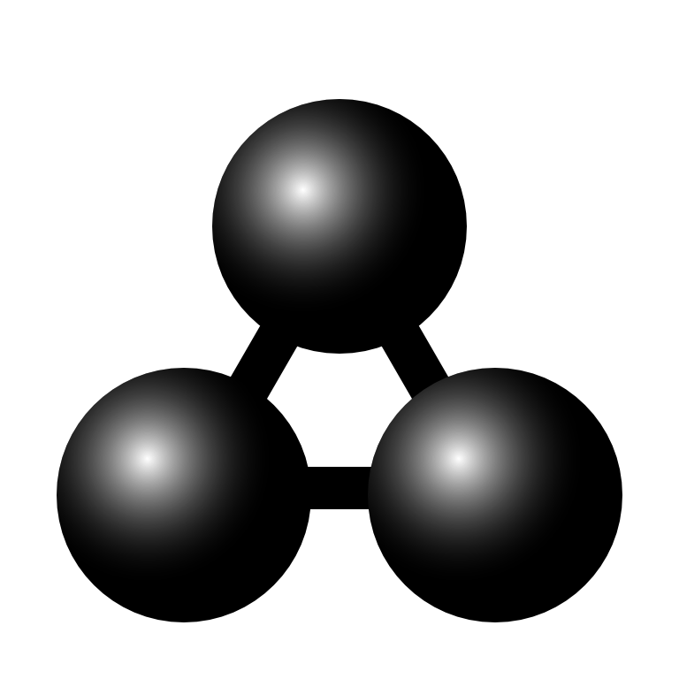

MolView manual
This is the manual for MolView version 2.2
MolView can be found at molview.org

Table of Contents
Table of Contents 2
1. Drawing structural formulas 3
Top toolbar 3
Left toolbar 3
Right toolbar 3
2. Finding structures 4
3. 3D model 5
Reset 5
Representation 5
Background 5
Engines 5
Model transformation 6
Crystallography 6
4. Advanced tools 7
Link 7
Export 7
Information card 7
Spectroscopy 7
Advanced search 8
5. Spectroscopy 9
Export data 9
6. Custom GLmol display 10
Biological assembly 10
Chain representation 10
Chain coloring 10
Fog and clipping 10
7. Advanced Jmol functions 12
Clear 12
Calculations 12
Measurement 12
Render mode 13

1. Drawing structural formulas
You can draw structural formulas using the Sketcher component.

Top toolbar
The top toolbar contains all general editing tools. The 2D to 3D tool converts the structural formula into a 3D molecule which is displayed in the model window.
Top toolbar, from left to right: delete all, erase, undo, redo, move atoms/bonds, center view, rectangle select, lasso select, clear selection, clean structural formula, 2D to 3D conversion

Left toolbar
In the left toolbar, you can select a tool you want to use in order to modify or extend the structural formula. You can draw a carbon chain using the chain tool (11th button in image) Just click a start point or atom and drag a chain.
Left toolbar (rotated), from left to right: single bond, double bond, triple bond, up/down bond, benzene, cyclopropane/butane/pentane/hexane/heptane, chain, charge+, charge-

Right toolbar
The right toolbar contains some common elements and a periodic table tool in case you want to use another element. You can select an atom and click an existing atom in order to replace it with the selected atom. Note that you can only replace existing atoms. In order to add an atom, you will first have to add a new bond using the tools from the left toolbar.
Right toolbar (rotated), from left to right: hydrogen, carbon, nitrogen, oxygen, sulfur, phosphorus, fluorine, iodine, chlorine, bromine, table of elements, info (about dialog)

2. Finding structures
You can load structures from large databases like PubChem via the search bar located on the right side of the menubar. Just type what you are looking for and find it in the autocomplete dropdown or click one of the search categories listed below to perform a more extensive search.
- Compounds: small molecules from the PubChem database
- Macromolecules: biological macromolecules from the RCSB database
- Crystals: crystal structures from the Open Crystallography Database
You can also enter a PubChem CID via Compounds, a PDB ID via Macromolecules or a COD ID via Crystals. It is also possible to enter a SMILES, InChi or InChiKey string in the search field.
You can show or hide search results using the leftmost button (contains an eye) Note that Macromolecules search is absent on mobile devices which do not support WebGL since they can't display macromolecules anyway.
Search bar, from left to right: input field, fast search, compounds search (PubChem), macromolecules search (RCSB) and crystals search (COD)

3. 3D model
You can find the general 3D Model menu in the menubar.

Reset
This function sets the model position, zoom and rotation back to default.

Representation
You can choose from a list of different molecule representations including; ball and stick, stick, van der Waals spheres, wireframe and lines. Macromolecules are automatically drawn using ribbons.

Background
You can switch between a black, grey or white background. The default background is black (exported images from GLmol or ChemDoodle have a transparent background)

Engines
You can choose from three different render engines: GLmol, Jmol and ChemDoodle. GLmol is used as default render engine. GLmol and ChemDoodle are based on WebGL, a browser technology to support 3D graphics. If WebGL is not available in your browser, Jmol wil be used for all rendering.
MolView automatically switches to:
- Jmol if you execute functions from the Jmol menu
- GLmol if you load macromolecules and WebGL is available
(due to significant higher performance)
- ChemDoodle if you load a crystal structure and WebGL is available
(GLmol cannot render crystal structures)
You might want to switch back to GLmol when you do no longer need Jmol or ChemDoodle since GLmol has a better performance.
Note that macromolecules are drawn slightly different in each engine. ChemDoodle provides the finest display. You should, however, avoid using ChemDoodle for very large macromolecules.

Model transformation
You can rotate, translate and zoom the 3D model using a mouse. Use the right button for rotation, the middle button for translation (except for ChemDoodle) and the scrollwheel for zooming. On touch devices, you can rotate the model using one pointer and scale the model using multi-touch.

Crystallography
You can load an array of crystal cells (2x2x2 or 1x3x3) or a single unit cell when viewing crystal structures.

4. Advanced tools
You can find the Tools menu in the menubar. This menu contains several utility functions.

Link
You can embed or share a specific compound, biomolecule or crystal using the provided URL or HTML code. Note that the linked structure is the one which is currently displayed in the model window. You can also copy the URL from the adress bar in order to link to the current structure.

Export
Export options in the Export menu:
- Structural formula image: PNG snapshot from sketcher (transparent background)
- 3D model image: PNG snapshot from model window
(transparent background in GLmol and ChemDoodle)
- SDF file: exports a MDL Molfile from the 3D model
(displayed if the 3D model is a common molecule)
- PDB file: exports a Protein Data Bank file from the 3D model
(displayed if the 3D model is a macromolecule)
- CIF file: exports a Crystallographic Information File from the 3D model
(displayed if the 3D model is a crystal structure)

Information card
This function collects and displays information about the current structural formula (loaded from the Sketcher) You can also find a database reference for the current 3D model.

Spectroscopy
This function shows a new layer where you can view molecular spectra of the current structural formula (loaded from the Sketcher) More details are covered in chapter 5.

Advanced search
You can perform three types of advanced search based on the structural formula from the sketcher.
- Similarity search: search for compounds with a similar structural formula
- Substructure search: search for compounds with the current structure as subset
- Superstructure search: search for compounds with the current structure as superset

5. Spectroscopy
You can open the Spectroscopy layer via Menu >Model > Chemical data > Spectrocopy. You can view three kinds of molecular spectra.
- H1-NMR prediction
- Mass spectrum
- IR spectrum

Export data
You can also export different kinds of data from the currently selected spectrum.
- PNG image: snapshot from interactive spectrum
- JCAMP file: JCAMP-DX file of the current spectrum

6. Custom GLmol display
The GLmol render engine contains some custom display functions for macromolecules. These functions are located under the GLmol menu in the menubar.

Biological assembly
Some macromolecules are only a small unit (asymmetric unit) from a much larger structure (biological unit) This function allows you to view the full biological unit.

Chain representation
GLmol offers five different chain representations.
- Ribbon: draws ribbon diagram (default representation)
- Cylinder and plate: solid cylinders for α-helices and solid plates for β-sheets
- C-alpha trace: lines between central carbon atom in amino-acids (very fast rendering)
- B-factor tube: tube were thickness is calculated from the B-factor (thermal motion)
- Bonds: all bonds are displayed as lines

Chain coloring
You can choose from five chain coloring methods.
- Secondary structures: different colors for α-helices, β-sheets, etc.
- Spectrum: chain colored with full color spectrum (blue-green-red)
- Chain: each chains gets a different color
- B-factor: blue for low B-factor and red for high B-factor (if provided)
- Polarity: colors polar amino-acids red and non polar amino-acids white

Fog and clipping
When you are viewing large structures, like proteins, it can be useful to hide a certain part using fog or clipping. GLmol offers a few options to do this.
- Fog: you can move the fog forward by dragging the mouse up while holding the CTRL and the SHIFT key (and vice versa)
- Clipping plane: you can move a frontal clipping plane into the structure by dragging the mouse to the left while holding the CTRL and the SHIFT key and (vice versa)

7. Advanced Jmol functions
Jmol offers some advanced functions. You can find them in the Jmol menu in the menubar. Note that all functions (except for render modes) are disabled when viewing proteins.

Clear
Clears all executed calculations and measurements.

Calculations
You can perform the following Jmol calculations in Jmol:
- MEP surface lucent/opaque: calculates and projects molecular electrostatic potential on a translucent or opaque on van der Waals surface
- Charge: calculates and draws the atomic charge as labels
- Bond dipoles: calculates and draws the individual bond dipoles
- Overall dipole: calculates and draws the netto bond dipole
- Energy minimization: executes an MMFF94 energy minimization
(note that this function only executes a maximum of 100 minimization steps at a time)

Measurement
You can do distance, angle and torsion measurements using Jmol. You can select one of these measurement modes via the Jmol menu (click selected mode again to deselect) Select atoms using the right mouse button.
- Distance: distance between two atoms in nm (select two atoms)
- Angle: angle between two bonds in deg (select three atoms)
- Torsion: torsion between four atoms in deg (select four atoms)
Note that the resolved 3D model is only an approach of the real molecule, this means you have to execute an Energy minimization in order to do reliable measurements.

Render mode
In Jmol, you can switch between different render modes in order to speed up performance or to increase quality.
There are three render modes:
- Everything: slowest but best quality
- Normal: average speed and quality
- Minimal: fastest but least quality

