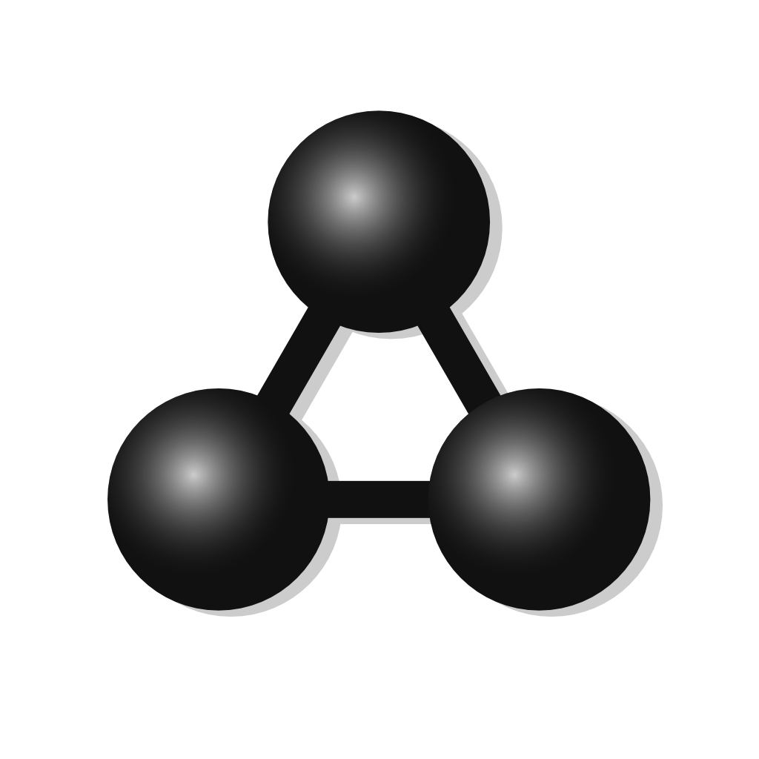

MolView manual
This is the first revision of the manual for MolView version 2.0.0
MolView can be found at molview.org

Table of Contents
1. Drawing structural formulas 3
2. Finding structures 3
3. 3D model 4
4. Advanced tools 5
5. Spectroscopy 7
6. Advanced Jmol functions 8

1. Drawing structural formulas
You can draw structural formulas using the sketching component.

Top toolbar
The top toolbar contains all general editing tools. These tools include a clear all tool, an erase tool, a move atoms tool, an undo and redo tool, two selection tools, a clear selection tool, a center structure tool, a cleanup tool and a 2D to 3D tool. The last one converts the structural formula to a 3D molecule displayed in the model window.

Left toolbar
In the left toolbar, you can select a tool you want to use in order to modify or extend the structural formula. In order to draw a carbon chain using the chain tool, you have to click a start point or atom and drag a chain.

Right toolbar
The right toolbar contains some common elements and a periodic table tool in case you want to use another element. Note that you can only replace existing atoms. So in order to add an atom, you frist have to add a new bond using the tools from the left toolbar.

2. Finding structures
You can load structures from large databases like PubChem via the search field located on the right side of the menubar. Just type whatever and enter or click the kind of structures you want to find:
- Compounds: small molecules
- Proteins: biopolymers
- Crystals: crystal structures
It's recommended to use only one or two words for crystal structures search due to database limitations.
You can show or hide search results using the leftmost button. Note that proteins search is absent on mobile browsers which do not support WebGL (because they cannot display proteins fast enough)

3. 3D model
You can find the general 3D Model menu in the menubar.

Reset
This function sets the model position, zoom and rotation back to default.

Representation
You can choose from a list of different molecule representations including; ball and stick, stick, van der Waals spheres, wireframe and lines. Proteins are automatically drawn using ribbons.

Engine
You can choose from three different render engines. MolView uses GLmol, Jmol and ChemDoodle Web as render engines. MolView automatically switches to:
- Jmol if your browser doesn't support WebGL
- Jmol if you execute functions from the Jmol menu
- ChemDoodle if you load a crystal structure
You might want to switch back to GLmol after case 2 and 3.
Note that proteins are drawn slightly different in each engine. ChemDoodle Web provides the most sophisticated protein display. You should, however, avoid using ChemDoodle Web for large proteins.

Crystallography
This submenu contains functions to load an array of crystal 'boxes'.
- 1x1x1 Unit cell (default)
- 2x2x2 supercel
- 3x3x1 supercel

4. Advanced tools
You can find the Tools menu in the menubar. This menu contains several utility functions.

Link
You can link to a specific compound, protein or crystal using URL parameters. This menu gives you two options:
- Share: use this option if you want to share the current MolView content including chemical structure, layout and molecule representation.
- Embed: use this option if you want to embed the current model into your website. To add the 3D view with the current structure to your website, you have to copy the given HTML code into your website.
If you only want to link to the current chemical structure, you can also copy the URL from the adress bar. (make sure the URL links to the right structure by reloading the page)

Export
Export options in the Export menu:
- Structural formula image: PNG snapshot from sketcher
- 3D model image: PNG snapshot from model window
- MOL file: exports a MDL Molfile from the 3D model
(displayed if the 3D model is a common molecule)
- PDB file: exports a Protein Data Bank file from the 3D model
(displayed if the 3D model is a protein)
- CIF file: exports a Crystallographic Information File from the 3D model
(displayed if the 3D model is a crystal structure)

Properties
Depending on the situation, this function gives you more information about the current molecule.
- If the model is a protein: hotlink to RCSB Protein Data Bank page
- If the model is a crystal structure: hotlink to Crystallography Open Database page
- Else: shows a dialog with a number of properties for the structural formula from the sketcher

Spectroscopy
This method shows a dialog where you can view spectra related to the structural formula from the sketcher. More details are covered in chapter 5.

Advanced search
You can perform three types of advanced search based on the structural formula from the sketcher.
- Similarity search: search for compounds with a similar structural formula
- Substructure search: search for compounds with the current structure as subset
- Superstructure search: search for compounds with the current structure as superset

5. Spectroscopy
The Spectroscopy menu item is located under Model > Chemical data in the menubar. This menuitem shows the spectroscopy dialog where you can choose from a number of spectra (if available)
- H1-NMR prediction
- Mass spectrum
- IR spectrum

Export data
The spectroscopy dialog allows you to export two kind of files from the current spectrum:
- PNG image: snapshot from interactive spectrum
- JCAMP file: JCAMP-DX file of the current spectrum

6. Advanced Jmol functions
Jmol provides several advanced functions. Some of these can be accessed via the Jmol menu in the menubar.

Clear
Clears all executed calculations and measurements.

Calculations
You can perform the following Jmol calculations in Jmol:
- MEP surface lucent/opaque: calculates and projects molecular electrostatic potential on a translucent or opaque van der Waals surface
- Charge: calculates and projects atomic charge as text label and white to atom color gradient
- Bond dipoles: calculates and draws individual bond dipoles
- Overall dipole: calculates and draws netto bond dipole
- Energy minimization: executes an MMFF94 energy minimization calculation

Measurement
You can perform the following measurements in Jmol:
- Distance (nm)
- Angle (deg)
- Torsion (deg)

Render mode
In Jmol, you can switch between different render modes in order to speed up performance or to increase quality.
There are three render modes:
- Everything: slowest but best quality
- Normal: average speed and quality
- Minimal: fastest but least quality

