[1]

Effect of varying the exposure area on the performance of He+ ion beam-irradiated monolayer MoS2 FETs

Jakub Jadwiszczak, Conor P. Cullen, Darragh Keane, Pierce Maguire, Georg S. Duesberg and Hongzhou Zhang

*Abstract*— In recent years, inert gas ion beams have emerged as a promising means of engineering the conductivity and carrier mobilities of novel 2D semiconductors. Here we report a systematic study of the electrical performance of monolayer CVD MoS2 FETs when irradiated with a focused helium ion beam as a function of increasing areal coverage. We determine an optimal coverage of ~ 10% which allows for improvement to both channel mobility and material conductance due to doping with beam-created sulfur vacancies. Larger areal irradiations introduce a higher concentration of scattering centers, hampering the electrical performance of the device. In addition, we compare the effect of irradiating one of the electrodes for a range of areal coverages and find its deleterious impact on charge transport when contrasted with channel-confined irradiations.

*Index Terms*—MoS2 FETs, ion beam doping, contacts, defects.

# INTRODUCTION

L

ayered two-dimensional (2D) semiconductors have come to the fore in recent years as promising candidates for low-power miniaturized electronics. In particular, transition metal dichalcogenides (TMDs) such as MoS2 have demonstrated impressive on/off ratios (~107) in field-effect transistors (FETs), while maintaining satisfactory carrier mobilities [1], [2]. With chemical vapor deposition (CVD) techniques allowing reliable millimeter-scale fabrication of well-performing monolayer TMD films[3], [4], it becomes crucial to understand the impact of defects such as chalcogen vacancies on the electrical transport properties of these materials. Moreover, the introduction of defects into TMD FETs may serve to improve charge transport if done controllably [5], [6].

Recently, noble gas ion beam irradiation has opened the field to exploring the effects of structurally modifying TMD devices on the nanometer scale [7]–[9]. The localized formation of defects by ion irradiation has been shown to induce unusual electronic properties in monolayer TMDs, such as pseudo-metallic phase transitions in MoS2 and WSe2 [10], [11]**.** Ion beam techniques are known to preferentially sputter sulfur from MoS2 while retaining micron-scale structural integrity for on-substrate flakes [12], [13]. Sulfur vacancies (SVs) can act as donors and shift the threshold voltage (Vth) of the FET to higher negative gate biases [6], [14]. In addition, the formation of a dislocation-divacancy complex can lead to significant n-doping in MoS2 [15]. These states can form stable impurity bands near the conduction band and improve carrier mobility [16]. A zero-sum game between the effective donor concentration and introduced scattering potentials from vacancies needs to be played out for optimum tuning of carrier transport in TMDs [17], [18]. As the spread of a typical focused He+ ion probe is several nanometers, the formation of other defects in the irradiated 2D lattice is expected [19], [20]. The deep n-type doping behavior hence achieved by ion sputtering will depend not only on the fluence of the ion beam, but the absolute number of defects that can be introduced. This directly translates to the irradiated channel area, which we focus on in this letter.

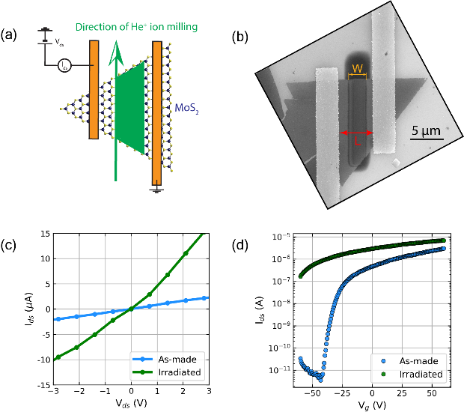

Fig. 1. (a) Sketch demonstrating the irradiation strategy on contacted monolayer MoS2 devices. The green area marks the designed irradiation area. (b) SEM image of an irradiated device. W marks the width of the exposed region, while L is the length of the FET channel. L is 5 µm in the image. (c) IV curve of a device post-irradiation (corresponding to IR = 7%). (d) Transfer curve of the same device demonstrating reduced gate tunability after He+ ion irradiation.

# Device Fabrication and ion beam irradiations

Monolayer MoS2 samples were grown by a CVD method described in previous work [21] on 285 nm SiO2/Si substrates which served as the back-gate. Devices were contacted with 5 nm Ti/35 nm Au electrodes. Ttesting was carried out using a dual channel sourcemeter in the vacuum chamber of a customized SEM, after devices were pumped at ~ 10-5 mbar for 12 hours to remove any surface adsorbates. Helium ion irradiations were carried out at a beam energy of 30 keV and He gas pressure of 2 × 10-6 mTorr. The average beam current was 37.5 ± 0.4 pA, with the probe size evaluated at 7 nm using the standard method [10]. The ion dose delivered to each sample was ~ 1017 ions cm-2, with a probe step size of 1 nm and dwell time of 4.3 µs on a unidirectional scan.

Figure 1(a) shows a sketch of the experimental geometry. The as-made MoS2 FETs were placed in the helium ion microscope after initial electrical testing and were all irradiated without leaving vacuum, with the stage tilt set at 0º. A micrograph of a typical irradiated device is presented in Fig. 2(b). The marked distances W and L denote the width of the irradiated region and length of the FET channel respectively. L was always 5 µm in this work, while W was varied to obtain an irradiation-to-channel ratio, IR = W/L. Following the patterning and electrical testing, the devices were analyzed in the SEM to accurately obtain these parameters.

# Results and Discussion

The beneficial effect of irradiating the MoS2 device at the dose of 1017 ions cm-2 is shown in Fig. 1(c). This dose causes a notably higher electrical conduction to emerge in the monolayer MoS2, with output current, Ids, increasing ~ 5-fold for the same drain-source bias Vds when compared to the as-made device. The post-irradiation transfer characteristics (Fig. 1(c)) reveal a much-reduced response to changes in the gate bias. The FET channel cannot now be effectively turned off in the tested bias range, with significant drain current still persistent at Vg = – 60 V. This is in stark contrast to the standard n-type device functionality noted for the MoS2 channel pre-irradiation. The sharp rise in the subthreshold swing and the large shift of Vth to negative gate biases may have several origins. The presence of the metallic 1T-MoS2 phase usually results in no gate tunability [25], [26], while our device retains a small on/off ratio of ~ 40. Hence, we rule out a phase transition or polymorphism as the cause. MoS2 samples rich in SVs have been shown to have increased subthreshold swings due to the increased concentration of surface traps [6], [27]. Channel-uniform Ar+ ion irradiation has demonstrated similar results, but the effect was to always reduce the conductance of the sample and shift Vth to positive biases with increasing ion fluence[14]. In our case, the ion beam serves to introduce donors into the device when IR (expressed as percentage in the figures) is kept below 20%.

Fig. 2. Note that all the plots share the same color legend on the right. (a) IV and (b) gate sweeps of different devices with varying IR. (c) Semi-log plot of the extracted electron branch on/off ratios corresponding to each gate curve in (b). The black line is a linear fit to the semi-log data. (d) Change in the field effect mobility relative to as-made device mobilities extracted from transfer curves in (b).

The effects of increasing IR are evident from changes to the output and transfer characteristics in Figs. 2(a)-(b). The curves are separated into 3 groups (marked by blue, green and red shades). The IV curves, taken at Vg = 0 V, demonstrate a clear drop in conductance of the device with increasing IR. The blue curves represent a small IR (2-18%), where the FET experiences severe Vth shifting to negative biases and a lowered on/off ratio, but also an increased conductance relative to the untreated device. Moreover, the conductance is seen to rise between the 2% and 7% irradiations but drops when it reaches 18%. This suggests that an optimal doping concentration provided by the ion beam, which balances impurity scattering and the provision of additional carriers, occurs when the areal channel exposure is close to 10%. As IR is increased into the green (28-41%) and red (48-76%) groups, the device conductance drops heavily while the on/off ratio is also seen to decrease roughly exponentially. This is demonstrated in Fig. 2(c), which tracks the log-transformed on/off ratio as a function of IR with a good linear correlation (R = -0.85) from the semi-logarithmic fit. At high IR values (red group), we see the emergence of a weak ambipolar response in our transfer curves. At these ratios, the device starts to enter a regime where more than half of the channel has been treated with the ion beam. We thus expect a 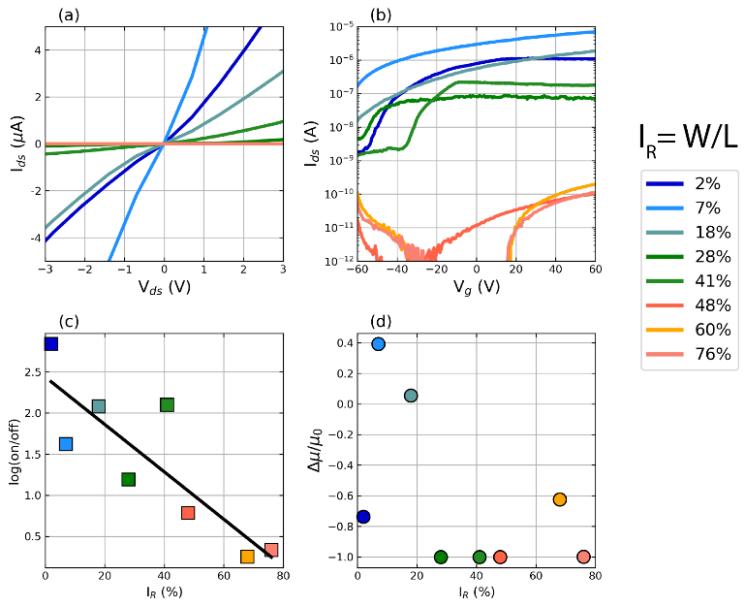dominant contribution of oxygen-containing atmospheric adsorbates (known p-type dopants) in saturating the vacancy sites created by the ion beam, allowing for residual hole conduction in the newly-formed effective medium channel [28]–[30].

Figure 2(d) charts the effect of IR on the change in field-effect mobility, µ, of the irradiated device relative to its as-made mobility, µ0. Extracted from the linear region of the transfer curve, µ is seen to improve by up to a factor of 0.4 in 2 out of 3 devices in the blue region. For the green and red regions of IR, µ is always seen to worsen as the area of the irradiated channel is increased. µ is expected to drop heavily as the rate of scattering rises with increased defective channel area. The improved mobility in the case of IR ~ 10% signifies the previously-discussed trade-off between optimal doping concentration and acceptable scattering center density introduced by the ion beam.

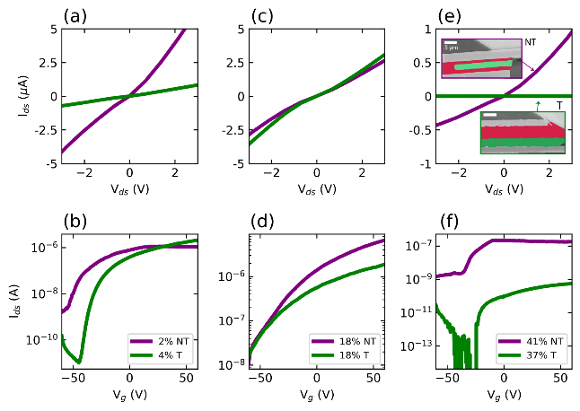

Fig. 3. Comparison of IV and gate curves for devices with a similar IR where the electrodes were not irradiated (purple curves) and where one electrode was irradiated (green curves) across different IR regimes: low (a)-(b), medium (c)-(d) and high (e)-(f). Insets of (e) are example SEM images of non-touching (NT) and touching (T) devices with similar IR. The colored green area in the SEM images is the area damaged by the He+ ion beam, while the red area is the unirradiated MoS2 channel.

As irradiating the whole MoS2 channel (including both electrodes) at this dose has previously resulted in increased conductivity[10], it may be crucial to consider the effect of irradiation on the metal/semiconductor interface. Recent work has shown that irradiation-inducing heating of the contact area can reverse majority carrier polarity in MoTe2 [31], while pre-treatment with a broad-beam argon ion source can decrease Ni-MoS2 contact resistance by two-fold [32]. Figure 3 presents three sets of data for the different IR regimes, where a similar area of the channel has been irradiated on each device. However, for one of the devices in each pair, a single electrode was also irradiated by intentionally overlapping the pattern as to introduce an asymmetry in the defectivity of the device. The accompanying SEM images in the inset of Fig. 3(e) show the irradiated areas colored in green and the unirradiated MoS2 areas in red. In all three IR regimes, allowing one of the electrode/MoS2 interfaces to be damaged by the beam leads to a larger drop in the channel conductance than in the case of channel-only damage. The gate curves in Figs. 3(b), (d), (f) indicate that as the device approaches the strong inversion regime, the electrode interface damage (green curve) inhibits high drain currents in the FET relative to the case of no electrode damage (purple curve).

It may be expected that an increase in the Schottky barrier height will occur if the usually-pinned Fermi level[33] is now a function of the beam-altered metal-semiconductor interface. Ion beam pre-treatment of the interface before metal deposition increases the concentration of dangling bonds available for hybridization when the contact is deposited[32]. As we are treating an already-hybridized interface, we suspect that the formation of defects therein will serve to trap carriers at the interface and will reduce the injection current at the contact. This may be further confirmed with a combination of low-temperature electrical characterization and capacitance measurements[34], [35] in future work.

# Conclusion

In conclusion, we have studied the effect of varying the irradiated channel area of helium ion-treated monolayer MoS2 FETs. Introducing a small concentration of defects into the material (~ 10% of irradiated-to-channel area) can serve to improve the carrier mobility and channel conductance. The effect of irradiating only one of the device electrodes was compared across three different irradiation-to-channel area ratios. We found that exposing the electrode/MoS2 interface was deleterious to the performance of the FET, with a larger conductance drop noticed for each of the areal irradiations. Our work demonstrates that by tuning the irradiation strategy and localizing the damage to specific sites, the electronic characteristics of on-dielectric MoS2 FETs can be well-controlled in the monolayer limit.

References

[1] D. Jariwala, V. K. Sangwan, D. J. Late, J. E. Johns, V. P. Dravid, T. J. Marks, L. J. Lauhon, and M. C. Hersam, “Band-like transport in high mobility unencapsulated single-layer MoS 2 transistors,” *Appl. Phys. Lett.*, vol. 102, no. 17, pp. 2–6, 2013.

[2] B. W. H. Baugher, H. O. H. Churchill, Y. Yang, and P. Jarillo-Herrero, “Intrinsic electronic transport properties of high-quality monolayer and bilayer MoS2,” *Nano Lett.*, vol. 13, no. 9, pp. 4212–4216, 2013.

[3] M. O’Brien, N. McEvoy, C. Motta, J.-Y. Zheng, N. C. Berner, J. Kotakoski, K. Elibol, T. J. Pennycook, J. C. Meyer, C. Yim, M. Abid, T. Hallam, J. F. Donegan, S. Sanvito, and G. S. Duesberg, “Raman characterization of platinum diselenide thin films,” *2D Mater.*, vol. 3, no. 2, p. 21004, Apr. 2016.

[4] H. Bergeron, V. K. Sangwan, J. J. McMorrow, G. P. Campbell, I. Balla, X. Liu, M. J. Bedzyk, T. J. Marks, and M. C. Hersam, “Chemical vapor deposition of monolayer MoS2 directly on ultrathin Al2O3 for low-power electronics,” *Appl. Phys. Lett.*, vol. 110, no. 5, p. 53101, 2017.

[5] Z. Lin, A. McCreary, N. Briggs, S. Subramanian, K. Zhang, Y. Sun, X. Li, N. J. Borys, H. Yuan, S. K. Fullerton-Shirey, A. Chernikov, H. Zhao, S. McDonnell, A. M. Lindenberg, K. Xiao, B. J. LeRoy, M. Drndić, J. C. M. Hwang, J. Park, M. Chhowalla, R. E. Schaak, A. Javey, M. C. Hersam, J. Robinson, and M. Terrones, “2D materials advances: from large scale synthesis and controlled heterostructures to improved characterization techniques, defects and applications,” *2D Mater.*, vol. 3, no. 4, p. 042001, 2016.

[6] J. Jadwiszczak, C. O’Callaghan, Y. Zhou, D. S. Fox, E. Weitz, D. Keane, C. P. Cullen, I. O’Reilly, C. Downing, A. Shmeliov, P. Maguire, J. J. Gough, C. McGuinness, M. S. Ferreira, A. L. Bradley, J. J. Boland, G. S. Duesberg, V. Nicolosi, and H. Zhang, “Oxide-mediated recovery of field-effect mobility in plasma-treated MoS 2,” *Sci. Adv.*, vol. 4, no. 3, p. eaao5031, Mar. 2018.

[7] V. Iberi, A. V Ievlev, I. Vlassiouk, S. Jesse, S. V Kalinin, D. C. Joy, A. J. Rondinone, A. Belianinov, and O. S. Ovchinnikova, “Graphene engineering by neon ion beams,” *Nanotechnology*, vol. 27, no. 12, p. 125302, 2016.

[8] J. Klein, A. Kuc, A. Nolinder, M. Altzschner, J. Wierzbowski, F. Sigger, F. Kreupl, J. J. Finley, U. Wurstbauer, A. W. Holleitner, and M. Kaniber, “Helium ion modified luminescence and robust valley polarization of atomically thin MoS$_{2}$,” 2017.

[9] M. G. Stanford, B. B. Lewis, K. Mahady, J. D. Fowlkes, and P. D. Rack, “Review Article: Advanced nanoscale patterning and material synthesis with gas field helium and neon ion beams,” *J. Vac. Sci. Technol. B, Nanotechnol. Microelectron. Mater. Process. Meas. Phenom.*, vol. 35, no. 3, p. 030802, 2017.

[10] D. S. Fox, Y. Zhou, P. Maguire, A. O’Neill, C. Ó’Coileáin, R. Gatensby, A. M. Glushenkov, T. Tao, G. S. Duesberg, I. V. Shvets, M. Abid, M. Abid, H.-C. Wu, Y. Chen, J. N. Coleman, J. F. Donegan, and H. Zhang, “Nanopatterning and Electrical Tuning of MoS 2 Layers with a Subnanometer Helium Ion Beam,” *Nano Lett.*, p. 150715144824008, 2015.

[11] M. G. Stanford, P. R. Pudasaini, E. T. Gallmeier, N. Cross, L. Liang, A. Oyedele, G. Duscher, M. Mahjouri-Samani, K. Wang, K. Xiao, D. B. Geohegan, A. Belianinov, B. G. Sumpter, and P. D. Rack, “High Conduction Hopping Behavior Induced in Transition Metal Dichalcogenides by Percolating Defect Networks: Toward Atomically Thin Circuits,” *Adv. Funct. Mater.*, vol. 27, no. 36, p. 1702829, Sep. 2017.

[12] Quan, “Controlled argon beam-induced desulfurization of monolayer molybdenum disulfide,” *J. Phys. Condens. Matter*, vol. 25, 2013.

[13] Z. Li and F. Chen, “Ion beam modification of two-dimensional materials: Characterization, properties, and applications,” *Appl. Phys. Rev.*, vol. 4, no. 1, p. 011103, 2017.

[14] S. Bertolazzi, S. Bonacchi, G. Nan, A. Pershin, D. Beljonne, and P. Samorì, “Engineering Chemically Active Defects in Monolayer MoS 2 Transistors via Ion-Beam Irradiation and Their Healing via Vapor Deposition of Alkanethiols,” *Adv. Mater.*, p. 1606760, 2017.

[15] Z. G. Yu, Y.-W. Zhang, and B. I. Yakobson, “An Anomalous Formation Pathway for Dislocation-Sulfur Vacancy Complexes in Polycrystalline Monolayer MoS 2.”

[16] V. K. Sangwan and M. C. Hersam, “Electronic Transport in Two-Dimensional Materials,” *Annu. Rev. Phys. Chem. Annu. Rev. Phys. Chem*, vol. 6912, 2018.

[17] S.-L. Li, E. Orgiu, P. Samorì, K. Tsukagoshi, and P. Samor, “Chem Soc Rev Charge transport and mobility engineering in two-dimensional transition metal chalcogenide semiconductors Charge transport and mobility engineering in two-dimensional transition metal chalcogenide semiconductors,” *Chem. Soc. Rev. Chem. Soc. Rev*, vol. 45, no. 45, pp. 1–226, 2016.

[18] K. Kaasbjerg, J. H. J. Martiny, T. Low, and A.-P. Jauho, “Symmetry-forbidden intervalley scattering by atomic defects in monolayer transition-metal dichalcogenides,” *Phys. Rev. B*, vol. 96, no. 24, p. 241411, Dec. 2017.

[19] J. Buchheim, R. M. Wyss, I. Shorubalko, and H. G. Park, “Understanding the interaction between energetic ions and freestanding graphene towards practical 2D perforation,” *Nanoscale*, vol. 8, no. 15, pp. 8345–8354, 2016.

[20] K. Yoon, A. Rahnamoun, J. L. Swett, V. Iberi, D. A. Cullen, I. V Vlassiouk, A. Belianinov, X. Sang, O. S. Ovchinnikova, A. J. Rondinone, R. R. Unocic, and A. C. T. Van Duin, “Atomistic-Scale Simulations of Defect Formation in Graphene Under Noble Gas Ion Irradiation,” 2016.

[21] M. O ’brien, N. Mcevoy, T. Hallam, H.-Y. Kim, N. C. Berner, D. Hanlon, K. Lee, J. N. Coleman, and G. S. Duesberg, “Transition Metal Dichalcogenide Growth via Close Proximity Precursor Supply.”

[22] S. Najmaei, M. Amani, M. L. Chin, Z. Liu, A. G. Birdwell, T. P. Oregan, P. M. Ajayan, M. Dubey, and J. Lou, “Electrical transport properties of polycrystalline monolayer molybdenum disulfide,” *ACS Nano*, vol. 8, no. 8, pp. 7930–7937, 2014.

[23] M. Ghorbani-Asl, A. N. Enyashin, A. Kuc, G. Seifert, and T. Heine, “Defect-induced conductivity anisotropy in MoS 2 monolayers,” *Phys. Rev. B*, vol. 88, no. 24, p. 245440, 2013.

[24] L. Peng, S. A. Wells, C. R. Ryder, M. C. Hersam, and M. Grayson, “All-Electrical Determination of Crystal Orientation in Anisotropic Two-Dimensional Materials,” *Phys. Rev. Lett.*, vol. 120, no. 8, p. 086801, Feb. 2018.

[25] J. S. Kim, J. Kim, J. Zhao, S. Kim, J. H. Lee, Y. Jin, H. Choi, B. H. Moon, J. J. Bae, Y. H. Lee, and S. C. Lim, “Electrical Transport Properties of Polymorphic MoS 2,” *ACS Nano*, p. acsnano.6b02267, 2016.

[26] N. Papadopoulos, G. A. Steele, and H. S. J. van der Zant, “Efros-Shklovskii variable range hopping and nonlinear transport in 1 T/1 T′− MoS 2,” *Phys. Rev. B*, vol. 96, no. 23, p. 235436, 2017.

[27] J. Zhu, Z. Wang, H. Yu, N. Li, J. Zhang, J. Meng, M. Liao, J. Zhao, X. Lu, L. Du, R. Yang, D. Shi, Y. Jiang, and G. Zhang, “Argon Plasma Induced Phase Transition in Monolayer MoS 2,” *J. Am. Chem. Soc.*, p. jacs.7b05765, 2017.

[28] P. R. Pudasaini, A. Oyedele, C. Zhang, M. G. Stanford, N. Cross, A. T. Wong, A. N. Hoffman, K. Xiao, G. Duscher, D. G. Mandrus, T. Z. Ward, and P. D. Rack, “High-performance multilayer WSe 2 field-effect transistors with carrier type control.”

[29] R. Dhall, Z. Li, E. Kosmowska, and S. B. Cronin, “Charge neutral {MoS}2 field effect transistors through oxygen plasma treatment,” *J. Appl. Phys.*, vol. 120, no. 19, p. 195702, Nov. 2016.

[30] G. Yoo, S. Hong, J. Heo, and S. Kim, “Enhanced photoresponsivity of multilayer MoS2 transistors using high work function MoOx overlayer,” *Appl. Phys. Lett.*, vol. 110, no. 5, 2017.

[31] S.-Y. Seo, J. Park, J. Park, K. Song, S. Cha, S. Sim, S.-Y. Choi, H. W. Yeom, H. Choi, and M.-H. Jo, “Writing monolithic integrated circuits on a two-dimensional semiconductor with a scanning light probe,” *Nat. Electron.*, vol. 1, no. 9, pp. 512–517, 2018.

[32] Z. Cheng, J. A. Cardenas, F. McGuire, and A. D. Franklin, “Modifying the Metal-MoS2 Contact Interface Using a Broad-Beam Ion Source,” *IEEE Electron Device Lett.*, vol. 7, no. 1, p. in review, 2015.

[33] C. Kim, I. Moon, D. Lee, M. S. Choi, F. Ahmed, S. Nam, Y. Cho, H.-J. Shin, S. Park, and W. J. Yoo, “Fermi Level Pinning at Electrical Metal Contacts of Monolayer Molybdenum Dichalcogenides,” *ACS Nano*, 2017.

[34] B. H. Moon, G. H. Han, H. Kim, H. Choi, J. J. Bae, J. Kim, Y. Jin, H. Y. Jeong, M.-K. Joo, Y. H. Lee, and S. C. Lim, “Junction-Structure-Dependent Schottky Barrier Inhomogeneity and Device Ideality of Monolayer MoS 2 Field-Effect Transistors,” *ACS Appl. Mater. Interfaces*, p. acsami.6b16692, 2017.

[35] H.-J. Kim, D.-H. Kim, C.-Y. Jeong, J.-H. Lee, and H.-I. Kwon, “Determination of Interface and Bulk Trap Densities in High-Mobility P-type WSe&lt;sub&gt;2&lt;/sub&gt; Thin-Film Transistors,” *IEEE Electron Device Lett.*, vol. 1, no. c, pp. 1–1, 2017.

1. Manuscript received xxxx xx, 2019; revised xxxx xx, 2019. Date of publication xxxxxx xx, 2019; date of the current version xxxxx xx, 2019. This work was supported by Leverhulme Trust International Networks Grant (PicoFIB), Science Foundation Ireland (12/TIDA/I2433) and the Irish Research Council (GOIPG/2014/972).

   J. Jadwiszczak, P. Maguire and H. Zhang are with the School of Physics, Trinity College Dublin, Ireland. C. P. Cullen, D. Keane and G. S. Duesberg are affiliated the School of Chemistry, Trinity College Dublin, Ireland. G. S. Duesberg is also with Bundeswehr University Munich, Germany. All authors are with CRANN and AMBER research institutes, Trinity College Dublin, Ireland. (e-mail: hozhang@tcd.ie).