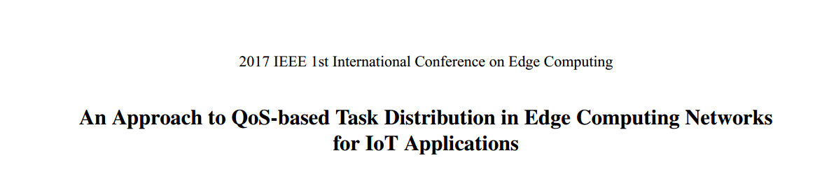

Yet, edge computing has its drawbacks, such as the limited computing resources of some edge computing devices and the unbalanced load among these devices

In this paper, an approach is presented to periodically distributing incoming tasks in the edge computing network so that the number of tasks, which can be processed in the edge computing network, is increased, and the qualityof-service (QoS) requirements of the tasks completed in the edge computing network are satisfied



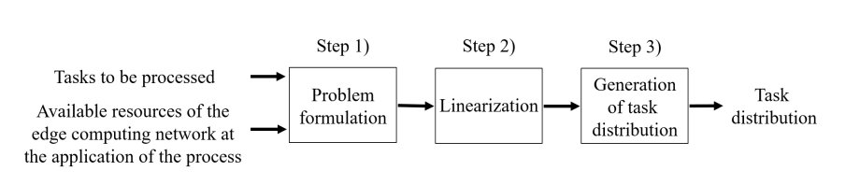

As incoming tasks to the edge computing network are continuously sent from IoT devices, the task distribution process needs to be applied periodically. Let σ be the time interval between two consecutive applications of task distribution process.

If the number of distributed tasks falls below a preset threshold, for example, 30, σ should be reduced so that the task distribution process will be applied more frequently



An edge computing network can be represented by a directed graph G = (V; E)

where V = fv0; : : : ; vi; : : : ; vm−1g is the set of edge nodes, and E = fe0; : : : ; ej; : : : ; en−1g is the set of edge links.

Each edge node runs a number of VMs, and each VM performs one task at a time

T = ft0; : : : ; tk; : : : ; t −1g be the set of tasks to be processed at the time of applying the task distribution process.

tk = (ak; wk; dk; s0 k; p0 k; δk)

ak is the access node of tk

we further denote bak as the access bandwidth for tk, which is the bandwidth between the IoT device that sends tk and its access point ak.

Let xk;i = 1 if tk has been decided to be distributed to vi,

Let fk;j; 0 ≤ fk;j ≤ bj, be the required bandwidth on ej for the flow of tk to pass through ej.



Each task tk can be assigned to at most one edge node, and must be executed and completed on the assigned edge node.



Each edge node vi, must have sufficient storage to store the data of all the tasks distributed to vi



The VMs on each node vi must be sufficiently secure in order to satisfy the specified security requirement of tk



Each node vi can only host at most hi tasks due to its available Vms



each accommodated task tk must be completed within the deadline specified by its IoT application.

the tk’s data transmission time duration between tk’s IoT device and its execution node vi, and the execution time duration of tk on node vi.



For each link ej, the sum of the required bandwidth for the flows of all the tasks to pass through ej must be no greater than the capacity of link ej



Note that due to Constraint (1), some tasks may not be distributed to any edge node for execution.

