

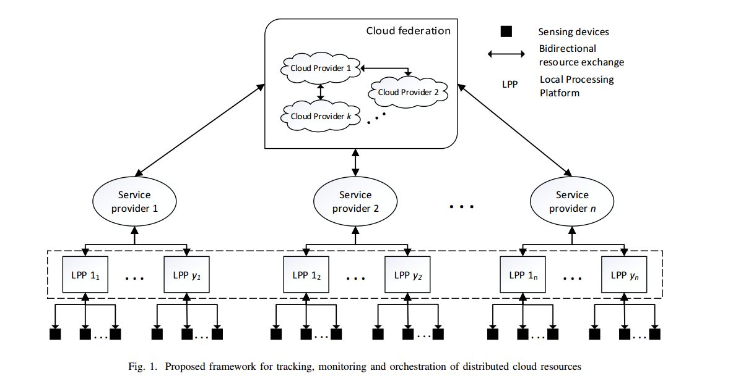

Once the data is processed by a LPP, it can be sent to the cloud for storage..

Since LPP may have limited energy, they may have to offload their tasks by requesting for a computational resource

the cloud federation looks for available resources that can be allocated to LPP in order to perform a particular task

two types of resource requests are considered in the proposed model i.e.

(a) computational capacity for processing and storing data

(b) low-latency computational capacity

The tracking and monitoring of tasks is performed using ATOM

In the proposed model, if the cloud providers cannot fulfill a new resource request, the LPP that have agreed to share their available resources with cloud are considered to acknowledge the request

Let Ct i denote the total capacity of the ith cloud provider, where that i = {1; 2; 3; : : : ; k}

Let Ciu denote the currently occupied capacity of the ith cloud provider.

