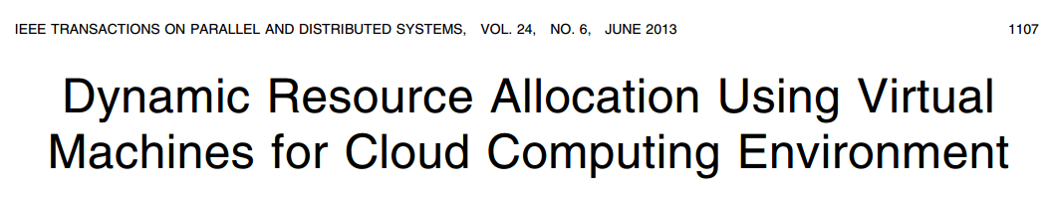

Here we study a different problem: how can a cloud service provider best multiplex its virtual resources onto the physical hardware?