A summary on 3 first part of

“Channel Occupancy Times and Handoff Rate for Mobile Computing and PCS Networks”

By: Mohammad Mahmoodian

Abstract

This paper presents a study of channel occupancy times and handoff rate for mobile computing in MC (MobileComputing) and PCS (Personal Communications Services) networks, using general operational assumptions. It is shown that, forexponentially distributed call holding times, a distribution more appropriate for conventional voice telephony, the channel occupancy times are exponentially distributed if and only if the cell residence times are exponentially distributed. It is further shown that themerged traffic from new calls and handoff calls is Poisson if and only if the cell residence times are exponentially distributed, too.

1. INTRODUCTION

We observe that the channel occupancy time corresponds to the service time, while the handoff call traffic to a cell forms a major part of the cell traffic, the resulting queuing network is used to find the very important design parameters, such as blocking probability. The handoff rate is used to characterize the handoff call traffic to a cell. Therefore, the channel occupancy time and the handoff rate are two important parameters for the MC/PCS networks.

A common assumption in most studies has been that the call holding time (the time requested for a call connection) is exponentially distributed.

Most analytical studies in the literature assume that the channel occupancy times are exponentially distributed. However, recent field studies showed that the channel occupancy times are not exponentially distributed for cellular systems. Therefore, further investigation on channel occupancy times is needed.

To model the MC/PCS networks in a realistic way, several observations are in order. First, due to the wide spectrum of the integrated communications carried jointly over an MC/PCS network, the assumption of call holding times being exponentially distributed, may no longer be valid. Second, due to user mobility (portables or mobile computers) and the irregular geographical cell shapes, the cell residence times (the time a user spends in a cell) will also typically have a general distribution. Third, the channel occupancy time in a cell, i.e., the time the channel is occupied by a call in a cell (a new call, a handoff call, regardless of the call being completed in the cell or moving out of the cell) is  
also not necessarily distributed exponentially, as generally assumed in the past. Last, during a  
communication session in an MC/PCS network, a user may traverse several cells and the call may consequently be handed off many times before it completes.

In this paper, we present a systematic study of channel occupancy times and handoff rate in MC/PCS systems under general systems assumptions, leading to a number of new results. Under the assumption that the call holding time is exponentially distributed, we present a necessary and sufficient condition for the new call channel occupancy time to be exponentially distributed. Specifically, we show that, in an MC/PCS system, the channel occupancy time is exponentially distributed if and only if cell residence times are exponentially distributed. When cell residence times are not exponentially distributed, we derive formulae to compute the distribution of channel occupancy times. In order to apply Erlang-B formula, the cell arrival traffic, which consists of merged traffic of new calls and handoff calls, has been assumed to be Poisson, a common assumption for the computation of blocking probability in cellular systems However, for cell arrival traffic in MC/PCS networks, we show that the cell arrival traffic is Poisson if and only if the cell residence times are exponentially distributed. The handoff rate, which is defined as the average number of handoffs during a call connection, is the second focus of this paper.

In this paper, we, therefore, derive a general formula for the computation of the handoff rate under general conditions, i.e., when the call holding times and cell residence times are generally distributed with nanolattice distribution functions.

We find that, for high mobility users, due to the variation of the call holding time, the handoff rate in a call and, hence, the handoff call arrival rate are significantly different from the case when the call holding time is assumed to be exponentially distributed.

The exponential distribution model for call holding time underestimates the handoff call arrival rate, hence the overall cell traffic rate, thus the blocking probability under the actual call holding time, are higher than those under exponential approximation for channel holding time.

Last, the technique proposed in this paper also leads to a practical model for deriving performance evaluation of GSM based mobile computing systems.

2. COMMENTS ON CLASSICAL ASSUMPTIONS REGARDING HANDOFF TRAFFIC AND CHANNEL  
OCCUPANCY TIMES

Assume that the call holding times (the times of requested connections to a MC/PCS network for new calls) are exponentially distributed with parameter $μ$.

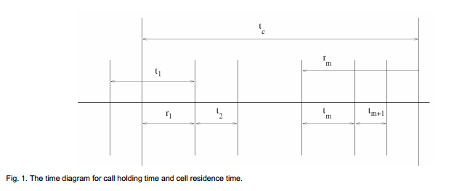

Let t­c be the call holding time for a typical new call, tm be the cell residence time, r1 be the time between the instant the new call is initiated at and the instant the new call moves out the cell if the new call is not completed, rm (m > 1) be the residual call holding time when the call finishes mth handoff successfully. Let tno and tho denote the channel occupancy times for a new call and a handoff call, respectively. Then, from Fig. 1, the new call channel occupancy time is

­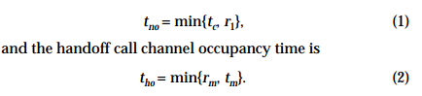

Let *tc*, *tm*, *r*1, *tho*, and *tno* have density functions *fc*(*t*), *f*(*t*), *fr*(*t*), *fho*(*t*), and *fno*(*t*).

We next show that the handoff call channel occupancy time *tho* is exponentially distributed if and only if the cell residence time *tm* is exponentially distributed. From (2), we obtain the probability

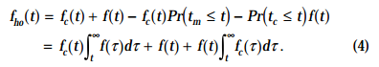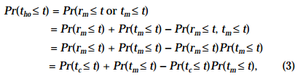

Suppose that the cell residence times are exponentially distributed with parameter $η$, then, from (4), we obtain



which is an exponential distribution. Conversely, suppose that the handoff call channel occupancy time has exponential distribution with parameter



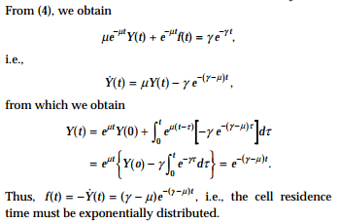

We now consider the new call channel occupancy time distribution case. From (1) and a similar argument, we obtain

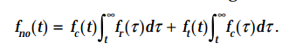

Suppose that the new call channel occupancy time is exponentially distributed with parameter, $μ_{1}$,from this identity and a similar argument as for the handoff call channel occupancy time case, we can deduce that



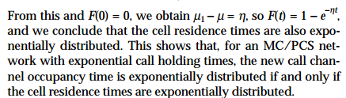

Let *tco* denote the channel occupancy time and $λ_{h}$ the handoff call arrival rate

$$p=\frac{λ}{λ+λ_{h}} , q=\frac{λ_{h}}{λ+λ_{h}}$$

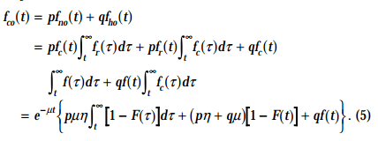

It is straightforward to show that when the cell residence times are exponentially distributed, then the channel occupancy time is also exponentially distributed. Conversely, suppose that the channel occupancy time is exponentially distributed with, parameter



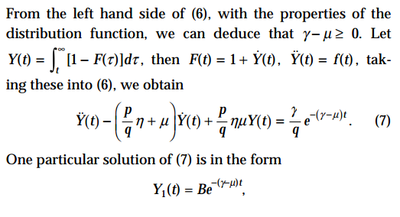



From *F*(0) = 0, we obtain *B*( $γ$- $μ$) = 1, hence *F*(*t*) = 1 – *exp(*-( $γ$- $μ$)*t)*, which implies that the cell residence times are exponentially distributed.

Next, we discuss the second commonly used assumption, i.e., the merged traffic of new calls and handoff calls in a cell is Poissonian. Assume that, in a typical cell of an MC/PCS network, the new call arrivals are Poisson, then the handoff call arrivals to the cell are independent of the new call arrivals. Let *Nn*(*t*) and *Nh*(*t*) be the numbers of new calls and handoff calls, respectively, up to time *t*. Let *N*(*t*) be the number of calls from the merged traffic of the new call traffic and the handoff call traffic. Then, we have

N(t) = Nn(t) + Nh(t)

We use the *Z*-transform theory and the following result

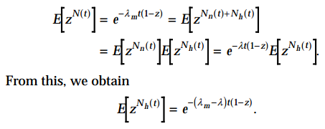

Thus, the handoff call traffic *Nh*(*t*) is also a Poisson process.

We next observe that the handoff call traffic is the departure process of the queuing system with the Poisson arrivals and with two virtual “servers”: one “server” for the calls which complete the connection successfully in the cell, the other “server” for calls which need handoffs. The departure process from the first server is a Poisson process, since the departure process from the *M*/*M*/1 queue is a Poisson process. As the handoff call traffic is Poisson from the above discussion, from the earlier referenced Burke’s result, the channel occupancy time must be exponentially distributed, hence, the cell residence times must be exponentially distributed, too.

3. CHANNEL OCCUPANCY TIMES

However, the assumption of exponential cell residence times is too restrictive, since it is important to know the distribution of channel occupancy time for generally distributed cell residence times.

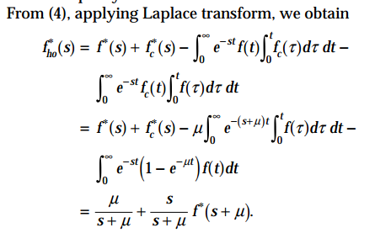

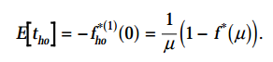



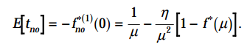

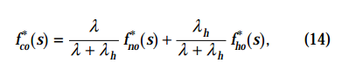

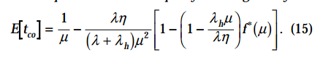

It is commonly assumed that the new call channel occupancy time and the handoff call channel occupancy time have the same distribution. However, we claim that this is true only when the cell residence times are exponentially distributed. In fact, suppose that channel occupancy times for both new call and handoff call have the same distribution, then their Laplace transforms are equal, $f_{n0}^{*}\left(s\right)=f_{ho}^{*}(s)$. This implies that the cell residence times must be exponentially distributed.

We can obtain the channel occupancy time density functions by the inverse Laplace transform, from which the distribution functions can be obtained It is known that an exponential distribution is uniquely determined by its expected value. It is reasonable to use the exponential distribution whose expected value is equal to the real expected value of channel holding time. There are many criteria to evaluate this approximation, known in statistics as the “goodness of fit.” A good choice will be the distance between the distribution functions of the real data and the exponential data. Hong and Rappaport proposed the following measure for the “goodness of fit”:

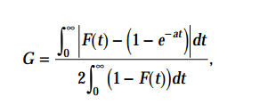

where *F*(*t*) is the distribution function of real data and *a* is the expected value of the exponential distribution used for the approximation.