According to the aforementioned lemma, the main centralized problem will turn into the following problem:

$$\operatorname{minimize}{\sum_{i=1}^{N}{f_{i}\left(β_{i}\right)+g_{i}\left(Δ+1-{\hat{δ}}_{i}\right)}}$$

$$s.t. \frac{β_{i}\sum_{j=1 }^{N}{A_{ij}u_{j}^{ }}+{\hat{δ}}_{i}u_{i}^{ }}{\left(Δ+1-\overline{ϵ}\right)u_{i}^{ }}≤1 ∀ all i_{s} (1)$$

$$\underline{β_{i}}≤β_{i}≤{\overline{β}}_{i} ∀ all i_{s} (2)$$

$$Δ+1-{\overline{δ}}_{i}≤{\hat{δ}}_{i}≤Δ+1-{\underline{δ}}_{i} ∀ all i_{s} (3)$$

Which:

$$δ_{i}^{*}=Δ+1-{\hat{δ}}_{i}^{*}$$

And:

$$Δ=\max{\{ \overline{ϵ}, {\overline{δ}}_{i} \}}$$

Given the equations above, we have reached a well-behaved centralized optimization problem to apply the goal of this project.

Now based on what we mentioned at the beginning, we need to solve the problem above using Decentralized and Distributed algorithms. According what we had in seminars during the semester, we conclude to utilize both decentralized ADMM and distributed ADMM in order to receive better and more sophisticated results.

1. ***Decentralized ADMM Algorithm***

Based on what we had in seminars, Decentralized ADMM algorithms tries to make an agreement among all the Agents using a Coordinator, which means all the Agents minimize their own cost function by using the parameters of other Agents which are provided by the Coordinator. The common parameter of all the agents is vector ***u.***

So by applying Decentralized ADMM to the well-behaved centralized optimization problem, the new decentralized problem is as follows:

$$\operatorname{minimize}{\sum_{i=1}^{N}{f_{i}\left(β_{i}\right)+g_{i}\left(Δ+1-{\hat{δ}}_{i}\right)}}$$

$$s.t. \frac{β_{i}\sum_{j=1 }^{N}{A_{ij}u_{i}^{j}}+{\hat{δ}}_{i}u_{i}^{i}}{\left(Δ+1-\overline{ϵ}\right)u_{i}^{i}}≤1 ∀ all i_{s} (1)$$

$$\underline{β_{i}}≤β_{i}≤{\overline{β}}_{i} ∀ all i_{s} (2)$$

$$Δ+1-{\overline{δ}}_{i}≤{\hat{δ}}_{i}≤Δ+1-{\underline{δ}}_{i} ∀ all i_{s} (3)$$

$$u_{i}=z ∀ all i_{s} (4)$$

So the Lagrangian function of problem above is:

$$L_{ρ}= \sum_{i=1}^{N}{f_{i}\left(β_{i}\right)+g_{i}\left(Δ+1-{\hat{δ}}_{i}\right)+y_{i}^{T}\left(u_{i}-z\right)+\frac{ρ}{2} {\left|\left|u_{i}-z\right|\right|}^{2}}$$

Now as it is obvious the Lagrange function of each agent can be decoupled from the other agent’s Lagrange function. So for each agent we have:

$$L_{ρ}^{i}=f_{i}\left(β_{i}\right)+g_{i}\left(Δ+1-{\hat{δ}}_{i}\right)+y_{i}^{T}\left(u_{i}-z\right)+\frac{ρ}{2} {\left|\left|u_{i}-z\right|\right|}^{2}$$

Hence, each agent can optimize its own problem by receiving the ***z*** vector from the coordinator and then replaces ***u*** with ***z.*** After each agent optimizes its own problem, all the agents send the copy their ***u*** vector to the coordinator. Accordingly the coordinator will update ***z*** and ***y*** (Lagrange multiplier) using the information that is received from the agents.

Finally the Decentralized ADMM algorithm is as follows:

***Decentralized ADMM algorithm***

1. Initializing the parameters $z^{0},u_{i}^{0},y_{i}^{0},β_{i}^{0},δ_{i}^{0}$

At iteration k:

1. Each agent optimize its own problem and then sends the related $u_{i}$ to the coordinator.

$$β_{i}^{k+1},δ_{i}^{k+1 }, u_{i}^{k+1 }=\arg{\min{L_{ρ}^{i}(}}β_{i}^{ },δ_{i}^{ }, u_{i}^{ }, y_{i}^{k},z^{k})= f_{i}\left(β_{i}^{ }\right)+g_{i}\left(Δ+1-{\hat{δ}}_{i}^{ }\right)+{y_{i}^{k}}^{T}\left(u_{i}^{ }-z^{k}\right)+\frac{ρ}{2} {\left|\left|u_{i}^{ }-z^{k}\right|\right|}^{2}$$

$$s.t. \frac{β_{i}\sum_{j=1 }^{N}{A_{ij}u_{i}^{j}}+{\hat{δ}}_{i}u_{i}^{i}}{\left(Δ+1-\overline{ϵ}\right)u_{i}^{i}}≤1 (1)$$

$$\underline{β_{i}}≤β_{i}≤{\overline{β}}_{i} (2)$$

$$Δ+1-{\overline{δ}}_{i}≤{\hat{δ}}_{i}≤Δ+1-{\underline{δ}}_{i} (3)$$

$$\prod_{j=1}^{n}{u_{i}^{j}=1 } (4)$$

***Normalization of the vectors $u_{i}$ is to ensure that the local estimates $u_{i}$ have the same direction.***

1. In this step coordinator updates $z$ and Lagrange multiplier $y$ using the information collected from the agents.
$$z^{k+1}=\frac{\sum_{i=1}^{N}{u_{i}^{k+1}}}{N}+\frac{1}{ρ}\frac{\sum_{i=1}^{N}{y_{i}^{k}}}{N}$$

$$y_{i}^{k+1}=y_{i}^{k}+ρ(u_{i}^{k+1}-z^{k+1})$$

2. Go to b until $\left|\left|z^{k+1}-z^{k}\right|\right|<ϵ$
3. ***Distributed ADMM Algorithm***

According what we had in previous section in decentralized method, each agent performs its own optimization problem and interact the results with a coordinator, actually the coordinator was responsible for the management of the agents and the constraints. But in distributed algorithms there is nothing like a coordinator and all the nodes must interact with themselves.

So given the explanation above the distributed ADMM algorithm for each node can be expressed as:

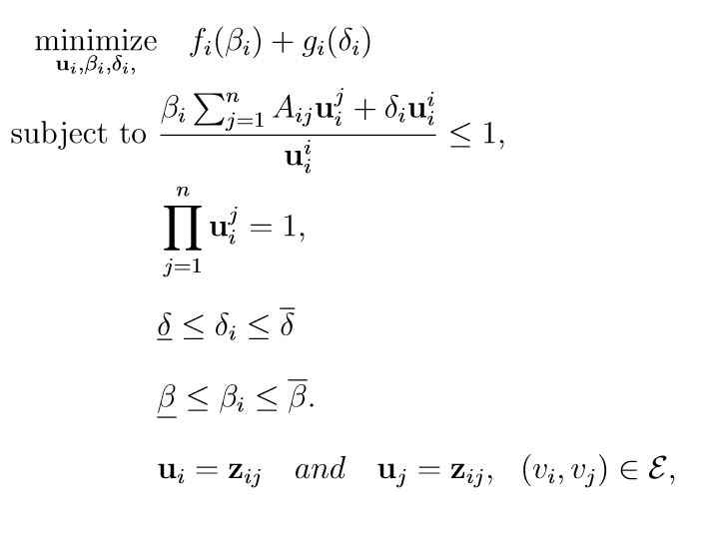

The constraints $u_{i} = z_{ij}$ and $u_{j} = z_{ij}$ imply that for all pairs of agents $(v_{i},v_{j})$ that form an edge, the feasible set is such that $u_{i} = u_{j}$. Assuming a strongly connected contact network, these local consensus constraints imply that feasible solutions must satisfy $u_{i}=u_{j}$ for all, not necessarily neighboring, pairs of agents $v_{i}$ and $v_{j}$.

So based on problem above, the augmented Lagrangian is as follows:

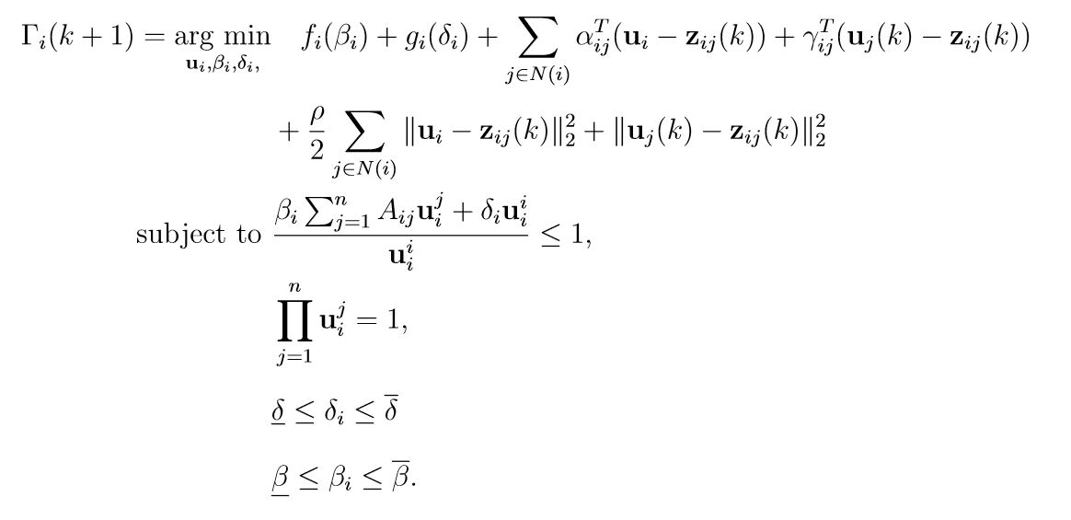

And the dual variables updates are:

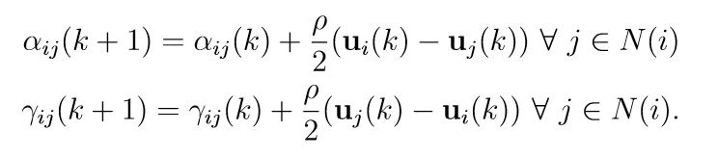

Now the paper has introduced a variable $ϕ_{i}\left(k\right)=\sum_{j∈N(i)}{\left( α_{ij}\left(k\right)+γ_{ji}\left(k\right)\right) ∀ v_{i}∈V}$

Therefore by using the new introduced variable and augmented Lagrangian the Distributed ADMM algorithm can be expressed:

