Graph Generation 1
Network Configuration 2
Distributed Algorithm 2
Decentralized Algorithm 41
Convergence Factors Calculation 80
Plotting Results 81

Graph Generation
addpath(genpath('Distributed'))
addpath(genpath('Decentralized'))
addpath(genpath('Graph'))
clear
clc
N = 8;
A = [];
while not (isConnected(A))
A = randomGraph ( N, 0.4 ) ;
end
G = graph(A);
figure
plot(G)
title('Network Graph')
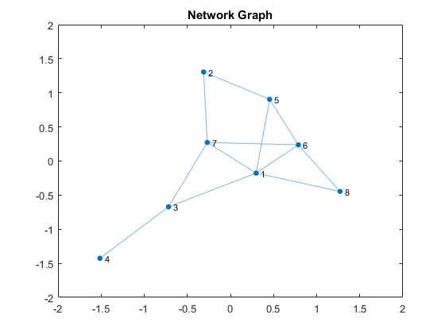

Network Configuration

Distributed Algorithm
rho = 1;
numofIterations = 30;
phi = zeros(N,N,numofIterations);
phi(:,:,1) = ones(N,N);
betaDist = zeros(N,numofIterations);
deltaDist = zeros(N,numofIterations);
uDist = zeros(N,N,numofIterations);
uDist(:,1) = ones(N,1);
for k = 1:numofIterations-1
for i = 1:N
phi(:,i,k+1) = phi(:,i,k) + rho * sum( A(i,:).*(uDist(:,i,k)-uDist(:,:,k)), 2 ) ;
[betaDist(i,k+1), deltaDist(i,k+1), uDist(:,i,k+1)] = updateLocalVariablesFminconDistributed(i, phi(:,i,k+1), uDist(:,:,k), betaMin, betaMax, deltaMin, deltaMax, A(i,:), rho, DeltaTilda, epsilonBar);
end
end

Decentralized Algorithm
y = zeros(N,N,numofIterations);
betaDecent = zeros(N,numofIterations);
deltaDecent = zeros(N,numofIterations);
uDecent = zeros(N,N,numofIterations);
uDecent(:,1) = ones(N,1);
z = zeros(N,numofIterations);
z(:,1) = ones(N,1);
for k = 1:numofIterations-1
for i = 1:N
[betaDecent(i,k+1), deltaDecent(i,k+1), uDecent(:,i,k+1)] = updateLocalVariablesFminconDecentralized(i, y(:,i,k), z(:,k), betaMin, betaMax, deltaMin, deltaMax, A(i,:), rho, DeltaTilda, epsilonBar);
end
z(:,k+1) = mean(uDecent(:,:,k+1),2) + mean(y(:,:,k),2)/rho;
y(:,:,k+1) = y(:,:,k) + rho*(uDecent(:,:,k+1)-z(:,k+1)) ;
end

Convergence Factors Calculation
SDist = zeros(numofIterations,1);
SDecent = zeros(numofIterations,1);
phiRecord = zeros(N,numofIterations);
yRecord = zeros(N,numofIterations);
for t = 1:numofIterations
for i=1:N
SDist(t) = SDist(t) + sum(sum((uDist(:,i,t)-uDist(:,:,t)).^2) .* A(i,:));
SDecent(t) = SDecent(t) + sum(sum((uDecent(:,i,t)-uDecent(:,:,t)).^2) .* A(i,:));
phiRecord(i,t) = norm(phi(:,i,t));
yRecord(i,t) = norm(y(:,i,t));
end
end

Plotting Results
nodesForPlot = [1, 4, 8];
figure
plot(SDist/max(SDist))
title('Convergence of Distributed and Decentralized Solutions')
xlabel('iterations')
ylabel('normalized sum of deviations across local estimations')
hold on
plot(SDecent/max(SDecent))
legend('Distributed', 'Decentralized', 'location', 'best')
grid on
hold off
DFE_ParamDist = max(eig(diag(betaDist(:,end))*A - diag(deltaDist(:,end))));
DFE_ParamDecent = max(eig(diag(betaDecent(:,end))*A - diag(deltaDecent(:,end))));
fprintf('Epsilon is %.4f\n', epsilonBar);
fprintf('DFE parameter of distributed solution that should be less than minus epsilon is: %.4f \n', DFE_ParamDist);
fprintf('DFE parameter of decentralized solution that should be less than minus epsilon is: %.4f \n', DFE_ParamDecent);
figure
grid on
hold on
title('Convergence of Distributed Solution')
xlabel('iterations')
ylabel('magnitude of \phi(t)')
msg = strings(length(nodesForPlot),1);
for i=1:length(nodesForPlot)
n = nodesForPlot(i);
plot(phiRecord(n,:))
msg(i) = sprintf('node %i',n);
end
legend(msg, 'location', 'best')
hold off
figure
title('Convergence of Decentralized Solutions')
xlabel('iterations')
ylabel('magnitude of y(t)')
grid on
hold on
msg = strings(length(nodesForPlot),1);
for i=1:length(nodesForPlot)
n = nodesForPlot(i);
plot(yRecord(n,:))
msg(i) = sprintf('node %i',n);
end
legend(msg, 'location', 'best')
hold off
figure
title('Convergence of Distributed and Decentralized Solutions')
xlabel('iterations')
ylabel('beta of nodes')
hold on
grid on
msg = strings(2*length(nodesForPlot),1);
for i=1:length(nodesForPlot)
n = nodesForPlot(i);
plot(betaDist(n,:))
plot(betaDecent(n,:))
msg(2*i-1) = sprintf('node %i Distributed',n);
msg(2*i) = sprintf('node %i Decentralized',n);
end
legend(msg, 'location', 'best')
hold off
figure
title('Convergence of Distributed and Decentralized Solutions')
xlabel('iterations')
ylabel('delta of nodes')
hold on
grid on
msg = strings(2*length(nodesForPlot),1);
for i=1:length(nodesForPlot)
n = nodesForPlot(i);
plot(deltaDist(n,:))
plot(deltaDecent(n,:))
msg(2*i-1) = sprintf('node %i Distributed',n);
msg(2*i) = sprintf('node %i Decentralized',n);
end
legend(msg, 'location', 'best')
hold off
Epsilon is 0.1000
DFE parameter of distributed solution that should be less than minus epsilon is: -0.0969
DFE parameter of decentralized solution that should be less than minus epsilon is: -0.1001
